1. indexOf(): 0 means position 0, -1 means not found

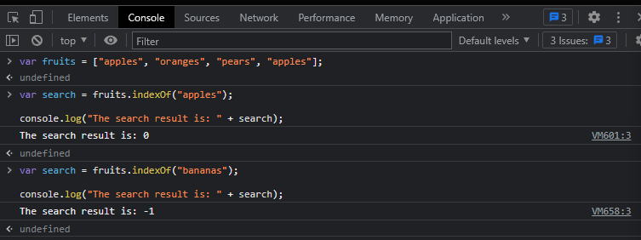

1. lastIndexOf(): Show position of the last item that matches the condition.

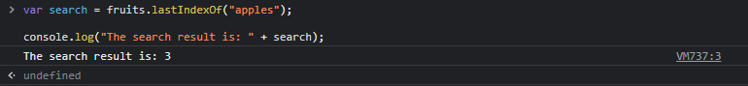

1. forEach(): console.log and document.write behave differently

1. includes(): return true or false

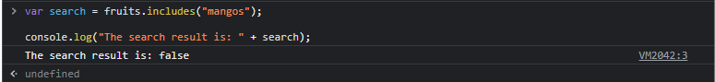

1. every(): every item in the array must meet the condition to create a TRUE (example #2)

1. some(): as long as more than one meets the criteria, returns TRUE.

1. map(): Most Popular,

1. filter(): creates a new array of items that meet the criteria.

1. reduce(): 如果是”+”, then all four numbers +, till there is only one number left. 也可以用”-”, 则四个数字相减.



1. Math.random(): default: 0-1; Example#2: 0-10; Example#3: 0-10, but round to integer.

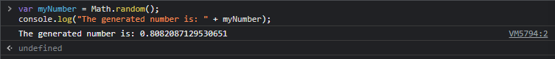

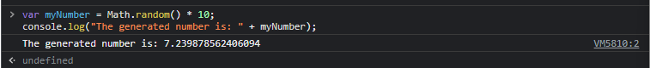

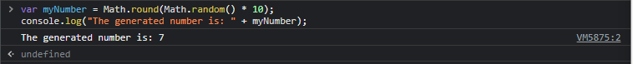

1. Math.random() \* 10+1: random number between 1 and 11(10+1)



1. Math.random() \* 10-1: random number between -1 and 9(10-1)



Create a new repo and submit.

