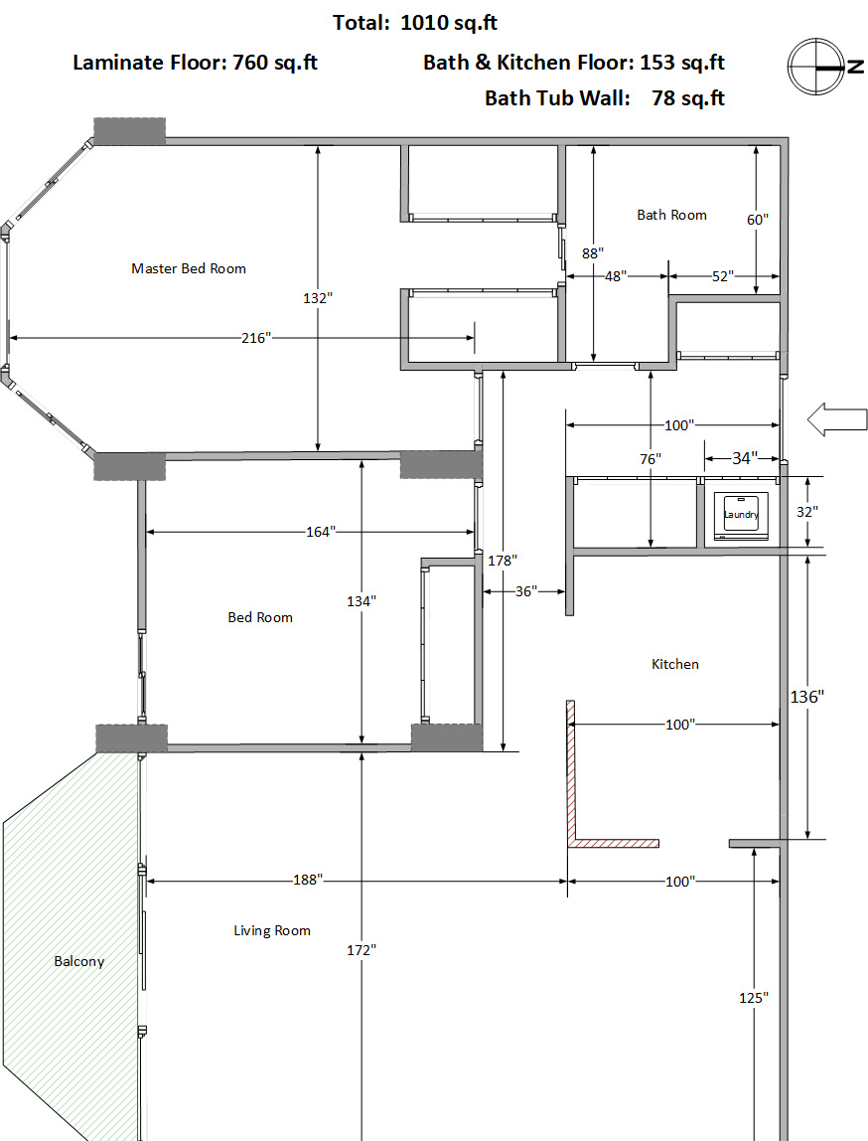

|  |  |  |  |  |
| --- | --- | --- | --- | --- |
| 地面瓷砖 |  |  |  |  |
| Area | Width (inch) | Height(inch) | Square Inch | Square Feet |
| Bath Room 1 | 52 | 60 | 3120 | 21.67 |
| Bath Room 2 | 48 | 88 | 4224 | 29.33 |
| Laundry Room | 34 | 32 | 1088 | 7.56 |
| Kitchen | 100 | 136 | 13600 | 94.44 |
| **Total** | | | | **153.00** |
|  |  |  |  |  |
| 浴缸墙面瓷砖 | Width (inch) | Height(inch) | Square Inch | Square Feet |
|  | 60 | 80 | 4800 | **33.33** |
|  | 36 | 80 | 2880 | **20.00** |
|  | 36 | 80 | 2880 | **20.00** |
| **Total** | | | | **73.33** |
|  |  |  |  |  |
| 复合地板 |  |  |  |  |
| Area | Width (inch) | Height(inch) | Square Inch | Square Feet |
| Living Room 1 | 100 | 125 | 12500 | 86.81 |
| Living Room 2 | 188 | 172 | 32336 | 224.56 |
| Master Bed Room | 216 | 132 | 28512 | 198.00 |
| Bed Room | 164 | 134 | 21976 | 152.61 |
| Corridor & Storage | 100 | 76 | 7600 | 52.78 |
| Corridor | 178 | 36 | 6408 | 44.50 |
| **Total** | | | | **759.25** |