<https://www.sitepoint.com/ultimate-angular-cli-reference/>

<https://github.com/angular/angular-cli/wiki> - 各个指令详解

**In this article, we’ll have a look at what Angular CLI is, what it can do for you, and how it performs some of its magic behind the scenes. Even if you already use Angular CLI, this article can serve as a reference to better understand its inner workings.**

Technically, you’re not required to use Angular CLI to develop an Angular application, but its many features can highly improve the quality of your code and save you a lot of time along the way.



This is the preliminary article in a 4-part series on how to write a Todo application in Angular.

1. **Part 0 — The Ultimate Angular CLI Reference Guide**
2. [Part 1 — Getting our first version of the Todo application up and running](https://www.sitepoint.com/angular-2-tutorial/)
3. [Part 2 — Creating separate components to display a list of todos and a single todo](https://www.sitepoint.com/understanding-component-architecture-angular/)
4. [Part 3 — Update the Todo service to communicate with a REST API](https://www.sitepoint.com/angular-rxjs-create-api-service-rest-backend/)
5. [Part 4 — Use Angular router to resolve data](https://www.sitepoint.com/component-routing-angular-router/).

### Some History

On September 15, 2016, [Angular Final was released](http://angularjs.blogspot.be/2016/09/angular2-final.html).

Where [AngularJS 1.x](https://angularjs.org/) was limited to a framework, [Angular](https://angular.io/) has grown into an ambitious platform that allows you to develop fast and scalable applications across all platforms such as web, mobile web, native mobile and even native desktop.

With this transition to a platform, tooling has become more important than ever. However, setting up and configuring tooling is not always easy. To make sure Angular developers can focus on building applications with as little friction as possible, the Angular team is putting a lot of effort into providing developers with a high-quality development toolset.

Part of that toolset are close integrations with a wide array of IDEs and editors. Another part of that toolset is [Angular CLI](https://cli.angular.io/).

So let’s get started!

**2017.04.25:** As of March 24, Angular CLI v1.0 was released. This article has been updated to reflect the latest changes. If you want to add the latest features of Angular CLI v1.0 to your existing Angular project that was generated with an earlier version of Angular CLI, check out the [Angular CLI v1.0 migration guide](https://github.com/angular/angular-cli/wiki/stories-1.0-update).

**2017.02.17:** As of February 9, 2017, the ng deploy command has been removed from the core of Angular CLI. Read more [here](https://github.com/angular/angular-cli/pull/4385).

**2017.01.27:** As of January 27, 2017, the official recommendation is to use the name AngularJS for any 1.x release and the name Angular for any 2+ release. This article has been updated to reflect the [official branding guidelines](http://angularjs.blogspot.be/2017/01/branding-guidelines-for-angular-and.html).

## What Is Angular CLI?

Angular CLI is a command-line interface (CLI) to automate your development workflow. It allows you to:

* create a new Angular application
* run a development server with LiveReload support to preview your application during development
* add features to your existing Angular application
* run your application’s unit tests
* run your application’s end-to-end (E2E) tests
* build your application for deployment to production.

Before we have a look at each of the above in detail, let’s first see how you can install Angular CLI.

## Prerequisites

Before you can use Angular CLI, you must have Node.js 6.9.0 and npm 3.0.0 or higher installed on your system.

You can download the latest version of Node.js for your operating system and consult the latest installation instructions on the [official Node.js website](https://nodejs.org).

If you already have Node.js and npm installed, you can verify their version by running:

$ node -v # => displays your Node.js version

$ npm -v # => displays your npm version

Once you have Node.js installed, you can use the npm command to install [TypeScript](http://www.typescriptlang.org/):

$ npm install -g typescript@2.2.0

Although TypeScript is technically not an absolute requirement, it’s highly recommended by the Angular team, so I recommend you install it to make working with Angular as comfortable as possible.

Now that you have Node.js and TypeScript installed, you can install Angular CLI.

## Installing Angular CLI

To install Angular CLI, run:

$ npm install -g @angular/cli

This will install the ng command globally on your system.

To verify whether your installation completed successfully, you can run this:

$ ng version

This displays the version you have installed:

@angular/cli: 1.0.0

node: 6.10.0

os: darwin x64

Now that you have Angular CLI installed, let’s use it to create a new application.

## Creating a New Angular Application

There are two ways to create a new application using Angular CLI:

* ng init: create a new application in the current directory
* ng new: create a new directory and run ng init inside the new directory.

So ng new is similar to ng init, except that it also creates a directory for you.

Assuming you haven’t created a directory yet, let’s use ng new to create a new project:

$ ng new my-app

Behind the scenes, the following happens:

* a new directory my-app is created
* all source files and directories for your new Angular application are created based on the name you specified (my-app) and best-practices from the [official Angular Style Guide](https://angular.io/styleguide)
* npm dependencies are installed
* TypeScript is configured for you
* the [Karma](https://karma-runner.github.io) unit test runner is configured for you
* the [Protractor](http://www.protractortest.org/) end-to-end test framework is configured for you
* environment files with default settings are created.

You’ll learn more about each of these aspects in the following sections.

At this point you have a working Angular application and your new directory my-app looks like this:

.

├── README.md

├── e2e

│ ├── app.e2e-spec.ts

│ ├── app.po.ts

│ └── tsconfig.e2e.json

├── karma.conf.js

├── package.json

├── protractor.conf.js

├── src

│ ├── app

│ │ ├── app.component.css

│ │ ├── app.component.html

│ │ ├── app.component.spec.ts

│ │ ├── app.component.ts

│ │ └── app.module.ts

│ ├── assets

│ ├── environments

│ │ ├── environment.prod.ts

│ │ └── environment.ts

│ ├── favicon.ico

│ ├── index.html

│ ├── main.ts

│ ├── polyfills.ts

│ ├── styles.css

│ ├── test.ts

│ ├── tsconfig.app.json

│ ├── tsconfig.spec.json

│ └── typings.d.ts

├── tsconfig.json

└── tslint.json

### Available Options

* --dry-run: boolean, default false, perform dry-run so no changes are written to filesystem
* --verbose: boolean, default false
* --link-cli: boolean, default false, automatically link the @angular/cli package ([more info](https://github.com/angular/angular-cli#development-hints-for-hacking-on-angular-cli))
* --skip-install: boolean, default false, skip npm install
* --skip-git: boolean, default false, don’t initialize git repository
* --skip-tests: boolean, default false, skip creating tests
* --skip-commit: boolean, default false, skip committing the first git commit
* --directory: string, name of directory to create, by default this is the same as the application name
* --source-dir: string, default 'src', name of source directory
* --style: string, default 'css', the style language to use ('css', 'less' or 'scss')
* --prefix: string, default 'app', the prefix to use when generating new components
* --mobile: boolean, default false, generate a Progressive Web App application (see section on [upcoming features](https://www.sitepoint.com/ultimate-angular-cli-reference/#aglimpseintothefuture))
* --routing: boolean, default false, add module with routing information and import it in main app module
* --inline-style: boolean, default false, use inline styles when generating the new application
* --inline-template: boolean, default false, use inline templates when generating the new application.

Run $ ng generate --help to see all available options of your locally installed Angular CLI.

Let’s see how you can start your application so you can see it in action.

## Running Your Application

To preview your new application in your browser, navigate to its directory:

$ cd my-app

and run:

$ ng serve

to start the built-in development server on port 4200:

** NG Live Development Server is running on http://localhost:4200 **

Hash: 09fb2ad840c1472e5885

Time: 6230ms

chunk {0} polyfills.bundle.js, polyfills.bundle.js.map (polyfills) 158 kB {4} [initial] [rendered]

chunk {1} main.bundle.js, main.bundle.js.map (main) 3.62 kB {3} [initial] [rendered]

chunk {2} styles.bundle.js, styles.bundle.js.map (styles) 9.77 kB {4} [initial] [rendered]

chunk {3} vendor.bundle.js, vendor.bundle.js.map (vendor) 2.37 MB [initial] [rendered]

chunk {4} inline.bundle.js, inline.bundle.js.map (inline) 0 bytes [entry] [rendered]

webpack: Compiled successfully.

You can now navigate your favorite browser to http://localhost:4200/ to see your application in action:

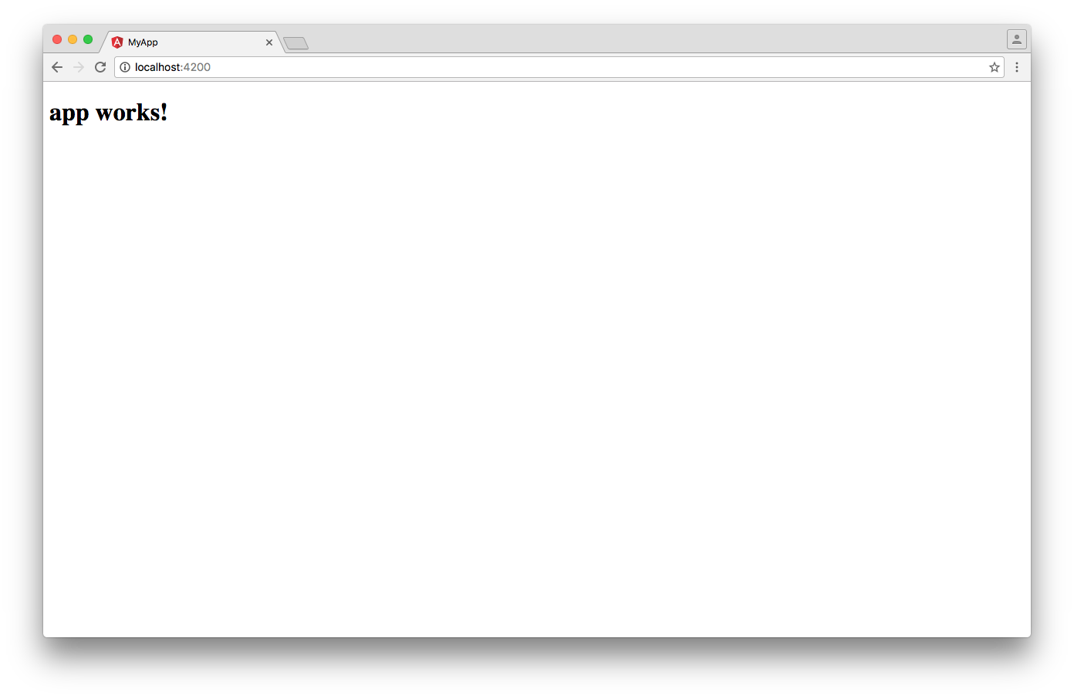

Behind the scenes, the following happens:

1. Angular CLI loads its configuration from .angular-cli.json
2. Angular CLI runs Webpack to build and bundle all JavaScript and CSS code
3. Angular CLI starts [Webpack dev server](https://webpack.github.io/docs/webpack-dev-server.html) to preview the result on localhost:4200.

Notice that the ng serve command doesn’t exit and return to your terminal prompt after step 3.

Instead, because it includes LiveReload support, the process actively watches your src directory for file changes. When a file change is detected, step 2 is repeated and a notification is sent to your browser so it can refresh automatically.

To stop the process and return to your prompt, press ctrl-c.

## Adding Features to Your Angular Application

You can use the ng generate command to add features to your existing application:

* ng generate class my-new-class: add a class to your application
* ng generate component my-new-component: add a component to your application
* ng generate directive my-new-directive: add a directive to your application
* ng generate enum my-new-enum: add an enum to your application
* ng generate module my-new-module: add a module to your application
* ng generate pipe my-new-pipe: add a pipe to your application
* ng generate service my-new-service: add a service to your application

The generate command and the different sub-commands also have shortcut notations, so the following commands are similar:

* ng g cl my-new-class: add a class to your application
* ng g c my-new-component: add a component to your application
* ng g d my-new-directive: add a directive to your application
* ng g e my-new-enum: add an enum to your application
* ng g m my-new-module: add a module to your application
* ng g p my-new-pipe: add a pipe to your application
* ng g s my-new-service: add a service to your application.

Each of the different sub-commands performs a different task and offers different options and parameters.

Let’s have a look at each of them.

### Adding a new class

To add a class called UserProfile, run:

$ ng generate class user-profile

installing component

create src/app/user-profile.ts

Angular CLI will automatically adjust the letter case of the file name and class name for you, so the following commands have the same effect:

# All three commands are equivalent

$ ng generate class user-profile

$ ng generate class userProfile

$ ng generate class UserProfile

Behind the scenes, the following happens:

* a file src/app/user-profile.ts is created that exports an empty class named UserProfile

#### Available options

* --spec: boolean, default false, generate spec file with unit test

Run $ ng generate --help to see all available options of your locally installed Angular CLI.

#### Examples:

# Generate class 'UserProfile'

$ ng generate class user-profile

# Generate class 'UserProfile' with unit test

$ ng generate class user-profile --spec

### Adding a new component

To add a component with a selector app-site-header, run:

$ ng generate component site-header

installing component

create src/app/site-header/site-header.component.css

create src/app/site-header/site-header.component.html

create src/app/site-header/site-header.component.spec.ts

create src/app/site-header/site-header.component.ts

update src/app/app.module.ts

Angular CLI will automatically adjust the letter case of the file name and component name for you and apply the prefix to the component selector, so the following commands have the same effect:

# All three commands are equivalent

$ ng generate component site-header

$ ng generate component siteHeader

$ ng generate component SiteHeader

Behind the scenes, the following happens:

* a directory src/app/site-header is created
* inside that directory four files are generated:
  + a CSS file for the component styles
  + an HTML file for the component template
  + a TypeScript file with a component class named SiteHeaderComponent and selector app-site-header
  + a spec file with a sample unit test for your new component
* SiteHeaderComponent is added as a declaration in the @NgModule decorator of the nearest module, in this case the AppModule in src/app/app.module.ts.

#### Available options

* --flat: boolean, default false, generate component files in src/app instead of src/app/site-header
* --inline-template: boolean, default false, use an inline template instead of a separate HTML file
* --inline-style: boolean, default false, use inline styles instead of a separate CSS file
* --prefix: boolean, default true, use prefix specified in .angular-cli.json in component selector
* --spec: boolean, default true, generate spec file with unit test
* --view-encapsulation: string, specifies the view encapsulation strategy
* --change-detection: string, specifies the change detection strategy.

Run $ ng generate --help to see all available options of your locally installed Angular CLI.

#### Examples:

# Generate component 'site-header'

$ ng generate component site-header

# Generate component 'site-header' with inline template and inline styles

$ ng generate component site-header --inline-template --inline-style

### Adding a new directive

To add a directive with a selector appAdminLink, run:

$ ng generate directive admin-link

installing directive

create src/app/admin-link.directive.spec.ts

create src/app/admin-link.directive.ts

update src/app/app.module.ts

Angular CLI will automatically adjust the letter case of the file name and directive name for you and apply the prefix to the directive selector, so the following commands have the same effect:

# All three commands are equivalent

$ ng generate directive admin-link

$ ng generate directive adminLink

$ ng generate directive AdminLink

Behind the scenes, the following happens:

* a file src/app/admin-link.directive.ts is created that exports a directive named AdminLinkDirective with a selector appAdminLink
* a file src/app/admin-link.directive.spec.ts is created with a unit test for the directive
* AdminLinkDirective is added as a declaration in the @NgModule decorator of the nearest module, in this case the AppModule in src/app/app.module.ts.

#### Available options

* --flat: boolean, default true, generate directive files in src/app instead of src/app/admin-link
* --prefix: boolean, default true, use prefix specified in .angular-cli.json in directive selector
* --spec: boolean, default true, generate spec file with unit test

Run $ ng generate --help to see all available options of your locally installed Angular CLI.

#### Examples:

# Generate directive 'adminLink'

$ ng generate directive admin-link

# Generate directive 'adminLink' without unit test

$ ng generate directive admin-link --spec=false

### Adding a new enum

To add an [enum](https://www.typescriptlang.org/docs/handbook/enums.html) called Direction, run:

$ ng generate enum direction

installing enum

create src/app/direction.enum.ts

Angular CLI will automatically adjust the letter case of the file name and enum name for you, so the following commands have the same effect:

# Both commands are equivalent

$ ng generate enum direction

$ ng generate enum Direction

Behind the scenes, the following happens:

* a file src/app/direction.enum.ts is created that exports an enum named Direction

#### Available options

There are no command line options available for this command.

### Adding a new module

To add a new module to your application, run:

$ ng generate module admin

installing module

create src/app/admin/admin.module.ts

Behind the scenes, the following happens:

* a directory src/app/admin is created
* an AdminModule module is created inside src/app/admin/admin.module.ts.

Notice that the AdminModule module is not added automatically to your main module AppModule in src/app/app.module.ts. It’s up to you to import the module where you need it.

To import your new module in another module, you can specify is as an import in an @NgModule definition. For example:

import { AdminModule } from './admin/admin.module';

@NgModule({

// ...

imports: [

AdminModule

]

})

export class AppModule { }

#### Available options

* --routing: boolean, default false, generate an additional module AdminRoutingModule with just the routing information and add it as an import to your new module
* --spec: boolean, default false, add src/app/admin/admin.module.spec.ts with a unit test that checks whether the module exists.

Run $ ng generate --help to see all available options of your locally installed Angular CLI.

#### Examples:

# Add module 'admin'

$ ng generate module admin

# Add module 'admin' with additional module containing routing information

$ ng generate module admin --routing

### Adding a new pipe

A [pipe](https://angular.io/docs/ts/latest/guide/pipes.html) is the Angular equivalent of a filter in AngularJS 1.x and allows you to transform a displayed value within a template.

To add a pipe with a name convertToEuro, run:

$ ng generate pipe convert-to-euro

installing pipe

create src/app/convert-to-euro.pipe.spec.ts

create src/app/convert-to-euro.pipe.ts

update src/app/app.module.ts

Angular CLI will automatically adjust the letter case of the file name and pipe name for you, so the following commands have the same effect:

# All three commands are equivalent

$ ng generate pipe convert-to-euro

$ ng generate pipe convertToEuro

$ ng generate pipe ConvertToEuro

Behind the scenes, the following happens:

* a file src/app/convert-to-euro.pipe.ts is created that exports a pipe class named ConvertToEuroPipe
* a file src/app/convert-to-euro.pipe.spec.ts is created with a unit test for the pipe
* ConvertToEuroPipe is added as a declaration in the @NgModule decorator of the nearest module, in this case the AppModule in src/app/app.module.ts.

#### Available options

* --flat: boolean, default true, generate component files in src/app instead of src/app/site-header
* --spec: boolean, default true, generate spec file with unit test.

Run $ ng generate --help to see all available options of your locally installed Angular CLI.

#### Examples:

# Generate pipe 'convertToEuro' with spec and in /src/app directory

$ ng generate pipe convert-to-euro

# Generate pipe 'convertToEuro' without spec and in /src/app/convert-to-euro directory

$ ng generate pipe convert-to-euro --spec=false --flat=false

### Adding a new service

To add a service with a dependency injection token BackendApiService, run:

$ ng generate service backend-api

installing service

create src/app/backend-api.service.spec.ts

create src/app/backend-api.service.ts

WARNING Service is generated but not provided, it must be provided to be used

Angular CLI will automatically adjust the letter case of the file name and pipe name for you, so the following commands have the same effect:

# All three commands are equivalent

$ ng generate service backend-api

$ ng generate service backendApi

$ ng generate service BackendApi

Behind the scenes, the following happens:

* a file src/app/backend-api.service.ts is created that exports a service class named BackendApiService
* a file src/app/backend-api.service.spec.ts is created with a unit test for your new service.

Notice how Angular CLI warns that the service is generated but not provided anywhere yet. It’s up to you to register the service as a provider by adding it to the providers: [] array where you need it (e.g. in a module or component). For example:

import { BackendApiService } from './backend-api.service';

@NgModule({

// ...

providers: [BackendApiService],

bootstrap: [AppComponent]

})

#### Available options

* --flat: boolean, default true, generate service file in src/app instead of src/app/backend-api
* --spec: boolean, default true, generate spec file with unit test

Run $ ng generate --help to see all available options of your locally installed Angular CLI.

#### Examples:

# Generate service with DI token 'BackendApiService' in /src/app directory

$ ng generate service backend-api

# Generate service with DI token 'BackendApiService' in /src/app/backend-api directory

$ ng generate service backend-api --flat=false

### Special note

Angular CLI does not just blindly generate code for you. It uses static analysis to better understand the semantics of your application.

For example, when adding a new component using ng generate component, Angular CLI finds the closest module in the module tree of your application and integrates the new feature in that module.

So if you have an application with multiple modules, Angular CLI will automatically integrate the new feature in the correct module, depending on the directory where you run the command from.

## Running Your Unit Tests

Angular CLI automatically configures the [Karma test runner](https://karma-runner.github.io) for you when your application is initially created.

When adding a feature to your application, you can use the --spec option to specify whether you want Angular CLI to also create a corresponding .spec.ts file with a sample unit test for your new feature.

Spec files are created in the same directory of their corresponding feature in the src directory. This allows you to easily locate them when working on a feature.

Running all unit tests of your application thus implies running all unit tests specified in all files ending in .spec.ts in all directories inside your src directory.

To run all unit tests, run:

$ ng test

The following output will appear in your console:

$ ng test

[karma]: No captured browser, open http://localhost:9876/

[karma]: Karma v1.4.1 server started at http://0.0.0.0:9876/

[launcher]: Launching browser Chrome with unlimited concurrency

[launcher]: Starting browser Chrome

[Chrome 57.0.2987 (Mac OS X 10.12.0)]: Connected on socket 4OBzlsVyIPZyE1AYAAAA with id 41455596

Chrome 57.0.2987 (Mac OS X 10.12.0): Executed 3 of 3 SUCCESS (0.132 secs / 0.121 secs)

A special browser instance will also be launched:

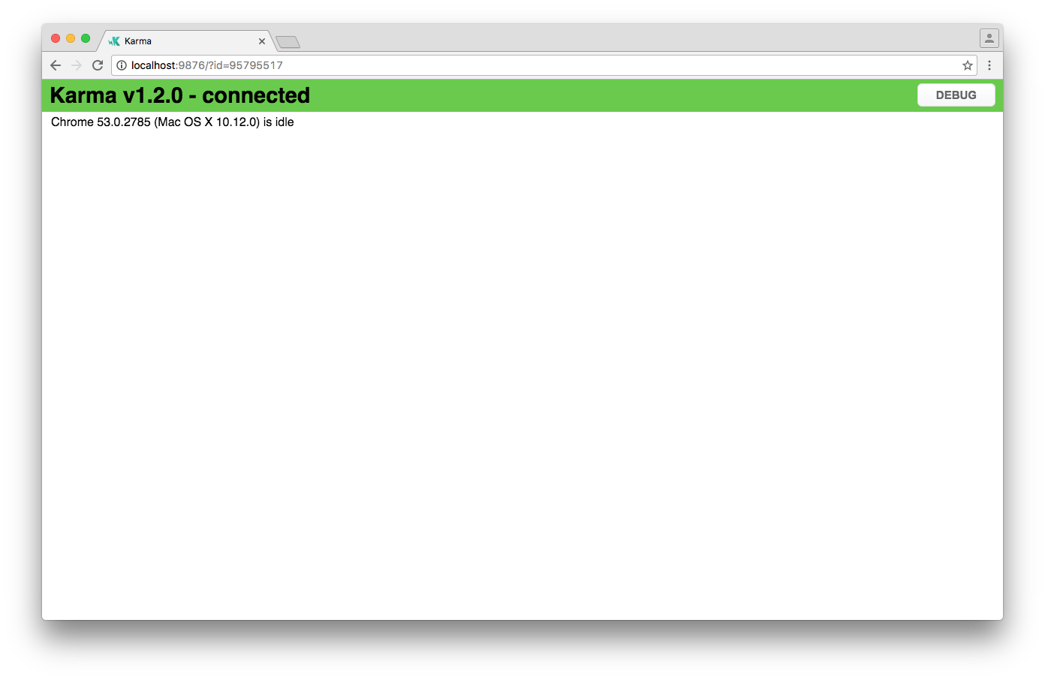

Here’s what happens behind the scenes:

1. Angular CLI loads .angular-cli.json.
2. Angular CLI runs Karma with the configuration specified in .angular-cli.json. By default this is karma.conf.js located in the root directory of your application.
3. Karma opens the browser specified in the Karma configuration. By default the browser is set to [Google Chrome](https://www.google.com/chrome/).
4. Karma then instructs the browser (Chrome) to run src/test.ts using the testing framework specified in the Karma config. By default this is the [Jasmine framework](http://jasmine.github.io/). The file src/test.ts is automatically created when your application is created. It’s pre-configured to load and configure the code that’s needed to test your Angular application and run all spec files ending in .spec.ts in your src directory.
5. Karma reports the result of the test run to the console.
6. Karma watches the src file for changes and repeats step 4 and 5 when a file change is detected.

To end the process, you can press ctrl-c.

If you want to learn more about testing your Angular code, you can check out the [Official Angular Testing Guide](https://angular.io/docs/ts/latest/guide/testing.html).

## Running Your End-to-end (E2E) Tests

Angular CLI automatically configures [Protractor](http://www.protractortest.org/) for you when your application is initially created.

To run your E2E tests, run:

$ ng e2e

The following output will appear in your console:

** NG Live Development Server is running on http://localhost:49152 **

Hash: e570d23ac26086496e1d

Time: 6087ms

chunk {0} polyfills.bundle.js, polyfills.bundle.js.map (polyfills) 158 kB {4} [initial] [rendered]

chunk {1} main.bundle.js, main.bundle.js.map (main) 3.62 kB {3} [initial] [rendered]

chunk {2} styles.bundle.js, styles.bundle.js.map (styles) 9.77 kB {4} [initial] [rendered]

chunk {3} vendor.bundle.js, vendor.bundle.js.map (vendor) 2.37 MB [initial] [rendered]

chunk {4} inline.bundle.js, inline.bundle.js.map (inline) 0 bytes [entry] [rendered]

webpack: Compiled successfully.

I/file_manager - creating folder /Users/jvandemo/Projects/test/my-app/node_modules/protractor/node_modules/webdriver-manager/selenium

I/downloader - curl -o /Users/jvandemo/Projects/test/my-app/node_modules/protractor/node_modules/webdriver-manager/selenium/chromedriver_2.29.zip https://chromedriver.storage.googleapis.com/2.29/chromedriver_mac64.zip

I/update - chromedriver: unzipping chromedriver_2.29.zip

I/update - chromedriver: setting permissions to 0755 for /Users/jvandemo/Projects/test/my-app/node_modules/protractor/node_modules/webdriver-manager/selenium/chromedriver_2.29

I/launcher - Running 1 instances of WebDriver

I/direct - Using ChromeDriver directly...

Spec started

my-app App

✓ should display message saying app works

Executed 1 of 1 spec SUCCESS in 0.523 sec.

I/launcher - 0 instance(s) of WebDriver still running

I/launcher - chrome #01 passed

A special browser instance will also be launched:

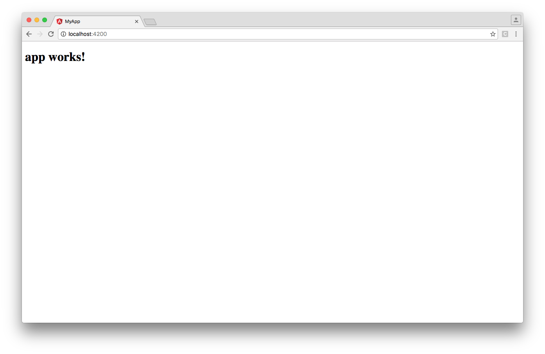

Here’s what happens behind the scenes:

1. Angular CLI loads .angular-cli.json.
2. Angular CLI runs Protractor with the configuration specified in .angular-cli.json. By default this is the protractor.conf.js file located in the root directory of your application.
3. Protractor opens the browser specified in the Protractor configuration. By default the browser is set to [Google Chrome](https://www.google.com/chrome/).
4. Protractor then instructs the browser (Chrome) to run all spec files ending in .e2e-spec.ts in your e2e directory.
5. Protractor reports the result of the test run to the console.

The process then exits automatically after step 5.

If you want to learn more about E2E testing your Angular code, you can check out the [Official Angular Testing Guide](https://angular.io/docs/ts/latest/guide/testing.html) and the [Protractor](http://www.protractortest.org/) documentation.

## Building Your Application for Production

Running ng serve builds and bundles your Angular application automatically to a virtual filesystem during development.

However, when your application is ready for production, you’ll need real files that you can deploy to your server or to the cloud.

To build and bundle your application for deployment, run:

$ ng build

The output of the command is sent to your console:

Hash: 59aaa9ef8eac5d46cdf8

Time: 5433ms

chunk {0} polyfills.bundle.js, polyfills.bundle.js.map (polyfills) 158 kB {4} [initial] [rendered]

chunk {1} main.bundle.js, main.bundle.js.map (main) 3.61 kB {3} [initial] [rendered]

chunk {2} styles.bundle.js, styles.bundle.js.map (styles) 9.77 kB {4} [initial] [rendered]

chunk {3} vendor.bundle.js, vendor.bundle.js.map (vendor) 2.07 MB [initial] [rendered]

chunk {4} inline.bundle.js, inline.bundle.js.map (inline) 0 bytes [entry] [rendered]

This is what happens behind the scenes:

1. Angular CLI loads its configuration from .angular-cli.json.
2. Angular CLI runs Webpack to build and bundle all JavaScript and CSS code.
3. The result is written to the outDir directory specified in your Angular CLI configuration. By default, this is the dist directory.

### Available options

* --aot: enable ahead-of-time compilation
* --base-href: string, the base href to use in the index file
* --environment: string, default dev, environment to use
* --output-path: string, directory to write the output to
* --target: string, default development, environment to use
* --watch: boolean, default false, watch files for changes and rebuild when a change is detected.

### Targets

Specifying a target impacts the way the build process operates. Its value can be one of the following:

* development: default mode, do not minify or uglify code
* production: minify and uglify code.

Building your application in production mode:

$ ng build --target=production

This results in bundles that are minified, uglified and have hashes in their names:

Hash: 4dea6adc9ac01de3c11b

Time: 5588ms

chunk {0} polyfills.2d45a4c73c85e24fe474.bundle.js (polyfills) 158 kB {4} [initial] [rendered]

chunk {1} main.a64b48e56248eb808195.bundle.js (main) 20.8 kB {3} [initial] [rendered]

chunk {2} styles.d41d8cd98f00b204e980.bundle.css (styles) 69 bytes {4} [initial] [rendered]

chunk {3} vendor.205c7417e47c580a2c34.bundle.js (vendor) 1.1 MB [initial] [rendered]

chunk {4} inline.310ccba0fff49a724c8f.bundle.js (inline) 0 bytes [entry] [rendered]

### Environments

Environments let you specify settings to customize your application behavior.

You can define your own environments in the .angular-cli.json file. The default ones are:

* source: use settings defined in environments/environment.ts
* dev: use settings defined in environments/environment.ts
* prod: use settings defined in environments/environment.prod.ts.

Here, environments/environment.ts equals:

export const environment = {

production: false

};

And environments/environment.prod.ts equals:

export const environment = {

production: true

};

The build process will use the dev environment by default.

If you specify a different environment, the build process will use the corresponding environment:

# Uses environments/environment.ts

$ ng build

# Also uses environments/environment.ts

$ ng build --environment=dev

# Uses environments/environment.prod.ts

$ ng build --environment=prod

As you can see in src/main.ts, you can access the environment settings from your code by importing environments/environment:

import { enableProdMode } from '@angular/core';

import { platformBrowserDynamic } from '@angular/platform-browser-dynamic';

import { AppModule } from './app/app.module';

import { environment } from './environments/environment';

if (environment.production) {

enableProdMode();

}

platformBrowserDynamic().bootstrapModule(AppModule);

The build process will make sure the right environment is provided when you import it.

## Deploying Your Application

As of February 9, 2017, the ng deploy command has been removed from the core of Angular CLI. Read more [here](https://github.com/angular/angular-cli/pull/4385).

## Ejecting your application

As of v1.0, Angular CLI provides a command to decouple your application from Angular CLI.

By default, Angular CLI manages the underlying webpack configuration for you so you don’t have to deal with its complexity.

If, at any given time, you wish to manually configure Webpack and you no longer want to use Angular CLI with your Angular application, you can run:

$ ng eject

This will generate the following output in your console:

==========================================================================================

Ejection was successful.

To run your builds, you now need to do the following commands:

- "npm run build" to build.

- "npm run test" to run unit tests.

- "npm start" to serve the app using webpack-dev-server.

- "npm run e2e" to run protractor.

Running the equivalent CLI commands will result in an error.

==========================================================================================

Some packages were added. Please run "npm install".

This is what happens behind the scenes:

1. A property ejected: true is added to the .angular-cli.json file
2. A webpack.config.js file is generated in the root of your application with a standalone Webpack configuration so you can build your project without Angular CLI
3. The build script in your package.json is updated so you can run npm run build to build your project
4. The test script in your package.json is updated so you can run npm run test or npm test to run your unit tests
5. The start script in your package.json is updated so you can run npm run start or npm start to start a development server
6. The e2e script in your package.json is updated so you can run npm run e2e to run your end-to-end tests.

After ejecting your application, you can manually update the Webpack configuration to your liking and the Angular CLI commands will no longer work.

So if, for some reason, you want to move away from Angular CLI, the eject command has you covered.

## A Glimpse into the Future

Angular CLI’s roadmap contains many exciting upcoming features:

* **progressive web app (PWA) support**  
  Angular CLI will be able to create a Web Application Manifest for you, generate an App Shell and provide Service Worker scripts to cache your application data.  
  [Learn more about mobile support here](https://github.com/angular/mobile-toolkit/blob/master/guides/cli-setup.md).
* **Refactoring Support**  
  In addition to adding features to your application, Angular CLI will also let you refactor existing features — for example, moving a component or renaming a service.
* **Upgrade Support**  
  Angular CLI will be able to help you with Angular upgrades. Because Angular CLI has a semantic understanding of your application, it will be able to help you with code changes that are required when upgrading to a newer version of Angular.
* **Extensibility**  
  Improved extensibility support so you can create your own custom add-ons and deployment scripts.
* **Increased Performance**  
  Improved performance so Angular CLI becomes faster.
* **Library Developer Mode**  
  In addition to creating a new application, Angular CLI will also let you create a new library that can be consumed by others.

Some of these features are already partially available. Check out the [GitHub repository](https://github.com/angular/angular-cli) if you want to play around with them.

## Summary

Angular CLI is a command-line interface (CLI) to automate your development workflow.

Today, you can already use Angular CLI to:

* create a new Angular application
* run a development server with LiveReload support to preview your application during development
* add features to your existing Angular application
* run your application’s unit tests
* run your application’s end-to-end (E2E) tests
* build your application for deployment to production
* deploy your application to a server.

Although it’s technically not required to use Angular CLI to develop an Angular application, it can definitely improve the quality of your code and save you a lot of time and effort.

Because of the many exciting features that will be added over time, Angular CLI will probably become an indispensable tool for developing Angular applications.

To learn more about Angular CLI, check out the [official website](https://cli.angular.io/) and the [GitHub repository](https://github.com/angular/angular-cli).

The Ultimate Angular CLI Reference Guide was peer reviewed by [*Tim Severien*](https://www.sitepoint.com/author/tseverien/), [*Vildan Softic*](https://www.sitepoint.com/author/vildansoftic/) and [*Joan Yin*](https://github.com/newjs). Thanks to all of SitePoint’s peer reviewers for making SitePoint content the best it can be!