C# Run as "Administrator"

1) 给程序添加： “app.manifest” - requireAdministrator

<requestedExecutionLevel level="asInvoker" uiAccess="false" />

<requestedExecutionLevel level="requireAdministrator" uiAccess="false" />

<requestedExecutionLevel level="highestAvailable" uiAccess="false" />

<requestedExecutionLevel level="requireAdministrator" uiAccess="false" />

2）Project property -> Security

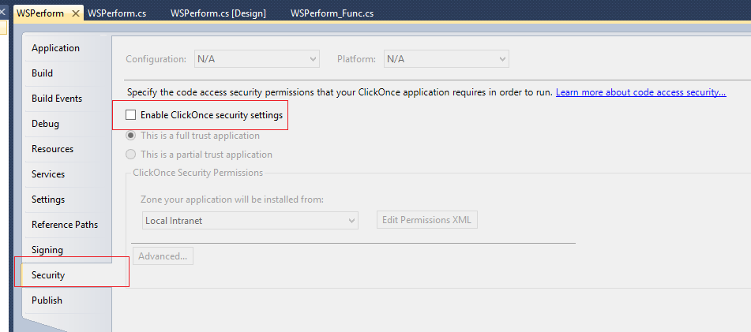

http://www.cnblogs.com/weixing/archive/2013/08/23/3277781.html

http://blog.csdn.net/dlxu/article/details/1495772