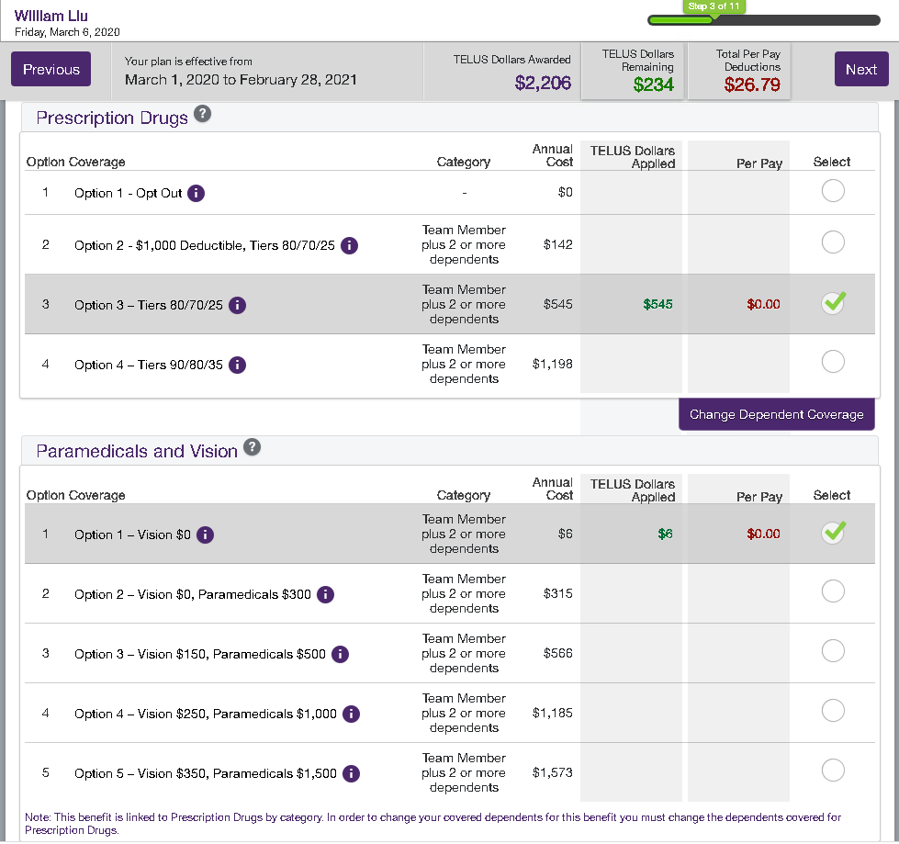

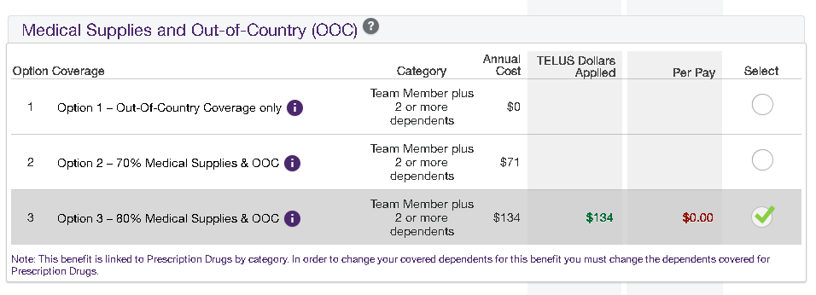

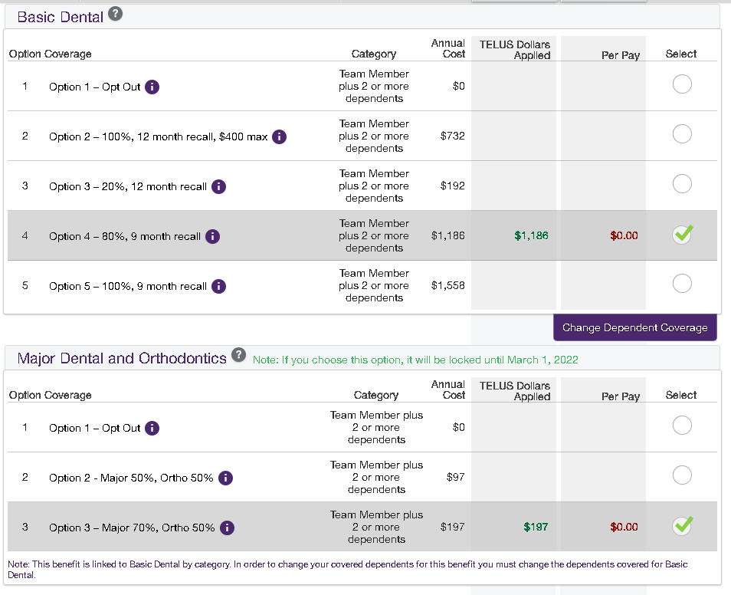

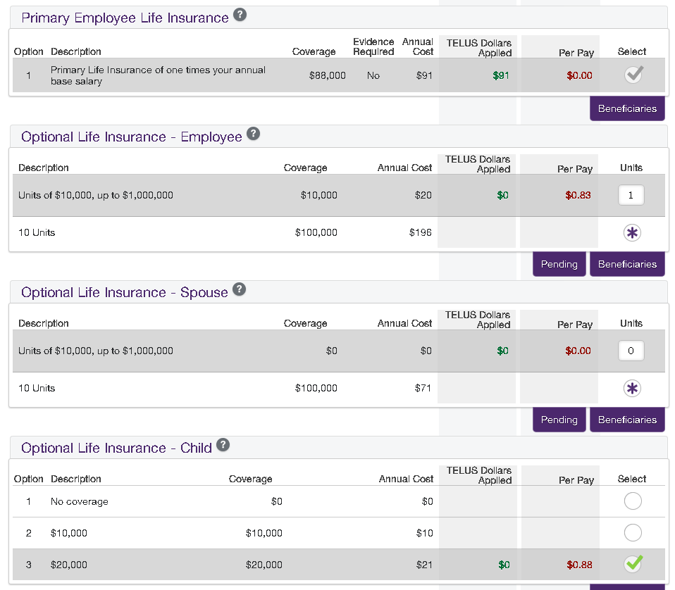

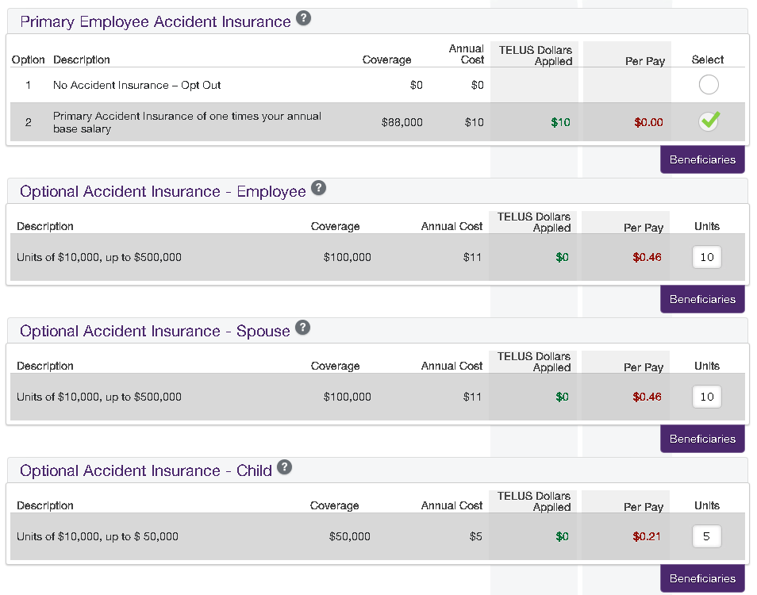

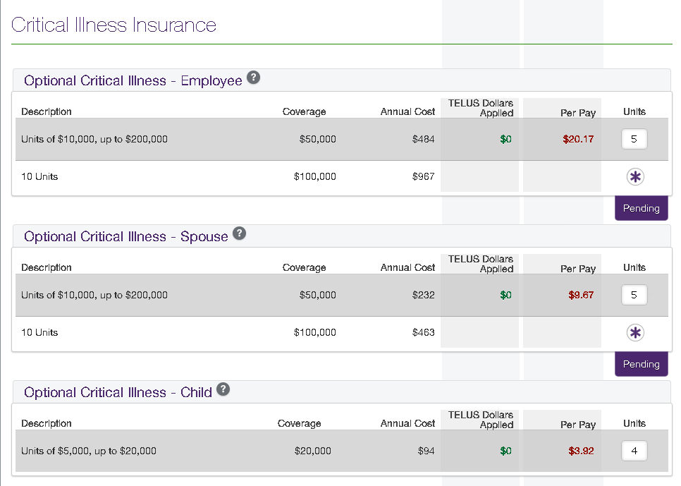

**Critical Illness Insurance** provides a lump-sum payment in the event that the insured employee, spouse, or child is stricken by a serious illness - such as cancer, heart attack or stroke - and survives the diagnosis. Intended to insure those who are currently healthy, this insurance may help you deal with the additional costs of treatment and recovery that provincial health care and extended health plans don't cover - for example, child care, lost wages for yourself or a caregiver, new treatment options and travel expenses, such as transportation and accomodation.

You must have employee and/or spouse critical illness insurance to be able to purchase child critical illness insurance.

Proof of good health is required for any coverage increases for employee and spouse insurance, with the exception of new hires or life events, and at annual enrolment, where the first $50,000 is available without providing proof. To provide proof of good health, you must complete a Statement of Health/Evidence of Insurability (EOI) form. The Statement of Health/Evidence of Insurability (EOI) form will be presented after you confirm your enrolment, or you can find it on the Home Page, in your EOI folder.

**Please refer to your benefits manual, found in the *Info* drop-down at the top of this page, for more information.**

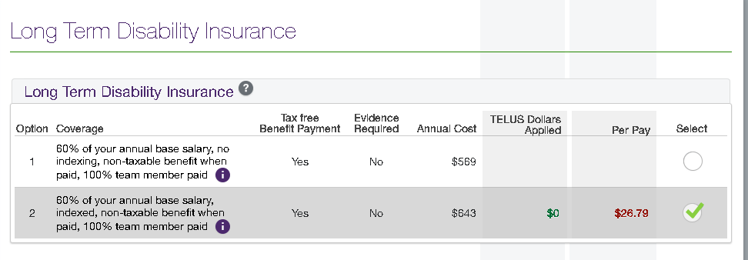

Long Term Disability Insurance Option 2 Coverage Details**Coverage:**

$4,351

**Description:**

60% of your annual base salary, indexed, non-taxable benefit when paid, 100% team member paid