Visual Studio 2017 Install Business Intelligence:

Download : SQL Server Data Tool : SSDT package

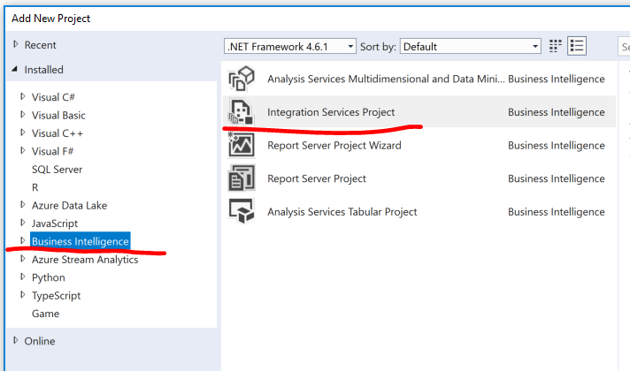

After Installation, if we can not create or open SSIS project, there is error message as below:

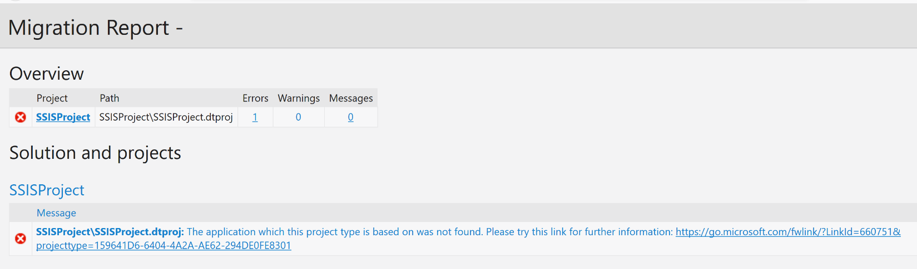

Go to “Tools” => “Extensions and Updates”

