Script component for transformation: 有 input 和 output
先添加新行, 再执行扫描。
public override void Intt_ProcessInputRow(InttBuffer Row)
{
OuttBuffer.AddRow();
OuttBuffer.ocom = "nEW";
OuttBuffer.oid = Row.id;
OuttBuffer.oname = Row.goods;

// 在此使用会遗漏第一条记录
While( Row.NextRow()) {
….
}
}
public override void Intt_ProcessInput(InttBuffer Buffer)
{
while (Buffer.NextRow())
{
Intt_ProcessInputRow(Buffer);
}
OuttBuffer.AddRow();
OuttBuffer.oid = 999;
OuttBuffer.oname = "lllll";
OuttBuffer.ocom = "new new";

OuttBuffer.AddRow();
OuttBuffer.oid = 999;
OuttBuffer.oname = "lllll";
OuttBuffer.ocom = "new new";

OuttBuffer.AddRow();
OuttBuffer.oid = 999;
OuttBuffer.oname = "lllll";
OuttBuffer.ocom = "new new";
}
public override void CreateNewOutputRows()
{
OuttBuffer.AddRow();
OuttBuffer.oid = 888;
OuttBuffer.oname = "fafafa";
OuttBuffer.ocom = "new fafa";
}

Destination : 有 input 和 output
对于 先添加新的CreateNew ， 然后再添加 input
public override void inn_ProcessInputRow(innBuffer Row)
{
ouuBuffer.AddRow();
ouuBuffer.sid = Row.oid;
ouuBuffer.sname = Row.oname;
ouuBuffer.scom = Row.ocom;
}

public override void inn_ProcessInput(innBuffer Buffer)
{
while (Buffer.NextRow())
{
inn_ProcessInputRow(Buffer);
}

}
public override void CreateNewOutputRows()
{
ouuBuffer.AddRow();
ouuBuffer.sid = 990;
ouuBuffer.sname = "addd new";
ouuBuffer.scom = "Add com";
}

Source : 只有 output

public override void CreateNewOutputRows()
{
Output00Buffer.AddRow();
Output00Buffer.id = 300;
Output00Buffer.age = 400;

Output00Buffer.AddRow();
Output00Buffer.id = 301;
Output00Buffer.age = 401;

Output00Buffer.AddRow();
Output00Buffer.id = 302;
Output00Buffer.age = 402;

Output11Buffer.AddRow();
Output11ffer.me = 666;
Output11Buffer.you = 999;

以上都是 output, 可以定义多路输出。
}

Slowly Changing Dimension: 可以实现对照更新,和新行插入.
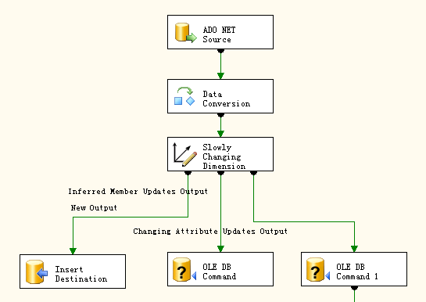

Analysis Service

Dimensions 和 Measures 的关系:
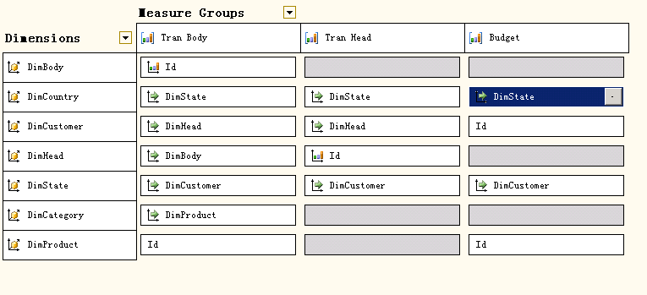
注意:
1) 在浏览里, 定制自己的报表时. 在只添加 Dimension 的时候, 将使用最靠左边的 Measure 定义的关系.
例如: 我们依次添加:
- DimCountry -> DimState -> DimCustomer – DimHead -> DimBody
- DimCountry -> DimProduct – -> DimBody

都不会产生不可理解的冗余组合. 因为各Dimensions的层次结构很清晰了.
2) 如果此时Dimensions是: DimCountry -> DimProduct, 我们添加Measure “Tran Head”->Tran_Count
则情况不秒:
- Measure “Tran Head”里, DimCountry是受到约束的. 所以出现两个有记录的国家,
- Measure “Tran Head”里, DimProduct, 是没有关系的, 所以出现了所有产品.

China | Apple |  | 1
China | Banana |  | 1
China | Beef |  | 1
China | Cake |  | 1
China | Cereal | 8 | 1
China | Grape |  | 1
China | Radio |  | 1
China | Stereo |  | 1
China | TV |  | 1
USA | Apple | 2 | 3
USA | Banana | 4 | 3
USA | Beef |  | 3
USA | Cake |  | 3
USA | Cereal |  | 3
USA | Grape |  | 3
USA | Radio |  | 3
USA | Stereo |  | 3
USA | TV | 11 | 3

- 我们在”Tran Head”, “Tran Body” , “Budget” 里取共同点: DimCountry->DimState->DimCustomer
则情况很完美:
Canada | C_William |  |  | 567
China | Z_guangdongzi | 8 | 1 | 456
USA | A_Jessia | 2 | 1 | 265
USA | A_Johnson | 15 | 2 | 588
USA | A_Kitty |  |  | 220

Canada | Vancouver | C_William |  |  | 567
China | Guangzhou | Z_guangdongzi | 8 | 1 | 456
USA | Florida | A_Johnson | 15 | 2 | 588
USA | NewYork | A_Kitty |  |  | 220
USA | Seatle | A_Jessia | 2 | 1 | 265

如果我们添加: DimProduct, 则糟糕,因为 “Tran Head” 没有.
Canada | Vancouver | C_William | Apple |  |  | 99
Canada | Vancouver | C_William | Banana |  |  | 123
Canada | Vancouver | C_William | TV |  |  | 345
China | Guangzhou | Z_guangdongzi | Apple |  | 1
China | Guangzhou | Z_guangdongzi | Banana |  | 1 | 456
China | Guangzhou | Z_guangdongzi | Beef |  | 1
China | Guangzhou | Z_guangdongzi | Cake |  | 1
China | Guangzhou | Z_guangdongzi | Cereal | 8 | 1
China | Guangzhou | Z_guangdongzi | Grape |  | 1
China | Guangzhou | Z_guangdongzi | Radio |  | 1
China | Guangzhou | Z_guangdongzi | Stereo |  | 1
China | Guangzhou | Z_guangdongzi | TV |  | 1
USA | Florida | A_Johnson | Apple |  | 2 | 11
USA | Florida | A_Johnson | Banana | 4 | 2 | 222
USA | Florida | A_Johnson | Beef |  | 2
USA | Florida | A_Johnson | Cake |  | 2
USA | Florida | A_Johnson | Cereal |  | 2 | 22
USA | Florida | A_Johnson | Grape |  | 2
USA | Florida | A_Johnson | Radio |  | 2
USA | Florida | A_Johnson | Stereo |  | 2
USA | Florida | A_Johnson | TV | 11 | 2 | 333
USA | NewYork | A_Kitty | Apple |  |  | 33
USA | NewYork | A_Kitty | Banana |  |  | 44
USA | NewYork | A_Kitty | Cereal |  |  | 88
USA | NewYork | A_Kitty | TV |  |  | 55
USA | Seatle | A_Jessia | Apple | 2 | 1 | 111
USA | Seatle | A_Jessia | Banana |  | 1 | 11
USA | Seatle | A_Jessia | Beef |  | 1
USA | Seatle | A_Jessia | Cake |  | 1
USA | Seatle | A_Jessia | Cereal |  | 1 | 77
USA | Seatle | A_Jessia | Grape |  | 1
USA | Seatle | A_Jessia | Radio |  | 1
USA | Seatle | A_Jessia | Stereo |  | 1
USA | Seatle | A_Jessia | TV |  | 1 | 66

4) 当我们使用: (注意忘记定义 DimCategory 参考到 DimProduct 了)
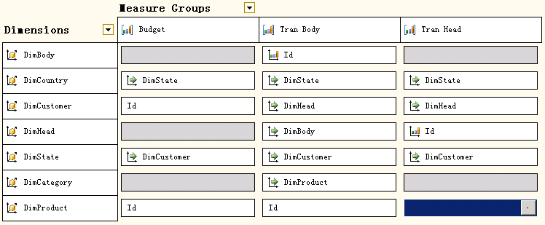

添加: DimCountry – DimProduct 则 OK
Canada | Apple
Canada | Banana
Canada | TV
China | Banana
USA | Apple
USA | Banana
USA | Cereal
USA | TV

添加: DimCountry – DimProduct – DimHead 则冗余
Canada | Apple | 9000
Canada | Apple | 9001
Canada | Apple | 9002
Canada | Apple | 9003
Canada | Banana | 9000
Canada | Banana | 9001
Canada | Banana | 9002
Canada | Banana | 9003
Canada | TV | 9000
Canada | TV | 9001
Canada | TV | 9002
Canada | TV | 9003
China | Banana | 9000
China | Banana | 9001
China | Banana | 9002
China | Banana | 9003
USA | Apple | 9000
USA | Apple | 9001
USA | Apple | 9002
USA | Apple | 9003
USA | Banana | 9000
USA | Banana | 9001
USA | Banana | 9002
USA | Banana | 9003
USA | Cereal | 9000
USA | Cereal | 9001
USA | Cereal | 9002
USA | Cereal | 9003
USA | TV | 9000
USA | TV | 9001
USA | TV | 9002
USA | TV | 9003

总结: 当我们使用单个 “Measure Group”时, 最好使用 Filter (默认是: All) 过滤出与此有关的Dimension.
对于使用多个Dimensions时,我们的报表应该是使用 共同的 Dimension 否则报表出现冗余.

Many to Many Dimension
多对多关系：例如一个订单可以有多个产品, 一个产品对应多个定单.

从不角度理解这可能关系不一样.
如果从订单明细的角度看, 每个订单明细对应一个产品, 产品和订单明细是一对多的关系,
每个产品对应多个订单明细, 每个明细对应一个产品.

多对多: 需要一个中间表:
SELECT DISTINCT tran_body.product_id, tran_body.order_id
FROM product INNER JOIN tran_body ON product.id = tran_body.product_id

tran_head: 在此并不是我们所需要关注的.
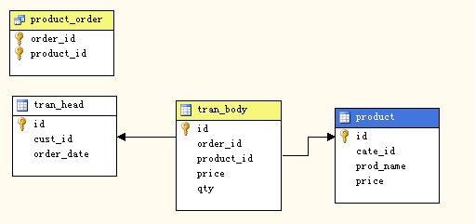

需要对中间表定义 measure group: 此group 可以是隐藏的.

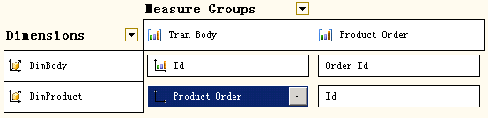

隐射关系: Measure:Product_Order(order_id) -> DimBody(order_id)
Measure:Product_Order(Product_id) -> DimProduct(id)
Measure:Tran_Body <-many-to-many-> DimProduct
原始表格:

id order_id product_id price qty
19006 9000 1000 10.00 2
19001 9001 1000 10.00 2
19007 9000 1010 12.00 3
19002 9002 1010 15.00 3
19003 9002 1010 15.00 1
19000 9000 1020 8.00 5
19004 9002 1020 8.00 6
19005 9003 1080 5.00 8

报表会出现许多重复的现象:
原因: 一个产品对应多个订单, 每个订单又对应多个产品. 所以牵连出 一个产品的对应订单的明细里的其他产品.
1000 | Apple | 19000 | 5
1000 | Apple | 19001 | 2
1000 | Apple | 19006 | 2
1000 | Apple | 19007 | 3
1010 | Banana | 19000 | 5
1010 | Banana | 19002 | 3
1010 | Banana | 19003 | 1
1010 | Banana | 19004 | 6
1010 | Banana | 19006 | 2
1010 | Banana | 19007 | 3
1020 | TV | 19000 | 5
1020 | TV | 19002 | 3
1020 | TV | 19003 | 1
1020 | TV | 19004 | 6
1020 | TV | 19006 | 2
1020 | TV | 19007 | 3
1080 | Cereal | 19005 | 8

多对多的报表是比较难理解的, 应尽量避免, 完全可以使用一对多的关系处理.

