Project : Excel Convertor

1. Visual Studio 2015
2. Install Shield Limited Edition - Create installation file

User Requirement :

I have a friend working for Financial Company. She want to convert Excel to import to other system. I create this small desktop application to greatly reduce her workload.

Input Sample:

|  |  |  |  |  |  |  |
| --- | --- | --- | --- | --- | --- | --- |
| EmpID | Name | C100 | C200 | C300 | C400 | C500 |
|  |  | 100 | 200 | 300 | 400 | 500 |
| A101 | Will | 11 |  | 22 | 33 |  |
| A102 | Tome |  | 44 |  |  |  |
| A103 | Shu |  |  | 55 |  | 66 |
| A104 | Peter |  | 77 |  | 88 |  |

After Convert:

Output :

|  |  |  |  |
| --- | --- | --- | --- |
| EmpID | Name | Code | Value |
| A101 | Will | 100 | 11 |
| A101 | Will | 300 | 22 |
| A101 | Will | 400 | 33 |
| A102 | Tome | 200 | 44 |
| A103 | Shu | 300 | 55 |
| A103 | Shu | 500 | 66 |
| A104 | Peter | 200 | 77 |
| A104 | Peter | 400 | 88 |

Application Screen Shot

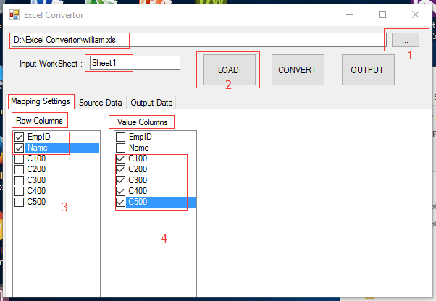

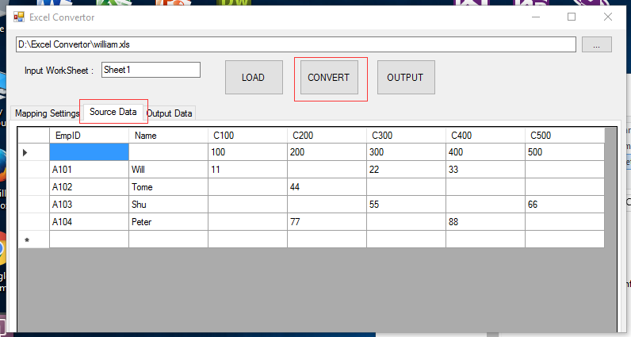

After Convert

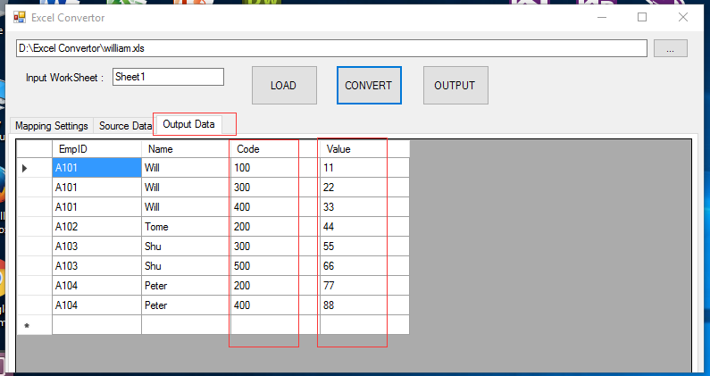

Output to CSV File:

