The Gilded Rose Expands

**Table of Contents**

1. Developer Environment
2. Functionality
3. Developer’s Guide
4. Test Plan

# Develop Environment

* Visual studio 2017
* .Net Core 2.2
* Entity Framework Core
* XUnit
* Moq
* AngularJS + JQuery + Bootstrap

# Functionality

## User Login

## Product List

## Add to Shopping Cart

## Check out

## Order History

## 

# Developer’s Guide

* 1. Database Table Relationship



* 1. DBContext is not required to connect to SQL Server for using UseInMemoryDatabase

# Test Plan

* 1. Open solution file “GildedRose.sln” with Visual Studio 2017 (require .net core 2.2)
  2. Rebuild the entire solution, then Run Debug

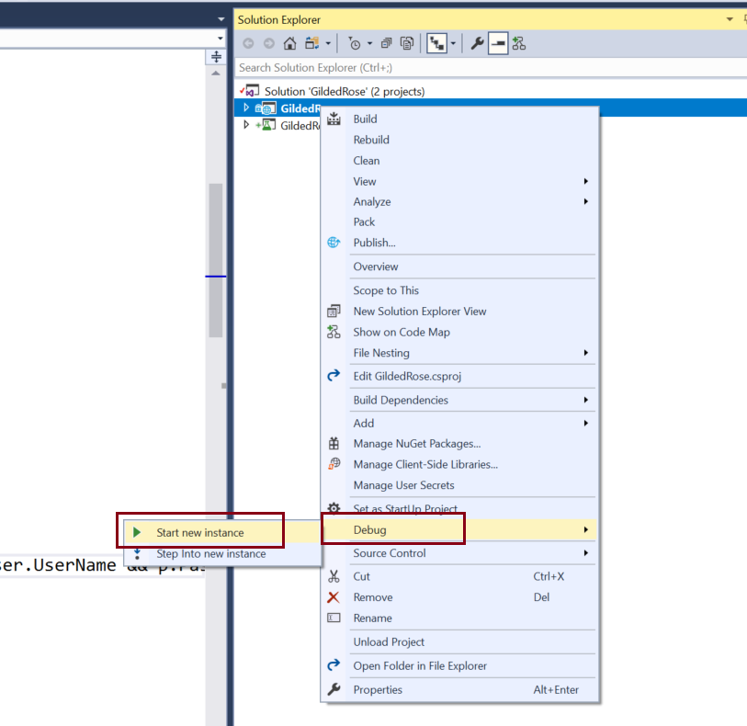

* 1. Integration Test Page as below:

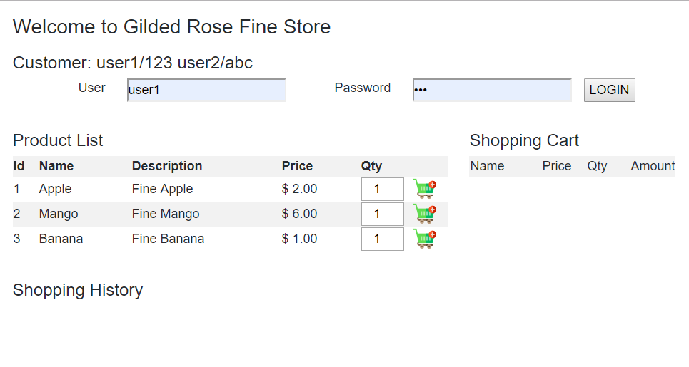

* 1. Test UserName and Password.

UserName: user1 Password: 123

UserName: user2 Password: abc

* 1. Add product to shopping cart, if user doesn’t login, Check out button will hide and can not process it.

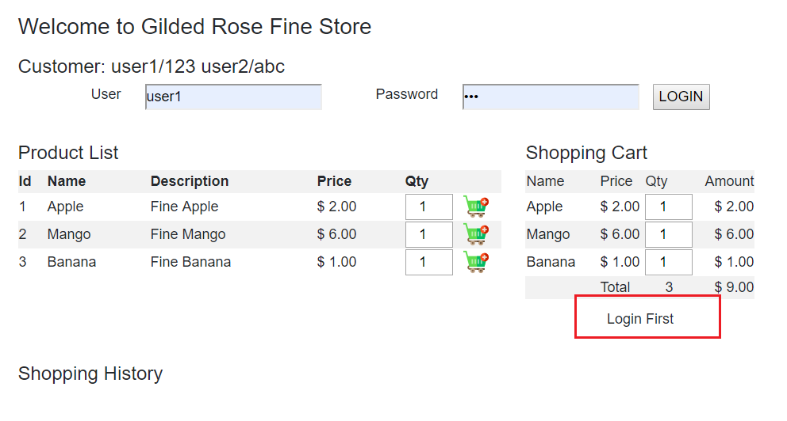

* 1. After login and check out successfully, you will see shopping cart will clean up and Shopping history will update.

