**Appendix A**

**Water Balance Model**

This document describes the development of the gridded monthly dataset of hydrological variables for the contiguous United States for the period 1895-2007 to enable estimates of change in climatic water balance metrics over time. This dataset is used in Dobrowski et al (2012) and was developed to allow for analysis of climate displacement vectors for the period 1916-2005 at a relatively fine resolution (30 arc-second or approximately 800m). Our general approach is to use the Penman-Monteith method to determine reference evapotranspiration, and a "single-bucket" hydrological model incorporating snowpack and soil water storage. All calculations are based on monthly data. A summary of input sources is given in table 1.

Table 1: Sources of input data

|  |  |  |  |  |
| --- | --- | --- | --- | --- |
| **input** | **source** | **resolution** | **units** | **timestep** |
| elevation | PRISM* | 30 arcsec | meters | constant |
| radiation | r.sun** | 30-arcsec | MJ/m2/day | monthly avg. |
| monthly avg. min. and max. temperature | PRISM* | 30-arcsec | C | monthly |
| dewpoint | PRISM* | 30-arcsec | C | monthly |
| precipitation | PRISM* | 30-arcsec | mm | monthly |
| soil available water capacity (AWC) | Penn State*** | 30-arcsec | mm | constant |
| wind | NLDAS-2**** | 7.5-min | m/s | monthly avg. |

*Daly et al.2008 obtained from PRISM Climate Group in August 2008

**Details below

***Available Water Content for top 250cm of soil; Miller & White 1998; [http://www.soilinfo.psu.edu/](http://www.soilinfo.psu.edu/index.cgi?soil_data&conus&data_cov&awc), accessed May 2011

****long-term (1979-2010) averages. From NLDAS-2 (Mitchell et al. 2004)

**Reference evapotranspiration**

We used the Penman-Monteith method (Monteith, 1965) for estimating reference evapotranspiration, ETo (eq. 1). We followed the methods of Allen et al. (1998) for a standard reference crop over monthly time-steps, but incorporated several modifications to create a reference "crop" which behaves more realistically under cold and snowy conditions. We repeat the Penman-Monteith equation (eq. 1) here with the variable definitions given by Allen et al. (1998) to illustrate where these modifications occurred:

 (1)

where *Rn* is net radiation, *λ* is latent heat of vaporization, *G* is soil heat flux, *ρa* is the mean air density at constant pressure, *cp* is the specific heat of the air, *(es-ea)* represents the vapor pressure deficit, *Δ* is the slope of the saturation vapour pressure temperature relationship, *ϒ* is the psychrometric constant, *ra* and *rs* are the aerodynamic and (bulk) surface resistances.

We found that the standard Penman-Montieth equation yielded high ET0, in some cases resulting in significant winter deficits and depletion of soil moisture, under conditions in which little evapotranspiration was possible due the combined effects of snow on radiation balance (shading and albedo), and temperature on leaf conductance (stomatal closure and loss of deciduous leaves). To counteract this we modified the inputs to the equation for reference evapotranspiration in two ways. First, we adjusted albedo when snow cover was present from the reference value of 0.23 to 0.8. Second, we modified the bulk surface resistance term *rs* (eq. 2) to reflect stomatal closure at low temperatures:

 (2)

where *rl* is bulk stomatal resistance of the well-illuminated leaf (the inverse of stomatal conductance) and *LAIactive* is the active (sunlit) leaf area index.

This was done by adjusting the term *rl* for bulk stomatal resistance using the scaling factor *ks(T)* for stomatal conductance (the inverse of resistance) given by Jarvis (1978). *ks(T)* ranges from 0-1 and its curve is defined by three parameters Tl, Th, and T0 specifying low, high and optimal temperatures respectively:

  (3)

where 

and 

The modified bulk surfaces resistance term is then calculated as:

 (4)

When mean monthly temperature was above 5 degrees C, we used the reference value for rl given by Allen et al. (1998) of 100 s/m. For temperatures below 5 degrees C, we used a modified value for rl, which is the reference value divided by the scaling factor of Jarvis (numerator of eq. 5). For the scaling factor we used a minimum temperature of -10 C, an optimal temperature of 5 C, and a maximum temperature of 100 C. To avoid dividing by zero, we used a minimum scaling factor of 0.01, resulting in a maximum stomatal resistance of 10000 s/m. The value of ks(T) over a range of temperatures is shown in fig. 1.

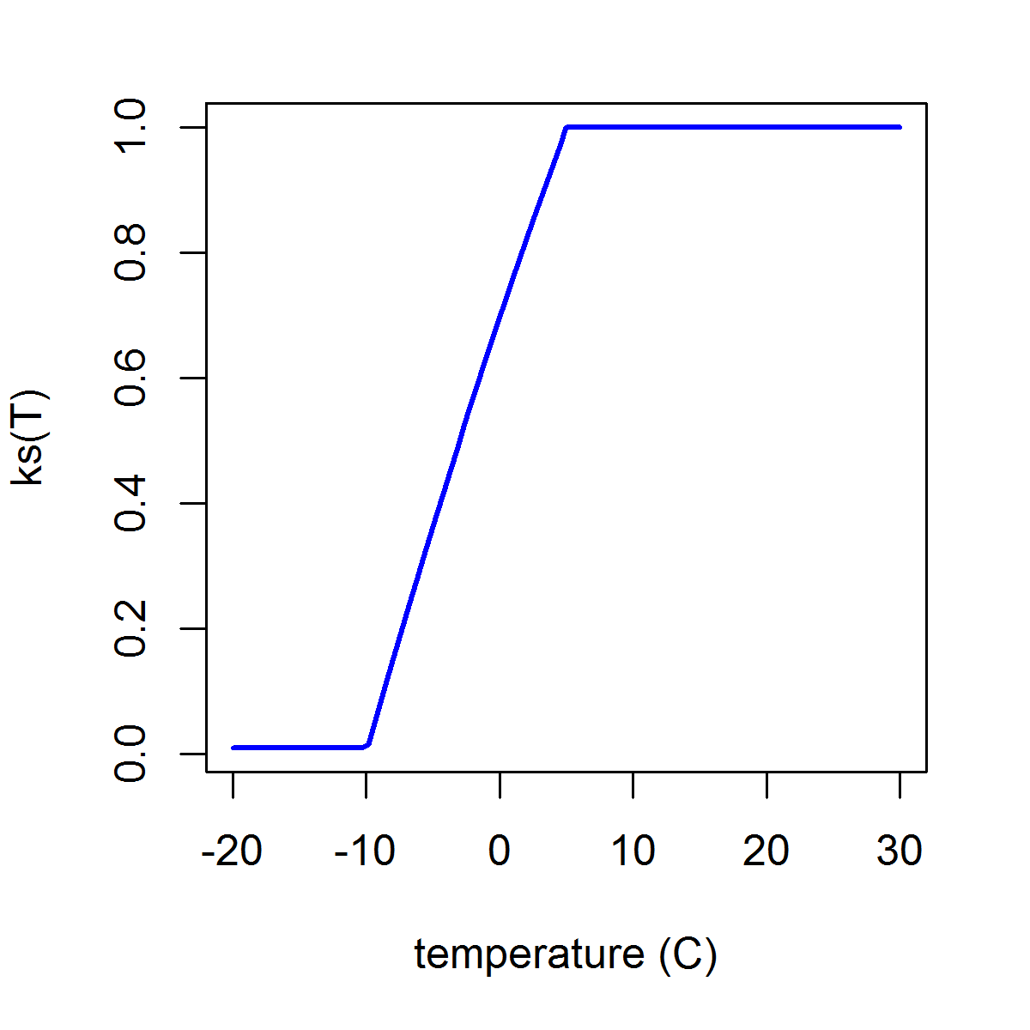

Figure 1: Values of the stomatal conductance scaling factor ks(T) over a range of temperatures.

**Radiation surface computation**

We developed a set of gridded surface radiation estimates which account for both fine-scale local topography (including shading and sky view reduction) and long-term average monthly cloudiness. Our basic approach was to first estimate high-resolution (30 arc-second) clear-sky beam and diffuse radiation under a reference, cloudless atmosphere, which results in a maximum possible surface irradiation for each location in the study area. Clouds, however, reduce this total amount of surface irradiation through absorption and reflection, as well as modifying the relative proportions of diffuse to beam radiation. While physical models of radiative transfer through a cloudy atmosphere are difficult to parameterize, other research (e.g. Schroeder et al. 2009, Súri and Hofierka,2004) found that a simple clearness-index approach can be used to modify the clear-sky estimates of beam and diffuse radiation.

We calculated the clear-sky radiation at 30-arc second resolutions using the r.sun model (Súri and Hofierka,2004). This model takes both local terrain (elevation, slope and aspect) into consideration, as well as uses ray-tracing models to determine the angular height of the horizon. We ran r.sun in clear-sky mode once per month, modeling the irradiation in 3 minute time intervals. The surface albedo was set to 0.2 and the Linke turbidity factor to 1.0. The angular height of the horizon was calculated in 1 degree azimuthal intervals (e.g. 360 directions were checked).

To determine mean real-sky radiation, we utilized the coarse-scale (7.5 min) NLDAS-2 average long-term (1979-2010) monthly mean surface downward shortwave radiation estimates (SWsurface; Mitchell et al. 2004). Additionally, we calculated top-of-the-atmosphere (extraterrestrial) radiation (SWtoa) using a daily time step following the methods of Allen et al. (1998). We adapted calibrated clearness indices published by Schroeder (2009) to be used by the r.sun model (Súri and Hofierka,2004). The two models have slightly different formulations of the clearness index: Schroeder et al. (2009) base their clearness index off a ratio of measured to top-of-atmosphere irradiation, whereas Súri and Hofierka (2004) bases the required clearness index off of the ratio of measured to clear-sky irradiation.

To downscale SWsurface, we first estimated a clearness index (*kc*) following Súri and Hofierka (2004) as the ratio of measured shortwave radiation from the NLDAS-2 product (SWsurface) to the clear sky estimates (SWclear), defined by

*kc* = SWsurface/SWclear (5)

and the Schroeder et al. (2009) clearness index (*kt*), defined by the measured surface radiation relative to top-of-the-atmosphere radiation

*kt* = SWsurface/SW­toa (6)

Schroeder’s clearness index was found to be related to the relative proportion of diffuse (SWdiff) to total irradiation.

SWdiff/SWsurface = -1.43 * (*kt*) + 1.16 (From Schroeder et al. 2009) (7)

From equations 6 and 7, we get

SWdiff/SWsurface = -1.43 * (SWsurface/SWtoa) + 1.16 (8)

We then reorder equation 5 for SW­surface and use it to expand equation 7:

SWsurface = SWclear * *kc* (9)

SWdiff/SWsurface = -1.43 * ((SW­clear * *kc*)/SWtoa) + 1.16 (10)

We then define the fraction of beam radiation relative to total incoming radiation as

SWbeam/SWsurface = 1-(SW­­diff/SW­surface) (11)

and the diffuse and beam coefficients as

coefdh = SWdiff/SWclear (12)

coefbh = SWbeam/SWclear (13)

We then reorder equation 5 for SW­clear and expand equations 12 and 13:

SW­clear = SWsurface/*kc*(14)

coefdh = *kc* * SWdiff/SWsurface (15)

coefbh = *kc* * SWbeam/SWsurface (16)

We then use the diffuse fraction from equation 9 to expand equations 14 and 15

coefdh = *kc* * (-1.43*((SW clear * *kc*)/SWtoa)+ 1.16) (17)

coefbh = *kc* * (1-(-1.43 * ((SW­clear * *kc*)/SWtoa) + 1.16)) (18)

Finally, we use the clearness index from equation 4 to redefine the beam and diffuse coefficients using clear-sky radiation, top-of-the-atmosphere radiation, and surface radiation:

coefdh = SWsurface/SWclear * (-1.43*( SWsurface/SWtoa) + 1.16) (19)

coefbh = SWsurface/SWclear * (1-(-1.43 * (SWsurface/SWtoa) + 1.16)) (20)

We then used the previously calculated radiation surfaces with long-term mean surface radiation to calculate coefdh and coefbh. These coefficients were used in a final *r.sun* radiation calculation to estimate “real-sky” solar radiation given cloud cover and topography.

**Hydrology model**

We followed the "single-bucket" methodology of Lutz et al. (2010) to model actual evapotranspiration (AET), climatic water deficit, and related hydrological variables barring a few modifications to the snowmelt model presented. Lutz et al. (2010), citing Dingman (2002), use a "melt function" to estimate both the fraction of precipitation falling as snow (MFsnow) and the fraction of existing snowpack melting during a given month (MFmelt). This function uses two parameters, TL and TH. At temperatures below TL Lutz et al. (2010) assume all precipitation falls as snow and there is no melting of the existing snowpack. Likewise, at temperatures above TH all precipitation is assumed to fall as rain and all existing snowpack melts. Between TL and TH, the melt function follows a linear relationship with temperature. Lutz et al. use a single melt function with TL = 6°C and TH = 6°C for both MFsnow and MFmelt. The monthly change in snowpack is given as:

*MFmelt(Tmean)=MFsnow(Tmean)=(Tmean-TL)/(TH-TL), 0 ≤ MF(Tmean) ≤ 1 (21)*

*snownew=(1-MFsnow(Tmean))*precip (22)*

*melt=MFmelt(Tmean)*(snowexisting+snownew) (23)*

*Δsnowpack=snownew -melt (24)*

To validate this model, we used it to estimate monthly changes in snowpack corresponding to 66,000 observations from the SNOTEL (Serreze et al. 1999) network of meteorological stations located throughout the western US. As inputs we used PRISM precipitation and temperature, deriving mean temperature as the average of the minimum and maximum monthly temperature, and SNOTEL measurements of existing snowpack at the beginning of each month. By using PRISM rather than SNOTEL for temperature and precipitation inputs, we implicitly account for any bias the PRISM data contains. PRISM and SNOTEL showed good agreement in temperature and precipitation inputs, with correlation coefficients of 0.992 and 0.996 respectively, and median bias of 0.56° C and 0.73mm respectively. We found that large snowmelt events were overestimated by the Dingman (2002) melt function (fig. 2a). In cases where the Dingman (2002) melt function estimated loss of snowpack exceeding 500mm, these loss estimates were biased, on average, by +189mm. Because of this we adopted a melt model similar to that of Hamlin et al (1998) in which the rate of snowpack melt (mm/month) is a linear function of both mean monthly temperature and radiation:

*melt = b0 + b1 * Tmean + b2 * radiation 0 ≤ melt ≤ snowexisting+snownew (25)*

Where *melt* is estimated mm/month of snowmelt, *Tmean* is mean monthly air temperature in degrees C, and *radiation* is average monthly surface radiation in MJ/m2/day. Hybrid temperature and radiation models such as this have proven better able to capture spatial variability in melting rates (Cazorzi and Fontana 1996; Hock 1999). In addition to estimating the parameters of the linear melt function, we used our SNOTEL data to empirically estimate the temperature endpoints of a stepwise linear snow accumulation function as used by Dingman (2002) and Lutz et al. (2010). By incorporating equations 22 and 25 into equation 24 we arrive at our final model for monthly change in snowpack:

*Δsnowpack = (1-MFsnow(Tmean))*precip - (b0 + b1 * Tmean + b2 * radiation) (26)*

We used numerical optimization methods within the R statistical package (R Development Core Team, 2011) to simultaneously estimate all 5 parameters of equation 26, with the sum of squared residual errors as the loss function. This resulted in a snow accumulation function with endpoints of -4.6° C and 6.3° C, yielding a curve similar to that found by Dai (2008) in a study of snow frequency (relative to rain) vs. surface temperature over 3 hour time periods. Parameters b0, b1 and b2 of the melt function were estimated as -398, 81.7 and 25.0 respectively (for temperature in C and radiation in MJ/m2/day). This modification resulted in an improved fit to the empirical data, reducing the bias in large (>500mm) melt estimates from +189mm to -19mm and increasing R2 from 0.79 to 0.90 (fig. 2b). The negative bias in melt estimates (underestimation of large melt events) was associated with late spring conditions and could likely be addressed by allowing the temperature coefficient b1 to vary seasonally with snowpack "ripening" (Dewalle and Rango 2008).

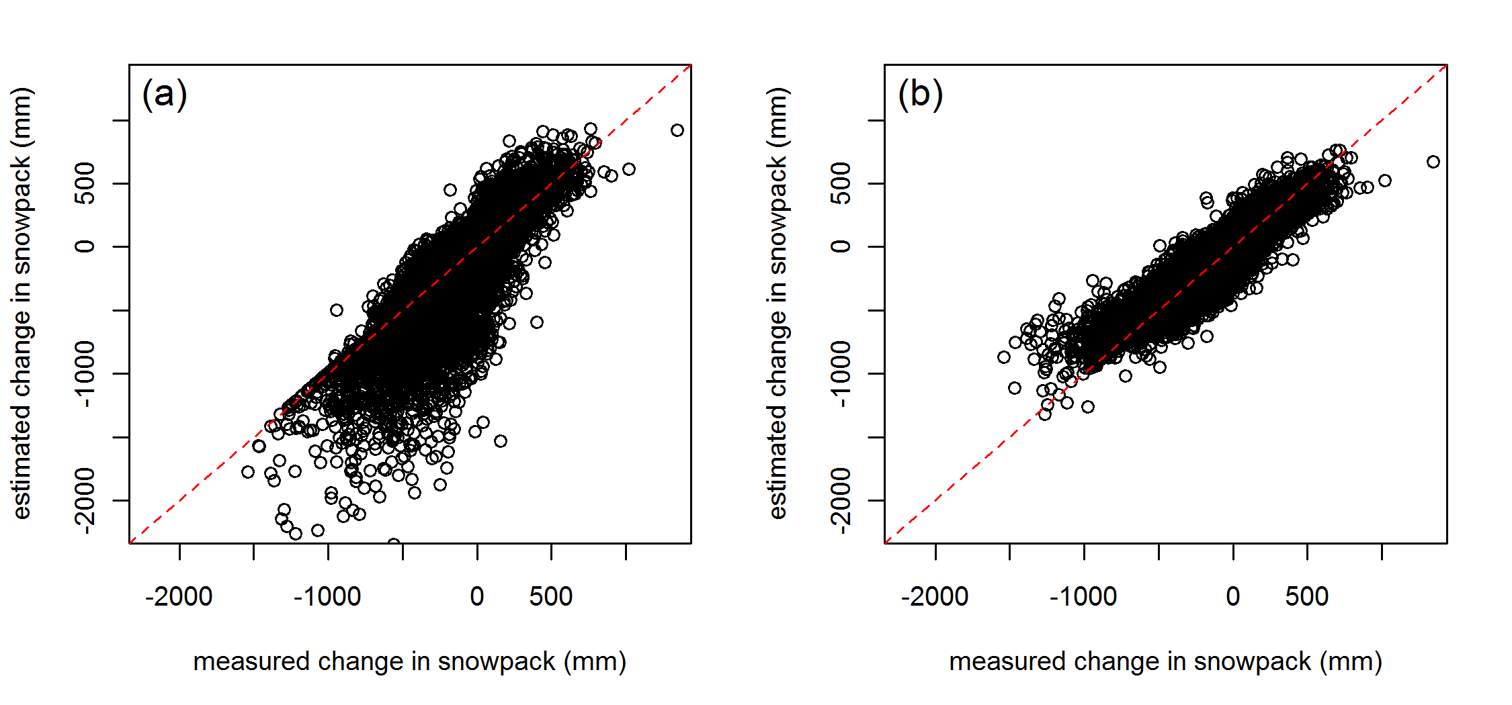

Figure 2: SNOTEL measurements of monthly change in snowpack vs. estimates from (a) the Dingman (2002) model and (b) our empirically based model.

The remaining water balance calculations follow Lutz et al. (2010).

**Validation**

To validate our surface radiation estimates, we compared them to recent (1982-2007) measurements from 21 stations in the California Irrigation Management Information System (CIMIS, <http://www.cimis.water.ca.gov/cimis>, accessed August 25, 2011). The CIMIS values are based on a summation of hourly measurements. We found good agreement (r=0.97; fig. 3) between estimates and a median bias of -1.55 MJ/m2/day.

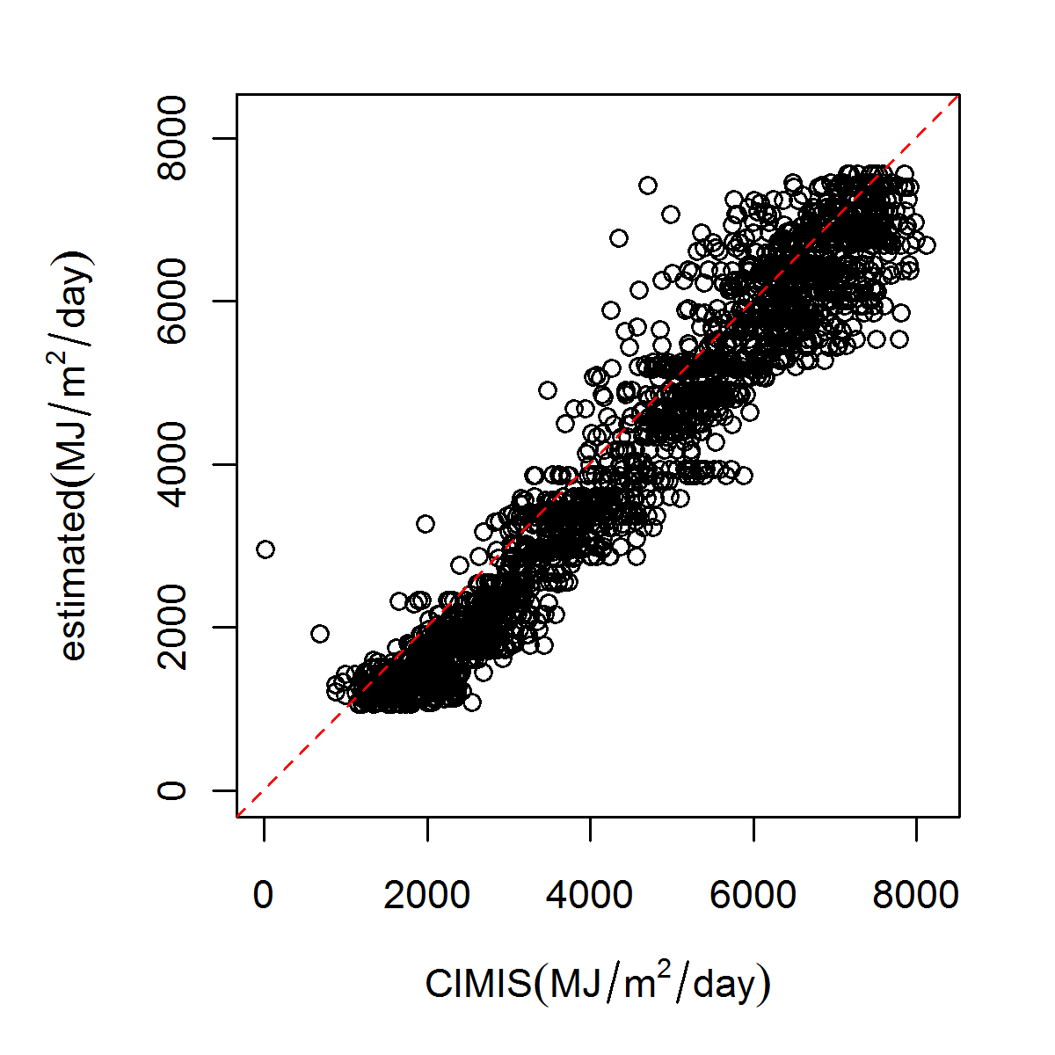

Figure 3: Comparison of our monthly average radiation estimates to monthly averages from measured values at 21 CIMIS stations.

To validate ET0, we compared our estimates to those from the same CIMIS stations. For this comparison our modifications for snow cover and low temperature had little impact since such conditions were rare at low elevation CIMIS sites. The CIMIS estimates are based on a modified Penman equation (Pruitt and Doorenbos 1977) with hourly meteorological measurements as inputs. We again found good agreement (r=0.92; median bias=2.7mm; fig. 4) and found that the discrepancies were primarily due to differences in wind inputs, with radiation and dewpoint estimates differing to a lesser degree.

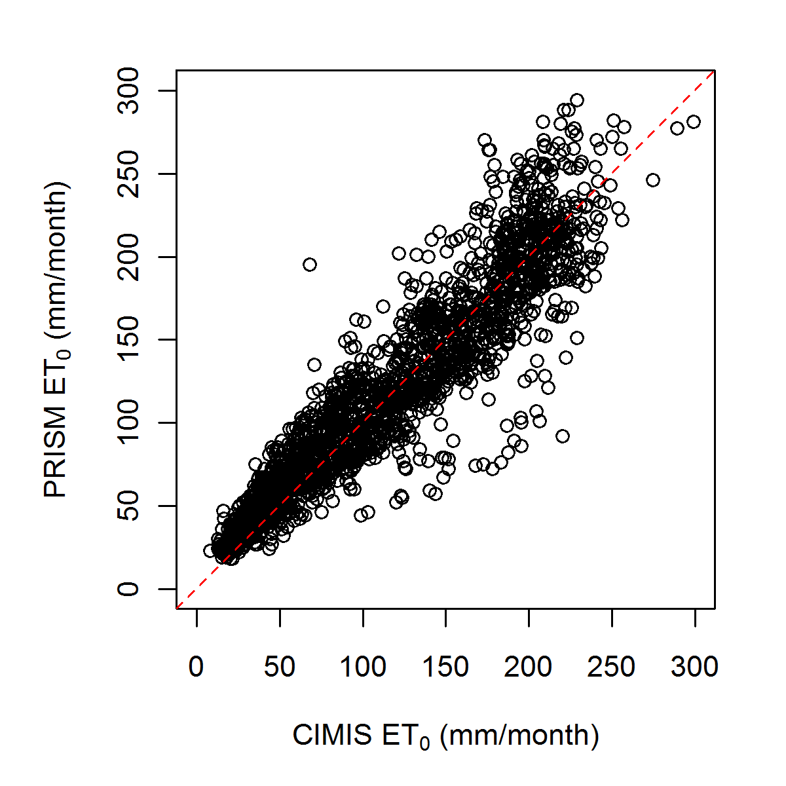

Figure 4: Comparison of our estimates of monthly ET0 to values estimated by CIMIS using measured hourly meteorological data.

As a further validation, we compared our annual ET0 estimates to estimates derived from daily observations at 1218 US Historical Climate Network (USHCN, http://cdiac.ornl.gov/ftp/ushcn daily/, last accessed 13 May 2011). Daily observations of maximum and minimum temperature and precipitation accumulation from the USHCN were supplemented by monthly average dewpoint depression from PRISM and defined as the difference between average minimum temperature and average dewpoint temperature. The monthly average dewpoint depression was then applied on a daily basis congruent with daily minimum temperature to estimate daily mean vapor pressure deficit defined as the average saturation vapor pressure coinciding with daily high and low temperature minus the saturation vapor pressure calculated for the daily mean dew point temperature (e.g,. Jensen et al., 1990). Since historical measurements of wind and radiation were unavailable, we used the same long-term monthly averages as was used in our ET0 calculations (Table 1). Because our snow model was developed for monthly time-steps, it could not be readily applied to the daily time steps of the HCN data, so we did not include the albedo adjustment for snow cover described above but did include the adjustment for stomatal conductance at low temperatures. We found that our annual ET0 estimates based on PRISM gridded monthly averages were highly correlated to those based on daily meteorological observations (fig. 5; r=0.986), but with the PRISM estimates being somewhat lower due to the albedo adjustment for snow cover.

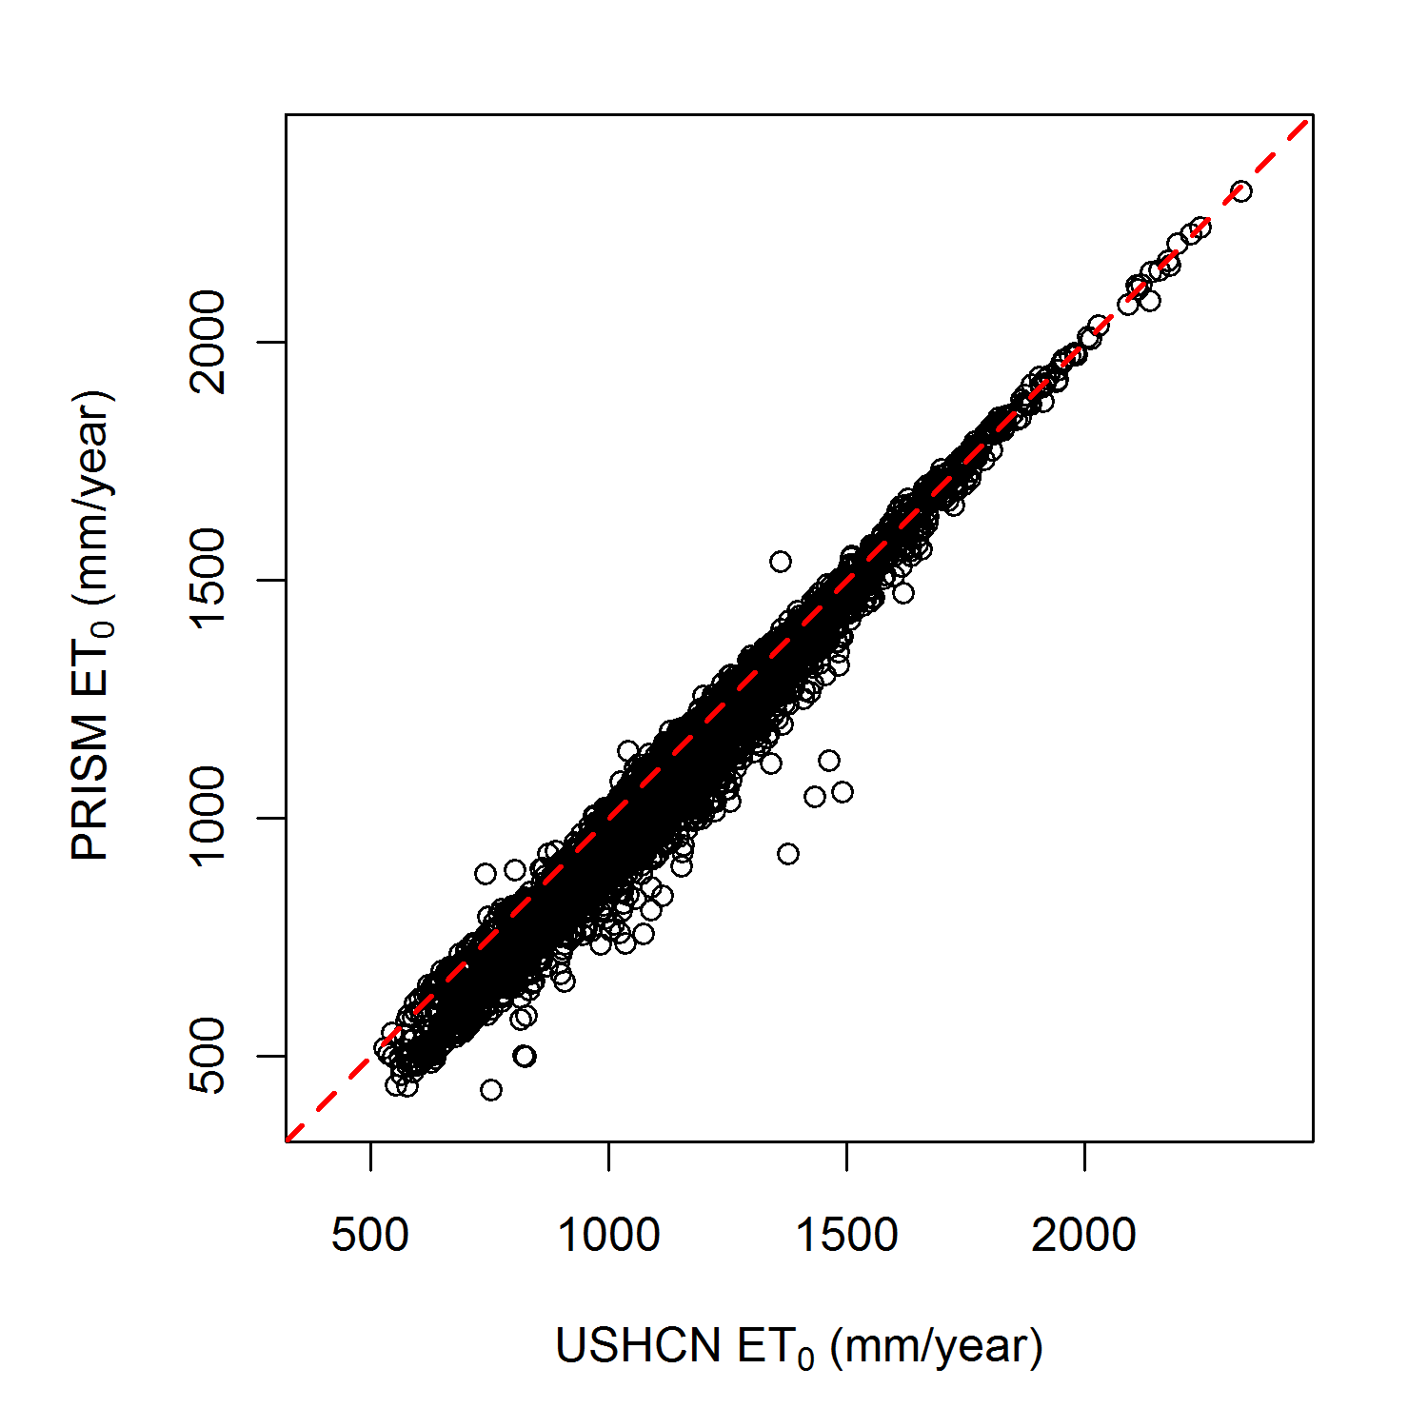

Figure 5: Comparison of our estimates of annual ET0 from monthly PRISM data to values estimated using daily measurements at 1218 USHCN sites. This shows little change in estimates in going from daily estimates from station data to monthly estimates from gridded meteorological data. The lower values for PRISM estimates are due to the albedo adjustment for snow cover, which was used for monthly PRISM but not for daily HCN estimates. For plotting purposes, a random sample of 5000 observations is shown.

**Citations:**

Allen, R. G., Pereira, L. S., Raes, D., Smith, M., & others. (1998). Crop evapotranspiration-Guidelines for computing crop water requirements-FAO Irrigation and drainage paper 56. FAO, Rome, Italy.

Cosgrove BA, et al., 2003. Real-time and retrospective forcing in the North American Land Data

Assimilation System (NLDAS) project, *Journal of Geophysical Research*, 108(D22), 8842.

Dai, A. (2008). Temperature and pressure dependence of the rain-snow phase transition over land and ocean. *Geophysical Research Letters*, 35, L12802.

Daly, Christopher, Halbleib, M., Smith, J. I., Gibson, W.P., Doggett, M. K., Taylor, G.H., Curtis, J., et al. (2008). Physiographically sensitive mapping of climatological temperature and precipitation across the conterminous United States. *International Journal of Climatology*, 28(15), 2031–2064.

DeWalle, D., Henderson, Z., & Rango, A. (2002). Spatial and temporal variations in snowmelt degree-day factors computed from SNOTEL data in the Upper Rio Grande basin*. Proceedings of the 70th Annual Meeting of the Western Snow Conference*. Granby,CO May 20-23, 2002, pp. 73-81.

DeWalle, D. (2008). *Principles of snow hydrology* Cambridge University Press, Cambridge, UK. 416p.

Dingman, S.L. (2002) *Physical hydrology*. Prentice Hall, Upper Saddle River, NJ.

Di Luzio, M., Johnson, G. L., Daly, Christopher, Eischeid, J. K., & Arnold, J. G. (2008). Constructing Retrospective Gridded Daily Precipitation and Temperature Datasets for the Conterminous United States. *Journal of Applied Meteorology and Climatology*, 47(2), 475-497.

Jarvis, P. (1976). The interpretation of the variations in leaf water potential and stomatal conductance found in canopies in the field. *Philosophical Transactions of the Royal Society of London. B, Biological Sciences*, 273(927), 593.

Jensen ME, Burman RD, Allen RG (Editors), 1990. *Evapotranspiration and irrigation water requirements*. ASCE Manuals and Reports on Engineering Practices No. 70. American Society for Civil Engineers, New York, 360pp.

Lutz, J. A., Van Wagtendonk, J. W., & Franklin, J. F. (2010). Climatic water deficit, tree species ranges, and climate change in Yosemite National Park. *Journal of Biogeography*, 37(5), 936–950.

Miller, D.A. and R.A. White, 1998: A Conterminous United States Multi-Layer Soil Characteristics Data Set for Regional Climate and Hydrology Modeling. *Earth Interactions,* 2, 1-26.

Mitchell, K. E., Lohmann, D., Houser, P. R., Wood, E. F., Schaake, J. C., Robock, A., Cosgrove, B. A., et al. (2004). The multi-institution North American Land Data Assimilation System (NLDAS): Utilizing multiple GCIP products and partners in a continental distributed hydrological modeling system. *Journal of Geophysical Research*, 109(D7), D07S90

Nelder, J. A. and Mead, R. (1965) A simplex algorithm for function minimization. *Computer Journal* 7, 308–313.

Pinker, R. T., Tarpley, J. D., Laszlo, I., Mitchell, K. E., Houser, P. R., Wood, E. F., Schaake, J. C., et al. (2003). Surface radiation budgets in support of the GEWEX Continental-Scale International Project (GCIP) and the GEWEX Americas Prediction Project (GAPP). *Journal of Geophysical Research*, 108, 8844.

Pruitt and Doorenbos (1977). *Proceeding of the International Round Table Conference on "Evapotranspiration", Budapest, Hungary*.

R Development Core Team. (2011). R: *A language and environment for statistical computing*. R Foundation for Statistical Computing, Vienna, Austria.

Schroeder, T. A., Hember, R., Coops, N. C., & Liang, S. (2009). Validation of solar radiation surfaces from MODIS and reanalysis data over topographically complex terrain*. Journal of Applied Meteorology and Climatology*, 48(12), 2441–2458.

Serreze, M., Clark, M., Armstrong, R., McGinnis, D., & Pulwarty, R. (1999). Characteristics of the western United States snowpack from snowpack telemetry(SNOTEL) data. *Water Resources*, 35(7), 2145-2160.

Súri, M., & Hofierka, J. (2004). A New GIS-based Solar Radiation Model and Its Application to Photovoltaic Assessments*. Transactions in GIS*, 8(2), 175–190.