Keeve Lab 10

## Exercise 1

library(rioja)

## This is rioja 0.9-15.1

data(SWAP)  
data(RLGH)

SWAP_wapls <- WAPLS(SWAP$spec,SWAP$pH,npls=2)  
SWAP_mat <- MAT(SWAP$spec,SWAP$pH)  
SWAP_wa <- WA(SWAP$spec,SWAP$pH)  
plot(SWAP_wapls)

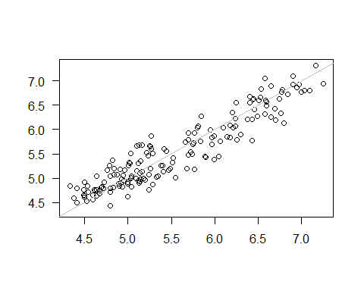

plot(SWAP_mat)

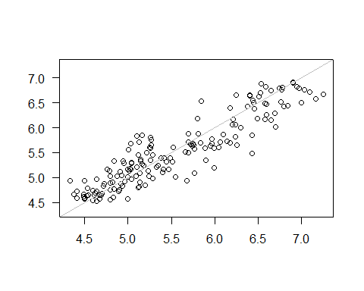

plot(SWAP_wa)

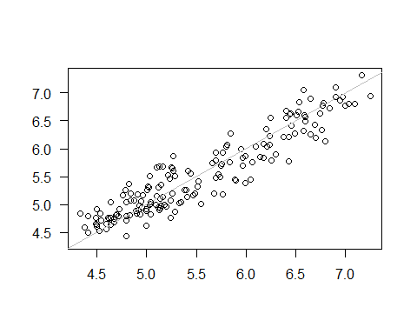

rioja::crossval(SWAP_wapls)

## Cross-validating:  
##   
 |   
 | | 0%  
 |   
 | | 1%  
 |   
 |= | 1%  
 |   
 |= | 2%  
 |   
 |== | 2%  
 |   
 |== | 3%  
 |   
 |== | 4%  
 |   
 |=== | 4%  
 |   
 |=== | 5%  
 |   
 |==== | 5%  
 |   
 |==== | 6%  
 |   
 |==== | 7%  
 |   
 |===== | 7%  
 |   
 |===== | 8%  
 |   
 |====== | 9%  
 |   
 |====== | 10%  
 |   
 |======= | 10%  
 |   
 |======= | 11%  
 |   
 |======== | 12%  
 |   
 |======== | 13%  
 |   
 |========= | 13%  
 |   
 |========= | 14%  
 |   
 |========== | 15%  
 |   
 |========== | 16%  
 |   
 |=========== | 16%  
 |   
 |=========== | 17%  
 |   
 |============ | 18%  
 |   
 |============ | 19%  
 |   
 |============= | 20%  
 |   
 |============== | 21%  
 |   
 |============== | 22%  
 |   
 |=============== | 23%  
 |   
 |================ | 24%  
 |   
 |================ | 25%  
 |   
 |================= | 26%  
 |   
 |================== | 27%  
 |   
 |================== | 28%  
 |   
 |=================== | 29%  
 |   
 |=================== | 30%  
 |   
 |==================== | 31%  
 |   
 |===================== | 32%  
 |   
 |===================== | 33%  
 |   
 |====================== | 34%  
 |   
 |======================= | 35%  
 |   
 |======================= | 36%  
 |   
 |======================== | 37%  
 |   
 |========================= | 38%  
 |   
 |========================= | 39%  
 |   
 |========================== | 40%  
 |   
 |========================== | 41%  
 |   
 |=========================== | 41%  
 |   
 |=========================== | 42%  
 |   
 |============================ | 43%  
 |   
 |============================ | 44%  
 |   
 |============================= | 44%  
 |   
 |============================= | 45%  
 |   
 |============================== | 46%  
 |   
 |============================== | 47%  
 |   
 |=============================== | 47%  
 |   
 |=============================== | 48%  
 |   
 |================================ | 49%  
 |   
 |================================ | 50%  
 |   
 |================================= | 50%  
 |   
 |================================= | 51%  
 |   
 |================================== | 52%  
 |   
 |================================== | 53%  
 |   
 |=================================== | 53%  
 |   
 |=================================== | 54%  
 |   
 |==================================== | 55%  
 |   
 |==================================== | 56%  
 |   
 |===================================== | 56%  
 |   
 |===================================== | 57%  
 |   
 |====================================== | 58%  
 |   
 |====================================== | 59%  
 |   
 |======================================= | 59%  
 |   
 |======================================= | 60%  
 |   
 |======================================== | 61%  
 |   
 |======================================== | 62%  
 |   
 |========================================= | 63%  
 |   
 |========================================== | 64%  
 |   
 |========================================== | 65%  
 |   
 |=========================================== | 66%  
 |   
 |============================================ | 67%  
 |   
 |============================================ | 68%  
 |   
 |============================================= | 69%  
 |   
 |============================================== | 70%  
 |   
 |============================================== | 71%  
 |   
 |=============================================== | 72%  
 |   
 |=============================================== | 73%  
 |   
 |================================================ | 74%  
 |   
 |================================================= | 75%  
 |   
 |================================================= | 76%  
 |   
 |================================================== | 77%  
 |   
 |=================================================== | 78%  
 |   
 |=================================================== | 79%  
 |   
 |==================================================== | 80%  
 |   
 |===================================================== | 81%  
 |   
 |===================================================== | 82%  
 |   
 |====================================================== | 83%  
 |   
 |====================================================== | 84%  
 |   
 |======================================================= | 84%  
 |   
 |======================================================= | 85%  
 |   
 |======================================================== | 86%  
 |   
 |======================================================== | 87%  
 |   
 |========================================================= | 87%  
 |   
 |========================================================= | 88%  
 |   
 |========================================================== | 89%  
 |   
 |========================================================== | 90%  
 |   
 |=========================================================== | 90%  
 |   
 |=========================================================== | 91%  
 |   
 |============================================================ | 92%  
 |   
 |============================================================ | 93%  
 |   
 |============================================================= | 93%  
 |   
 |============================================================= | 94%  
 |   
 |============================================================= | 95%  
 |   
 |============================================================== | 95%  
 |   
 |============================================================== | 96%  
 |   
 |=============================================================== | 96%  
 |   
 |=============================================================== | 97%  
 |   
 |=============================================================== | 98%  
 |   
 |================================================================ | 98%  
 |   
 |================================================================ | 99%  
 |   
 |=================================================================| 99%  
 |   
 |=================================================================| 100%

##   
## Method : Weighted Averaging Partial Least Squares  
## Call : WAPLS(y = SWAP$spec, x = SWAP$pH, npls = 2)   
##   
## No. samples : 167   
## No. species : 277   
## No. components : 2   
## Cross val. : loo   
##   
##   
## Performance:  
## RMSE R2 Avg.Bias Max.Bias Skill  
## Comp01 0.2756 0.8717 0.0016 0.1930 87.1676  
## Comp02 0.2321 0.9090 0.0006 0.1536 90.9006  
## Comp01_XVal 0.3067 0.8421 0.0131 0.3546 84.1180  
## Comp02_XVal 0.2986 0.8501 0.0191 0.3775 84.9459

analogue::optima(SWAP$spec,SWAP$pH)

##   
## Weighted Average Optima For: SWAP$pH  
##   
## AC001A AC002A AC004A AC013A AC014A AC014B AC014C AC017A   
## 6.391870 6.390380 6.143205 6.337889 4.872948 5.130048 5.410085 5.954913   
## AC018A AC019A AC022A AC025A AC028A AC029A AC030A AC034A   
## 6.226881 6.178677 5.200095 6.255318 5.746221 5.763416 6.065965 6.291338   
## AC035A AC039A AC042A AC044A AC046A AC048A AC9964 AC9965   
## 6.195437 6.342105 6.105013 5.615805 5.668511 5.630603 6.180631 5.749658   
## AC9968 AC9969 AC9975 AC9996 AM001A AM001B AM001D AS001A   
## 5.196932 6.085539 4.913026 6.064632 6.188653 6.825107 6.372088 6.718995   
## AS003A AT001A AU001C AU002A AU003B AU003D AU004A AU004B   
## 4.942885 5.131810 5.596840 6.500123 7.021573 7.059654 5.239846 5.961804   
## AU004C AU004D AU005A AU005B AU005D AU005E AU005J AU005L   
## 5.736427 5.327831 5.391870 6.120225 5.779317 5.012466 6.042784 6.808867   
## AU009A AU009B AU010A AU010B AU014A AU022A AU023A AU9983   
## 6.452710 5.365533 5.245831 5.168809 5.675902 6.933716 5.000000 6.413181   
## AU9984 AU9987 AU9988 BR001A BR003A BR004A BR005A BR006A   
## 5.630266 5.580902 5.021488 5.938892 4.788705 5.212293 6.682530 5.298437   
## BR9997 CA018A CC001A CM004A CM010A CM013A CM014A CM015A   
## 5.359548 6.639938 7.160000 6.340316 5.165520 6.690273 5.147159 6.401941   
## CM015B CM017A CM020A CM031A CM031C CM038A CM048A CM050A   
## 6.340000 5.084739 5.875921 6.115911 5.254492 6.318335 5.747689 7.125273   
## CM051A CM052A CM101B CM9989 CM9995 CO001A CO001B CY001A   
## 6.156664 6.387611 6.723777 5.056829 4.977483 6.677402 6.942000 6.697727   
## CY002A CY003A CY004A CY007A CY010A CY013A CY9991 DE001A   
## 6.856985 6.942000 6.170910 6.732602 6.684801 4.500000 6.292045 6.789421   
## DT002A DT003A DT004B EU002A EU002B EU002D EU002E EU002K   
## 5.844772 6.339250 6.541467 5.494897 5.393005 5.402762 5.518692 5.238856   
## EU003A EU004A EU009A EU009C EU011A EU013A EU014A EU015A   
## 5.357044 5.167489 5.064030 5.097029 5.055075 5.795851 4.689540 5.125939   
## EU016A EU017A EU019A EU020A EU021A EU022A EU025A EU027A   
## 5.338856 5.667389 5.260537 5.152957 5.645646 5.325298 5.112205 4.804029   
## EU028A EU028B EU031A EU034A EU039A EU040A EU046C EU047A   
## 4.883259 4.734234 5.542663 5.130405 5.068189 5.144991 4.703086 5.056132   
## EU048A EU049A EU049B EU051A EU051B EU056A EU057A EU058A   
## 4.950387 5.472081 5.293949 5.097642 5.413136 5.302624 5.321476 4.675294   
## EU9961 EU9962 EU9965 EU9969 FR001A FR001B FR002A FR002C   
## 5.192557 5.471678 4.889374 5.043360 6.343205 6.254040 6.598967 6.171183   
## FR005A FR005D FR006A FR007A FR008A FR009F FR010A FR011A   
## 5.558934 5.698662 6.492085 6.328192 7.008896 6.240000 5.371060 6.010973   
## FR015A FR018A FR9991 FU002A FU002B FU002F GO003A GO004A   
## 5.470155 6.564130 4.683372 5.120969 5.173162 5.295851 5.783958 5.764200   
## GO006C GO013A GO023A GO025B GO025F GY005A HN001A ME019A   
## 6.053800 6.160208 6.661725 6.561954 6.616286 7.160000 5.955994 5.607095   
## NA002A NA003A NA003B NA005A NA005B NA006A NA006B NA007A   
## 5.463491 6.218315 6.054642 6.121030 6.414171 5.353125 5.156900 6.562142   
## NA008A NA013A NA014A NA015A NA016A NA032A NA033A NA037A   
## 6.613639 6.111603 6.255649 5.447810 5.896107 5.717606 5.211043 5.644886   
## NA038A NA042A NA043A NA044A NA045A NA046A NA048A NA063A   
## 5.185541 6.072514 6.452144 5.286432 5.646395 5.801026 5.060848 6.630172   
## NA068A NA084A NA086A NA099A NA101A NA102A NA112D NA113A   
## 5.797265 6.577000 6.297220 5.047937 6.878816 6.568537 6.349672 6.160973   
## NA114A NA115A NA129A NA133A NA135A NA140A NA149A NA151A   
## 6.507217 5.019151 6.219000 5.860350 5.257653 4.905698 5.980457 6.412941   
## NA156A NA158A NA160A NA167A NA170A NA9904 NA9919 NA9955   
## 5.090226 4.934526 5.464112 4.859099 6.064604 6.087969 5.973559 6.079393   
## NA9963 NA9964 NE003A NE003B NE003C NE004A NE012A NE020A   
## 5.584184 5.319150 5.336385 5.017068 5.651123 5.127014 5.484129 5.451155   
## NE023A NI002A NI005A NI008A NI009A NI009B NI017A NI021A   
## 5.738833 6.341801 5.737781 6.395290 6.239170 6.169422 5.877377 5.949433   
## NI026A NI027A NI152A NI9984 OP001A PE002A PI005A PI007A   
## 6.295821 6.546756 5.813076 7.250000 6.465227 5.331847 5.269995 5.453201   
## PI011A PI014A PI015A PI016A PI018A PI018B PI022B PI023A   
## 5.354191 5.833683 5.649451 5.929813 5.243574 5.331454 4.963960 5.350816   
## PI055A PI056A PI139A PI164A RH006B SA001A SA001B SA006A   
## 6.600000 4.895904 5.517000 5.505341 6.258497 5.586822 5.870518 5.924093   
## SA042A SE001A SP002A ST004A ST010A SU002A SU004A SU005A   
## 5.056502 4.764743 5.265415 6.860809 7.093000 5.517000 5.321936 5.322800   
## SU006A SY002A SY003A SY004A SY009A SY010A SY013A SY043A   
## 5.004872 6.435810 6.430885 6.687533 6.248336 6.044152 6.587861 5.894069   
## TA001A TA002A TA003A TA004A TA9996   
## 5.421338 5.865716 4.685068 4.888238 6.069182

Predict models in order to plot reconstructions

SWAP_wapls_pred <- predict(SWAP_wapls,newdata=RLGH$spec)  
SWAP_wa_pred <- predict(SWAP_wa,newdata=RLGH$spec)  
SWAP_mat_pred <- predict(SWAP_mat,newdata=RLGH$spec)

Time series plot

plot(y=SWAP_wapls_pred$fit[,2],x=RLGH$depths$Age, type="l",col="black",xlab="Age",ylab="Predicted pHs",main="Time Series Plot")  
lines(y=SWAP_mat_pred$fit[,2],x=RLGH$depths$Age, type="l",col="red")  
lines(y=SWAP_wa_pred$fit[,2],x=RLGH$depths$Age, type="l",col="green")

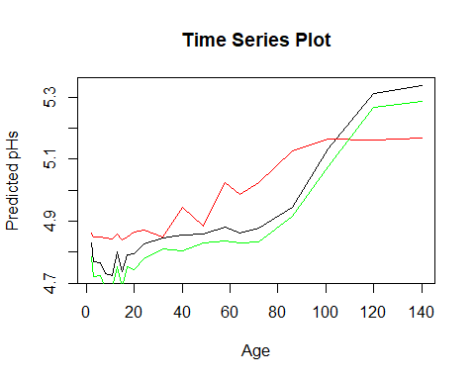 Correlations among three reconstructions

all_models <- data.frame(SWAP_wapls_pred$fit[,2],SWAP_mat_pred$fit[,2],SWAP_wa_pred$fit[,2])  
colnames(all_models) <- c("WAPLS","MAT","WA")  
cor(all_models)

## WAPLS MAT WA  
## WAPLS 1.0000000 0.8854099 0.9989719  
## MAT 0.8854099 1.0000000 0.8870978  
## WA 0.9989719 0.8870978 1.0000000

Highest correlation between WA and WAPLS

## Exercise 2

library(palaeoSig)

## Loading required package: vegan

## Loading required package: permute

## Loading required package: lattice

## This is vegan 2.5-2

data(arctic.pollen)  
data(arctic.env)

Run and cross-validate MAT and WA

arctic_mat_tjul <- rioja::MAT(y=arctic.pollen,x=arctic.env$tjul,lean=FALSE)

## Warning in rioja::MAT(y = arctic.pollen, x = arctic.env$tjul, lean = FALSE): Inter-sample distances < 1.0E-6 found (duplicate samples?  
## These have been replaced by 1.0E-6

arctic_mat_sjul <- rioja::MAT(y=arctic.pollen,x=arctic.env$sjul,lean=FALSE)

## Warning in rioja::MAT(y = arctic.pollen, x = arctic.env$sjul, lean = FALSE): Inter-sample distances < 1.0E-6 found (duplicate samples?  
## These have been replaced by 1.0E-6

arctic_wa_tjul <- rioja::WA(y=arctic.pollen,x=arctic.env$tjul,lean=FALSE)  
arctic_wa_sjul <- rioja::WA(y=arctic.pollen,x=arctic.env$sjul,lean=FALSE)  
  
arctic_mat_tjul_cv <- rioja::crossval(arctic_mat_tjul)

## Cross-validating:  
##   
 |   
 | | 0%  
 |   
 |====== | 10%  
 |   
 |============= | 20%  
 |   
 |==================== | 30%  
 |   
 |========================== | 40%  
 |   
 |================================ | 50%  
 |   
 |======================================= | 60%  
 |   
 |============================================== | 70%  
 |   
 |==================================================== | 80%  
 |   
 |========================================================== | 90%  
 |   
 |=================================================================| 100%

arctic_mat_sjul_cv <- rioja::crossval(arctic_mat_sjul)

## Cross-validating:  
##   
 |   
 | | 0%  
 |   
 |====== | 10%  
 |   
 |============= | 20%  
 |   
 |==================== | 30%  
 |   
 |========================== | 40%  
 |   
 |================================ | 50%  
 |   
 |======================================= | 60%  
 |   
 |============================================== | 70%  
 |   
 |==================================================== | 80%  
 |   
 |========================================================== | 90%  
 |   
 |=================================================================| 100%

arctic_wa_tjul_cv <- rioja::crossval(arctic_wa_tjul)

## Cross-validating:  
##   
 |   
 | | 0%  
 |   
 | | 1%  
 |   
 |= | 1%  
 |   
 |= | 2%  
 |   
 |== | 2%  
 |   
 |== | 3%  
 |   
 |== | 4%  
 |   
 |=== | 4%  
 |   
 |=== | 5%  
 |   
 |==== | 5%  
 |   
 |==== | 6%  
 |   
 |==== | 7%  
 |   
 |===== | 7%  
 |   
 |===== | 8%  
 |   
 |====== | 9%  
 |   
 |====== | 10%  
 |   
 |======= | 10%  
 |   
 |======= | 11%  
 |   
 |======== | 12%  
 |   
 |======== | 13%  
 |   
 |========= | 13%  
 |   
 |========= | 14%  
 |   
 |========= | 15%  
 |   
 |========== | 15%  
 |   
 |========== | 16%  
 |   
 |=========== | 16%  
 |   
 |=========== | 17%  
 |   
 |=========== | 18%  
 |   
 |============ | 18%  
 |   
 |============ | 19%  
 |   
 |============= | 19%  
 |   
 |============= | 20%  
 |   
 |============= | 21%  
 |   
 |============== | 21%  
 |   
 |============== | 22%  
 |   
 |=============== | 22%  
 |   
 |=============== | 23%  
 |   
 |=============== | 24%  
 |   
 |================ | 24%  
 |   
 |================ | 25%  
 |   
 |================= | 25%  
 |   
 |================= | 26%  
 |   
 |================= | 27%  
 |   
 |================== | 27%  
 |   
 |================== | 28%  
 |   
 |=================== | 29%  
 |   
 |=================== | 30%  
 |   
 |==================== | 30%  
 |   
 |==================== | 31%  
 |   
 |==================== | 32%  
 |   
 |===================== | 32%  
 |   
 |===================== | 33%  
 |   
 |====================== | 33%  
 |   
 |====================== | 34%  
 |   
 |====================== | 35%  
 |   
 |======================= | 35%  
 |   
 |======================= | 36%  
 |   
 |======================== | 36%  
 |   
 |======================== | 37%  
 |   
 |======================== | 38%  
 |   
 |========================= | 38%  
 |   
 |========================= | 39%  
 |   
 |========================== | 39%  
 |   
 |========================== | 40%  
 |   
 |========================== | 41%  
 |   
 |=========================== | 41%  
 |   
 |=========================== | 42%  
 |   
 |============================ | 42%  
 |   
 |============================ | 43%  
 |   
 |============================ | 44%  
 |   
 |============================= | 44%  
 |   
 |============================= | 45%  
 |   
 |============================== | 45%  
 |   
 |============================== | 46%  
 |   
 |============================== | 47%  
 |   
 |=============================== | 47%  
 |   
 |=============================== | 48%  
 |   
 |================================ | 49%  
 |   
 |================================ | 50%  
 |   
 |================================= | 50%  
 |   
 |================================= | 51%  
 |   
 |================================== | 52%  
 |   
 |================================== | 53%  
 |   
 |=================================== | 53%  
 |   
 |=================================== | 54%  
 |   
 |=================================== | 55%  
 |   
 |==================================== | 55%  
 |   
 |==================================== | 56%  
 |   
 |===================================== | 56%  
 |   
 |===================================== | 57%  
 |   
 |===================================== | 58%  
 |   
 |====================================== | 58%  
 |   
 |====================================== | 59%  
 |   
 |======================================= | 59%  
 |   
 |======================================= | 60%  
 |   
 |======================================= | 61%  
 |   
 |======================================== | 61%  
 |   
 |======================================== | 62%  
 |   
 |========================================= | 62%  
 |   
 |========================================= | 63%  
 |   
 |========================================= | 64%  
 |   
 |========================================== | 64%  
 |   
 |========================================== | 65%  
 |   
 |=========================================== | 65%  
 |   
 |=========================================== | 66%  
 |   
 |=========================================== | 67%  
 |   
 |============================================ | 67%  
 |   
 |============================================ | 68%  
 |   
 |============================================= | 68%  
 |   
 |============================================= | 69%  
 |   
 |============================================= | 70%  
 |   
 |============================================== | 70%  
 |   
 |============================================== | 71%  
 |   
 |=============================================== | 72%  
 |   
 |=============================================== | 73%  
 |   
 |================================================ | 73%  
 |   
 |================================================ | 74%  
 |   
 |================================================ | 75%  
 |   
 |================================================= | 75%  
 |   
 |================================================= | 76%  
 |   
 |================================================== | 76%  
 |   
 |================================================== | 77%  
 |   
 |================================================== | 78%  
 |   
 |=================================================== | 78%  
 |   
 |=================================================== | 79%  
 |   
 |==================================================== | 79%  
 |   
 |==================================================== | 80%  
 |   
 |==================================================== | 81%  
 |   
 |===================================================== | 81%  
 |   
 |===================================================== | 82%  
 |   
 |====================================================== | 82%  
 |   
 |====================================================== | 83%  
 |   
 |====================================================== | 84%  
 |   
 |======================================================= | 84%  
 |   
 |======================================================= | 85%  
 |   
 |======================================================== | 85%  
 |   
 |======================================================== | 86%  
 |   
 |======================================================== | 87%  
 |   
 |========================================================= | 87%  
 |   
 |========================================================= | 88%  
 |   
 |========================================================== | 89%  
 |   
 |========================================================== | 90%  
 |   
 |=========================================================== | 90%  
 |   
 |=========================================================== | 91%  
 |   
 |============================================================ | 92%  
 |   
 |============================================================ | 93%  
 |   
 |============================================================= | 93%  
 |   
 |============================================================= | 94%  
 |   
 |============================================================= | 95%  
 |   
 |============================================================== | 95%  
 |   
 |============================================================== | 96%  
 |   
 |=============================================================== | 96%  
 |   
 |=============================================================== | 97%  
 |   
 |=============================================================== | 98%  
 |   
 |================================================================ | 98%  
 |   
 |================================================================ | 99%  
 |   
 |=================================================================| 99%  
 |   
 |=================================================================| 100%

arctic_wa_sjul_cv <- rioja::crossval(arctic_wa_sjul)

## Cross-validating:  
##   
 |   
 | | 0%  
 |   
 | | 1%  
 |   
 |= | 1%  
 |   
 |= | 2%  
 |   
 |== | 2%  
 |   
 |== | 3%  
 |   
 |== | 4%  
 |   
 |=== | 4%  
 |   
 |=== | 5%  
 |   
 |==== | 5%  
 |   
 |==== | 6%  
 |   
 |==== | 7%  
 |   
 |===== | 7%  
 |   
 |===== | 8%  
 |   
 |====== | 9%  
 |   
 |====== | 10%  
 |   
 |======= | 10%  
 |   
 |======= | 11%  
 |   
 |======== | 12%  
 |   
 |======== | 13%  
 |   
 |========= | 13%  
 |   
 |========= | 14%  
 |   
 |========= | 15%  
 |   
 |========== | 15%  
 |   
 |========== | 16%  
 |   
 |=========== | 16%  
 |   
 |=========== | 17%  
 |   
 |=========== | 18%  
 |   
 |============ | 18%  
 |   
 |============ | 19%  
 |   
 |============= | 19%  
 |   
 |============= | 20%  
 |   
 |============= | 21%  
 |   
 |============== | 21%  
 |   
 |============== | 22%  
 |   
 |=============== | 22%  
 |   
 |=============== | 23%  
 |   
 |=============== | 24%  
 |   
 |================ | 24%  
 |   
 |================ | 25%  
 |   
 |================= | 25%  
 |   
 |================= | 26%  
 |   
 |================= | 27%  
 |   
 |================== | 27%  
 |   
 |================== | 28%  
 |   
 |=================== | 29%  
 |   
 |=================== | 30%  
 |   
 |==================== | 30%  
 |   
 |==================== | 31%  
 |   
 |==================== | 32%  
 |   
 |===================== | 32%  
 |   
 |===================== | 33%  
 |   
 |====================== | 33%  
 |   
 |====================== | 34%  
 |   
 |====================== | 35%  
 |   
 |======================= | 35%  
 |   
 |======================= | 36%  
 |   
 |======================== | 36%  
 |   
 |======================== | 37%  
 |   
 |======================== | 38%  
 |   
 |========================= | 38%  
 |   
 |========================= | 39%  
 |   
 |========================== | 39%  
 |   
 |========================== | 40%  
 |   
 |========================== | 41%  
 |   
 |=========================== | 41%  
 |   
 |=========================== | 42%  
 |   
 |============================ | 42%  
 |   
 |============================ | 43%  
 |   
 |============================ | 44%  
 |   
 |============================= | 44%  
 |   
 |============================= | 45%  
 |   
 |============================== | 45%  
 |   
 |============================== | 46%  
 |   
 |============================== | 47%  
 |   
 |=============================== | 47%  
 |   
 |=============================== | 48%  
 |   
 |================================ | 49%  
 |   
 |================================ | 50%  
 |   
 |================================= | 50%  
 |   
 |================================= | 51%  
 |   
 |================================== | 52%  
 |   
 |================================== | 53%  
 |   
 |=================================== | 53%  
 |   
 |=================================== | 54%  
 |   
 |=================================== | 55%  
 |   
 |==================================== | 55%  
 |   
 |==================================== | 56%  
 |   
 |===================================== | 56%  
 |   
 |===================================== | 57%  
 |   
 |===================================== | 58%  
 |   
 |====================================== | 58%  
 |   
 |====================================== | 59%  
 |   
 |======================================= | 59%  
 |   
 |======================================= | 60%  
 |   
 |======================================= | 61%  
 |   
 |======================================== | 61%  
 |   
 |======================================== | 62%  
 |   
 |========================================= | 62%  
 |   
 |========================================= | 63%  
 |   
 |========================================= | 64%  
 |   
 |========================================== | 64%  
 |   
 |========================================== | 65%  
 |   
 |=========================================== | 65%  
 |   
 |=========================================== | 66%  
 |   
 |=========================================== | 67%  
 |   
 |============================================ | 67%  
 |   
 |============================================ | 68%  
 |   
 |============================================= | 68%  
 |   
 |============================================= | 69%  
 |   
 |============================================= | 70%  
 |   
 |============================================== | 70%  
 |   
 |============================================== | 71%  
 |   
 |=============================================== | 72%  
 |   
 |=============================================== | 73%  
 |   
 |================================================ | 73%  
 |   
 |================================================ | 74%  
 |   
 |================================================ | 75%  
 |   
 |================================================= | 75%  
 |   
 |================================================= | 76%  
 |   
 |================================================== | 76%  
 |   
 |================================================== | 77%  
 |   
 |================================================== | 78%  
 |   
 |=================================================== | 78%  
 |   
 |=================================================== | 79%  
 |   
 |==================================================== | 79%  
 |   
 |==================================================== | 80%  
 |   
 |==================================================== | 81%  
 |   
 |===================================================== | 81%  
 |   
 |===================================================== | 82%  
 |   
 |====================================================== | 82%  
 |   
 |====================================================== | 83%  
 |   
 |====================================================== | 84%  
 |   
 |======================================================= | 84%  
 |   
 |======================================================= | 85%  
 |   
 |======================================================== | 85%  
 |   
 |======================================================== | 86%  
 |   
 |======================================================== | 87%  
 |   
 |========================================================= | 87%  
 |   
 |========================================================= | 88%  
 |   
 |========================================================== | 89%  
 |   
 |========================================================== | 90%  
 |   
 |=========================================================== | 90%  
 |   
 |=========================================================== | 91%  
 |   
 |============================================================ | 92%  
 |   
 |============================================================ | 93%  
 |   
 |============================================================= | 93%  
 |   
 |============================================================= | 94%  
 |   
 |============================================================= | 95%  
 |   
 |============================================================== | 95%  
 |   
 |============================================================== | 96%  
 |   
 |=============================================================== | 96%  
 |   
 |=============================================================== | 97%  
 |   
 |=============================================================== | 98%  
 |   
 |================================================================ | 98%  
 |   
 |================================================================ | 99%  
 |   
 |=================================================================| 99%  
 |   
 |=================================================================| 100%

Use random data to train the transfer functions

random_test <- as.matrix(runif(n=828))  
arctic_random <- arctic.pollen  
arctic_random[] <- random_test  
random_mat <- rioja::MAT(y=arctic_random,x=arctic.env$tjul,lean=FALSE)

## Warning in rioja::MAT(y = arctic_random, x = arctic.env$tjul, lean = FALSE): Inter-sample distances < 1.0E-6 found (duplicate samples?  
## These have been replaced by 1.0E-6

random_mat_cv <- rioja::crossval(random_mat)

## Cross-validating:  
##   
 |   
 | | 0%  
 |   
 |====== | 10%  
 |   
 |============= | 20%  
 |   
 |==================== | 30%  
 |   
 |========================== | 40%  
 |   
 |================================ | 50%  
 |   
 |======================================= | 60%  
 |   
 |============================================== | 70%  
 |   
 |==================================================== | 80%  
 |   
 |========================================================== | 90%  
 |   
 |=================================================================| 100%

Use spatially structure random data to train the transfer function

tjul <- readRDS("C:/CKGit/Geography523/Wk10_Transfer_Functions/data/tjul.RDS")  
sjul <- readRDS("C:/CKGit/Geography523/Wk10_Transfer_Functions/data/sjul.RDS")  
  
dup <- duplicated(tjul$sim1)

## Loading required package: sp

tjul_new <- tjul[!dup,]  
  
#rioja::MAT(y=tjul_new,x=arctic.env$tjul,lean=FALSE)  
  
length(tjul_new)

## [1] 796

length(arctic.env$tjul)

## [1] 828

Compare cross validated r2

arctic_mat_tjul_cv

##   
## Method : Modern Analogue Technique  
## Call : MAT(y = y, x = x, dist.method = "sq.chord", k = 5, lean = FALSE)   
##   
## Distance : sq.chord   
## No. samples : 828   
## No. species : 39   
## Cross val. : lgo : no. groups = 10   
##   
##   
## Performance:  
## RMSE R2 Avg.Bias Max.Bias Skill  
## N01 1.5586 0.8130 -0.0884 2.4333 80.6392  
## N02 1.4405 0.8374 -0.0893 1.8250 83.4611  
## N03 1.4146 0.8416 -0.0690 2.0556 84.0518  
## N04 1.3824 0.8485 -0.0723 2.1917 84.7689  
## N05 1.3550 0.8542 -0.0638 2.3600 85.3663  
## N01.wm 1.5586 0.8130 -0.0884 2.4333 80.6392  
## N02.wm 1.4272 0.8402 -0.0817 1.8867 83.7653  
## N03.wm 1.3891 0.8472 -0.0685 2.0823 84.6215  
## N04.wm 1.3481 0.8558 -0.0779 2.1966 85.5160  
## N05.wm 1.3225 0.8611 -0.0708 2.3461 86.0596  
## N01_XVal 1.5714 0.8101 -0.0761 1.3524 80.3206  
## N02_XVal 1.4654 0.8317 -0.0717 1.7583 82.8856  
## N03_XVal 1.4485 0.8343 -0.0734 2.0389 83.2785  
## N04_XVal 1.3781 0.8495 -0.0699 2.2083 84.8632  
## N05_XVal 1.3493 0.8555 -0.0734 2.6400 85.4886  
## N01.wm_XVal 1.5714 0.8101 -0.0761 1.3524 80.3206  
## N02.wm_XVal 1.4479 0.8355 -0.0665 1.7464 83.2917  
## N03.wm_XVal 1.4168 0.8413 -0.0711 2.0104 84.0017  
## N04.wm_XVal 1.3493 0.8556 -0.0715 2.1750 85.4890  
## N05.wm_XVal 1.3222 0.8612 -0.0769 2.5179 86.0659

arctic_wa_tjul_cv

##   
## Method : Weighted Averaging  
## Call : rioja::WA(y = arctic.pollen, x = arctic.env$tjul, lean = FALSE)   
##   
## Tolerance DW : No   
## Monotonic deshrink : No   
## No. samples : 828   
## No. species : 39   
## Cross val. : loo   
##   
## Deshrinking regression coefficients:  
## Inverse d/s Classical d/s  
## wa.b0 -13.8076 7.4381  
## wa.b1 2.3929 0.2497  
##   
## Performance:  
## RMSE R2 Avg.Bias Max.Bias Skill  
## WA.inv 2.2475 0.5974 0.0000 4.9551 59.7399  
## WA.cla 2.9079 0.5974 0.0000 3.2987 32.6077  
## WA.inv_XVal 2.2614 0.5924 0.0013 4.9862 59.2404  
## WA.cla_XVal 2.9188 0.5933 0.0025 3.3426 32.0979

random_mat_cv

##   
## Method : Modern Analogue Technique  
## Call : MAT(y = y, x = x, dist.method = "sq.chord", k = 5, lean = FALSE)   
##   
## Distance : sq.chord   
## No. samples : 828   
## No. species : 39   
## Cross val. : lgo : no. groups = 10   
##   
##   
## Performance:  
## RMSE R2 Avg.Bias Max.Bias Skill  
## N01 4.8830 0.0000 0.0356 8.3000 -90.0357  
## N02 4.2766 0.0003 -0.0534 7.7444 -45.7680  
## N03 4.0094 0.0024 0.0277 7.9241 -28.1223  
## N04 3.8705 0.0057 -0.0225 7.7111 -19.3975  
## N05 3.8006 0.0060 -0.0378 8.0511 -15.1220  
## N01.wm 4.8830 0.0000 0.0356 8.3000 -90.0357  
## N02.wm 4.5067 0.0000 -0.0211 8.1171 -61.8782  
## N03.wm 4.3922 0.0000 0.0090 8.1579 -53.7540  
## N04.wm 4.3352 0.0000 -0.0035 8.1116 -49.7923  
## N05.wm 4.3126 0.0000 -0.0077 8.2196 -48.2301  
## N01_XVal 4.8154 0.0000 0.0571 8.8889 -84.8130  
## N02_XVal 4.2782 0.0002 0.0031 8.2556 -45.8768  
## N03_XVal 3.9952 0.0030 0.0264 7.9148 -27.2177  
## N04_XVal 3.9036 0.0030 0.0244 8.3014 -21.4461  
## N05_XVal 3.8294 0.0039 -0.0114 8.2078 -16.8760  
## N01.wm_XVal 4.8154 0.0000 0.0571 8.8889 -84.8130  
## N02.wm_XVal 4.5001 0.0001 0.0192 8.6813 -61.3996  
## N03.wm_XVal 4.3815 0.0000 0.0150 8.4565 -53.0087  
## N04.wm_XVal 4.3373 0.0000 0.0233 8.5570 -49.9360  
## N05.wm_XVal 4.3165 0.0001 0.0194 8.5614 -48.5035

Non-random MAT has strongest r2 values, followed by WA

## Exercise 3

#July WAPLS  
tjul_wapls <- WAPLS(y=arctic.pollen,x=arctic.env$tjul)  
plot(tjul_wapls,main="July WAPLS")

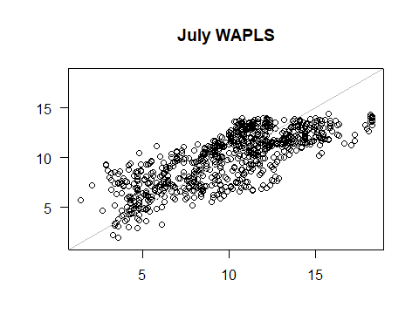

#January WAPLS  
tjan_wapls <- WAPLS(y=arctic.pollen,x=arctic.env$tjan)  
plot(tjan_wapls, main="January WAPLS")

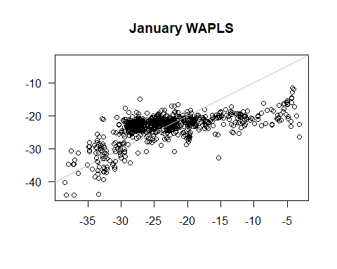

#July MAT  
tjul_mat <- rioja::MAT(y=arctic.pollen,x=arctic.env$tjul)

## Warning in rioja::MAT(y = arctic.pollen, x = arctic.env$tjul): Inter-sample distances < 1.0E-6 found (duplicate samples?  
## These have been replaced by 1.0E-6

plot(tjul_mat, main="July MAT")

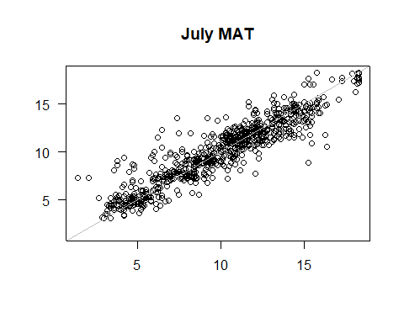

#Jan MAT  
tjan_mat <- rioja::MAT(y=arctic.pollen,x=arctic.env$tjan)

## Warning in rioja::MAT(y = arctic.pollen, x = arctic.env$tjan): Inter-sample distances < 1.0E-6 found (duplicate samples?  
## These have been replaced by 1.0E-6

plot(tjan_wapls, main="January MAT")

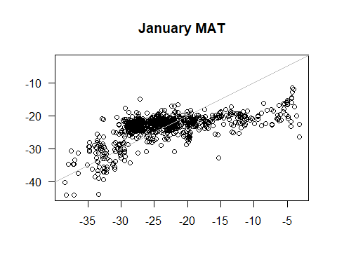

#July WA  
tjul_wa <- rioja::WA(y=arctic.pollen,x=arctic.env$tjul)  
plot(tjul_wa, main="July WA")

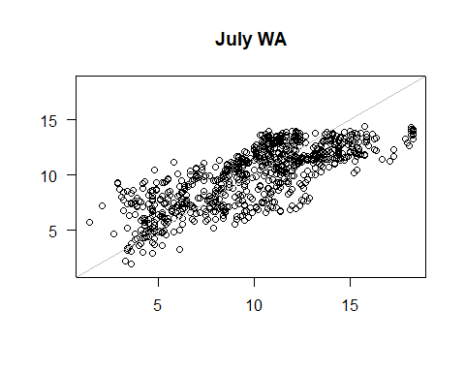

#January WA  
tjan_wa <- rioja::WA(y=arctic.pollen,x=arctic.env$tjan)  
plot(tjan_wa, main="January WA")

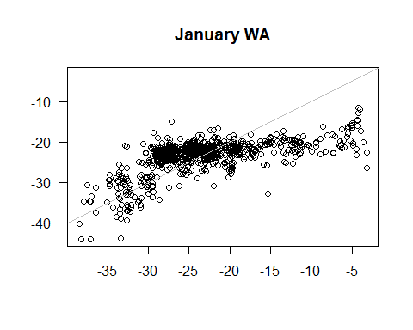 For July temperature, WAPLS and WA are fairly consistent with each other, with MAT being distinguished by a lower deviance from the line of regression. January temperature is consistent across the board.

Comparison of correlations:

#WA optima  
tjan_opt <- analogue::optima(x=arctic.pollen,env=arctic.env$tjan)  
tjul_opt <- analogue::optima(x=arctic.pollen,env=arctic.env$tjul)  
  
both_opt <- data.frame(tjan_opt,tjul_opt)  
colnames(both_opt) <- c("January Optima","July Optima")  
cor(both_opt)

## Warning in cor(both_opt): the standard deviation is zero

## January Optima July Optima <NA> <NA>  
## January Optima 1.0000000 NA 0.6768686 NA  
## July Optima NA 1 NA NA  
## <NA> 0.6768686 NA 1.0000000 NA  
## <NA> NA NA NA 1

#Jan and July temp  
both_temp <- data.frame(arctic.env$tjul,arctic.env$tjan)  
colnames(both_temp) <- c("July Temp","January Temp")  
cor(both_temp)

## July Temp January Temp  
## July Temp 1.0000000 0.2440338  
## January Temp 0.2440338 1.0000000

Correlation between January and July optima is .68, significantly stronger than correlation between January and July temperature, which is .24

Assess analogue quality