Michael Peyton

GEOG 920

09/12/2018

1. Devil’s Lake Site ID: 666

Latitude: 43.4178 Longitude: -89.73205

1. (a). Louisiana

(b.) New York

1. Wisconsin, Iowa, Colorado, New Mexico.
2. (a.) 1120 Sites, 1392 datasets (using map extent). 1338 Sites, 1491 datasets (using draw shape and including most of North America).

(b.) Roughly 3000 person years and $42 million

1. This is likely due to the extensive work done trying to understand the extent and timing of glacial advance and retreat during the Quaternary
2. 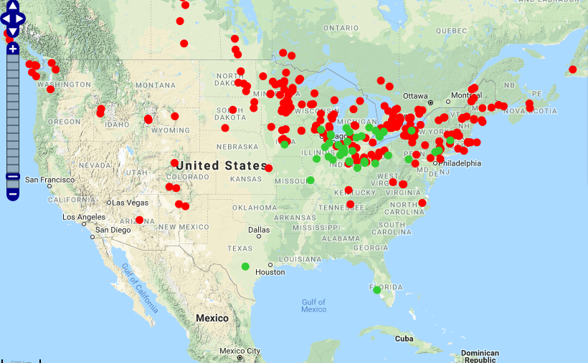

For the most part, mastodons appeared to live in regions where spruce was present, although there are a few notable exceptions further south (although these are found in regions where pollen records in general are also fairly scarce).

Two possible explanations for this association are that spruce facilitated mastodon population growth, or that mastodons facilitated spruce reproduction. The first explanation suggests that the type of community characterized by spruce during this time period (non-analog spruce woodland) may have provided ideal habitat for mastodons. Conversely, mastodons could have been a key dispersal agent for spruce.

1. 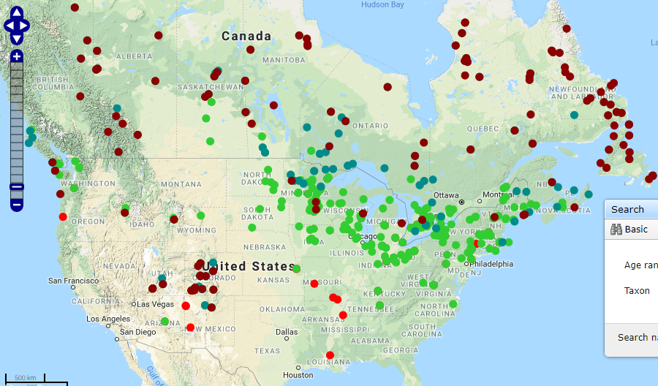

21,000 years ago *Picea* was found much farther south. Its distribution gradually shifted northward, presumably following the retreat of the glaciers until around roughly 7,000 years ago. A gradual warming which both lead to and was facilitated by the retreat of the glaciers likely lead to this shift in distributions The appearance of bare ground also allowed *Picea* to move into previously uninhabitable regions, likely lagging behind by several decades to centuries while soil conditions shifted to become more favorable for *Picea* establishment. Due to *Picea*’s fairly long-distance dispersal capabilities, it is likely that shifts in the distribution of *Picea* were limited more by climate and soils than by dispersal.

1. 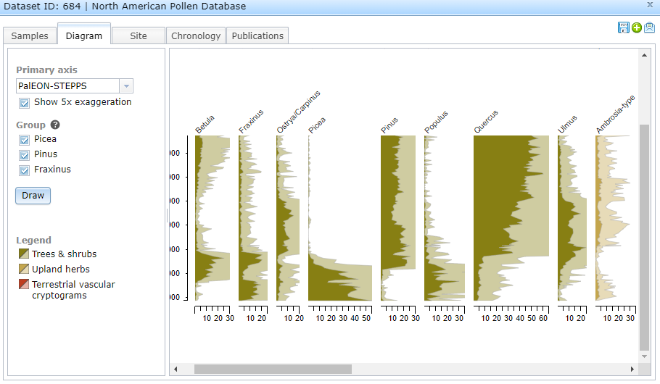

Could not find a way to display the entire diagram for the screenshot.

1. *Picea*
2. *Quercus*
3. 11 age controls, 10 of which are radiocarbon dates (although the last one is an average of two radiocarbon dates).
4. Maher, 1982 and Bender et al., 1980
5. Dataset only included depths at 0.5cm and 2cm. At both 0.5cm and 2cm *Quercus* was most abundant, at 172 and 275, respectively.
6. It appear that if we overlay the glacial extent over *Picea* occurrence in the pollen record >20% (as we did earlier), there seems to be more instances of *Picea* pollen being found in areas where glaciers occurred as we go farther back in the record. This seems to be an example of increased error along the time dimension as we get farther away from the present. For example:

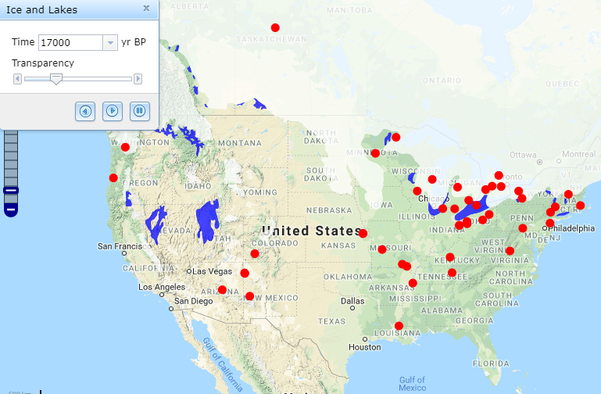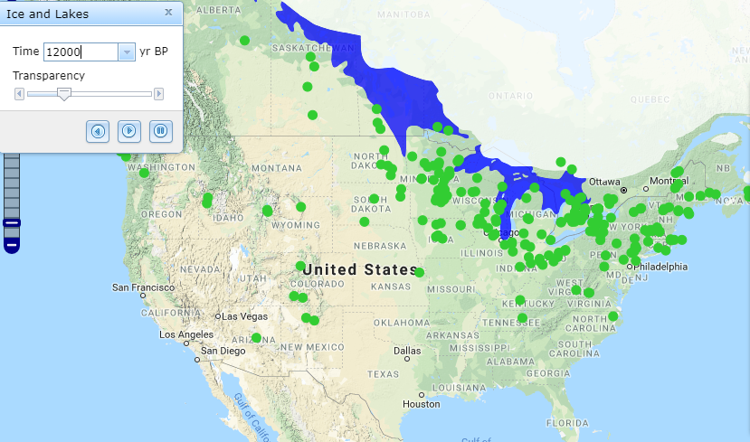

(~17000 years ago) (~1200 years ago)

Fungi appear to have been counted in samples in North America, South America, and Western Europe, but not in other regions. Similarly, pollen records from Europe and North America are well-represented within the database, but other areas do not have as much information. Is this due to a lack of sampling done in these other continents, or is this just a function of researchers from these regions not having as easy access to Neotoma?

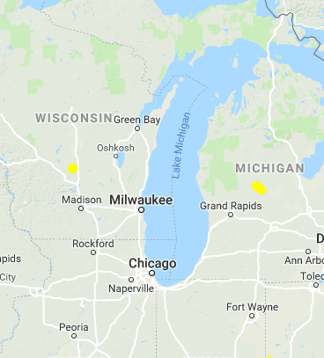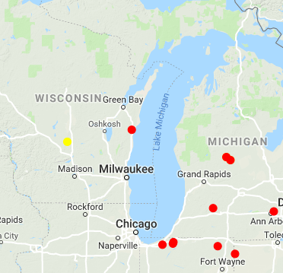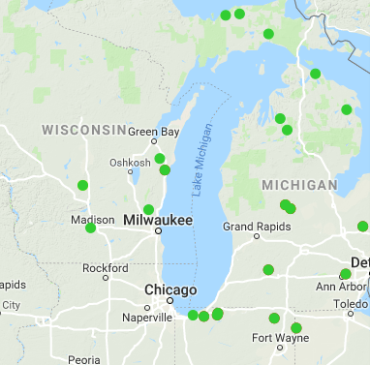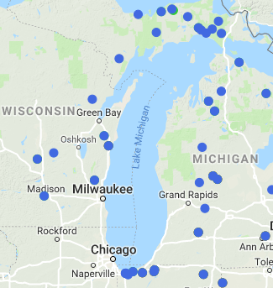

*Fagus*14000-10000 *Fagus*9000-7000 *Fagus*6500-4000 *Fagus*3500-2000

The movement of beech from East to West is particularly interesting in Wisconsin due to the presence of Lake Michigan as a barrier to entry. The plot from 14000 – 10000 indicates that rare instances of long-distance dispersal likely lead to isolated pockets of beech west of Lake Michigan (although this could also be from long-distance pollen dispersal). From 9000-7000 years ago there appears to be an infiltration around the south end of Lake Michigan into southern Wisconsin. By 6500-4000, beech appears to have already migrated north in Wisconsin, but hasn’t gotten above the current day location of the tension zone. We also see a second migration around the upper peninsula above northern Lake Michigan. By 3500-2000 we see that the second migration has allowed beech to occupy both northern and southern Wisconsin; from this information, it appears that beech was able to move into Wisconsin through two different pathways – first in the south where conditions were likely more favorable, and then again through the north.