Allie Jensen

GEOG 920

Lab 3

#1: The median calibrated age for radiocarbon age 13000 is 15552 cal BP using the IntCal13 curve. The 95% confidence interval is from 15232 to 15879 cal BP. The median calibrated age using the Marine13 curve is 14897 cal BP and the 95% confidence interval is from 14339 to 15249 cal BP.

#2: The CALIB and clam calibrated age ranges are very similar. Using the terrestrial NH calibration curve, clam estimates the 95% confidence interval from 15239 to 15873, with the min just 7 years older and the max just 6 years younger than the CALIB estimate. Using the Marine calibration curve, clam estimates the 95% confidence interval from 14358 to 15250, with the min about 20 years older and the max just one year older than the CALIB estimate. Finding the 95% confidence interval using the Marine curve with a specified marine reservoir connection in clam produces the most different result compared to the CALIB estimate -- the min and max are about 100 years greater/less than the CALIB numbers.

#3:

Interpolation

/Users/amj2ud/Desktop/GEOG920/clam_runs/DevilsLake2/DevilsLake2_interpolated.pdf

Linear Regression

/Users/amj2ud/Desktop/GEOG920/clam_runs/DevilsLake2/DevilsLake2_linear_regr.pdf

3rd Order Polynomial

/Users/amj2ud/Desktop/GEOG920/clam_runs/DevilsLake2/DevilsLake2_polyn_regr.pdf

Cubic Spline

/Users/amj2ud/Desktop/GEOG920/clam_runs/DevilsLake2/DevilsLake2_cubic_spline.pdf

|  |  |  |  |
| --- | --- | --- | --- |
| Picea decline 500cm | Point Estimate (cal BP) | 95% CI Max. | 95% CI Min. |
| Interpolation | 10244 | 10318 | 10126 |
| Linear Regression | 10406 | 10544 | 10242 |
| 3rd Order Polynomial | 10280 | 10357 | 10222 |
| Cubic Spline | 10140 | 10427 | 9780 |

|  |  |  |  |
| --- | --- | --- | --- |
| Ulmus decline 300cm | Point Estimate (cal BP) | 95% CI Max. | 95% CI Min. |
| Interpolation | 5330 | 5463 | 5199 |
| Linear Regression | 5758 | 5951 | 5530 |
| 3rd Order Polynomial | 5246 | 5361 | 5149 |
| Cubic Spline | 5256 | 5427 | 5096 |

#4:

Low smoothing parameter (0.1)

clam_runs/DevilsLake2/DevilsLake2_smooth_spline_0.1.pdf

Default smoothing parameter (0.3)

clam_runs/DevilsLake2/DevilsLake2_smooth_spline_0.3.pdf

High smoothing parameter (0.6)clam_runs/DevilsLake2/DevilsLake2_smooth_spline_0.6.pdf

|  |  |  |  |
| --- | --- | --- | --- |
| Picea decline 500cm | Point Estimate (cal BP) | 95% CI Max. | 95% CI Min. |
| Low Smoothing | 10199 | 10305 | 10077 |
| Default Smoothing | 10221 | 10288 | 10153 |
| High Smoothing | 10326 | 10388 | 10264 |

|  |  |  |  |
| --- | --- | --- | --- |
| Ulmus decline 300cm | Point Estimate (cal BP) | 95% CI Max. | 95% CI Min. |
| Low Smoothing | 5267 | 5429 | 5115 |
| Default Smoothing | 5319 | 5470 | 5161 |
| High Smoothing | 5378 | 5460 | 5301 |

#5:

Bacon default

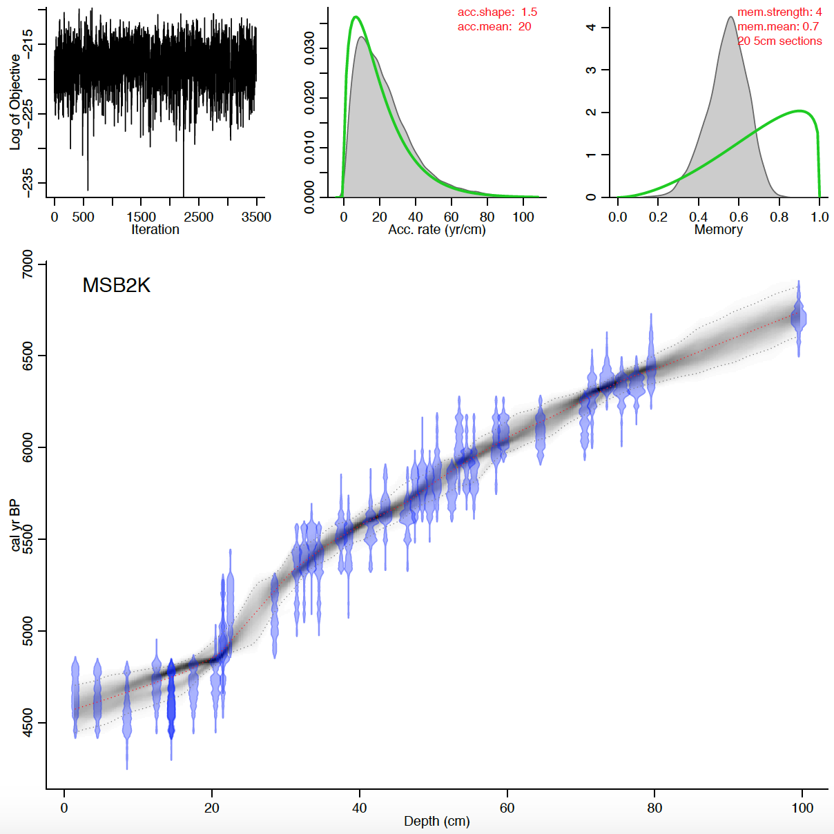

Bacon Devil’s Lake

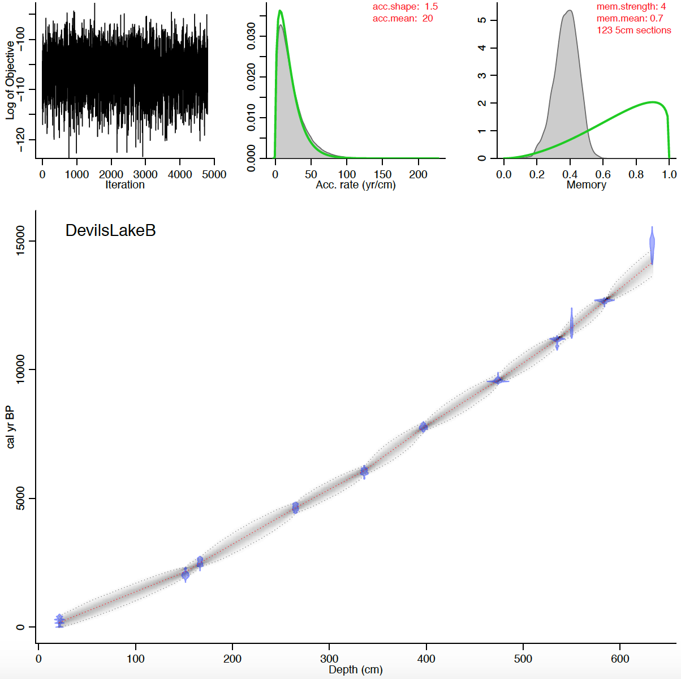

|  |  |  |  |
| --- | --- | --- | --- |
| Picea decline 500cm | Point Estimate (cal BP) | 95% CI Max. | 95% CI Min. |
| Interpolation | 10244 | 10318 | 10126 |
| Linear Regression | 10406 | 10544 | 10242 |
| 3rd Order Polynomial | 10280 | 10357 | 10222 |
| Cubic Spline | 10140 | 10427 | 9780 |
| Bacon | 10275.119 | 10652.272 | 9933.809 |

|  |  |  |  |
| --- | --- | --- | --- |
| Ulmus decline 300cm | Point Estimate (cal BP) | 95% CI Max. | 95% CI Min. |
| Interpolation | 5330 | 5463 | 5199 |
| Linear Regression | 5758 | 5951 | 5530 |
| 3rd Order Polynomial | 5246 | 5361 | 5149 |
| Cubic Spline | 5256 | 5427 | 5096 |
| Bacon | 5353.722 | 5691.277 | 4987.34 |

#6: The first experiment I did was run Bacon using a high thickness of 20 compared to the default value of 5. I wanted to see how this would affect Bacon's run time. There was a very significant difference -- usually Bacon takes 10 minutes to run on my computer, but in this experiment, it only took a few minutes. The output graphs do look different, as running Bacon with a thickness of 10 results in higher uncertainty between the dated ages.

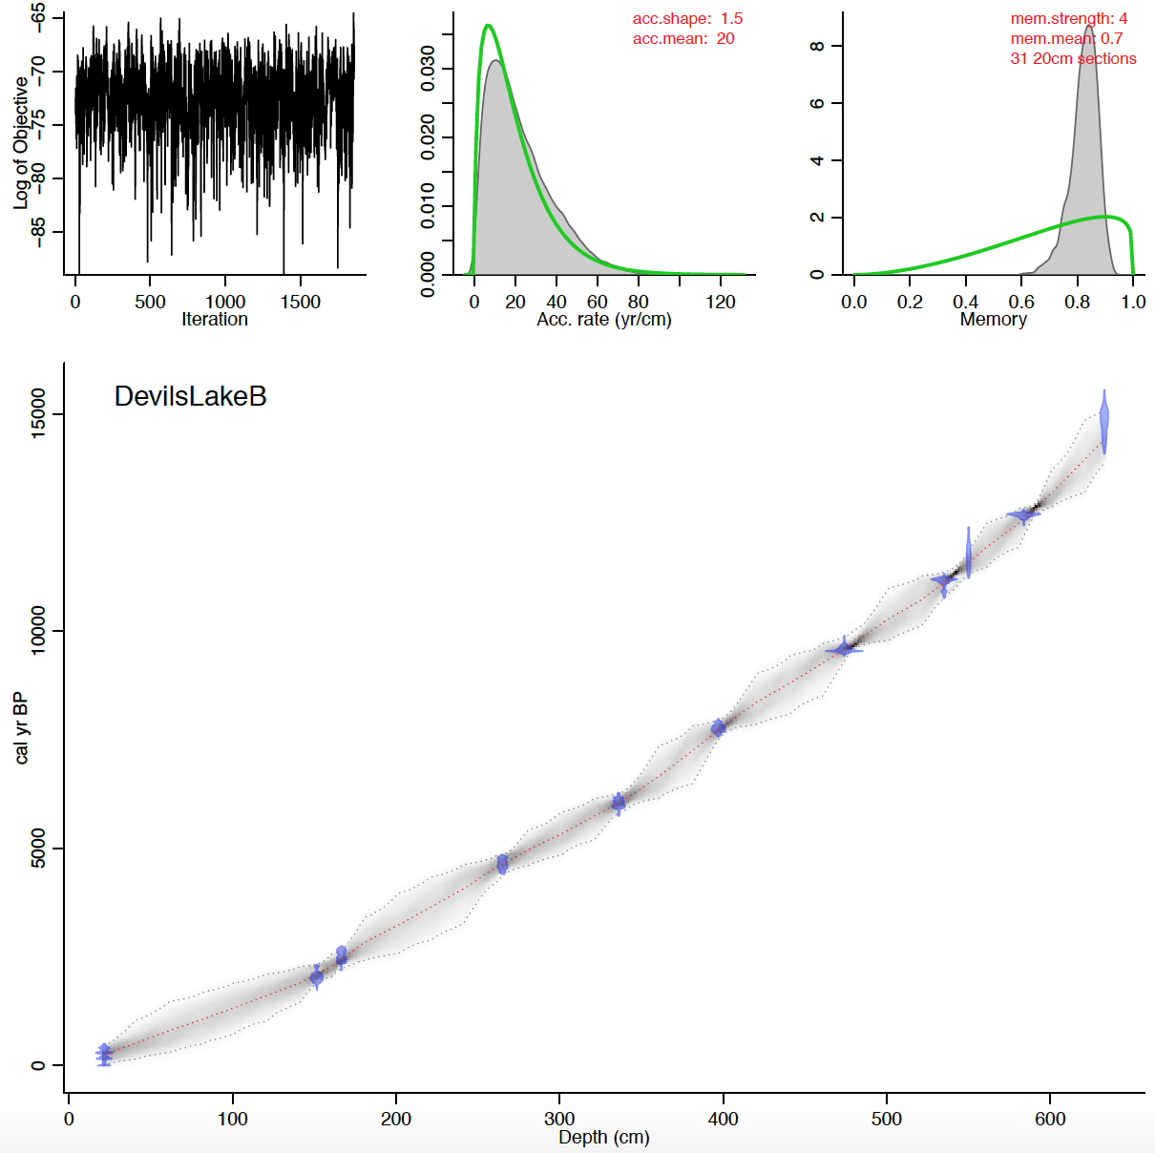

Next I ran Bacon with a thickness of 10 and added two hiatuses at 200 cm and 400 cm. I specified that the hiatus max should be 50 yrs. The output chronology appears to shift slightly upward at the two hiatus points, but besides that, the chronology looks similar. The output includes a graph of hiatus size, and although there is no clear peak, the frequency is highest between 0 and 10 yrs and starts decreasing from 10 to 50 yrs.

