**Part 1: Comparing calibrated radiocarbon ages**

When using CALIB 7.1 online to calibrate 13,000 14C age the calibrated age range is:

|  |  |  |
| --- | --- | --- |
| Calibration Curve | Median Age | 2 Error |
| Intcal13 | 15,552 | 15,232 - 15,879 |
| Marine13 | 15,897 | 14,339 - 15,249 |

Comparing this to clam we get:

|  |  |  |
| --- | --- | --- |
| Calibration Curve | Median Age | 2 Error |
| Intcal13 |  | 15,239 - 15,873 |
| Marine13 |  | 14,358 - 15,250 |
| Marine13 with correction |  | 14,267 – 15,175 |

The calibrations appear close but not identical.

**Part 2: Classic Age Models**

Summary of age of events for different models:

|  |  |  |
| --- | --- | --- |
| Model | Age for Event 1 – 4060 cm | Age for Event 2 – 4000 cm |
| Interpolated | 44,813 ka  95% CI: 44,127 – 45,651 | 49,113 ka  95% CI: 48,169 – 49,732 |
| Regression | 43,805 ka  95% CI: 42,139 – 46,224 | 42,269 ka  95% CI: 40,676 – 44,590 |
| 3rd order polynomial | 40,909 ka  95% CI: 39,188 – 43,315 | 41,437 ka  95% CI: 39,924 – 43,363 |
| Cubic Spline | 47,814 ka  95% CI: 46,667 – 49,053 | 49,631 ka  95% CI: 48,641 – 50,274 |
| Spline (smoothness = 2) | 48,421 ka  95% CI: 41,832 – 58,062 | 46,677 ka  95% CI: 40,383 – 55,902 |
| Spline (smoothness = 3) | 19,884 ka  95% CI 9,133 – 29,579 | 18, 351 ka  95% CI 8,094 – 26,925 |
| Spline (smoothness = 4) | 20,128 ka  95% CI: 9,755 – 29,642 | 18,649 ka  95% CI: 7,929 – 27,767 |
| Bacon (thickness = 10) | 45,587 ka  95% CI: 44,309 – 49,063 | 44,918 ka  95% CI: 43,695 – 47,851 |

Interpolated

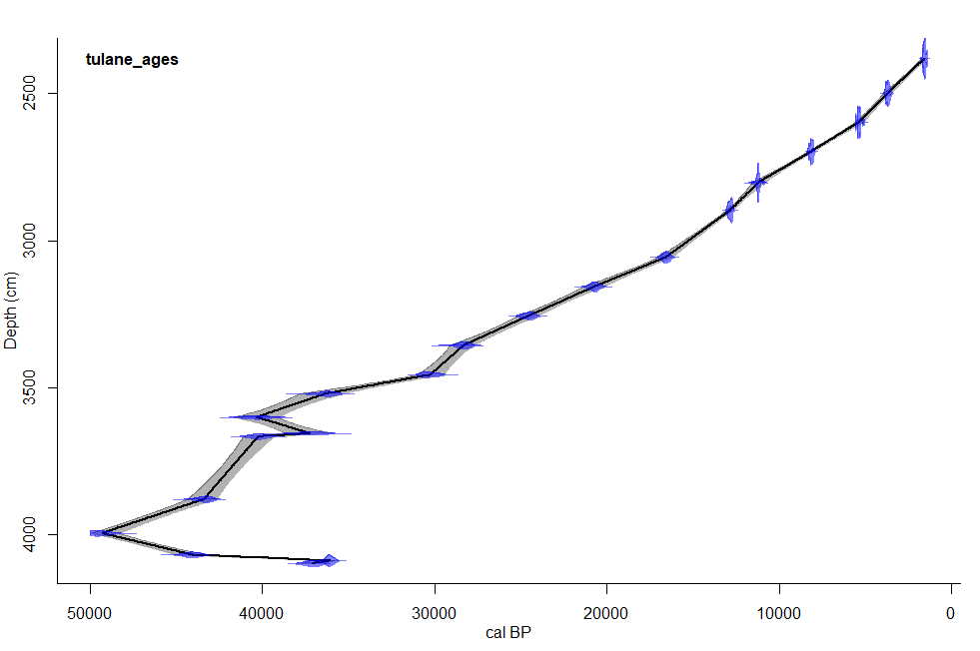

Regression

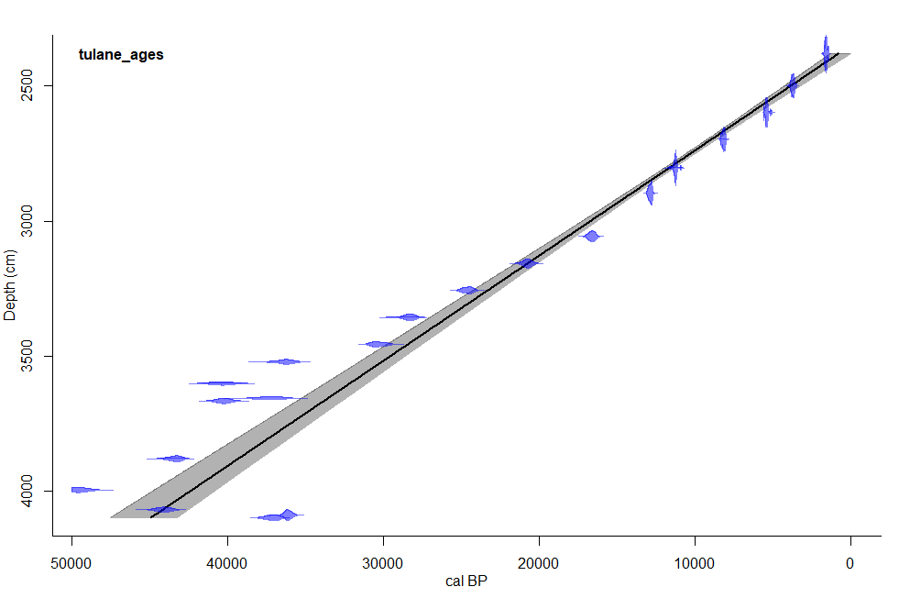

3rd order polynomial

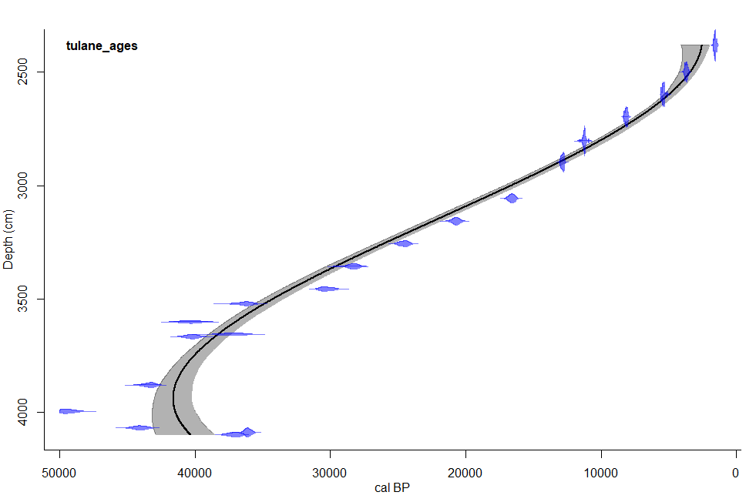

Cubic spline

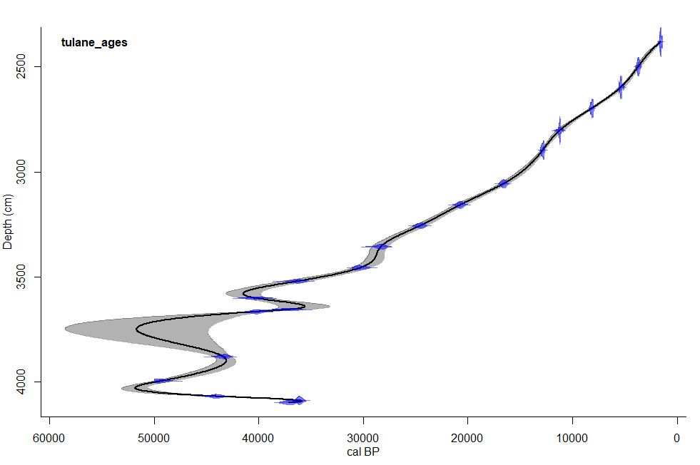

Spline with smoothness of 2

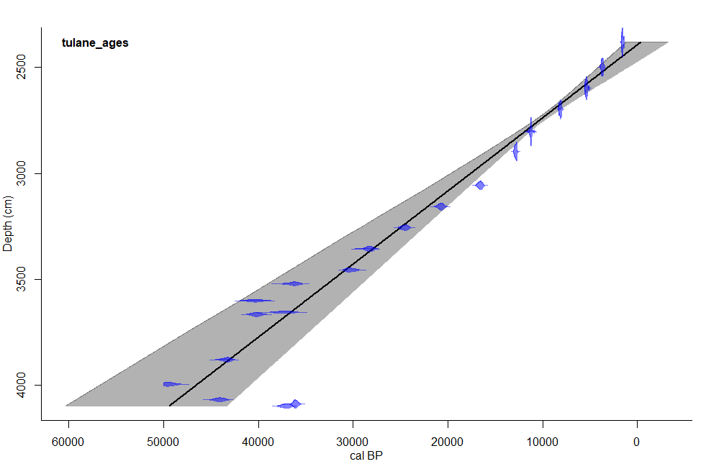

Spline with smoothness of 3

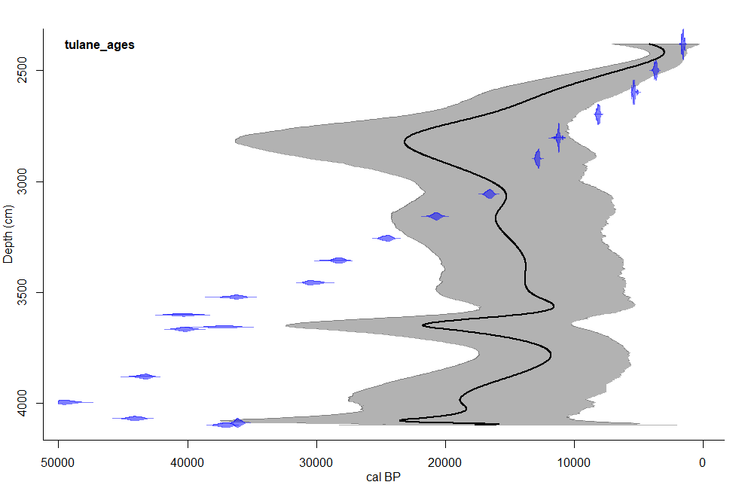

Spline with smoothness of 4

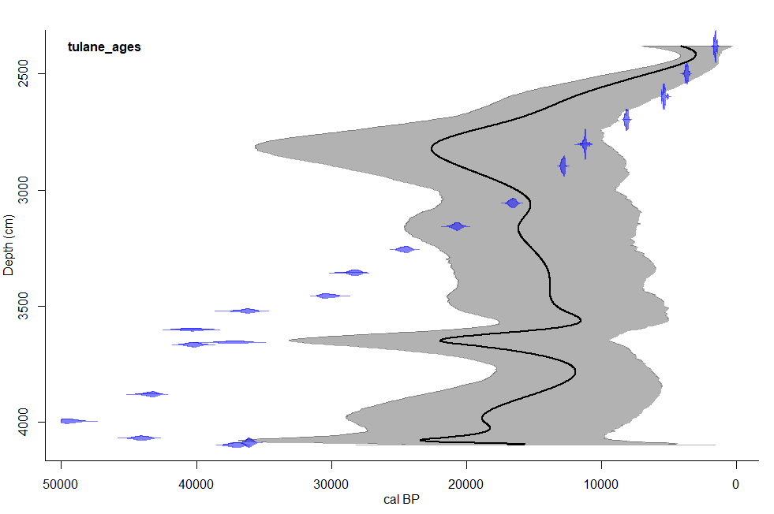

**Part 3: Bayesian Age Models**

Below are three Bacon runs for Lake Tulane at varying thicknesses. The most apparent effect of changing the thickness was the large decrease in model runtime, especially for a record as long as lake Tulane. At a section thickness of 10 cm the model took ~5 minutes to run and this was halved when the thickness was changed to 20 cm, and again halved when thickness was increased to 30 cm. Visually the effect on the age depth relationship seems large because a thickness of 10 cm resulted in different radiocarbon dates being selected as outliers. Furthermore, the bounds of the ghost plot was more jagged with a thickness of 20 cm. The effect of making the bounds of the ghost plot more jagged became increasingly apparent with a thickness of 30 cm however the plots seemed similar.

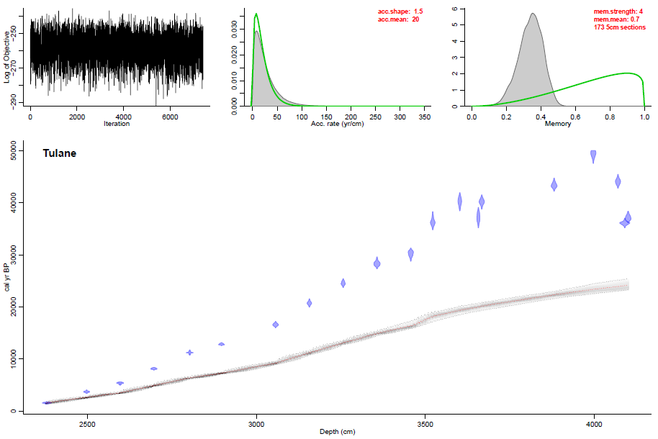

10 cm thickness

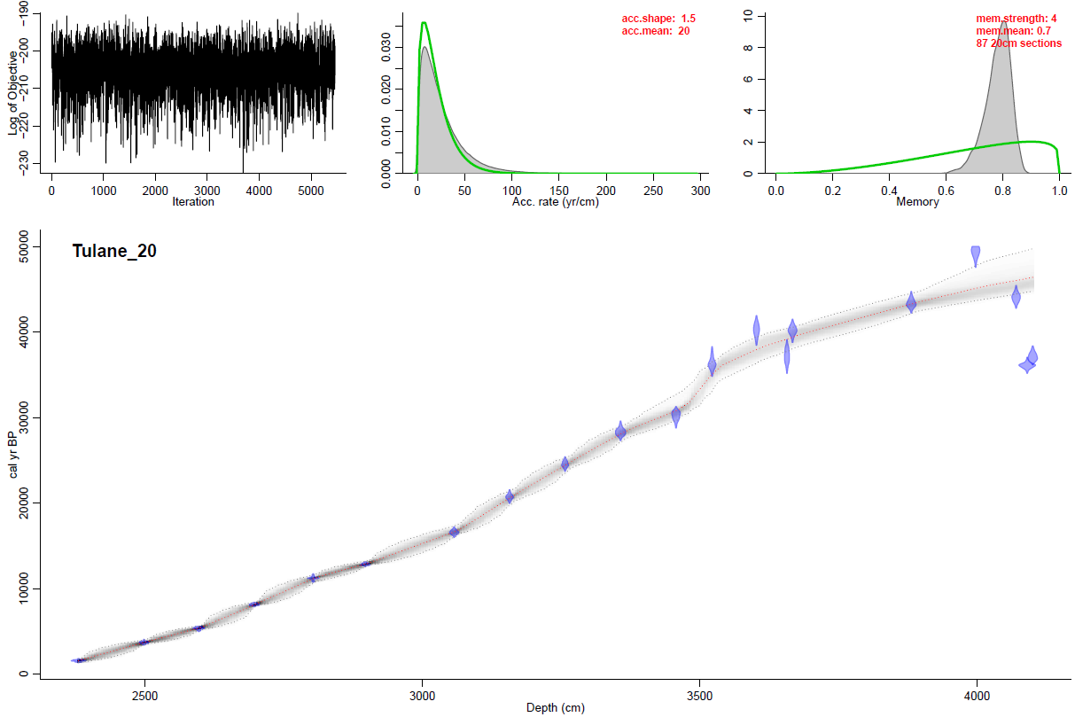

20 cm thickness

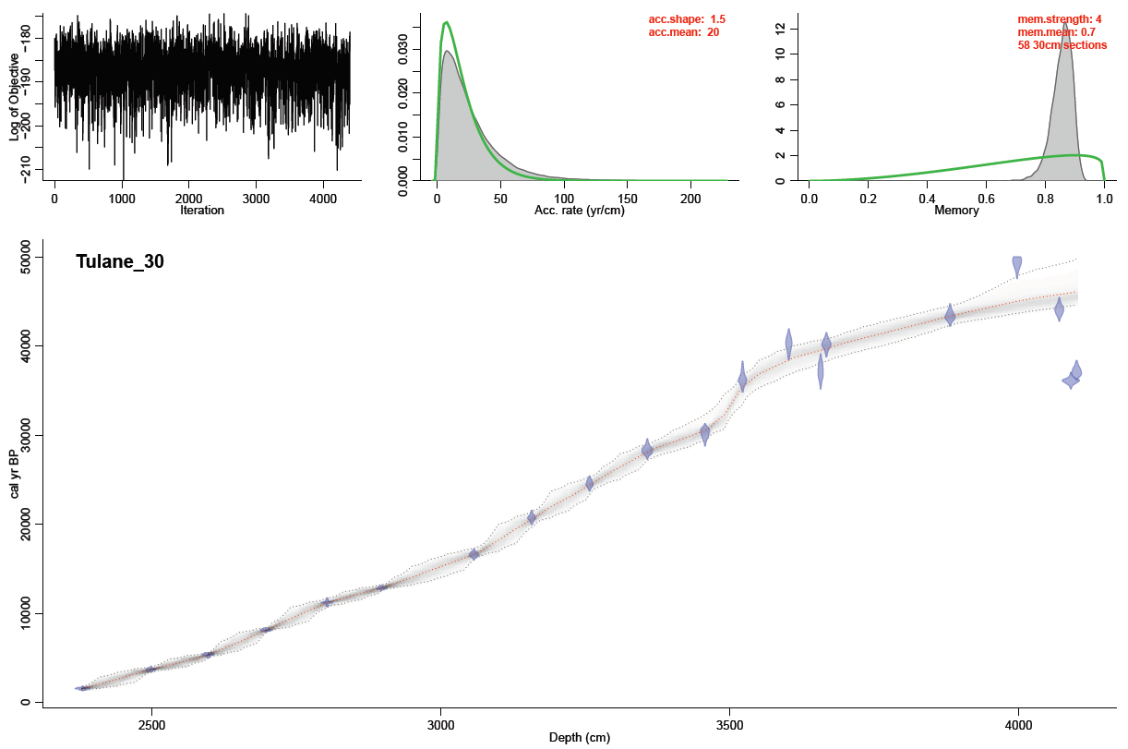

30 cm thickness