**Lab 3 – Christian Keeve**

**Calib**

median estimate: 14897

2 sigma: 95.4

**Clam**

install.packages('clam')

library(clam)

calibrate(13000,100)

calibrate(13000,100,cc=2)

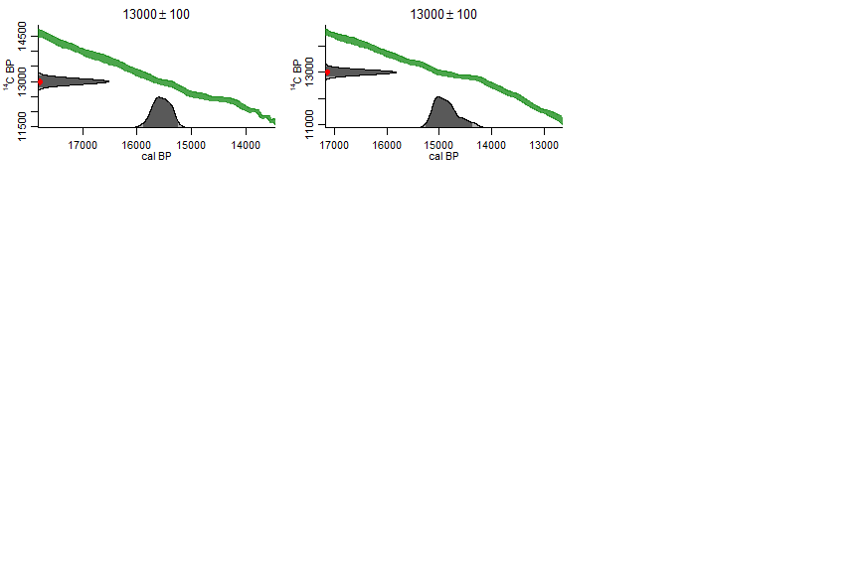

##Basic clam run for Devil’s Lake geochronology

clam(core="DevilsLakeAMS",storedat=TRUE)

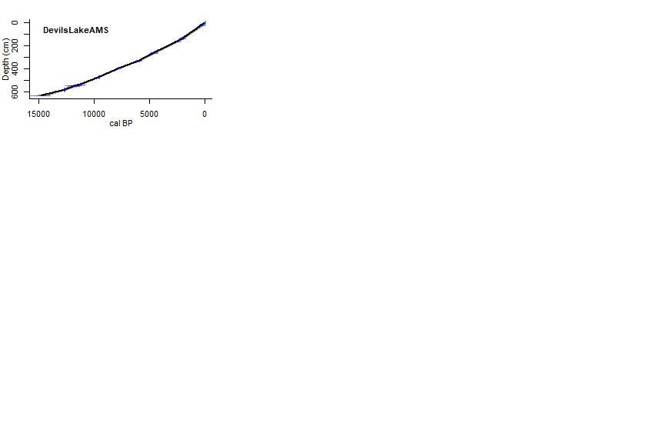

##Linear interpolation

linear_interp <- clam(core="DevilsLakeAMS",type=1,storedat = TRUE)

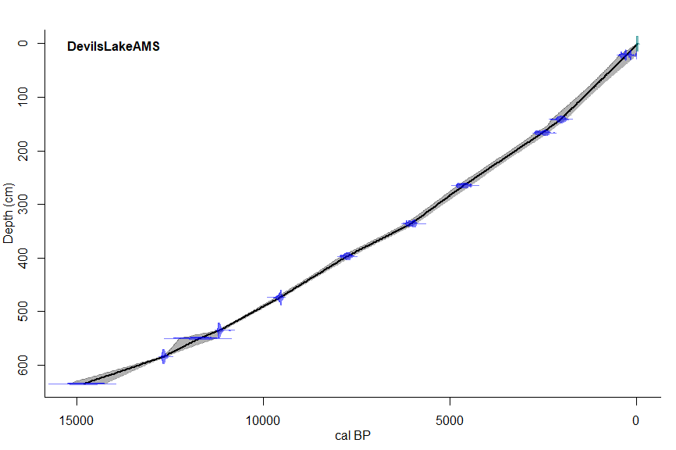

##Linear regression

linear_reg <- clam(core="DevilsLakeAMS",type=2,storedat=TRUE)

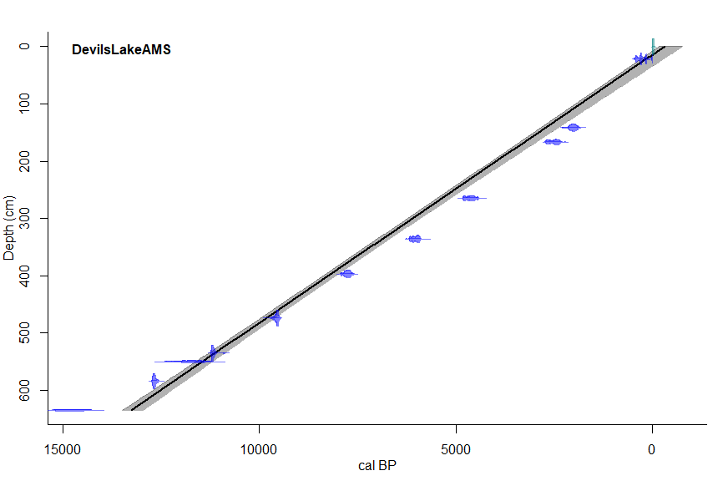

##Third order polynomial

third_order <- clam(core="DevilsLakeAMS",type=2, smooth=3,storedat=TRUE)

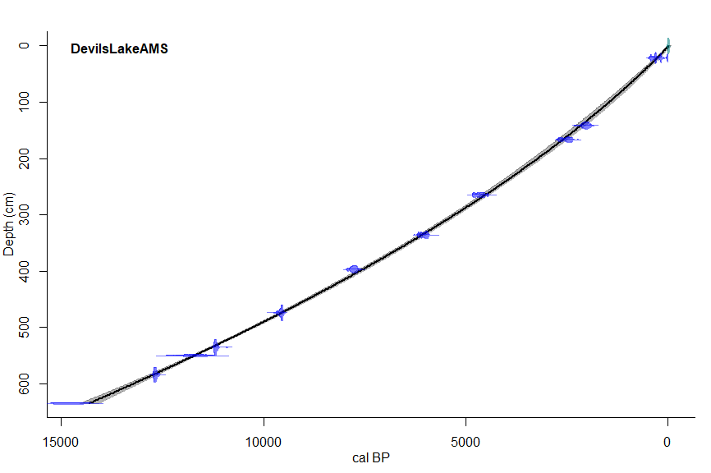

##Cubic spline

cubic_spline <- clam(core="DevilsLakeAMS",type=3,storedat=TRUE)

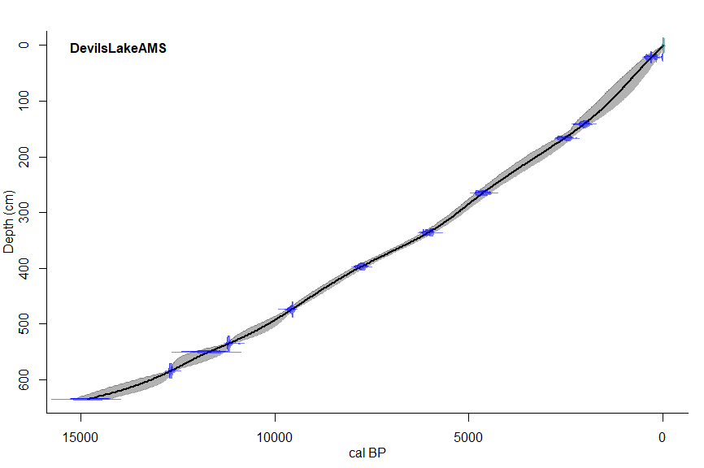

|  |  |  |  |  |
| --- | --- | --- | --- | --- |
| ***Picea Decline*** | ***Date(BP)*** | ***Depth(cm)*** | ***Min 95% Range*** | ***Max 95% Range*** |
| *Linear interpolation* | 11739 | 550 | 11285.88 | 12347.00 |
| *Linear regression* | 11451 | 550 | 11216.54 | 11627.00 |
| *3rd order polynomial* | 11705 | 550 | 11652.02 | 11783.23 |
| *Cubic Spline* | 11702 | 550 | 11302.55 | 12085.45 |
|  |  |  |  |  |
| ***Quercus Eruption – 450cm*** | ***Date(BP)*** | ***Depth(cm)*** | ***Min 95% Range*** | ***Max 95% Range*** |
| *Linear interpolation* | 9004 | 450 | 8935.92 | 9089.17 |
| *Linear regression* | 9314 | 450 | 9121.35 | 9455.72 |
| *3rd order polynomial* | 8906 | 450 | 8820.26 | 8989.50 |
| *Cubic Spline* | 9042 | 450 | 8903.52 | 9207.10 |

**Bacon**

library(rbacon)

##Example run

Bacon()

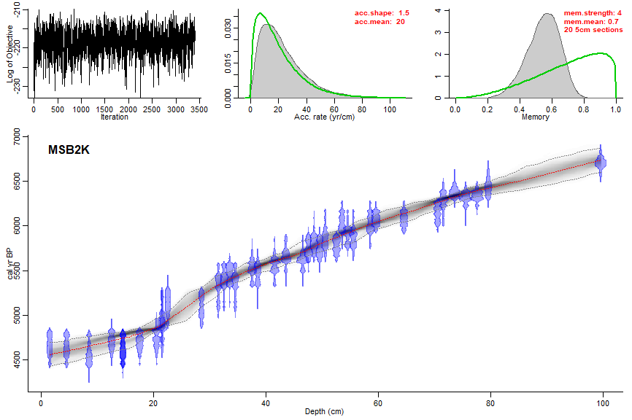

##Bacon run for Devil’s Lake geochronology

Bacon(core="DevilsLakeAMS")

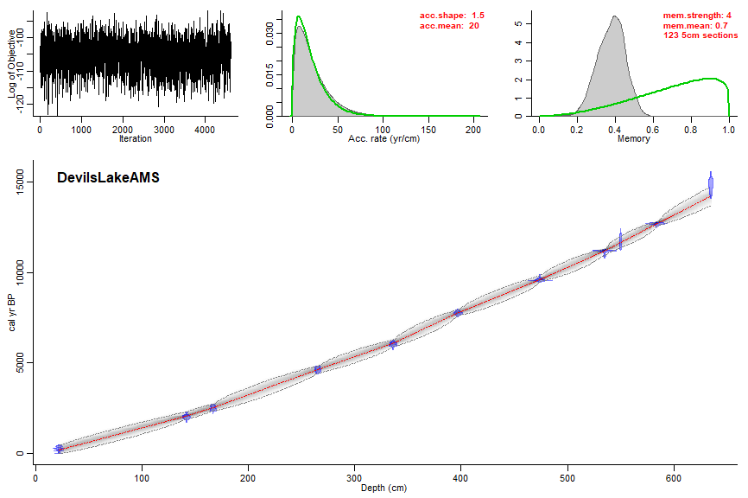

##Bacon run with thickness of 5

Bacon(core="DevilsLakeAMS",thick=5)

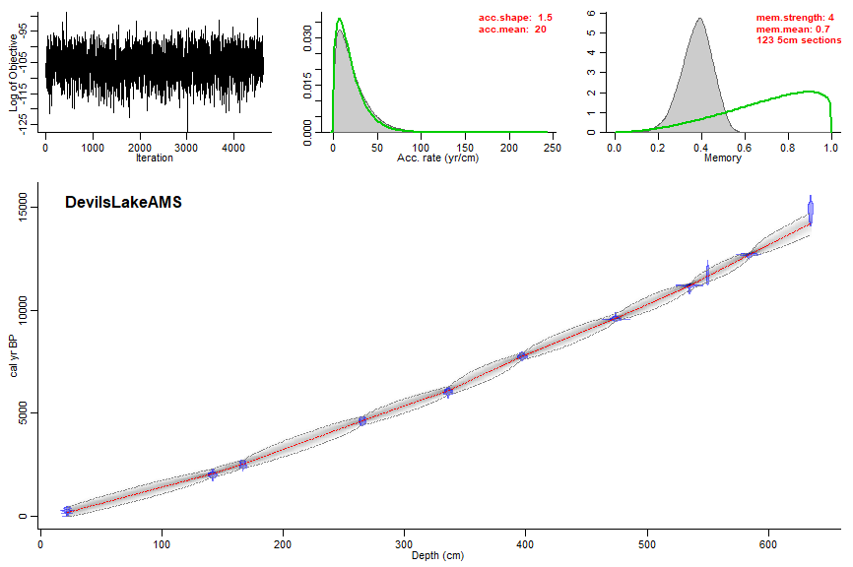

##Bacon run with thickness of 20

Bacon(core="DevilsLakeAMS",thick=20)

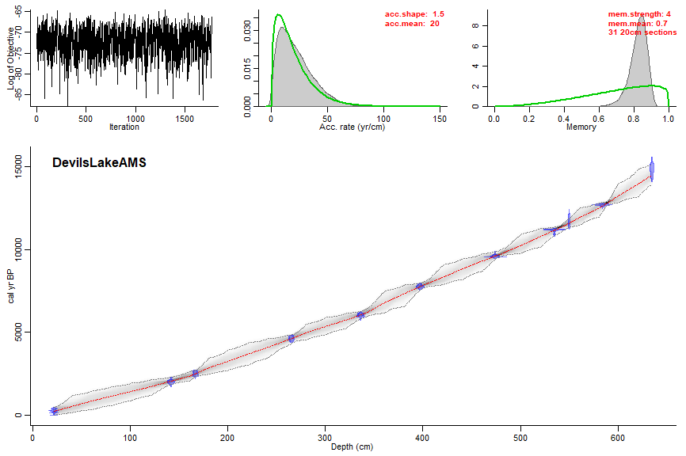

##Bacon run with thickness of 100

Bacon(core="DevilsLakeAMS",thick=100)

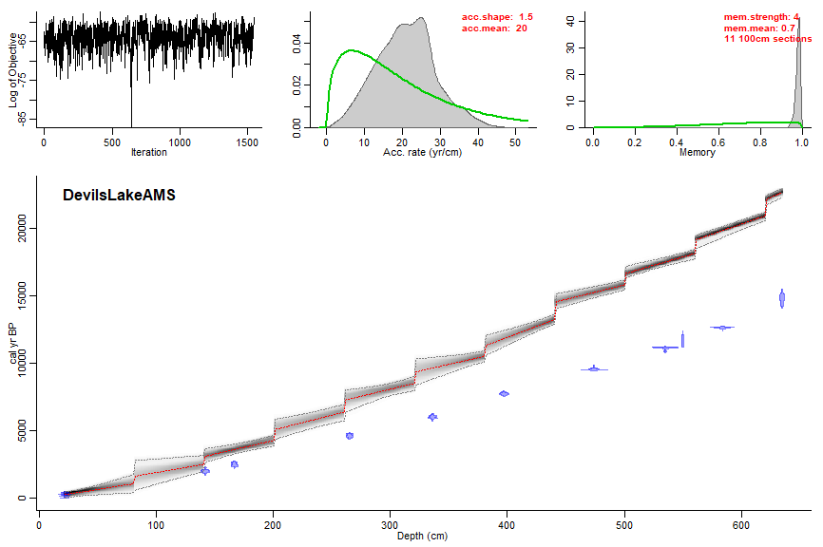

##Bacon run with thickness of 5 and a hiatus at 450cm

Bacon(core="DevilsLakeAMS",thick=5,hiatus.depths=450)

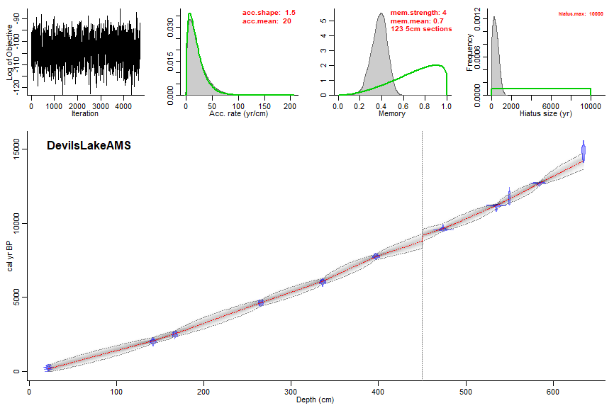

##Bacon run with hiatus at 450cm with max length of 100cm

Bacon(core="DevilsLakeAMS",hiatus.depths=450,hiatus.max=100)

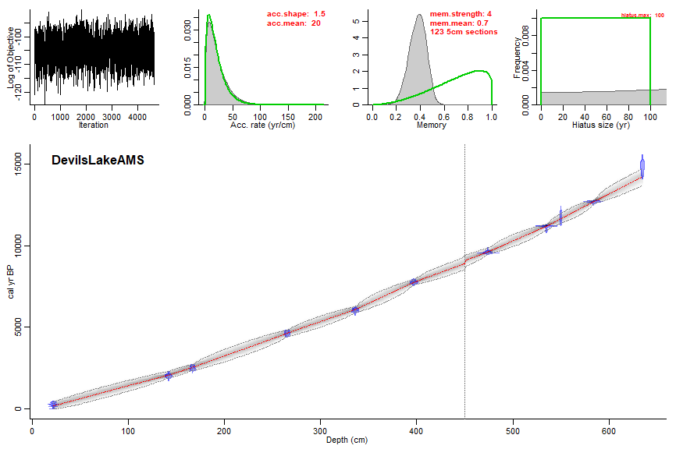

##Bacon run with hiatus at 200cm with max length of 300cm

Bacon(core="DevilsLakeAMS",hiatus.depths=200,hiatus.max=300)

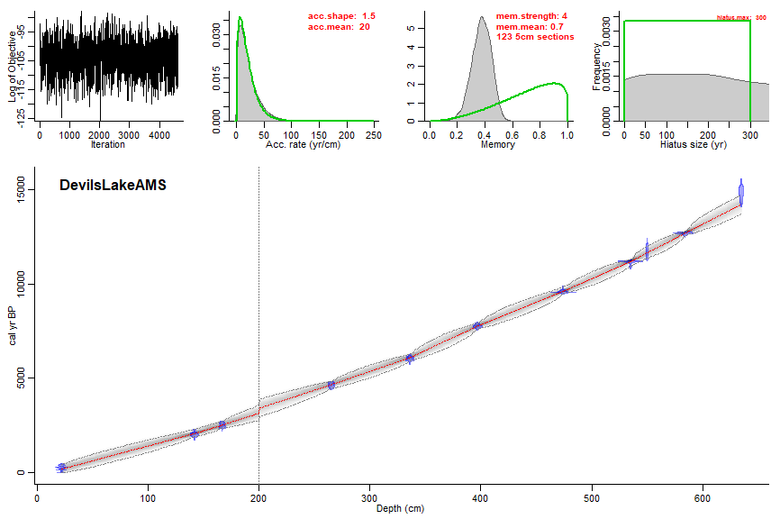

Increases in thickness positively correlate to increases in uncertainty, and when taken far enough (i.e. thick=100), produce an unreliable and choppy line of best fit. Varying hiatus depths did not have as significant an impact. This may point positively to the consistency of the geochronology itself.