Lab 5

Exercise 1

#Find sites containing the string 'Wisc' in the site name

#url: [http://api.neotomadb.org/v1/data/sites?sitename=*wisc*](http://api.neotomadb.org/v1/data/sites?sitename=*wisc*)

#Find sites between 5000 and 10000 meters in elevation

#url: <http://api.neotomadb.org/v1/data/sites?altmin=5000&altmax=10000>

#Find codes for geopolitical units

#url: <http://api.neotomadb.org/apdx/geopol.htm>

#Find all sites in Everglades National Park

#url: <http://api.neotomadb.org/v1/data/sites?gpid=9783>

Exercise 2

#Find all datasets in Everglades National Park

#url: <http://api.neotomadb.org/v1/data/datasets?gpid=9783>

#Access dataset for Northeast Shark River Slough

#url: <http://api.neotomadb.org/v1/data/downloads/10967>

Exercise 3

#Return 50 records from the Geochronology table

#url: <http://api.neotomadb.org/v1/dbtables/Geochronology?limit=50&offset=0>

Exercise 4

#Install neotoma package

install.package('neotoma')

#Access neotoma library

library(neotoma)

#Test: Samwell Cave

samwell_site <- get_site(sitename='Samwell%')

print(samwell_site)

#Find all sites with the name 'clear' in the site name

get_site(sitename='*clear*')

#48 sites returned

Exercise 5

#Find all sites in Minnesota

MN_sites <- get_site(gpid=7467)

#518 sites returned

#Find all sites in Wisconsin

WI_sites <- get_site(gpid=9227)

#459 records returned

#Minnesota has more sites

Exercise 6

#Search for Devil's Lake site in Wisconsin, narrowing down to 1 site

devil_search <- get_site(sitename = '*devil*',gpid=9227)

view(devil_search)

#Find all datasets for Devil's Lake

devil_dataset <- get_dataset(devil_search)

view(devil_dataset)

#5 datasets for Devil's Lake

Exercise 7

#Access analogue package

library(analogue)

#Access rioja package

library(rioja)

#Find all sites in Everglades Natl Park

everglades_sites <- get_site(gpid=9783)

#Access and download data for Northeast Shark River Slough

NE_shark_river <- get_dataset(6505)

view(NE_shark_river)

NE_shark_river_pollen <- get_download(10967)

#Convert to percentages

NE_shark_river_pct <- analogue::tran(x=NE_shark_river_pollen[["10967"]][["counts"]],method='percent')

#Drop rare taxa

NE_shark_river_pct_common <- NE_shark_river_pct[, colMeans(NE_shark_river_pct, na.rm = TRUE) > 2]

#Plot in rioja

rioja::strat.plot(NE_shark_river_pct_common)

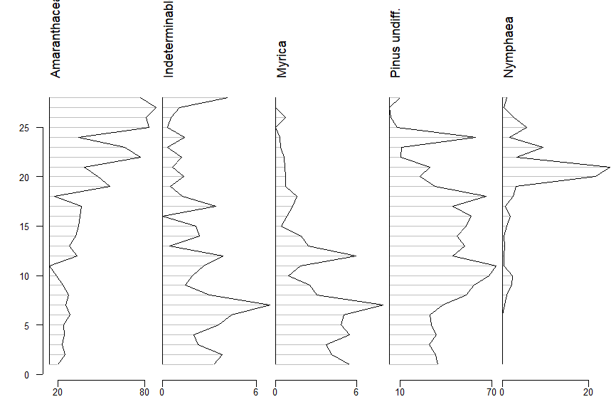

Exercise 8

install.packages('rworldmap')

library(rworldmap)

map <- getMap()

# Search for datasets with Picea in them

picea_sets <- get_dataset(taxonname = "Picea*",

datasettype = "pollen",loc = c(-98.6, 36.5, -66.1, 49.75),

ageyoung=4500,ageold=6000)

# Download the datasets

picea_dl <- get_download(picea_sets)

plot(picea_dl)

plot(map,add=TRUE)

picea_compiled <- compile_downloads(picea_dl)

#Extract taxa

all_taxa <- do.call(rbind.data.frame, lapply(picea_dl, function(x)x$taxon.list[,1:6]))

#Remove duplicates

all_taxa <- all_taxa[!duplicated(all_taxa),]

#Limit taxa to trees/shrubs and change punctuation

good_cols <- c(1:10, which(colnames(picea_compiled) %in%

gsub("[ ]|[[:punct:]]", ".",

all_taxa[all_taxa$ecological.group %in%

c("TRSH", "UPHE"),1])))

#Transform counts to proportions

picea_compiled <- picea_compiled[ ,good_cols]

picea_pct <- picea_compiled[,11:ncol(picea_compiled)] / rowSums(picea_compiled[,11:ncol(picea_compiled)], na.rm = TRUE)

picea_only <- rowSums(picea_pct[,grep("Picea", colnames(picea_pct))], na.rm = TRUE)

#Pull ages and plot

age_cols <- grep("^age", colnames(picea_compiled))

picea_all <- data.frame(ages = rowMeans(picea_compiled[,age_cols], na.rm = TRUE),

prop = picea_only)

plot(picea_all, col = rgb(0.1, 0.1, 0.1, 0.3), pch = 19, cex = 0.4,

xlim = c(0, 20000), ylab = "Proportion of Picea", xlab = "Years Before Present")

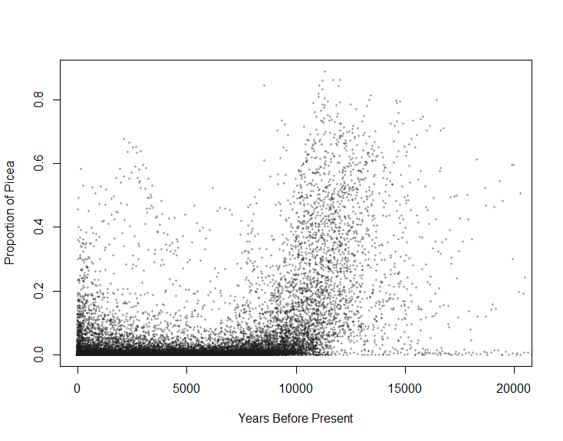

Exercise 9

one_slice <- get_dataset(taxonname='Picea*', loc=c(-150, 20, -100, 60), ageyoung = 0, ageold = 500)

#Increment every 500 years for 21000 years

increment <- seq(from = 0, to = 21000, by = 500)

#Increment through time slices

for(i in 1:42){ one_slice <- get_dataset(taxonname = 'Picea*', datasettype = 'pollen',

loc = c(-150, 20, -100, 60),

ageyoung = increment[i], ageold = increment[i + 1]) }

site_nos <- rep(NA, 42)

for(i in 1:42) { one_slice <- get_dataset(taxonname = 'Picea*',

datasettype = 'pollen',

loc = c(-150, 20, -100, 60),

ageyoung = increment[i],

ageold = increment[i + 1])

site_nos[i] <- length(one_slice) }

plot(increment[-1], site_nos)

fSte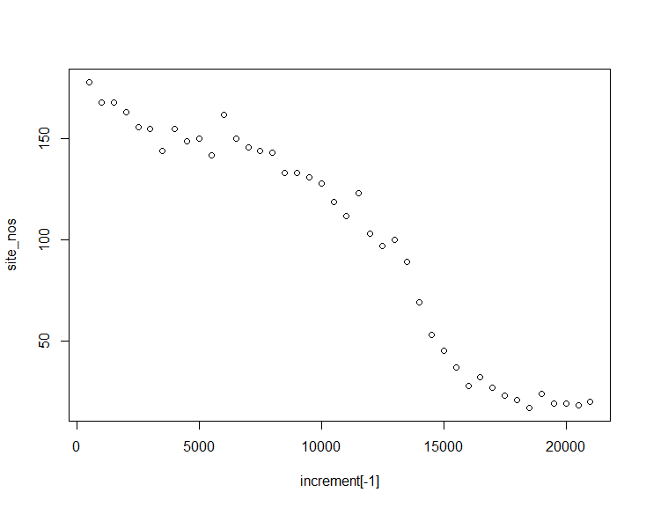

Steady rise in Picea abundance which especially speeds up towards the end of the last ice age.