Run pca on this data set using *rda* and *princomp*. Explore differences between pca using the covariance matrix/centered variables and correlation matrix/standardized variables.

**RDA:**

Inertia Rank

Total 119778

Unconstrained 119778 6

Inertia is variance

Eigenvalues for unconstrained axes:

PC1 PC2 PC3 PC4 PC5 PC6

119469 232 42 17 16 2

**PCA:**

princomp(x = arctic_new2)

Standard deviations:

Comp.1 Comp.2 Comp.3 Comp.4 Comp.5 Comp.6

345.433734 15.211532 6.496717 4.142304 3.987426 1.463184

**Make ordination biplots using *biplot* for*princomp* (make sure to set pc.biplot=TRUE) and *plot* for *rda* using plot for rda.**

**For RDA -**

Code:

my.rda.object<-rda(arctic_new2[,-7]); #eliminating the 7th column because it contains biome names that I’ll use later but don’t want to use now

#Making RDA plot and labeling it:

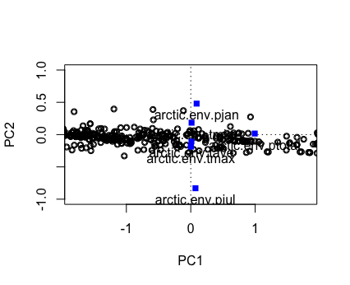plot(my.rda.object,scaling=1,display=c("sites"),xlim=c(-1,1),ylim=c(-1,1)) #“display = ‘sites’” corresonds to the rows of data; one datapoint per row

points(my.rda.object,display=c("sites"),scaling=1)

points(my.rda.object,display=c("species"),scaling=0,pch = 15,col=4)

text(my.rda.object,display=c("species"),scaling=0,pos=1)

For princomp (with pc.biplot=TRUE):

#Run PCA on this data using princomp:

my.pca<-princomp(arctic_new2[,-7],cor=F)

biplot(my.pca,pc.biplot=TRUE)

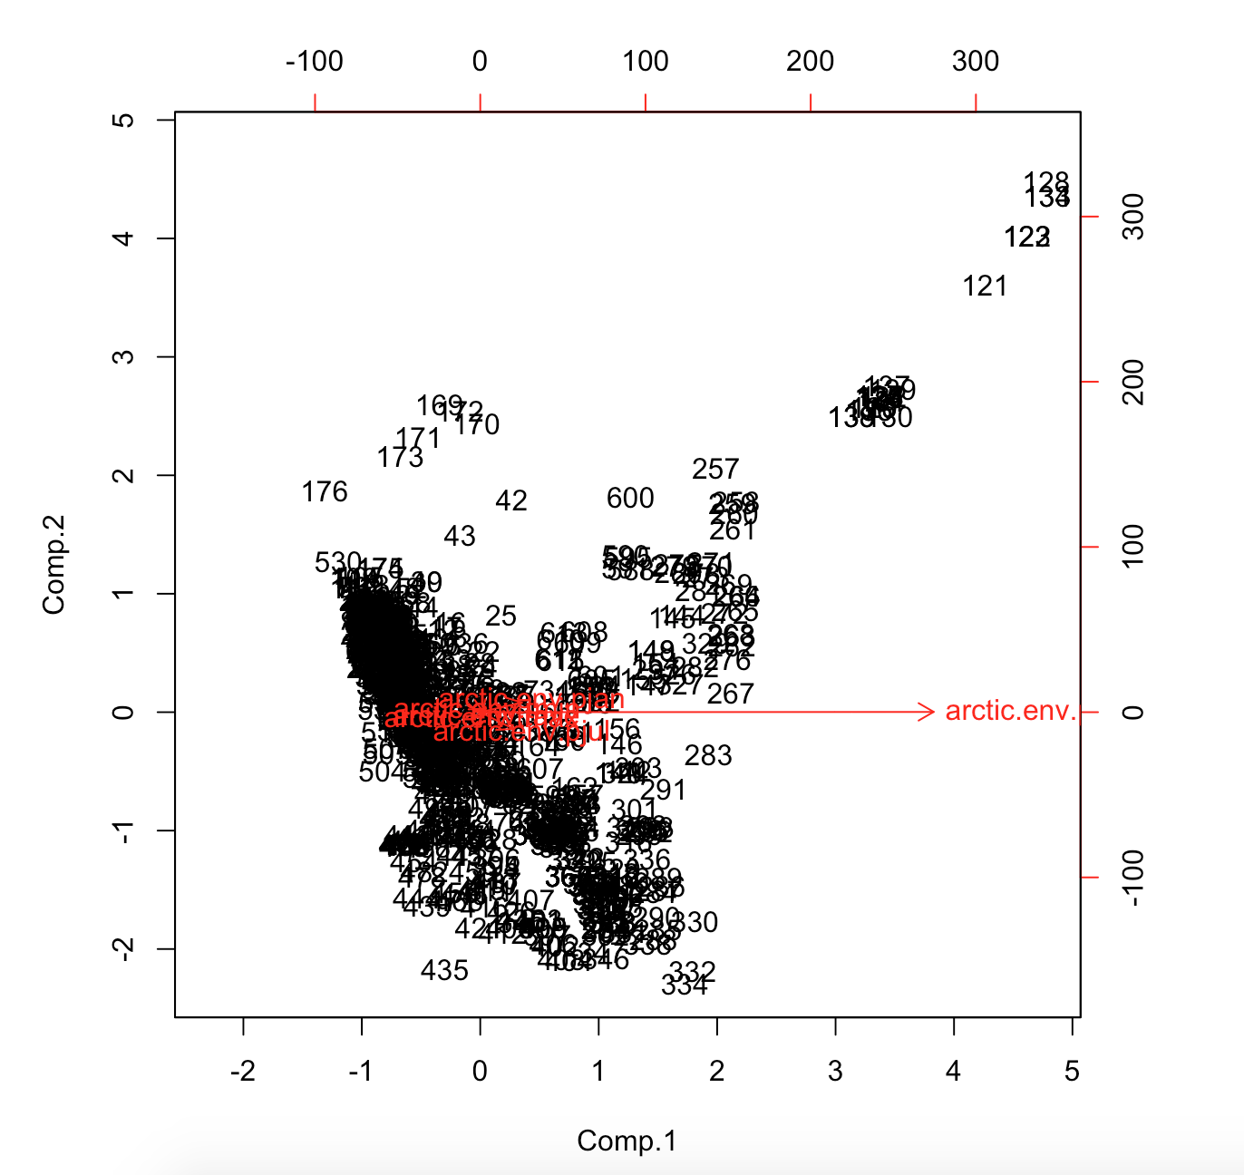

#Making the screeplot:

screeplot(my.pca,bstick=TRUE);

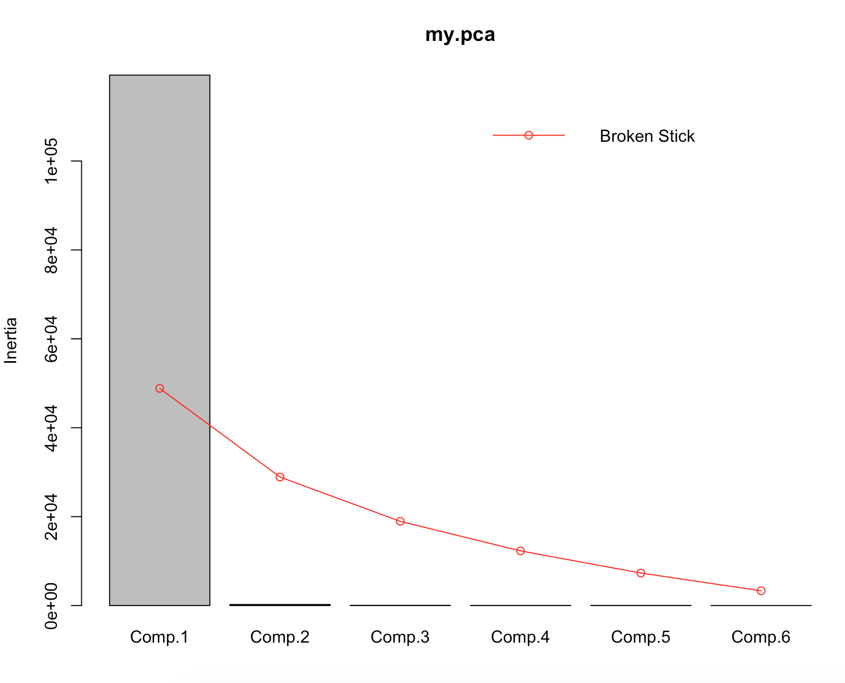

#I do not know why the y-axis says “inertia” ?? Trying to fix for that..

pc.cr<-princomp(arctic_new2[-7])

summary(pc.cr<-rincomp(arctic_new2[-7],cor=TRUE))

loadings(pc.cr)

plot(pc.cr)

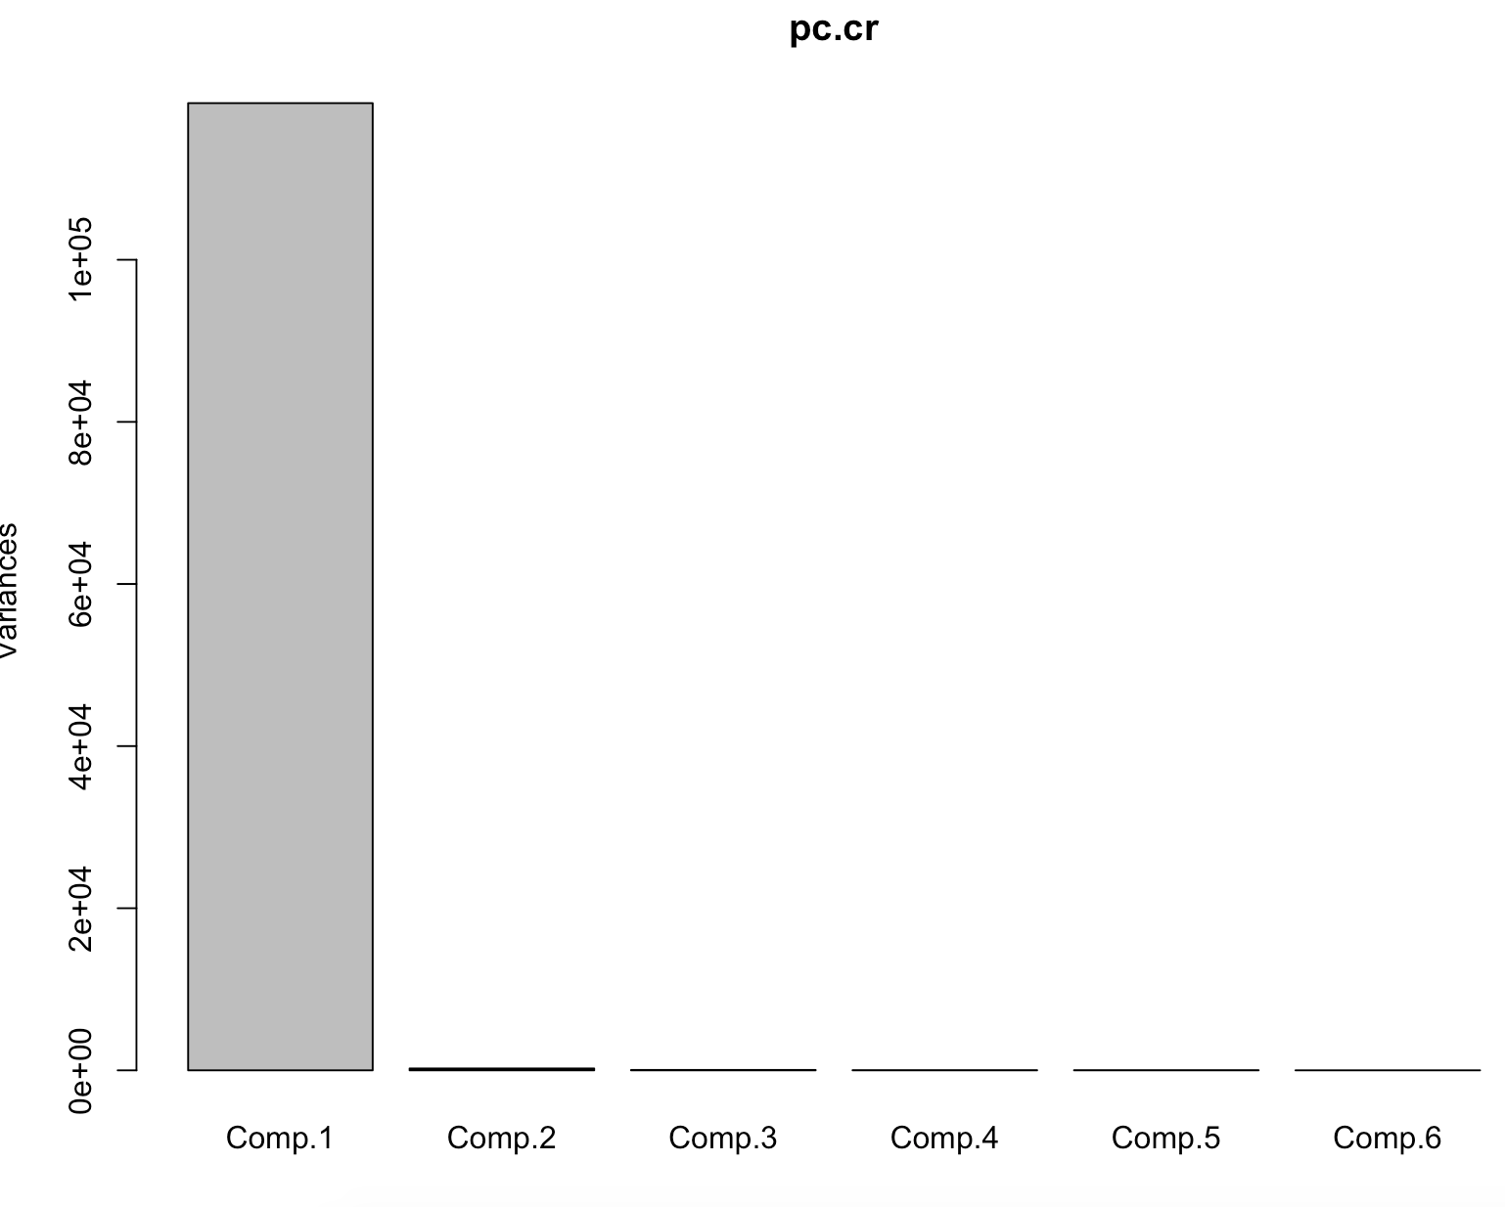

Once again I do not know why my y-axis values are off by orders of magnitude (this doesn’t make sense because when I ask what “pc.cr” is I get this:

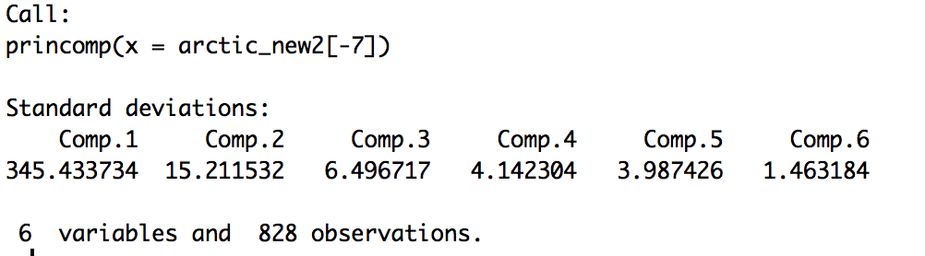

And I can see from this that most of the variance is described by Comp. 1, but also 2.

#Run PCA on this data using princomp:

my.pca<-princomp(arctic_new2[,-7],cor=T)

biplot(my.pca,pc.biplot=TRUE)

screeplot(my.pca,bstick=TRUE);

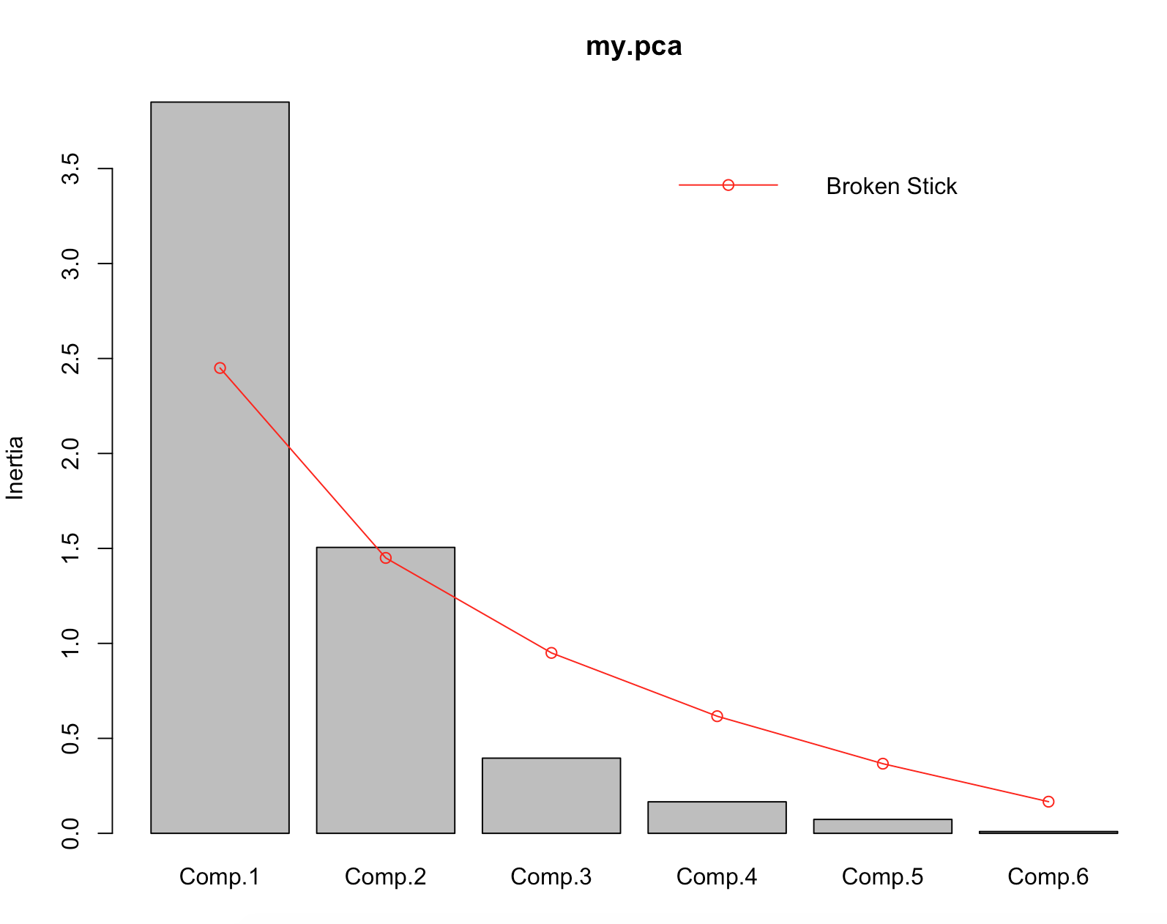

When I say cor=T (a logical value indicating whether the calculation should use the correlation matrix or the covariance matrix. (The correlation matrix can only be used if there are no constant variables.) )

**PCA on a pollen dataset:**

I picked Richland Creek Dataset from Illinois in Peiora.

Run a pca on the data:

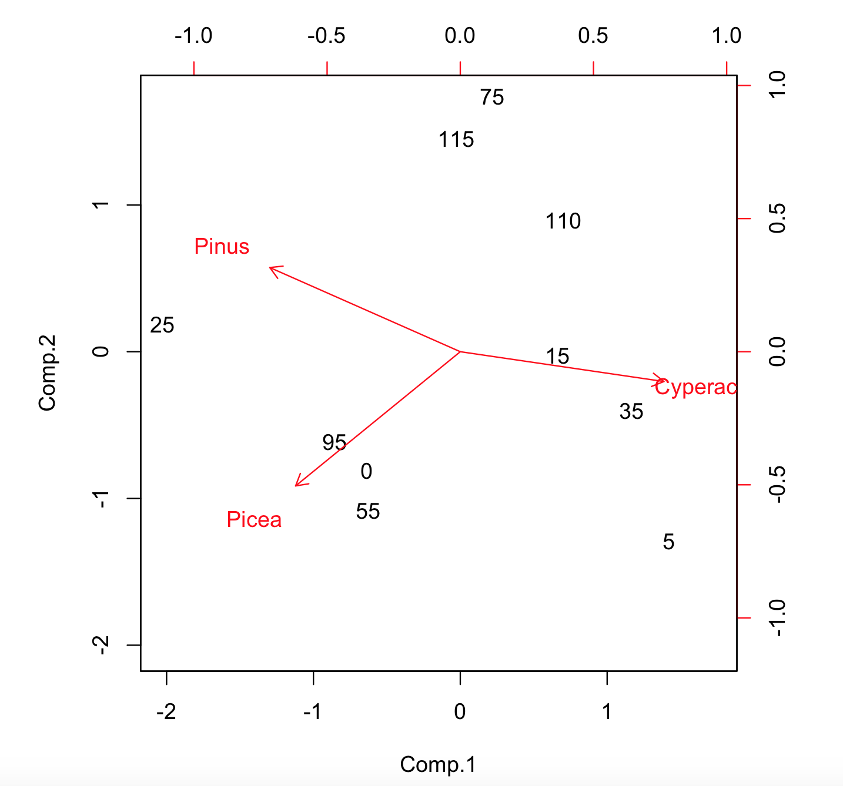

**Make a scree plot:**

