- For your homework, write down the median estimate and 2-sigma (95% CI) age ranges. Note that there is no convenient way to summarize the calibrated age distribution (the full PDF is best) but the 95%CI is a common summary.
Int cal 95.4 (2 sigma) cal BP 15232 - 15879
Marine 95.4 (2 sigma) cal BP 14339 – 15249

- Now, having done this by hand using CALIB, do the same calibration using the calibration function in clam
- calibrate(13000,100) Calibrate using the default NH calibration curve:
  - min max prob
  - 15239 15873 95
- calibrate(13000,100,cc=2)) Calibrate using using the MARINE13 curve
  - min max prob
  - 14358 15250 95
- calibrate(13000,100,reservoir=c(50,30),cc=2) Calibrate using using the MARINE13 curve and a specified marine reservoir correction of 50 years with uncertainty of 30 years.
  - min max prob
  - 14267 15175 95
- Hopefully your CALIB and clam numbers agree! They do!

Classic age model (clam)
- Pick a site from Neotoma and download geochronological data & pollen data, using the scripts you developed in the previous lab. You may use the same site as last week or a new one. Try to pick a site that spans at least the last 15,000 years and has a few bends in its age-depth plot. Neotoma Explorer's Stratigraphic Diagrammer may be helpful here. Devils Lake WI is a good default option.
I chose the Bears Lake record from the center of Bears Lake in UT/ID. The pollen ages for this span back about 23,000 years ago.
- Build the following age models using clam:
  - Linear interpolation BearsLake's 95% confidence ranges span from 125 to 888 yr (average 312 yr), Fit (-log, lower is better): 18.86

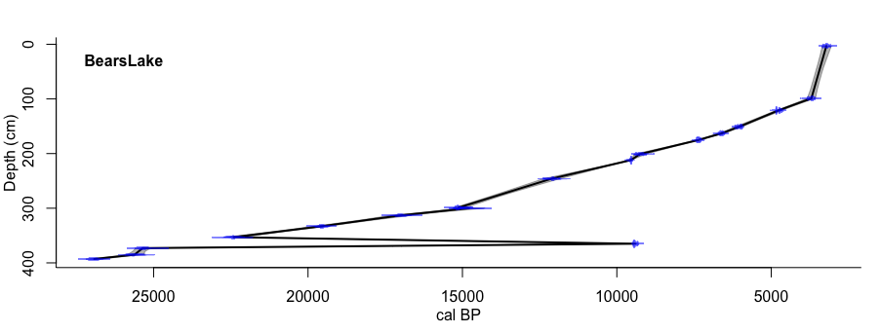

We can see the linear interpolation ignores the presence of an outlier and still creates the age model going through the outlier point; which is why Bayesian models are preferred.

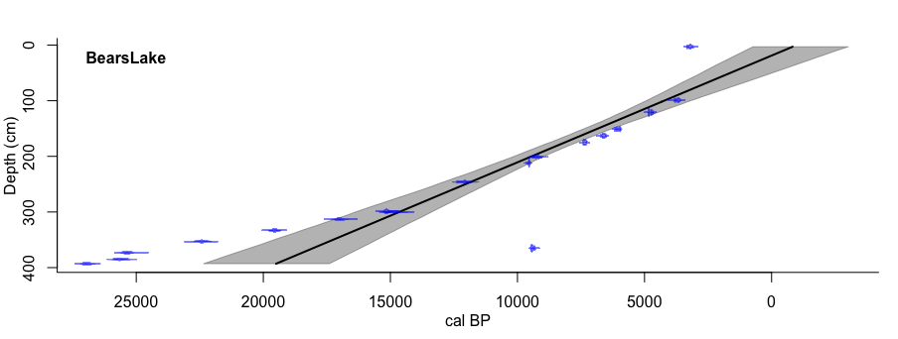
  - Linear Regression BearsLake's 95% confidence ranges span from 1054 to 4953 yr (average 2471 yr), Fit (-log, lower is better):

The linear regression is also sill weighting the age model over towards the outlier, which shifts all of these ages to be more to the right than they should be.

  - 3rd-order polynomial (type=”regr”) BearsLake's 95% confidence ranges span from 489 to 8268 yr (average 2140 yr), Fit (-log, lower is better): Inf
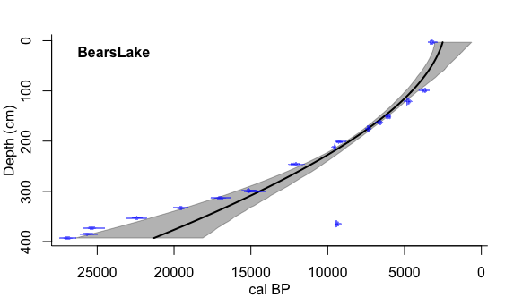

The polynomial plot is also biased towards the outlier.
  - Cubic spline (type=”spline”) BearsLake's 95% confidence ranges span from 136 to 8652 yr (average 1291 yr), Fit (-log, lower is better): 18.15
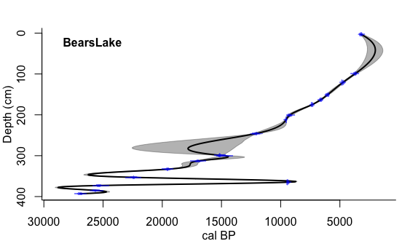

From all of these plots produced by clam, we can see that the classic age models are all influenced by the outlier, which is not good since we know this outlier is most definitely due to stratigraphy.

Below, I replotted the Bear lake record without the outliers:
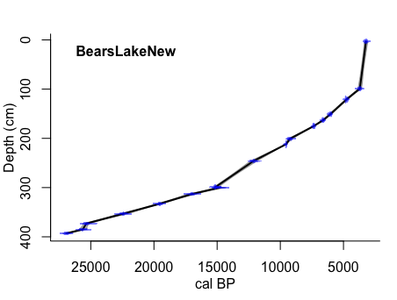
Linear Interpolation:

#4: Using clam, construct a smooth spline (type=”smooth”) with the default smoothing parameter (I did this for the data without the outlier), type=4:

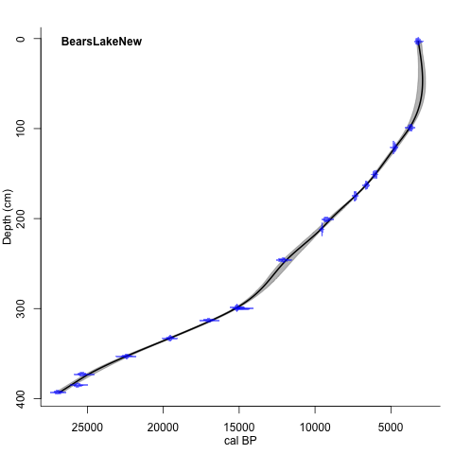

3 (part b). Looking at events in the pollen record:

I have identified two events in this pollen record that stick out to me. First, there is a collapse of the Juniperus at depths 220-215 cm. I have collected the age model dates for this event on the left. I have also identified an increase in Artemisia, Pinus and Poaceae, yet a decrease in lycopodium at 50 cm depth, which I have collected the age model dates for this on the right.
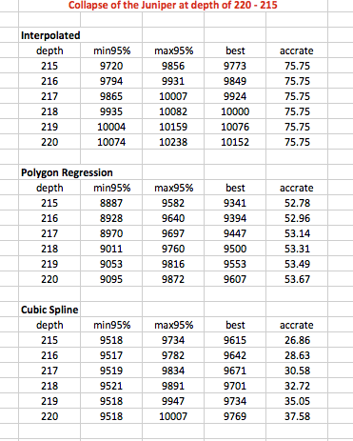
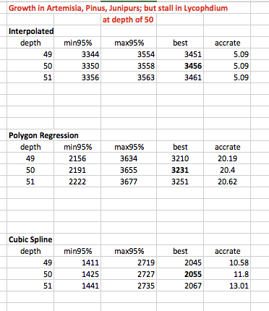

BACON
Mean 95% confidence ranges 1118.1 yr, min. 272.2 yr at 177 cm, max. 2191.3 yr at 348 cm
Kept the thickness to 5, so there were only 71 sections.

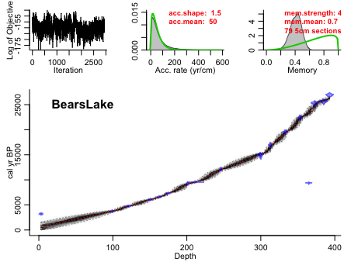

Changed thickness to 3, so it split it up into 131 sections. It’s taking a little longer to run (because it’s being more detailed).

Run with thickness of 15:

It appears that as we decrease the thickness, the Bacon age model uncertainty gets smaller and it is more of a tight fit to the specified ages. If we increase the thickness, the sections in which is iterates is increased, and the uncertainties become larger. In addition, it appears the accumulation rate curves are better fit with decreased thicknesses (more sections).

Overall, this exercise demonstrated the importance of how Bayesian statistical methods are able to discount the presence of outliers when constructing an age model, which is an important distinction to be made when creating an age model.

