R_Programming in Coursera.

A different way ot implement the caching solution:

Just as a reminder, we are charged with creating the following two functions:

1.  `makeCacheMatrix`: This function creates a special "matrix" object

    that can cache its inverse.

2.  `cacheSolve`: This function computes the inverse of the special

    "matrix" returned by `makeCacheMatrix` above. If the inverse has

    already been calculated (and the matrix has not changed), then

    `cacheSolve` should retrieve the inverse from the cache.

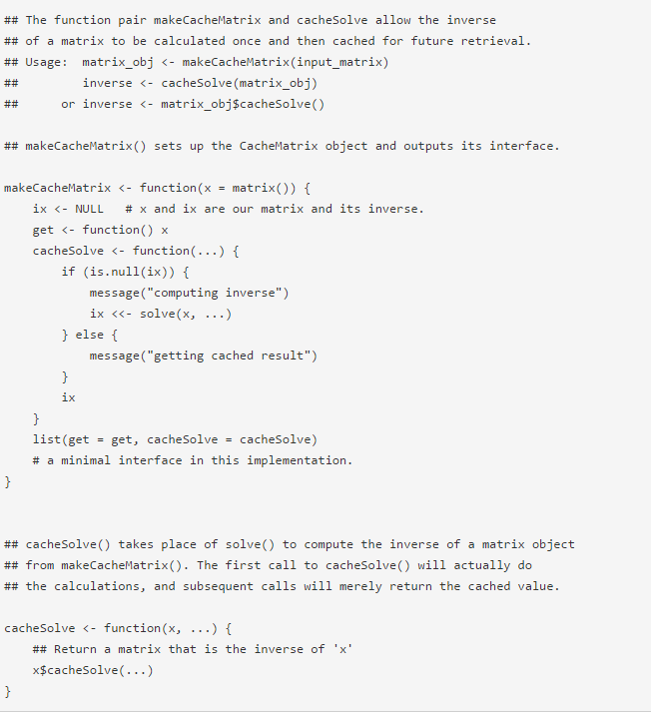

Anonymous· [38 minutes ago](https://class.coursera.org/rprog-011/forum/thread?thread_id=1011" \l "post-4690)

The requirements imply that the value of the matrix could change but your code allows no such thing. One would always have to create a new object to achieve this goal. Therefore I would be tempted to say that your solution does not meet all the objectives.