已经掌握的sipxecs的功能

Sipxecs提供了方便的WEB UI操作界面，基本的配置都在web页面里面进行配置。提供的功能都在web页面里进行配置。下面的配置都在页面里进行的

## 1.关于用户

添加sipphone用户

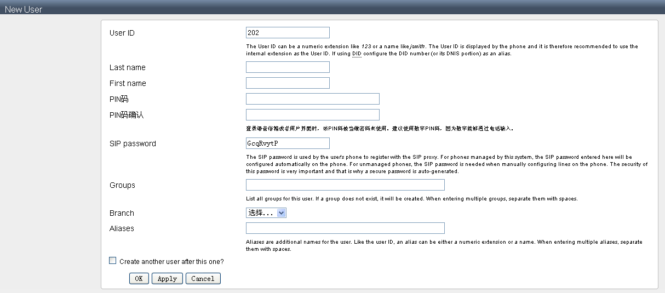

显示Sipxecs的用户

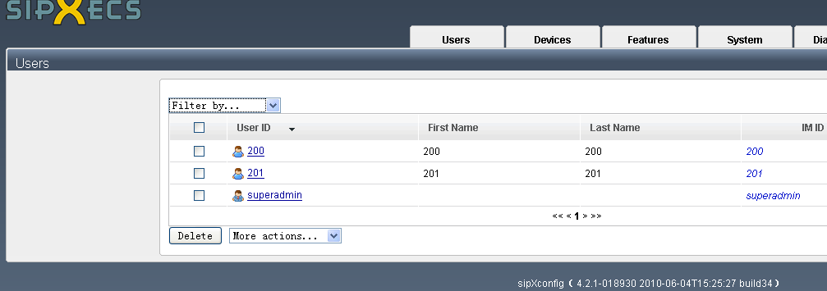 添加用户组

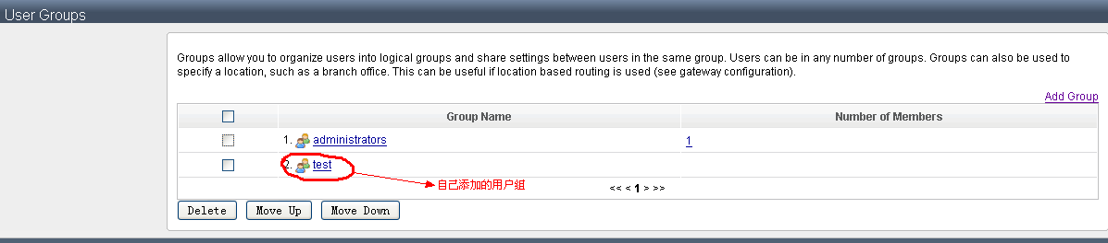

## 2关于呼叫中心的ACD

ACD 全称：Automatic Call Distribution，即大量的大量的电话打入时进行自动分配，分配给坐席或者IVR

下面是网上找到的配置实例

* 配置sipxecs服务器的ACD

Steps to reproduce :  
1.Login as admin user.  
2.Navigate to Features---->ACD Call Center  
3.Set a ACD server with Queue 'Queue1' as following parameters :  
      Answer Mode: Deferred  
      Call Routing Scheme: Circular.  
       Maximum ring delay: 15  
      Maximum Queue Length :10  
      Maximum wait time : 60  
      Welcome audio: welcome.wav  
      Queue audio:queue1.wav  
      Agent wrap up Time: 0;  
      Agent Non-Responsive time: 0;  
      Maximum Bounce Count: 0  
4.Assign 3 Agents 200,201,and 202 to Queue1.  
5. Set ACD Line as 555 to Queue1.  
6.From Agent Availability page Sign in all the Agents  
7. Activate the configured ACD server.   
8. Dial 555, and call will be routed to the available agent.  
9. sipxpbx stop and sipxpbx start  
9. Dial 555, got "ACD No Agent" error even though Agent still shown as Signed in.  
To recover from this, you have to sign-out and then sign-in to trigger an agent status update.  
From my initial investigation, here is what I think the problem is:  
The problem is that after ACD recover from a failure or after being restarted, it forgets the status of all the agents, and blindly assume all the agents are signed-out. So even though the agents are signed in according to agents availability, when call ACD line, you get "no ACD agent" error. In order for ACD server to synchronize with the agents status with presence server, have to sign-out and sign-in all agents to trigger an status update from presence server to ACD server . I think the correct behavior should be that when ACD server is restarted, it should first query the presence server for all agents status to stay synchronized with presence server.

Feature/ACD打开显示的服务器连接，就到了下面的页面

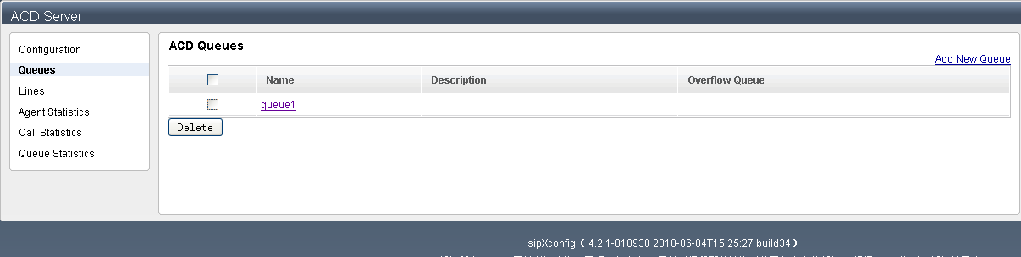

队列：是呼入电话的处理队列

添加一个队列下面是添加时所需的配置

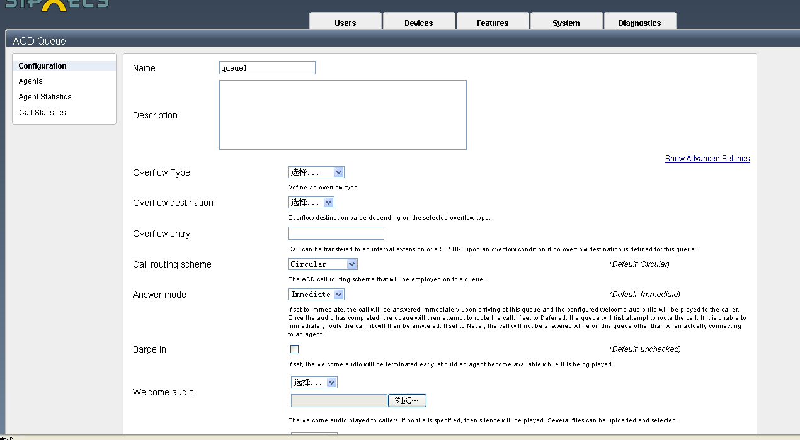

为队列添加坐席，分配201和202到队列Queue1

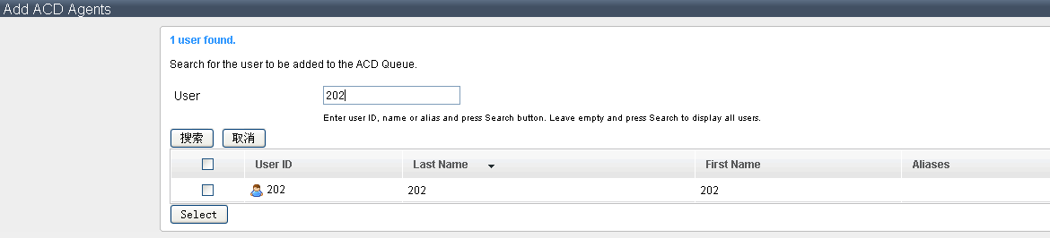

查看坐席状态：

Features/Agent status 打开

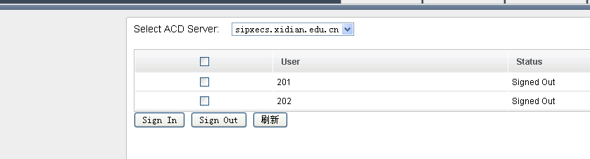

显示了已添加的坐席

已经登入的坐席状态

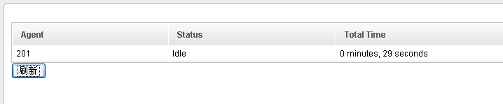

为队列添加lines555到队列Queue1

成功配置后看Queue Statistics

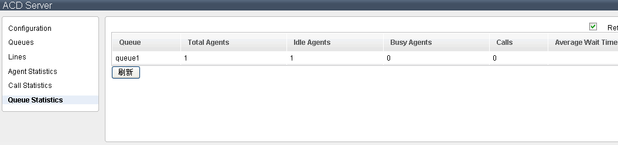

测试：

1用Sjphone打<SIP:555@192.168.118.65>

2用软电话注册到201作为坐席

测试版本：4.2.1-018930（sipxecs）

测试结果

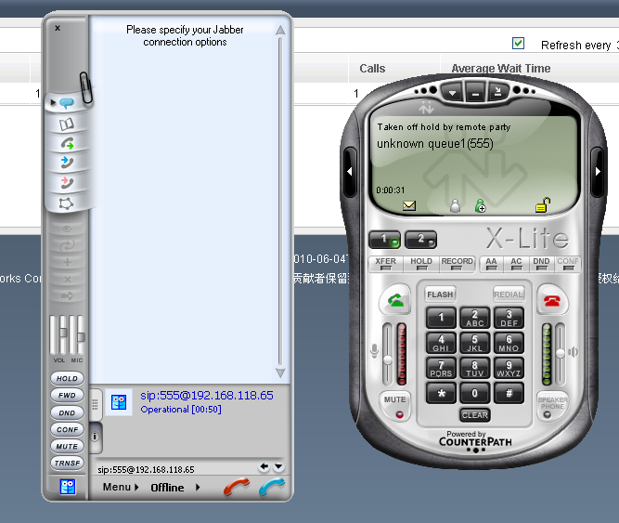

## 3单用户的呼叫转接

即在sipx服务器中进行配置，例如：当电话打到201上时，可以设置在同时或者20秒之后没人接听时进行转接。

下面是配置方法：

Users/选201进行详细设置/再选Call Forwarding

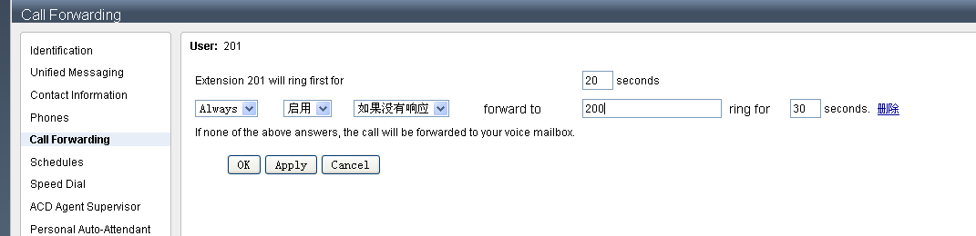

进行设置

如果打201，在30秒之后没人接听，会直接转到200上。通过了测试