1)

a)

create table Categoria(

id bigint identity(1,1) primary key not null,

titulo varchar(200) null,

descricao varchar(500) null

)

go

create table Series(

id bigint identity(1,1) primary key not null,

nome varchar(200) null,

data_disponivel datetime null,

id_categoria bigint not null,

CONSTRAINT FK_series_categoria FOREIGN KEY (id_categoria) REFERENCES Categoria (id)

)

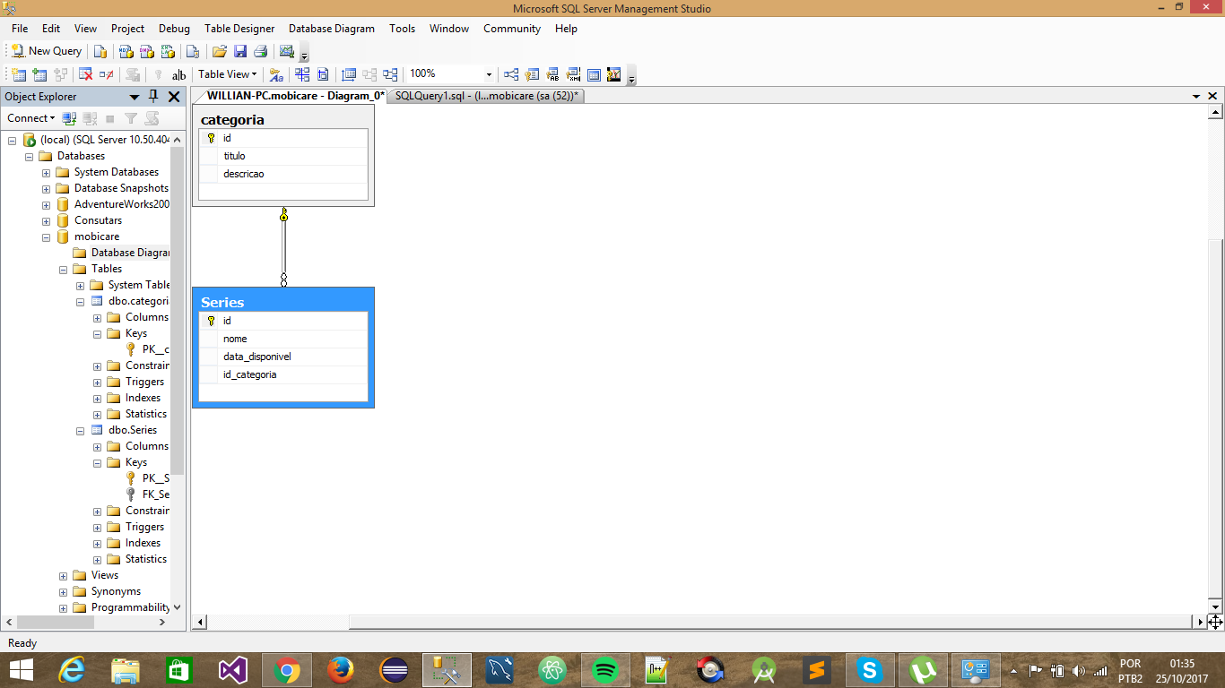

b)

create table Categoria(

id bigint identity(1,1) primary key not null,

titulo varchar(200) null,

descricao varchar(500) null

)

go

create table Series(

id bigint identity(1,1) primary key not null,

nome varchar(200) null,

data_disponivel datetime null

)

go

create table Series_Categoria(

id_series bigint not null,

id_categoria bigint not null,

CONSTRAINT FK_series_categoria PRIMARY KEY (id_categoria,id_series),

CONSTRAINT FK_series_categoria_categoria FOREIGN KEY (id_categoria) REFERENCES Categoria (id),

CONSTRAINT FK_series_categoria_series FOREIGN KEY (id_series) REFERENCES Series (id)

)

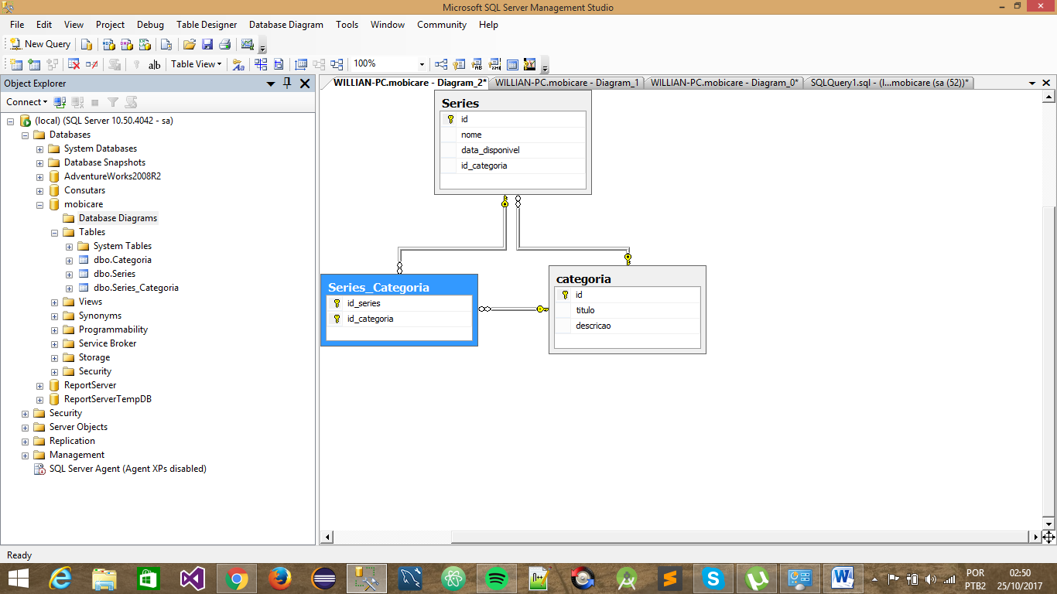

c)

select s.nome,c.titulo from Series s

inner join Series_Categoria b on s.id = b.id_series

inner join Categoria c on c.id = b.id_categoria

order by s.data_disponivel desc

2)

create table Cliente(

id bigint identity(1,1) primary key not null,

nome varchar(200) null

)

go

create table Modem(

id bigint identity(1,1) primary key not null,

nome varchar(200) null,

)

go

create table Cliente_Modem(

id_Cliente bigint not null,

id_Modem bigint not null,

CONSTRAINT PK_cliente_modem_cliente PRIMARY KEY (id_Cliente,id_Modem),

CONSTRAINT FK_cliente_modem_cliente FOREIGN KEY (id_Cliente) REFERENCES Cliente (id),

CONSTRAINT FK_cliente_modem_cliente FOREIGN KEY (id_Modem) REFERENCES Modem (id)

)

3)

6)

i.

SELECT f.nome, s.nome FROM Funcionario_Setor a

INNER JOIN Funcionarios f ON a.ID_FUNC = f.ID

INNER JOIN Setor s on a.ID_SETOR = S.id

WHERE s.ID = 1

ii.

SELECT s.NOME, count(*) as qtd_func FROM Funcionario_Setor a

INNER JOIN Funcionarios f ON a.ID_FUNC = f.ID

INNER JOIN Setor s on a.ID_SETOR = S.id

group by a.ID_SETOR,s.NOME ORDER BY s.NOME ASC

iii.

SELECT s.NOME as qtd_func FROM Funcionario_Setor a

LEFT JOIN Funcionarios f ON a.ID_FUNC = f.ID

LEFT JOIN Setor s on a.ID_SETOR = S.id

WHERE f.ID IS NULL

iv.

SELECT s.NOME, SUM(f.SALARIO) as TOTAL FROM Funcionario_Setor a

INNER JOIN Funcionarios f ON a.ID_FUNC = f.ID

INNER JOIN Setor s on a.ID_SETOR = S.id

group by a.ID_SETOR,s.NOME ORDER BY s.NOME DESC

v.

SELECT f.nome, s.nome FROM Funcionario_Setor a

INNER JOIN Funcionarios f ON a.ID_FUNC = f.ID

INNER JOIN Setor s on a.ID_SETOR = S.id

WHERE month(data_associacao) <=9