# HW #2

## Name : Erjia Li UID : 113778278

1. The non-trivial functional dependency satisfied by the following relation is:

**B->A, C🡪A, C🡪B, C🡪AB, AC🡪B, BC🡪A**

2. (a)

(1)BC🡪E

**(augmentation) Using B🡪D and augmenting with C, we get BC🡪CD.**

**(transitivity) Using BC🡪CD and CD🡪E, we get BC🡪E.**

(2)E🡪C

**(reflexivity) Using E🡪D, we get E🡪ED.**

**(augmentation) Using E🡪A and augmenting with D, we get ED🡪AD.**

**(transitivity) Using ED🡪AD and AD🡪C, we get ED🡪C.**

**(transitivity) Using E🡪ED and ED🡪C, we get E🡪C.**

(b)

(1) (AE)+ :

result = AE. A🡪D and A ∈ result cause us to include D in result.

result = ADE. AD🡪C and AD ∈ result cause us to include C in result.

result = ACDE.

**So, (AE)+ = ACDE.**

(2)(B)+

result = B. B🡪D and A ∈ result cause us to include D in result.

result = BD.

**So, (B)+ = BD.**

(c)

**Attribute D is extraneous** in AD🡪C, cause we can use Armstrong’s axioms to get F logically implies (F- {AD🡪C})∪{A🡪C}.

(d)prime attributes can be {A,B},{B,C} or {B,E}

(e) Canonical cover

Cause each left side of functional dependency in Fc must be unique and no functional dependency in Fc contains an extraneous attribute.

First, we eliminate extraneous attributes and then get F={A🡪D, A🡪C, B🡪D, CD🡪E, E🡪A}.

Second, we use union rule to merge right sides and then get **Fc={A🡪CD, B🡪D, CD🡪E, E🡪A}.**

3.

(a) Candidate key is AB.

(b) The FD violates that the relation is in BCNF is D🡪C. This FD is not trivial. D is not the super key of this relation.

(c)

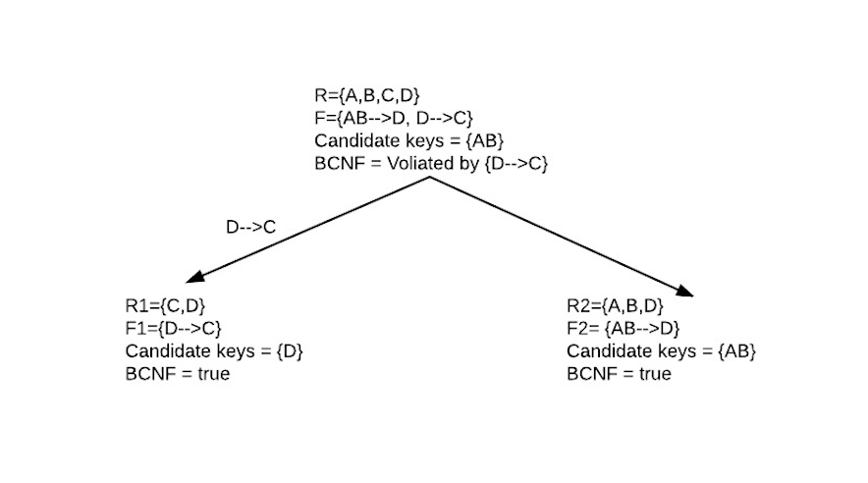

The decomposition result is R1=(C,D) R2=(A,B,D)

(d) FDs= {AB🡪D, D🡪C} violate that the relation is 3NF because D-AB and C-Dare not contained in a candidate key for R.

(e)

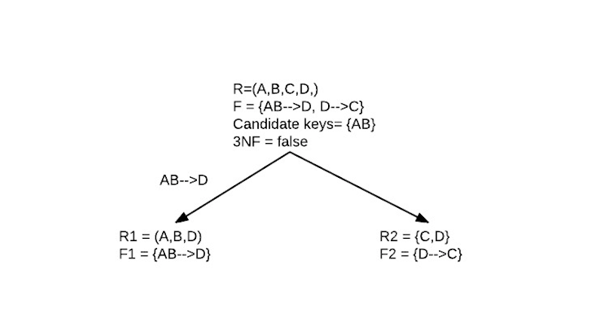

The decomposition result is R1=(A,B,D) R2=(C,D)

4.

(a)Candidate keys {AB,AE,AD}

(b) The FDs violate that the relation is in BCNF is {BC🡪D, D🡪E, A🡪C, E🡪B}. These FDs is not trivial. And the left side of these FDs are not the super key of this relation.

(c)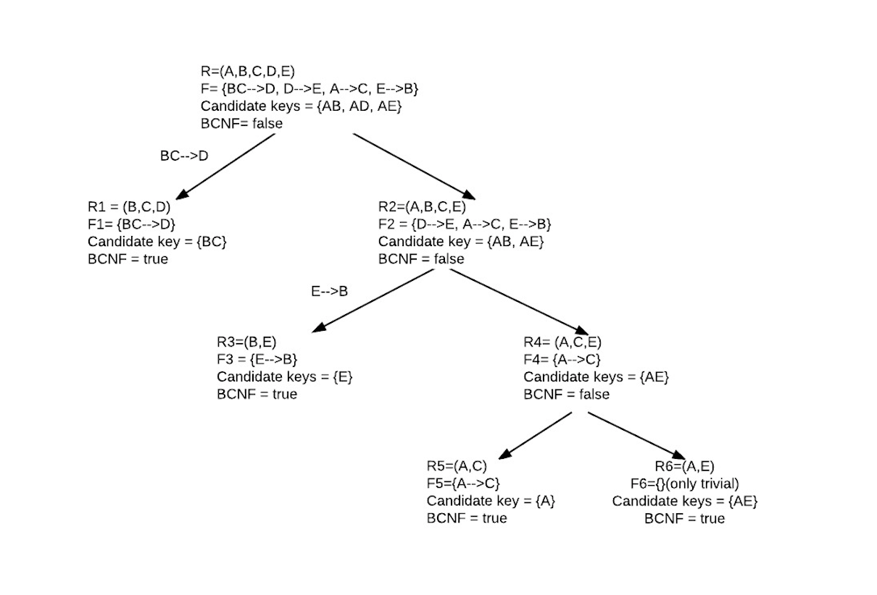

The decomposition result is R1=(B, C,D) R3=(B,E) R5=(A,C) R6=(A,E)

(d) This relation in not in 3NF. One FD violates that this relation is not in 3NF is A🡪C. C-A=C, and C is not contained in a candidate key for R.

(e)

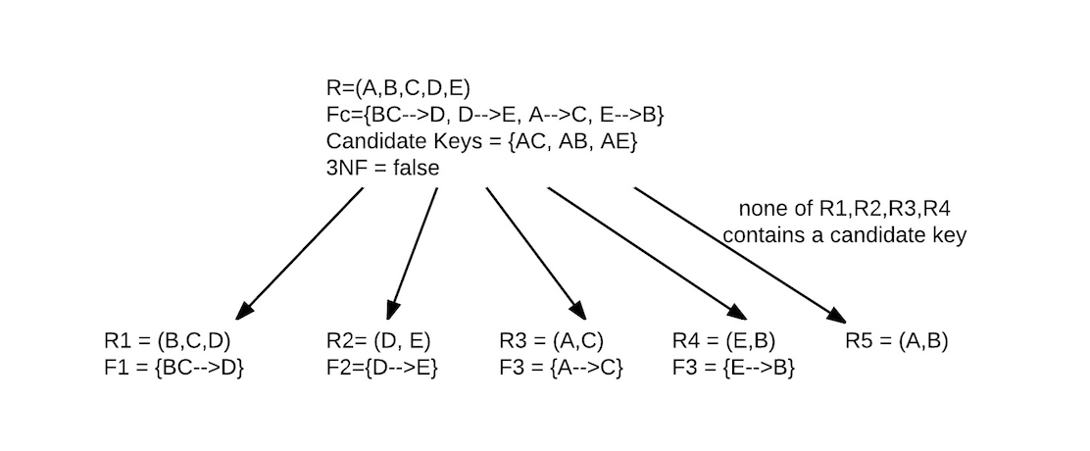

The decomposition result is R1=(B,C,D) R2=(B,E) R3=(A,C) R4=(B,E) R5=(A,B)

5.

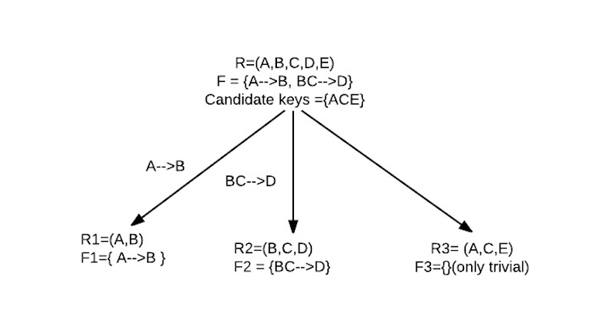

None of R1 and R2 contains a candidate key. So, R3 contains a candidate key is created.

The decomposition result is R1=(A,B) R2=(B,C,D) R3=(A,C,E)