Systems Analysis and Design Project

Mobile Phone Retailer and Distributor

Jack Morrison 13127853

Colm O’Brien

William O’ Dwyer

Contents

**Use Case Diagrams** 3

Customer Main Activities 3

Administrator Main Activities 4

**Use Case Structured Descriptions** 5

Login 5

Create Account 5

Browse Catalogue 5

Search Catalogue 5

Add Product to Cart 6

View Cart 6

Remove Product from Cart 6

Edit Product Quantity in Cart 6

Add Product 7

Remove Product 7

Edit Product 7

View Orders 7

Change Customer Category 7

Remove User 8

Return Stock 8

Ship Order 8

**Requirements**

# **Use Case Diagrams**

## Customer Main Activities

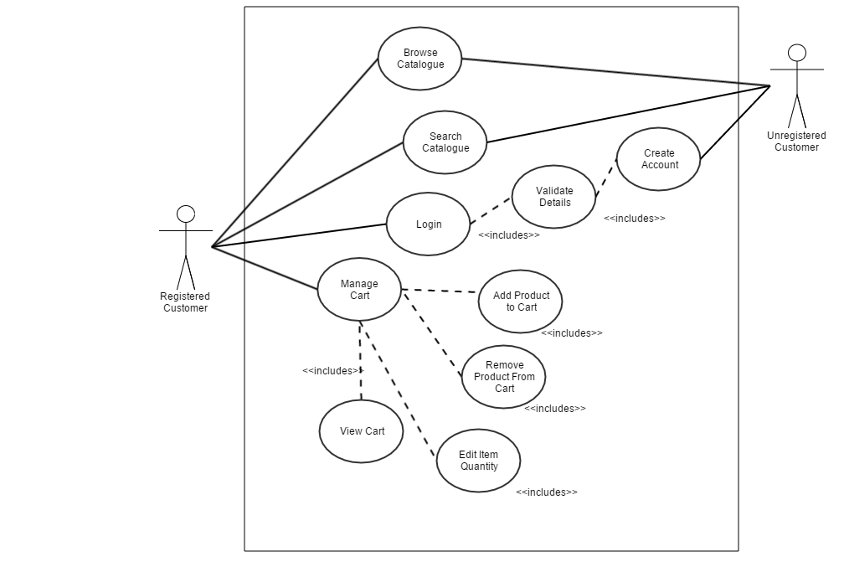

## Administrator Main Activities

# **Use Case Structured Descriptions**

## Login

|  |  |
| --- | --- |
| **ACTOR’S ACTION** | **SYSTEM RESPONSE** |
| 1. Customer selects Login from initial screen. | 1. Login form is displayed. |
| 1. Customer enters Username and password and clicks ‘Login’ button. | 1. Login details entered correctly, customer is logged in. |
| **ALTERNATIVE ROUTE** | |
| 3a. Customer enters wrong login details. | 4a. Login details are incorrect, error message with ‘Unable to Login’ is shown. |

## Create Account

|  |  |
| --- | --- |
| **ACTOR’S ACTION** | **SYSTEM RESPONSE** |
| 1. Customer selects ‘Create Account’ from initial screen. | 1. Register form is displayed. |
| 1. Customer enters Username, email address and desired password and clicks ‘Login’ button. | 1. Login details entered correctly, ‘Account created successfully.’ message is shown. |
| **ALTERNATIVE ROUTE** | |
| 3a. Desired username is already taken. | 4a. Customer is unable to create account, error message with ‘Username already taken, please choose another.’ is shown. |

## Browse Catalogue

|  |  |
| --- | --- |
| **ACTOR’S ACTION** | **SYSTEM RESPONSE** |
| 1. Customer selects ‘Browse Catalogue’ from initial screen. | 1. Catalogue is displayed. |
| 1. Customer clicks on a product in the catalogue. | 1. Product info page is shown. |

## Search Catalogue

|  |  |
| --- | --- |
| **ACTOR’S ACTION** | **SYSTEM RESPONSE** |
| 1. Customer selects ‘Search Catalogue’ from initial screen. | 1. Search Catalogue screen is displayed. |
| 1. Customer enters search query in text box. | 1. Search results are shown. |
| **ALTERNATIVE ROUTE** | |
| 3a. Search results not found. | 4a. Message ‘No results found.’ shown. |

Non-Functional Requirements:

* Search should not take longer than 5 seconds.

## Add Product to Cart

|  |  |
| --- | --- |
| **ACTOR’S ACTION** | **SYSTEM RESPONSE** |
| 1. Customer selects ‘Add Product to Cart’ on Product Info screen. | 1. Product is added to cart successfully with message ‘Product added to cart’ shown. |
| **ALTERNATIVE ROUTE** | |
| 3a. Product is out of stock. | 4a. Message ‘Sorry, this product is not in stock.’ is shown. Product is not added to cart. |

## View Cart

|  |  |
| --- | --- |
| **ACTOR’S ACTION** | **SYSTEM RESPONSE** |
| 1. Customer selects ‘View Cart’ on initial screen. | 1. Cart and its contents are shown on screen. |
| **ALTERNATIVE ROUTE** | |
| 3a. Cart is empty. | 4a. Message ‘Your cart is empty.’ is shown. |

## Remove Product from Cart

|  |  |
| --- | --- |
| **ACTOR’S ACTION** | **SYSTEM RESPONSE** |
| 1. Customer selects ‘Remove product from Cart’ on View Cart screen. | 1. Product is removed from cart successfully with message ‘Product removed from cart’ shown. |

## Edit Product Quantity in Cart

|  |  |
| --- | --- |
| **ACTOR’S ACTION** | **SYSTEM RESPONSE** |
| 1. Customer selects ‘Edit Product Quantity’ on View Cart screen. | 1. Product quantity is updated successfully and new quantity is shown on View Cart Screen. |
| **ALTERNATIVE ROUTE** | |
| 3a. There is not enough stock to fulfil quantity change. | 4a. Error message ‘Sorry there are not enough products in stock’ is shown. |

## Add Product

|  |  |
| --- | --- |
| **ACTOR’S ACTION** | **SYSTEM RESPONSE** |
| 1. Administrator selects ‘Add Product’ on the administrator screen. | 1. ‘Add Product’ page is shown. |
| 1. Administrator enters Product name, price and stock. | 1. Product details are updated successfully, product is added to the catalogue. |

## Remove Product

|  |  |
| --- | --- |
| **ACTOR’S ACTION** | **SYSTEM RESPONSE** |
| 1. Administrator selects ‘Remove Product’ on the administrator screen. | 1. List of products currently in catalogue is shown. |
| 1. Administrator selects product to remove. | 1. Product is removed successfully, catalogue is updated successfully. |

## Edit Product

|  |  |
| --- | --- |
| **ACTOR’S ACTION** | **SYSTEM RESPONSE** |
| 1. Administrator selects ‘Edit Product’ on the administrator screen. | 1. List of products currently in catalogue is shown. |
| 1. Administrator selects product to edit. | 1. Product edit page is shown. |
| 1. Administrator edits product. | 1. Product is updated successfully. |

## View Orders

|  |  |
| --- | --- |
| **ACTOR’S ACTION** | **SYSTEM RESPONSE** |
| 1. Administrator selects ‘View Orders’ on the administrator screen. | 1. List of all Orders is shown. |

## Change Customer Category

|  |  |
| --- | --- |
| **ACTOR’S ACTION** | **SYSTEM RESPONSE** |
| 1. Administrator selects ‘View Customers’ on administrator screen. | 1. List of all customers is shown. |
| 1. Administrator selects customer to update. | 1. Customer details screen is shown. |
| 1. Administrator selects change customer category | 1. Customer category is updated correctly. |

## Remove User

|  |  |
| --- | --- |
| **ACTOR’S ACTION** | **SYSTEM RESPONSE** |
| 1. Administrator selects ‘View Customers’ on administrator screen. | 1. List of all customers is shown. |
| 1. Administrator selects customer to remove. | 1. Customer details screen is shown. |
| 1. Administrator selects ‘Remove Customer’ | 1. Message ‘Are you sure you would like to remove customer?’ is shown. |
| 1. Administrator selects ‘Yes’. | 1. Customer is removed and customer list is updated successfully. |
| **ALTERNATIVE ROUTE** | |
| 7a. Administrator selects ‘No’. | 8a. Customer is not removed from system and the administrator is brought back to customer details screen |

## Return Stock

|  |  |
| --- | --- |
| **ACTOR’S ACTION** | **SYSTEM RESPONSE** |
| 1. Administrator selects ‘Return Stock’ on administrator screen. | 1. Return Stock screen is shown. |
| 1. Administrator selects supplier from drop-down to return stock to. | 1. Supplier is selected successfully. |
| 1. Administrator selects product to return to supplier. | 1. Product is selected successfully; available stock to return is shown. |
| 1. Administrator selects quantity of stock to return, selects ‘Return Stock’. | 1. Message ‘Stock returned successfully’ is shown. |
| **ALTERNATIVE ROUTE** | |
| 7a. Administrator selects ‘No’. | 8a. Customer is not removed from system and the administrator is brought back to customer details screen |

## Ship Order

|  |  |
| --- | --- |
| **ACTOR’S ACTION** | **SYSTEM RESPONSE** |
| 1. Administrator selects ‘View Orders’ on the administrator screen. | 1. List of all Orders is shown. |
| 1. Administrator selects Order to Ship. | 1. Order details screen is shown. |
| 1. Administrator selects ‘Ship Order’. | 1. Message ‘Order shipped successfully’ is shown. |
| **ALTERNATIVE ROUTE** | |
| 1. Product on order is not in stock. | 1. Message ‘Product is not in stock, order cannot be shipped’ is shown. |