Final Project
INFO-C451
Joshua Willis
2025
Contents
Introduction to Implementation 2
Implementation Planning 3
Managing System Projects 5
Installation Strategy 6
Data Migration Plan 6
System Testing 7
User Training & Documentation 9
Data Design 11
Security and Control 12

Introduction to Implementation
1. SmartHealth Clinic, a multi-specialty medical clinic, currently uses a paper-based medical record system that creates significant operational challenges. Being forced to manually search for patient records leads to longer wait times for patients and reduced throughput. Lost or misplaced files hurt a patient’s continuity of care and increase the risk of medical errors. Manual data entry creates regular billing errors, resulting in revenue losses and frequent disputes with insurance providers. These issues are exacerbated by the clinic’s current rate of growth, making scalability different without turning to a digital solution.
2. Given the clinic’s limited IT staff, the system implementation process will be critical to put the clinic in position to fulfill their goals with the new system and attain stability beyond this phase. An electronic health record will be essential for improving efficiency, accuracy, and compliance. Digital patient records that can be accessed quickly and easily will reduce patient wait times and allow staff to focus more on patient interactions. Automated billing procedures will minimize errors and increase revenue. Ultimately, the aim of the implementation will be to support the clinic’s growth and improve the patient experience.
3. I will recommend a waterfall implementation methodology for this project. The structured framework allowed by this choice should lend itself well to compliance focused phases like data migration and security setup. Given the limited IT staff of the clinic, it will be incumbent on the implementation team to properly plan out each phase and ensure that there is thorough documentation available for each step of the project to help mitigate the risks that come with the rigidity of this implementation method.

Implementation Planning
1. Work Breakdown Structure
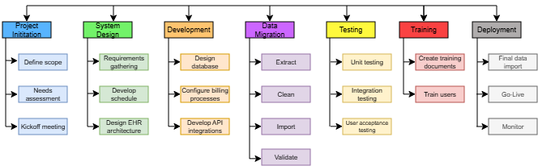
2. Gantt Chart
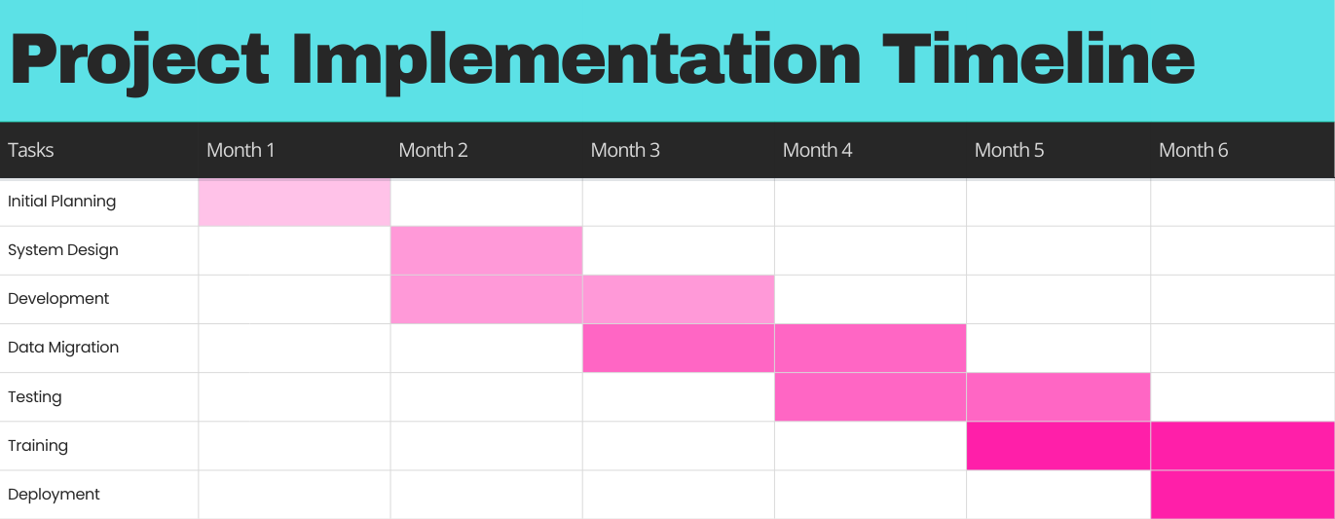

3. Resource requirements
- People: project manager, technical lead, business analyst, EHR vendor, clinical staff (physicians, nurses, medical assistants, front desk)
- Hardware: Workstations, secure backups, mobile devices for patient messaging
- Software: Internet browser, EHR application, lab tools, security software package (anti-virus, web filter)
- Services: vendor support, compliance auditors
4. Risk Assessment
Category | Description | Probability | Impact | Mitigation Plan
Operations | Staff resistance | Medium | High | Involve staff in planning and provide thorough training
Operations | API Integration failure | Low | Impact | Conduct phased testing with vendors
Finances | Budget overruns | Low | Medium | Allocate a 15% contingency fund for unforeseen costs
Security | Data breach | Medium | High | Implement encryption and access controls
Operations | Migration downtime | High | Low | Schedule migration during off-hours

Managing System Projects
1. Project Tasks, Dependencies, and Durations
- Initial Planning – 4 weeks, no dependencies
- System Design – 4 weeks, depends on planning
- Development – 8 weeks, depends on design
- Data Migration – 8 weeks, depends on development
- Testing – 8 weeks, depends on development
- Training – 8 weeks, depends on testing
- Deployment – 4 weeks, depends on testing
2. Pert diagram
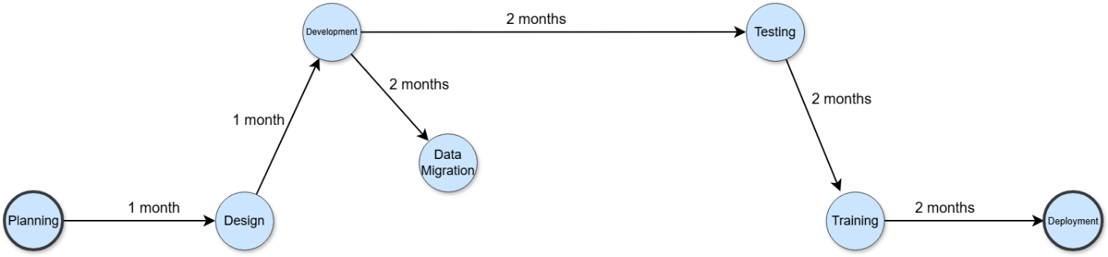

3. Progress will be monitored using tools like Microsoft Project or Kanban board within Microsoft teams. Milestones and task completion rates will be tracked with these tools as well. Weekly reports will be generated and shared via email, as well as access to a real-time report dashboard built with PowerBI. There will be weekly meeting with the project team to update stakeholders on the status of the project.

Installation Strategy
1. For this implementation project we’ll rely on a phased installation approach and roll out each module one by one. We’ll begin with appointment scheduling, followed by patient records, followed by billing processes, followed by lab results APIs, and ending with secure messaging.
2. Because the clinic is moving from paper to digital and not from one digital system to another, this opens the door for a phased approach to minimize the disruption to the patient’s experience. This allows the clinic to maintain normal operations during deployment and suits the limited IT staff available.
3. The risks that come with approach include prolonged transition periods that could inflate costs. Also, if periods are prolonged there is an increased risk in inconsistencies with data and workflows from phase to phase.

Data Migration Plan
1. Data sources include paper patient records, paper billing invoices, lab result printouts
2. Data migration plan
- Extraction: Scan in paper files, use optical character recognition tools like Adobe Acrobat or Foxit Pro to convert into text
- Cleaning: Remove duplicates, manually review for misspelling and data entry errors
- Mapping: Ensure fields names are planned out and aligned with existing paper records
- Validation: Compare data sample pre and post-migration to ensure accuracy
- Backup procedures: create full backups before migration, store offline backup drives in fireproof safe offsite
3. We’ll employ ETL tools for error handling to maintain integrity throughout the migration process. We’ll keep audit trails and use checksums to validate the files in migration as well. Thorough audits will be completed before and after the migration to verify the accuracy of the data.

System Testing
1. Unit Test Cases
Case ID | Description | Input | Expected Output
UTC1 | Create patient demographic record | Patient name, DOB, primary phone | Record saves without error
UTC2 | Create patient bill from service | Consultation service entered | $100 patient balance generated
UTC3 | Send text message | “Please confirm appointment” | Message encrypted and sent

2. Integration Test Cases
Case ID | Description | Input | Expected Output
ITC1 | Lab results transmit to EHR | Upload test lab results | Results save to patient record
ITC2 | Billing module submits claim to insurance | Test billing batch submitted | Claim is processed with insurance via api
ITC3 | Text confirmation transmits to EHR schedule | Text confirmation message to test patient | Appointment status changes to confirmed

3. System Test Cases
Case ID | Description | Input | Expected Output
STC1 | Common patient flow | Create record, schedule appointment, bill claim | All steps complete in order
STC2 | 25 user load test | Simulate concurrent access | No crashes or timeouts
STC3 | Security test | Attempt unauthorized access | Access is denied and attempt is logged

4. User Acceptance Test Cases
Case ID | Description | Input | Expected Output
UAT1 | Front desks schedules appointment | Search patient record, enter appointment type and time | Appointment is scheduled
UAT2 | Doctor accesses patient record diagnosis | Search patient record, navigate to diagnosis section | Accurate record is displayed
UAT3 | Biller processes claim | Enter payment information | Invoice is generated

5. Error-Logging Format
Timestamp | User ID | Module | Error Code | Description
YYYY-MM-DD HH:MM:SS | Jw01 | Billing | Error1001 | Invalid input

6. Selenium and Postman will be used to automate testing tasks and ensure consistency. The goal of using these will be to reduce as much manual effort as possible and mitigate the chance for human error during testing.

User Training & Documentation
1. User Groups and needs
- Doctors: Need training on access records, secure messaging, diagnosis, prescribing
- Front Desk: Need training on appointment scheduling and lab integration
- Billing Staff: Need training on invoice generation, claims processing
2. Training plan
- Timeline: 4 weeks pre go-live, 4 weeks post go-live
- Methods: Instructor led with simulations in classroom setting, e-learning modules for self-paced training afterwards. Sessions will be split by staff role
3. Sample user documentation page
Click on Schedule tab to open up schedule.
Click a box within the column of the appropriate date you want to schedule a visit.
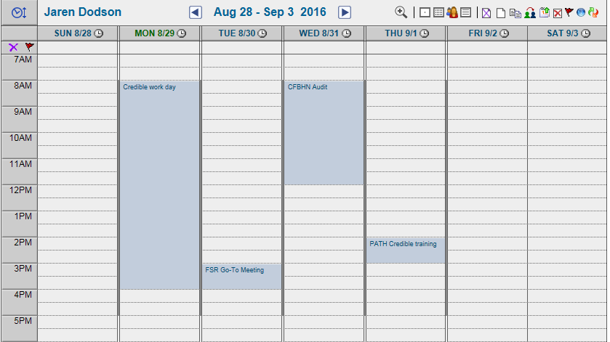

After clicking the box, a small pop-up window will appear. This window will allow you to select the Visit Type, Person Served, and Time of Visit. Use the box with 3 dots (…) to search for the correct Person served and the drop downs to choose the visit and time of visit.
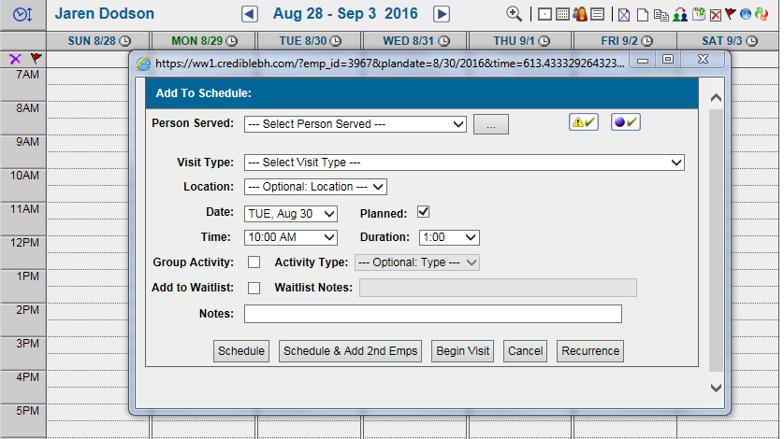

Once you have filled out the scheduler, click Schedule to add it to your schedule.
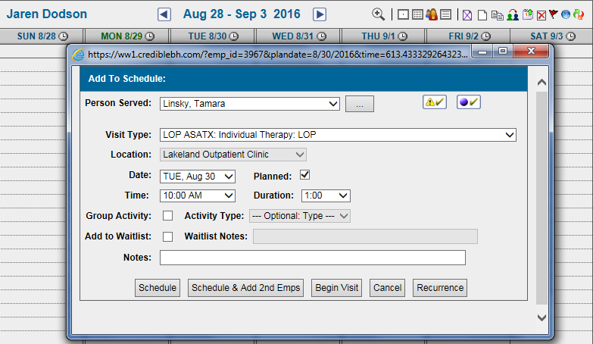
4. Documentation supports long-term system maintenance by providing reference material for troubleshooting scenarios that can crop up over time. It also gives staff a starting point for processes like onboarding new hires and updating their system access and responsibilities as their positions change. It also helps to ensure consistency and reduce manual errors that arise from bad practices over time.

Data Design
1. Entity-Relationship Diagram
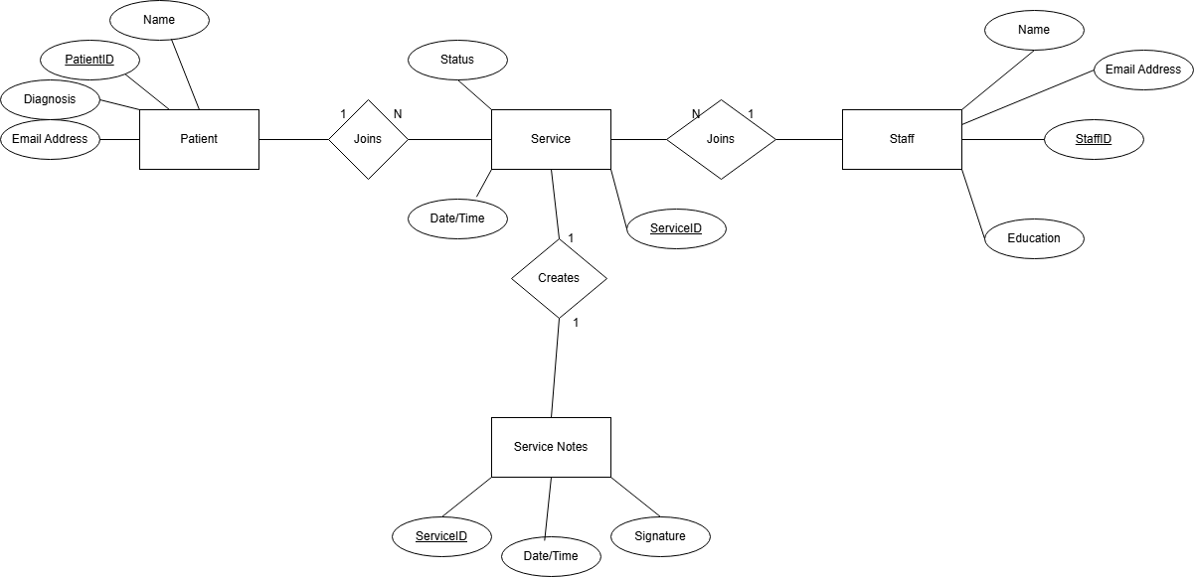

2. Normalization is an important factor in assuring the quality of data especially in a migration scenario. It can help to ensure the consistency of patient data as it is moved from one format to another, as well as remove any possible redundancies in that data. As the amount of data in the system grows, a normalized structure can help mitigate the strains that come with scaling the system up.
3. Data at rest and in transit will be protected by encryption. Role-based access will be implemented to ensure that data is only accessible to the minimum necessary staff. Multi-factor authentication will be enabled for all logins.

Security and Control
1. Role-based access control will be implemented for security. Roles will be broken down by administrator, physician, assistant, billing. Read/write access to patient records will be restricted to the minimum necessary staff. Authentication will be enforced via usernames and strong password policy, as well as multi-factor authentication.
2. A Global HIPAA log will track all access and change events in the system across all users. Each user will have their own HIPAA log that tracks their events by staff ID, and each patient record will have their own HIPAA log that tracks the same events.
3. HIPAA and 42 CFR compliance standards will apply to the system. The policy will be to always default to whichever standard is the most stringent.
4. Acceptable Use Policy
SmartHealth Clinic presents these guidelines for the safe, secure, and effective use of company electronic computing resources to include, but not limited to, workstations and laptop computers, electronic notebooks, company, and personal cell phones. These resources are to be used for SmartHealth business purposes only, in serving the interests of SmartHealth person served, or in conducting SmartHealth normal business operations.
While SmartHealth’s IT Department desires to provide a reasonable level of privacy, users should be aware that the data they create on company systems remains the property of SmartHealth Clinic.
Use that is acceptable and encouraged:
- Communications and information exchanges directly relating to the mission, charter, and work tasks of SmartHealth Clinic.
- Announcements of policies, procedures, services, or activities.
- Use of advisory, standards, research, analysis, and professional society or development activities related to the user's job duties.
- Use in applying for or administering payroll, accounting, inventory, and general business activities related to the user's job duties, including authorized employees working from a remote location.
Uses that are unacceptable:
It is unacceptable for any person to use, submit, publish, display, or transmit on any computer system resource any information which:
- Violates or infringes on the rights of any other person, including the right to privacy.
- Contains defamatory, false, inaccurate, abusive, obscene, pornographic, or illegal material.
- Violates SmartHealth, or departmental regulations
- Install software (personal or other) that was not provided by the company.
- Restricts or inhibits other users from using the system or inhibits the efficiency of any personal computer or the computer network.
- Uses unauthorized codes or passwords to gain access to restricted files/data to include password sharing.
- Uses the system for any illegal purpose or any non-approved business.
- Transmits material, information, or software in violation of any local, state, or federal law.
- Make any unauthorized purchases.
Data Backup/Recovery Policy
Policy: SmartHealth shall maintain data backup for all systems utilized by all clinic sites.
Purpose: To provide continuity, restoration, and recovery of critical data and systems in the event of equipment failure, intentional destruction of data, corruption, or disaster.
ProceduresS: The following procedures will be used to ensure the integrity of the data stored on SmartHealth servers and computers.
- Electronic information stored on Tri-County's data network is copied routinely onto a secure back-up device
  - Data is automatically and continuously backed up from an on-site server
that snapshots all the virtual servers and places a copy on the local backup storage device.
  - Snapshots of live data storage are completed every 4 hours. The snap shots are automatic routed to the storage device. There the backed-up data is available for quick restoration.
  - Once backups are complete, they are pushed to cloud storage
  - Technicians check back-up completions for errors and mitigate identified errors, when necessary
- Data contained in cloud-based systems including electronic health record, payroll and financial data systems, are the responsibility of the vendor according to service level agreements and contracts.
5. SIEM tools will be employed to monitor logs in real-time. Automated alerts will be configured for anomalies like unusual access or repeated failed login attempts. Vulnerability scans on the system will be conducted quarterly through CISA’s critical infrastructure cybersecurity program.

