# William mannix

# Nikita Pantskhava

# Software Development Year 2 Group Assignment 20%

# Documentation

This Software Documentation will provide documentation which will be used to explain the details for how the software was built.

In this documentation there will be narrative and graphical documentation of the software design and testing for the project including Snippets of the main code and testing using test data.

There are 4 sections to this Documentation.

## GUI designs

## Test Plans.

## Code.

## Test Results.

## 1 GUI Design

The following section of the documentation aims to explain how we came to the final design of our graphic user interface. It will go through each section of the GUI and what functions and features of the visual studio .NET windows forms designer, images, events where used in order to achieve all the design elements of the GUI on our desktop application.

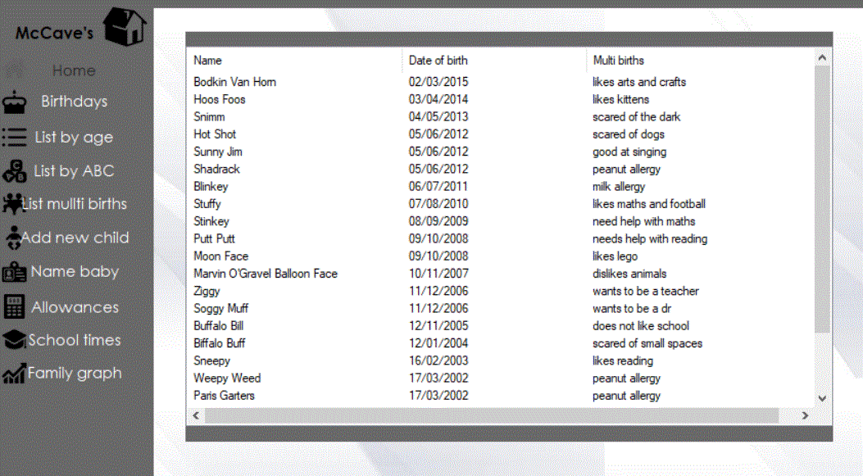

A lot of thought went into designing the GUI. It was important we got the right balance of colours right. The colour combination of the silver abstract background along with a grey side menu with black icons and white font gives the GUI a very eloquent look.

### Menu Side bar

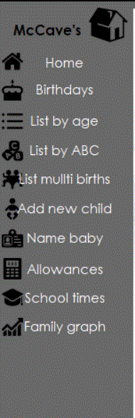

The menu sidebar is achieved by using a grey panel with 10 buttons to navigate the different sections of the form with the text of the buttons used as the labels. A dim grey colour is used. Black picture icons are used to represent each section of the desktop app.

### Listview

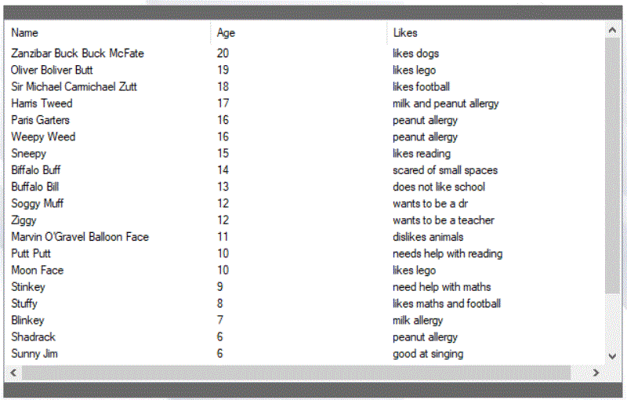

An 841 x 456 list view with a grey panel at both the top and bottom and a white back colour is used to display the data.

### Form background



This 1124 x 574 image was used as the forms background image which really gave the form a sleek look.

### Side panel

A 924x10 panel was used at the very top of the form to add an extra feature of design.



### User Input

Simple text boxes and a button is used to retrieve data from a user

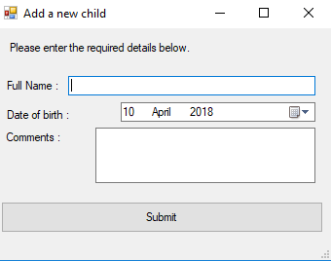

# Code

This section of the documentation will demonstrate key snippets of code from the main functions within the project.

**Class Person**

The main class within the program is the person class. It has three properties used to describe the name, date of birth and comment of each child.

## Test results

### Option 1 – List birthdays in the next 7 day’s

Condition - Shot”,10/04/2012,scared of dogs is the only child listed as having a birthday in the next 7 days. = TRUE

Test Result = Pass

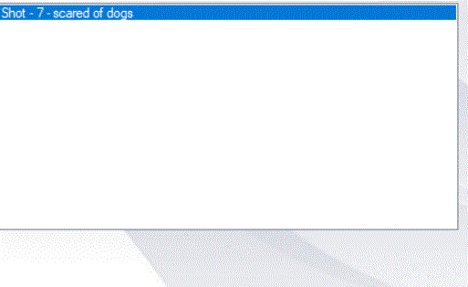

### Option 2 – List Children by age starting with the oldest first

Condition = Zanzibar Buck-Buck McFate is the oldest and Bodkin Van Horn is the youngest. = TRUE

Test Result = Pass

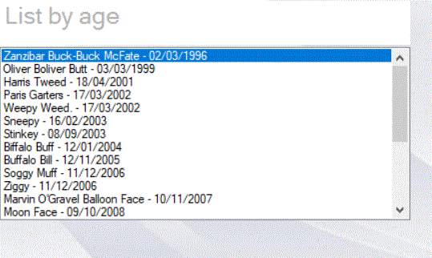

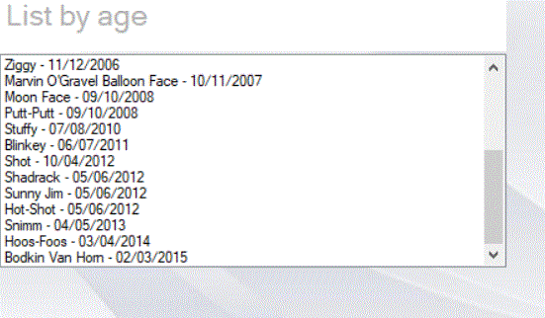

### Option 3 – List Children by ABC

Condition = Biffalo buff is at the top of the alphabetical order list = TRUE

Condition = Ziggy is at the bottom of alphabetical order list. = TRUE

Test Result = Pass

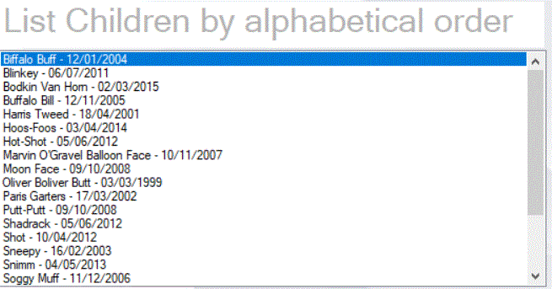

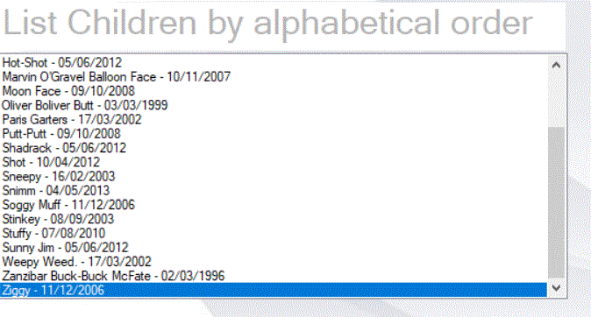

### Option 4 – List Children by Multibirth type

Condition - Putt-Putt,Moon-face,Ziggy,Soggy Muff, Weepy Weed,Paris Garters are listed as twins = TRUE

Condition - Hot-Shot,Sunny Jim and Shadrack are listed as triplets. = TRUE

Test Result = Pass

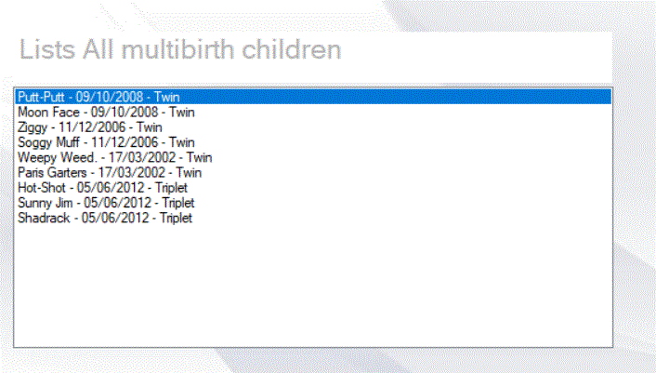

### Option 5 – Add Child

Test Result = Pass

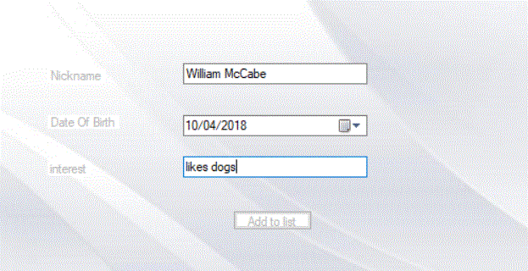

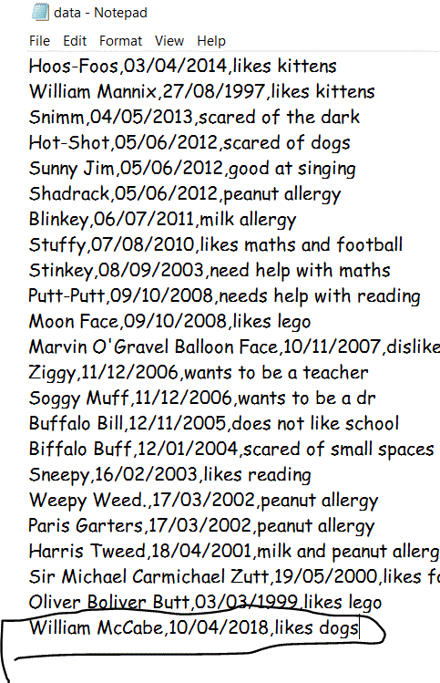

### Option 6 – Nickname Generator

Test Result = Pass

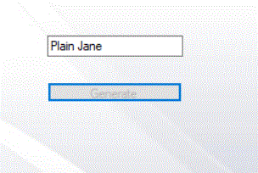

### Option 7 – List Children by Milestone

Test Result = Pass

