Chapter I: Methods
Initially, we used a variety of classification methods from scikit-learn to classify the OpenML Dataset (ID:4538). The data contains 9,873 samples and 5 gesture classes. From the initial tests, we choose 8 classification methods for the coursework. The chosen methods are:
- Logistic Regression without PCA (Peng, et al., 2002)
- Decision Tree with PCA (Mienye & Jere, 2024)
- Random Forest without PCA (Salman, et al., 2024)
- Gradient Boost with PCA (Chen, 2024 )
- Linear SVM without PCA (Ladicky & Torr, 2019 )
- RBF SVM with PCA (Cao, et al., 2008)
- KNN without PCA (Zhang, 2016)
- Adaptive Boost with PCA (Mangina, 2024)
PCA was used to demonstrate how the dimensional reduction could affect the learning. (Salem & Sahar Hussein, 2019) Most of the code were written by copying from scikit-learn initially. In final stages, the methods were put into an array, and we performed grid search with balanced accuracy as the target on the array. Finally, we chose the best parameters each method for the final evaluation of the methods.

Tuned Hyper Parameter
We used grid search to find the best parameters for each model. We used the following parameters for our final models:
- Logistic Regression without PCA: C= 0.1, solver= newton-cg
- Decision Tree with PCA: max_depth= 10, min_samples_leaf= 1, min_samples_split= 2, PCA components= 10
- Random Forest without PCA: n_estimators= 500, max_depth= None, min_samples_leaf= 5
- Gradient Boost with PCA: n_estimators= 400, learning_rate= 0.1, max_depth= 15, subsample= 0.8, PCA components= 20
- Linear SVM without PCA: C = 10, loss = squared hinge, dual = False
- RBF SVM with PCA: C = 10, gamma = 0.1, PCA components = 15
- KNN without PCA: n_neighbors = 1, metric = Manhattan, weights = uniform
- Adaptive Boost with PCA: n_estimators = 500, learning_rate = 1, PCA components = 20

Chapter II: Results
The final performance of models was evaluated using multiple scoring metrics. The metrics such as balanced accuracy, accuracy, precision, recall, F1 and AUC were used to measure. The results will be shown with a table below.
All the scores in the table are higher the better. The best scores will be highlighted with bold and underline in the table.
Table 1: Evaluation metrics of classification models
Evaluation Metrics | Balanced Accuracy | Accuracy | Recall |  | Precision |  | F1 |  | AUC
Classification Methods |  |  | Micro | Macro | Micro | Macro | Micro | Macro | Micro | Macro
Logistic Regression  without PCA | 0.4363 | 0.4406 | 0.4406 | 0.4363 | 0.4406 | 0.4262 | 0.4406 | 0.4098 | 0.7580 | 0.7546
Decision Tree  with PCA | 0.4814 | 0.4730 | 0.4730 | 0.4814 | 0.4730 | 0.4626 | 0.4730 | 0.4519 | 0.7409 | 0.7591
Random Forest  without PCA | 0.6045 | 0.6313 | 0.6313 | 0.6045 | 0.6313 | 0.6073 | 0.6313 | 0.6023 | 0.8774 | 0.8887
Gradient Boost  with PCA | 0.5982 | 0.6671 | 0.6671 | 0.5982 | 0.6671 | 0.6920 | 0.6671 | 0.6219 | 0.8840 | 0.8977
Linear SVM  without PCA | 0.4085 | 0.4676 | 0.4676 | 0.4085 | 0.4676 | 0.4386 | 0.4676 | 0.3958 | 0.7482 | 0.7576
RBF SVM  with PCA | 0.4985 | 0.5354 | 0.5354 | 0.4985 | 0.5354 | 0.4987 | 0.5354 | 0.4934 | 0.7911 | 0.8018
KNN  without PCA | 0.6354 | 0.6594 | 0.6594 | 0.6354 | 0.6594 | 0.6421 | 0.6594 | 0.6373 | 0.7732 | 0.7871
Adaptive Boost  with PCA | 0.3784 | 0.4649 | 0.4649 | 0.3784 | 0.4649 | 0.4101 | 0.4649 | 0.3588 | 0.7578 | 0.7885
The Confusion Matrix for Gradient Boost will be presented since they have highest scores in different metrics.
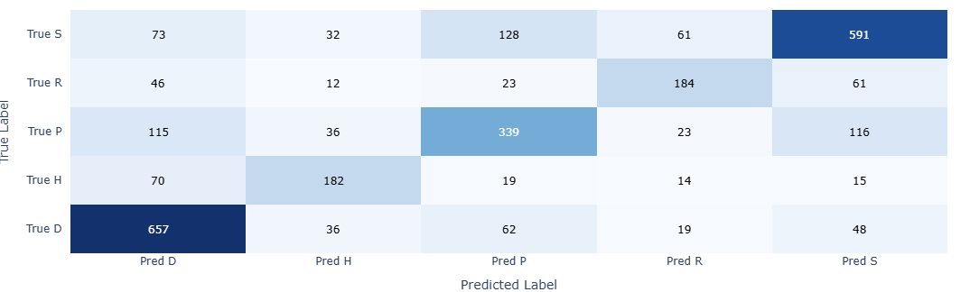
Figure 1: Confusion Matrix KNN
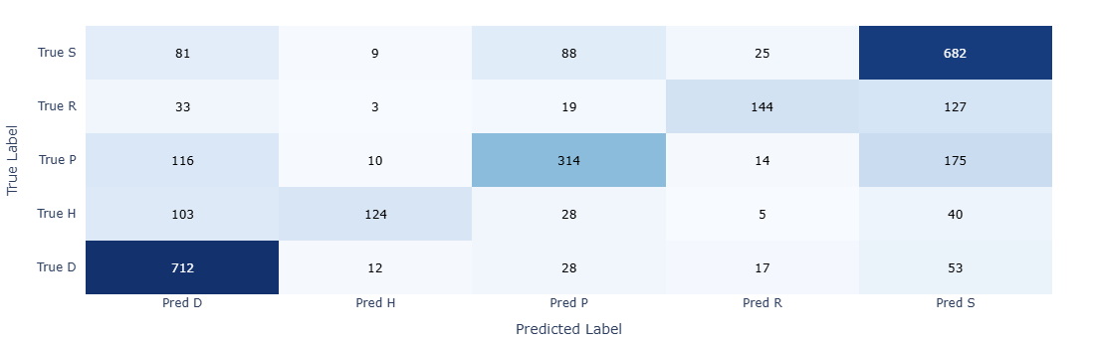
Figure 2: Confusion Matrix Gradient Boost (PCA)

Chapter III: Conclusion
- KNN have the most balanced performance across the different classes, as seen in Confusion Matrix KNN (Figure 1).
This is because KNN predicts the classes based on local neighbourhoods in the space. Thus, KNN does not learn of a global decision boundary and the predictions distributes more equally among classes. This reduces the class bias and allow more minority class to be correctly classified. However, this allows the model to more sensitive to the noise in the data.
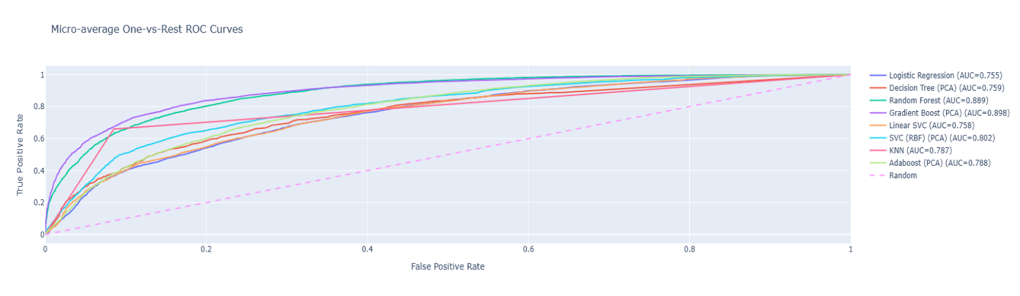
Figure 3: Micro-Average ROC Curves
- Gradient Boost has the strongest overall scores across different evaluation methods, as seen in (Table 1) and (Figure 3).
This performance due to the nature of the method where the prediction accuracy is increased by combining the decision trees sequentially. When we assess at the (Table 1), we can see the decision tree already showing strong predictions. While the method does have bias towards dominant class as seen in confusion matrix (Figure 1), this method can be very effective depending on the scenario.
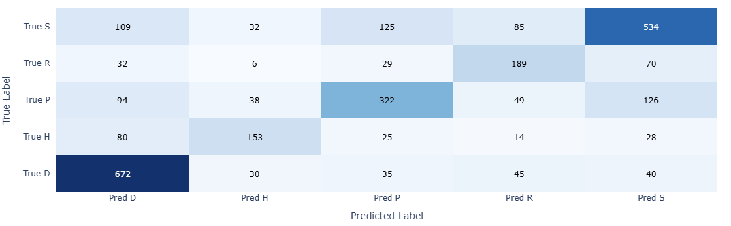
Figure 4: Random Forest Confusion Matrix
- Random Forest is the most optimal model for the dataset with slightly lower scores than Gradient Boost and similar distribution as KNN, as seen in (Table 1) and comparison between (Figure 1) and (Figure 4).
Random Forest may have slightly lower metrics scores when compared to the gradient boost. However, random forest is better for most scenarios since it is generally robust against overfitting. Moreover, gradient boost requires more training time and can be overfitted if it is not properly tuned. Overall, Random Forest is the most optimal model for this dataset due to its flexibility and robustness against overfitting.

References
Cao, H., Naito, T. & Ninomiya, Y., 2008. Introduction. In: Low-Power High-Speed ADCs for Nanometer CMOS Integration. Analog Circuits and Signal Processing Series.. s.l.:Springer, Dordrecht.
Chen, H.-H., 2024 . Understanding Gradient Boosting Classifier: Training, Prediction, and the Role of.
Ladicky, L. & Torr, P. H. S., 2019 . Locally Linear Support Vector Machines. s.l.:0minpress.
Mangina, V. S. R. S. H., 2024. Adaptive boosting with dynamic weight adjustment.
Mienye, I. D. & Jere, N., 2024. A Survey of Decision Trees: Concepts, Algorithms, and Applications.
Peng, C.-Y. J., Lee, K. L. & Ingersoll, G. M., 2002. An Introduction to Logistic Regression Analysis and Reporting. The Journal of Educational Research.
Salem, N. & Sahar Hussein, 2019. Data dimensional reduction and principal components analysis. Procedia Computer Science, pp. 292-299.
Salman, H., Kalakech, A. & Steiti, A., 2024. Random Forest Algorithm Overview. Babylonian Journal of Machine Learning, p. 69–79.
Zhang, Z., 2016. Introduction to machine learning: k-nearest neighbors. Annals of Translational Medicine, Volume 4.

Appendix I – Use of Generative AI
This submission is my own independent work and all sources used in the submission are referenced. Generative AI was USED for this submission, as outlined by the relevant references. For each reference, I provide a full record of prompts given to the generative AI tool, and responses received below. I have also included references that acknowledge the usage of AI in the reference list of this coursework, based on the guidance provided.
Generative AI tool used: ChatGPT (OpenAI)
Record of use: “Help me understand the overview of coursework”
Response: Provided overview for the coursework materials.

Appendix II – Self Evaluation
For this coursework, our team worked individually in the initial stage. During this stage, we trained all presented models in the assignment with and without dimensional reduction. Finally, we randomly chose 8 models out of it and compile it into a notebook. I believe everyone contributed equally to the group project.
Project Part | Weight | Mark  (0-10) | Henry Longe  k2552174 | Nsetu Tarimo  k2604076 | Thaw Zin Lin Myat  k2543493 | Henry Akwarandu  k2557070
I. Code | 4 | 10 | 5 | 4 | 5 | 3
II. Report | 6 | 10

