CI7521_CW1_05032026_1900

Coursework 1 Group (text)¶
Group number: 9
Student names and k-numbers:
- Henry Longe - k2552174
- Nsetu Tarimo - k2604076
- Thaw Zin Lin Myat - k2543493
- Henry Akwarandu - k2557070

Load modules (code)¶
In [12]:
import pandas as pd
import numpy as np
# import matplotlib.pyplot as plt
# import seaborn as sns
import plotly.graph_objects as go
import plotly.figure_factory as ff
from sklearn.model_selection import train_test_split
#sklearn classification models
from sklearn.linear_model import LogisticRegression
from sklearn.tree import DecisionTreeClassifier
from sklearn.ensemble import RandomForestClassifier
from sklearn.neighbors import KNeighborsClassifier
from sklearn.svm import LinearSVC
from sklearn.svm import SVC
# from sklearn.naive_bayes import GaussianNB
from sklearn.ensemble import GradientBoostingClassifier
from sklearn.ensemble import AdaBoostClassifier
#Pipeline
from sklearn.pipeline import Pipeline
#preprocessing
from sklearn.preprocessing import StandardScaler
from sklearn.preprocessing import RobustScaler
from sklearn.preprocessing import LabelEncoder
from sklearn.preprocessing import label_binarize
#Dimensionality Reduction
from sklearn.decomposition import PCA
#Hyperparameter Tuning
from sklearn.model_selection import GridSearchCV
#Evaluation Metrics
from sklearn.metrics import balanced_accuracy_score
from sklearn.metrics import roc_auc_score
from sklearn.metrics import roc_curve
from sklearn.metrics import accuracy_score
from sklearn.metrics import precision_score
from sklearn.metrics import recall_score
from sklearn.metrics import f1_score
#Confusion Matrix
from sklearn.metrics import confusion_matrix

Load data¶
In [13]:
#data load
from sklearn.datasets import fetch_openml
dataset = fetch_openml(data_id=4538, as_frame=False) # fetch the dataset

Checking Integrity and Train Test Split¶
In [14]:
# X and y
X = dataset.data
y = dataset.target
print("The shape of the Features are: ", X.shape)
print("The shape of the Target is: ",y.shape)
#checking integrity of data
distribution = np.unique(y, return_counts=True)
isnan = np.isnan(X).sum()
print("General distribution of data :", distribution)
print("Number of Null values (Nans) in dataset: ", isnan)
The shape of the Features are: (9873, 32)
The shape of the Target is: (9873,)
General distribution of data : (array(['D', 'H', 'P', 'R', 'S'], dtype=object), array([2741, 998, 2097, 1087, 2950]))
Number of Null values (Nans) in dataset: 0

Isolation Outlier Detection¶
In [15]:
from sklearn.ensemble import IsolationForest
iso = IsolationForest(
contamination=0.05,
random_state=42
)
outlier_labels = iso.fit_predict(X)
# -1 = outlier, 1 = inlier
n_outliers = (outlier_labels == -1).sum()
print("Detected outliers:", n_outliers)
Detected outliers: 494

Train Test Split¶
In [16]:
#train test split
X_train, X_test, y_train, y_test = train_test_split(X, y, train_size=0.7, test_size=0.3, stratify=y, random_state=42)
print(f"The shape of the training dataset is: Features: {X_train.shape} Target: {np.unique(y_train)}")
print(f"The shape of the testing dataset is: Features: {X_test.shape} Target: {np.unique(y_test)}")
le = LabelEncoder()
y_train_enc = le.fit_transform(y_train)
y_test_enc = le.transform(y_test)
print(f"The following training target labels {np.unique(y_train)} have been encoded into {np.unique(y_train_enc)}")
print(f"The following testing target labels {np.unique(y_test)} have been encoded into {np.unique(y_test_enc)}")
The shape of the training dataset is: Features: (6911, 32) Target: ['D' 'H' 'P' 'R' 'S']
The shape of the testing dataset is: Features: (2962, 32) Target: ['D' 'H' 'P' 'R' 'S']
The following training target labels ['D' 'H' 'P' 'R' 'S'] have been encoded into [0 1 2 3 4]
The following testing target labels ['D' 'H' 'P' 'R' 'S'] have been encoded into [0 1 2 3 4]

Classification¶

Classification methods used (text)¶
- Logistic Regression without PCA cite: https://scikit-learn.org/stable/modules/linear_model.html#logistic-regression
- Decision Tree with PCA cite: https://scikit-learn.org/stable/modules/tree.html
- Random Forest without PCA cite: https://scikit-learn.org/stable/modules/ensemble.html
- Gradient Boost with PCA cite: https://scikit-learn.org/stable/modules/ensemble.html
- Linear SVM without PCA cite: https://scikit-learn.org/stable/modules/generated/sklearn.svm.LinearSVC.html
- RBF SVM with PCA cite: https://scikit-learn.org/stable/api/sklearn.svm.html
- KNN without PCA cite: https://scikit-learn.org/stable/modules/generated/sklearn.neighbors.KNeighborsClassifier.html
- Adaptive Boost with PCA cite: https://scikit-learn.org/stable/modules/generated/sklearn.ensemble.AdaBoostClassifier.html

Training (code)¶

Tuning Hyperparameters¶
In [6]:
#hyperparameter tuning with and finding out the best hyper parameter
models_tuning = {
"Logistic Regression": (
Pipeline([
("scaler", RobustScaler()),
("lg", LogisticRegression(
max_iter=2000,
class_weight="balanced",
random_state=42
))
]),
{
"lg__C": [0.001, 0.01, 0.1, 1, 10,100],
"lg__solver": ['lbfgs', 'saga', 'newton-cg']
}
),
"Decision Tree (PCA)": (
Pipeline([
("pca", PCA()),
("dt", DecisionTreeClassifier(
class_weight="balanced",
random_state=42
))
]),
{
"pca__n_components": [5 ,10 ,15 ,20],
"dt__max_depth": [None ,1 , 5 , 10, 20],
"dt__min_samples_split": [2, 5, 10],
"dt__min_samples_leaf": [1, 5, 10]
}
),
"Random Forest": (
Pipeline([
("rf", RandomForestClassifier(
class_weight="balanced",
random_state=42
))
]),
{
"rf__n_estimators": [200, 500],
"rf__max_depth": [None,3,5,7],
"rf__min_samples_leaf": [5, 10, 15]
}
),
"Gradient Boost (PCA)": (
Pipeline([
("pca", PCA()),
("gb", GradientBoostingClassifier(random_state=42))
]),
{
"pca__n_components": [5,10,15,20],
"gb__n_estimators": [200,400],
"gb__learning_rate": [0.01,0.1,1],
"gb__max_depth": [5,10,15],
"gb__subsample": [0.8,1.0]
}
),
"Linear SVC": (
Pipeline([
("scaler", StandardScaler()),
("clf", LinearSVC(
class_weight="balanced",
max_iter=5000
))
]),
{
"clf__C": [1e-4, 1e-3, 1e-2, 1e-1, 1, 10, 100],
"clf__loss": ["squared_hinge"],
"clf__dual": [False]
}
),
"SVC [RBF] (PCA)": (
Pipeline([
("scaler", StandardScaler()),
("pca", PCA()),
("clf", SVC(
kernel="rbf",
class_weight="balanced",
probability=False
))
]),
{
"pca__n_components": [5 ,10 ,15 ,20],
"clf__C": [0.1, 1, 10, 100],
"clf__gamma": [0.001, 0.01, 0.1]
}
),
"KNN": (
Pipeline([
("scaler", StandardScaler()),
("clf", KNeighborsClassifier(
algorithm="brute",
))
]),
{
"clf__n_neighbors": list(range(1, 51, 2)),
"clf__weights": ["uniform", "distance"],
"clf__metric": ["euclidean", "manhattan"]
}
),
"Adaboost (PCA)": (
Pipeline([
("pca", PCA()),
("ada", AdaBoostClassifier(random_state=42))
]),
{
"pca__n_components": [5,10,15,20],
"ada__n_estimators": [200, 400, 500],
"ada__learning_rate": [0.01, 0.1, 1],
}
)
}
tuned_results = {}
best_models = {}
best_params ={}
for name, (model, params) in models_tuning.items():
grid = GridSearchCV(
model,
params,
scoring="balanced_accuracy",
cv=5,
n_jobs=-1
)
grid.fit(X_train, y_train_enc)
best_model = grid.best_estimator_
y_pred = best_model.predict(X_test)
acc = balanced_accuracy_score(y_test_enc, y_pred)
tuned_results[name] = acc
best_models[name] = best_model
best_params[name] = grid.best_params_
In [7]:
# Print Tuned Results for each different model
print("\nTuned Results (Balanced Accuracy):")
for k, v in tuned_results.items():
print(f"{k}: {v:.4f}")
Tuned Results (Balanced Accuracy):
Logistic Regression: 0.4363
Decision Tree (PCA): 0.4814
Random Forest: 0.6045
Gradient Boost (PCA): 0.5982
Linear SVC: 0.4085
SVC [RBF] (PCA): 0.4985
KNN: 0.6354
Adaboost (PCA): 0.3784
In [19]:
# Print Best Models for each different model
print("\nBest Model:")
for k, v in best_models.items():
print(f"{k}: {v}")
Best Model:
Logistic Regression: Pipeline(steps=[('scaler', RobustScaler()),
('lg',
LogisticRegression(C=0.1, class_weight='balanced',
max_iter=2000, random_state=42,
solver='newton-cg'))])
Decision Tree (PCA): Pipeline(steps=[('pca', PCA(n_components=10)),
('dt',
DecisionTreeClassifier(class_weight='balanced', max_depth=10,
random_state=42))])
Random Forest: Pipeline(steps=[('rf',
RandomForestClassifier(class_weight='balanced',
min_samples_leaf=5, n_estimators=500,
random_state=42))])
Gradient Boost (PCA): Pipeline(steps=[('pca', PCA(n_components=20)),
('gb',
GradientBoostingClassifier(max_depth=15, n_estimators=400,
random_state=42, subsample=0.8))])
Linear SVC: Pipeline(steps=[('scaler', StandardScaler()),
('clf',
LinearSVC(C=10, class_weight='balanced', dual=False,
max_iter=5000))])
SVC [RBF] (PCA): Pipeline(steps=[('scaler', StandardScaler()), ('pca', PCA(n_components=15)),
('clf', SVC(C=10, class_weight='balanced', gamma=0.1))])
KNN: Pipeline(steps=[('scaler', StandardScaler()),
('clf',
KNeighborsClassifier(algorithm='brute', metric='manhattan',
n_neighbors=1))])
Adaboost (PCA): Pipeline(steps=[('pca', PCA(n_components=20)),
('ada',
AdaBoostClassifier(learning_rate=1, n_estimators=500,
random_state=42))])
In [20]:
# Print Best Hyperparameters for each different model
print("\nBest Hyperparameter:")
for k, v in best_params.items():
print(f"{k}: {v}")
Best Hyperparameter:
Logistic Regression: {'lg__C': 0.1, 'lg__solver': 'newton-cg'}
Decision Tree (PCA): {'dt__max_depth': 10, 'dt__min_samples_leaf': 1, 'dt__min_samples_split': 2, 'pca__n_components': 10}
Random Forest: {'rf__max_depth': None, 'rf__min_samples_leaf': 5, 'rf__n_estimators': 500}
Gradient Boost (PCA): {'gb__learning_rate': 0.1, 'gb__max_depth': 15, 'gb__n_estimators': 400, 'gb__subsample': 0.8, 'pca__n_components': 20}
Linear SVC: {'clf__C': 10, 'clf__dual': False, 'clf__loss': 'squared_hinge'}
SVC [RBF] (PCA): {'clf__C': 10, 'clf__gamma': 0.1, 'pca__n_components': 15}
KNN: {'clf__metric': 'manhattan', 'clf__n_neighbors': 1, 'clf__weights': 'uniform'}
Adaboost (PCA): {'ada__learning_rate': 1, 'ada__n_estimators': 500, 'pca__n_components': 20}

Hypertuned models¶
In [17]:
models = {
# Logistic Regression
"Logistic Regression": (
Pipeline([
("scaler", RobustScaler()),
("lr", LogisticRegression(
max_iter=2000,
class_weight="balanced",
random_state=42
))
]),
{
"lr__C":0.1,
"lr__solver": 'newton-cg',
}
),
# Decision Tree
"Decision Tree (PCA)": (
Pipeline([
("pca", PCA()),
("dt", DecisionTreeClassifier(
class_weight="balanced",
random_state=42
))
]),
{
"dt__max_depth": 10,
"dt__min_samples_leaf": 1,
"dt__min_samples_split": 2,
"pca__n_components": 10,
}
),
# Random Forest
"Random Forest": (
Pipeline([
("rf", RandomForestClassifier(
n_estimators=500,
max_depth=None,
min_samples_leaf=5,
class_weight="balanced",
random_state=42
))
]),
{
"rf__n_estimators":500,
"rf__max_depth": None,
"rf__min_samples_leaf": 5,
}
),
# Gradient Boost
"Gradient Boost (PCA)": (
Pipeline([
("pca", PCA()),
("gb", GradientBoostingClassifier(
random_state=42
))
]),
{
"gb__n_estimators": 400,
"gb__learning_rate": 0.1,
"gb__max_depth": 15,
"gb__subsample":0.8,
"pca__n_components": 20,
}
),
# Linear SVC
"Linear SVC": (
Pipeline([
("scaler", StandardScaler()),
("lsvm", LinearSVC(
loss="squared_hinge",
dual=False,
class_weight="balanced",
max_iter=5000,
random_state=42
))
]),
{
"lsvm__C": 10,
"lsvm__loss": "squared_hinge",
}
),
# SVC RBF
"SVC (RBF) (PCA)": (
Pipeline([
("scaler", StandardScaler()),
("pca", PCA()),
("rbf", SVC(
kernel="rbf",
class_weight="balanced",
probability=False,
random_state=42
))
]),
{
"rbf__C": 10,
"rbf__gamma": 0.1,
"pca__n_components": 15,
}
),
# KNN
"KNN": (
Pipeline([
("scaler", StandardScaler()),
("knn", KNeighborsClassifier(
weights="uniform",
algorithm="brute",
))
]),
{
"knn__n_neighbors": 1,
"knn__metric": "manhattan",
}
),
"Adaboost (PCA)": (
Pipeline([
("pca", PCA()),
("ada", AdaBoostClassifier(random_state=42))
]),
{
"pca__n_components": 20,
"ada__n_estimators": 500,
"ada__learning_rate": 1,
}
),
}

Evaluation (code)¶

Evaluate function¶
In [18]:
def evaluate_models(models, X_train, X_test, y_train, y_test, label_encoder=None):
encoded_classes = np.unique(y_train)
if label_encoder is not None:
classes = label_encoder.classes_
else:
classes = encoded_classes
n_classes = len(np.unique(y_train))
y_test_bin = label_binarize(y_test, classes=np.unique(y_train))
results = {}
metrics = {}
macro_rocs = {}
micro_rocs = {}
for name, (pipeline, params) in models.items():
# Set parameters
if params:
pipeline.set_params(**params)
# Wrap in OneVsRest for ROC computation
clf = pipeline
clf.fit(X_train, y_train)
y_pred = clf.predict(X_test)
# Balanced Accuracy
bal_acc = balanced_accuracy_score(y_test, y_pred)
# Get probability
if hasattr(clf, "predict_proba"):
y_score = clf.predict_proba(X_test)
else:
y_score = clf.decision_function(X_test)
#Accuracy Score
acc = accuracy_score(y_test, y_pred)
#Recall Score
micro_rec = recall_score(y_test, y_pred, average= 'micro')
macro_rec = recall_score(y_test, y_pred, average= 'macro')
#Precision Score
micro_pre = precision_score(y_test, y_pred, average= 'micro', zero_division=0)
macro_pre = precision_score(y_test, y_pred, average= 'macro', zero_division=0)
#F1 Score
micro_f1 = f1_score(y_test, y_pred, average= 'micro')
macro_f1 = f1_score(y_test, y_pred, average= 'macro')
# ROC AUC
macro_auc = roc_auc_score(y_test_bin, y_score, average="macro")
micro_auc = roc_auc_score(y_test_bin, y_score, average="micro")
# #Just some Prints
# print(f"Balanced Accuracy: {bal_acc:.4f}")
# print(f"Macro-average OvR ROC AUC: {macro_auc:.4f}")
# print(f"Micro-average OvR ROC AUC: {micro_auc:.4f}")
# ---- Micro ROC ----
fpr_micro, tpr_micro, _ = roc_curve(
y_test_bin.ravel(), y_score.ravel()
)
per_class = {}
fpr_dict = {}
tpr_dict = {}
for i in range(n_classes):
fpr_i, tpr_i, _ = roc_curve(
y_test_bin[:, i], y_score[:, i]
)
per_class[i] = (fpr_i, tpr_i)
fpr_dict[i] = fpr_i
tpr_dict[i] = tpr_i
# ---- Macro ROC ----
all_fpr = np.unique(
np.concatenate([fpr_dict[i] for i in range(n_classes)])
)
mean_tpr = np.zeros_like(all_fpr)
for i in range(n_classes):
mean_tpr += np.interp(all_fpr, fpr_dict[i], tpr_dict[i])
mean_tpr /= n_classes
macro_rocs[name] = (all_fpr, mean_tpr)
micro_rocs[name] = (fpr_micro,tpr_micro)
#Confusion Matrix
cm = confusion_matrix(y_test, y_pred, labels=encoded_classes)
#results
results[name] = {
"balanced_accuracy": bal_acc,
"accuracy": acc,
"micro_recall": micro_rec,
"macro_recall": macro_rec,
"micro_precision": micro_pre,
"macro_precision": macro_pre,
"micro_f1": micro_f1,
"macro_f1": macro_f1,
"macro_auc": macro_auc,
"micro_auc": micro_auc,
"confusion_matrix": cm,
"roc": {
"macro": macro_rocs[name],
"micro": micro_rocs[name],
"per_class": per_class
}
}
metrics[name] ={
"balanced_accuracy": bal_acc,
"accuracy": acc,
"micro_recall": micro_rec,
"macro_recall": macro_rec,
"micro_precision": micro_pre,
"macro_precision": macro_pre,
"micro_f1": micro_f1,
"macro_f1": macro_f1,
"macro_auc": macro_auc,
"micro_auc": micro_auc,
}
# =============================
# Summary Table
# =============================
print("\n" + "="*80)
print("Model PERFORMANCE SUMMARY")
print("="*80)
for name, result_metrics in results.items():
print(f"{name}")
print(f" Balanced Accuracy: {result_metrics['balanced_accuracy']:.4f}")
print(f" Accuracy: {result_metrics['accuracy']:.4f}")
print(f" Micro Recall: {result_metrics['micro_recall']:.4f}")
print(f" Macro Recall: {result_metrics['macro_recall']:.4f}")
print(f" Micro Precision: {result_metrics['micro_precision']:.4f}")
print(f" Macro Precision: {result_metrics['macro_precision']:.4f}")
print(f" Micro F1: {result_metrics['micro_f1']:.4f}")
print(f" Macro-average ROC AUC: {result_metrics['macro_auc']:.4f}")
print(f" Micro-average ROC AUC: {result_metrics['micro_auc']:.4f}")
print("-"*60)
return results, classes, metrics

Plot Functions¶
In [19]:
def plot_macro_roc(results):
fig = go.Figure()
for name, res in results.items():
fpr, tpr = res["roc"]["macro"]
auc = res["macro_auc"]
fig.add_trace(go.Scatter(
x=fpr,
y=tpr,
mode="lines",
name=f"{name} (AUC={auc:.3f})"
))
fig.add_trace(go.Scatter(
x=[0, 1],
y=[0, 1],
mode="lines",
line=dict(dash="dash"),
name="Random"
))
fig.update_layout(
title="Macro-average One-vs-Rest ROC Curves",
xaxis_title="False Positive Rate",
yaxis_title="True Positive Rate"
)
fig.show()
In [20]:
def plot_micro_roc(results):
fig = go.Figure()
for name, res in results.items():
fpr, tpr = res["roc"]["micro"]
auc = res["micro_auc"]
fig.add_trace(go.Scatter(
x=fpr,
y=tpr,
mode="lines",
name=f"{name} (AUC={auc:.3f})"
))
fig.add_trace(go.Scatter(
x=[0, 1], y=[0, 1],
mode="lines",
line=dict(dash="dash"),
name="Random"
))
fig.update_layout(
title="Micro-average One-vs-Rest ROC Curves",
xaxis_title="False Positive Rate",
yaxis_title="True Positive Rate"
)
fig.show()
In [21]:
def plot_per_class_roc(results, classes):
for i, cls in enumerate(classes):
fig = go.Figure()
for name, res in results.items():
fpr, tpr = res["roc"]["per_class"][i]
fig.add_trace(go.Scatter(
x=fpr,
y=tpr,
mode="lines",
name=name
))
fig.add_trace(go.Scatter(
x=[0, 1], y=[0, 1],
mode="lines",
line=dict(dash="dash"),
name="Random"
))
fig.update_layout(
title=f"One-vs-Rest ROC Curves – Class {cls}",
xaxis_title="False Positive Rate",
yaxis_title="True Positive Rate"
)
fig.show()
In [22]:
def plot_confusion_matrices(results, classes):
for name, res in results.items():
cm = res["confusion_matrix"]
fig = ff.create_annotated_heatmap(
z=cm,
x=[f"Pred {c}" for c in classes],
y=[f"True {c}" for c in classes],
colorscale="Blues"
)
fig.update_layout(
title=f"Confusion Matrix – {name}",
xaxis=dict(title="Predicted Label", side="bottom"),
yaxis=dict(title="True Label")
)
fig.show()

Results¶
In [23]:
results, classes, metrics = evaluate_models(
models, X_train, X_test, y_train_enc, y_test_enc, label_encoder=le
)
================================================================================
Model PERFORMANCE SUMMARY
================================================================================
Logistic Regression
Balanced Accuracy: 0.4363
Accuracy: 0.4406
Micro Recall: 0.4406
Macro Recall: 0.4363
Micro Precision: 0.4406
Macro Precision: 0.4262
Micro F1: 0.4406
Macro-average ROC AUC: 0.7580
Micro-average ROC AUC: 0.7546
------------------------------------------------------------
Decision Tree (PCA)
Balanced Accuracy: 0.4814
Accuracy: 0.4730
Micro Recall: 0.4730
Macro Recall: 0.4814
Micro Precision: 0.4730
Macro Precision: 0.4626
Micro F1: 0.4730
Macro-average ROC AUC: 0.7409
Micro-average ROC AUC: 0.7591
------------------------------------------------------------
Random Forest
Balanced Accuracy: 0.6045
Accuracy: 0.6313
Micro Recall: 0.6313
Macro Recall: 0.6045
Micro Precision: 0.6313
Macro Precision: 0.6073
Micro F1: 0.6313
Macro-average ROC AUC: 0.8774
Micro-average ROC AUC: 0.8887
------------------------------------------------------------
Gradient Boost (PCA)
Balanced Accuracy: 0.5982
Accuracy: 0.6671
Micro Recall: 0.6671
Macro Recall: 0.5982
Micro Precision: 0.6671
Macro Precision: 0.6920
Micro F1: 0.6671
Macro-average ROC AUC: 0.8840
Micro-average ROC AUC: 0.8977
------------------------------------------------------------
Linear SVC
Balanced Accuracy: 0.4085
Accuracy: 0.4676
Micro Recall: 0.4676
Macro Recall: 0.4085
Micro Precision: 0.4676
Macro Precision: 0.4386
Micro F1: 0.4676
Macro-average ROC AUC: 0.7482
Micro-average ROC AUC: 0.7576
------------------------------------------------------------
SVC (RBF) (PCA)
Balanced Accuracy: 0.4985
Accuracy: 0.5354
Micro Recall: 0.5354
Macro Recall: 0.4985
Micro Precision: 0.5354
Macro Precision: 0.4987
Micro F1: 0.5354
Macro-average ROC AUC: 0.7911
Micro-average ROC AUC: 0.8018
------------------------------------------------------------
KNN
Balanced Accuracy: 0.6354
Accuracy: 0.6594
Micro Recall: 0.6594
Macro Recall: 0.6354
Micro Precision: 0.6594
Macro Precision: 0.6421
Micro F1: 0.6594
Macro-average ROC AUC: 0.7732
Micro-average ROC AUC: 0.7871
------------------------------------------------------------
Adaboost (PCA)
Balanced Accuracy: 0.3784
Accuracy: 0.4649
Micro Recall: 0.4649
Macro Recall: 0.3784
Micro Precision: 0.4649
Macro Precision: 0.4101
Micro F1: 0.4649
Macro-average ROC AUC: 0.7578
Micro-average ROC AUC: 0.7885
------------------------------------------------------------
In [24]:
table_metrics = pd.DataFrame(metrics)
print("Performance Metrics")
print(table_metrics)
Performance Metrics
Logistic Regression Decision Tree (PCA) Random Forest \
balanced_accuracy 0.436341 0.481435 0.604517
accuracy 0.440581 0.472991 0.631330
micro_recall 0.440581 0.472991 0.631330
macro_recall 0.436341 0.481435 0.604517
micro_precision 0.440581 0.472991 0.631330
macro_precision 0.426232 0.462605 0.607254
micro_f1 0.440581 0.472991 0.631330
macro_f1 0.409769 0.451868 0.602325
macro_auc 0.758000 0.740902 0.877387
micro_auc 0.754603 0.759127 0.888672
Gradient Boost (PCA) Linear SVC SVC (RBF) (PCA) \
balanced_accuracy 0.598212 0.408458 0.498492
accuracy 0.667117 0.467589 0.535449
micro_recall 0.667117 0.467589 0.535449
macro_recall 0.598212 0.408458 0.498492
micro_precision 0.667117 0.467589 0.535449
macro_precision 0.692022 0.438588 0.498715
micro_f1 0.667117 0.467589 0.535449
macro_f1 0.621920 0.395816 0.493379
macro_auc 0.883979 0.748245 0.791108
micro_auc 0.897653 0.757644 0.801811
KNN Adaboost (PCA)
balanced_accuracy 0.635420 0.378383
accuracy 0.659352 0.464889
micro_recall 0.659352 0.464889
macro_recall 0.635420 0.378383
micro_precision 0.659352 0.464889
macro_precision 0.642117 0.410100
micro_f1 0.659352 0.464889
macro_f1 0.637278 0.358780
macro_auc 0.773209 0.757755
micro_auc 0.787095 0.788486

Plot Results¶
In [25]:
plot_macro_roc(results)
plot_micro_roc(results)
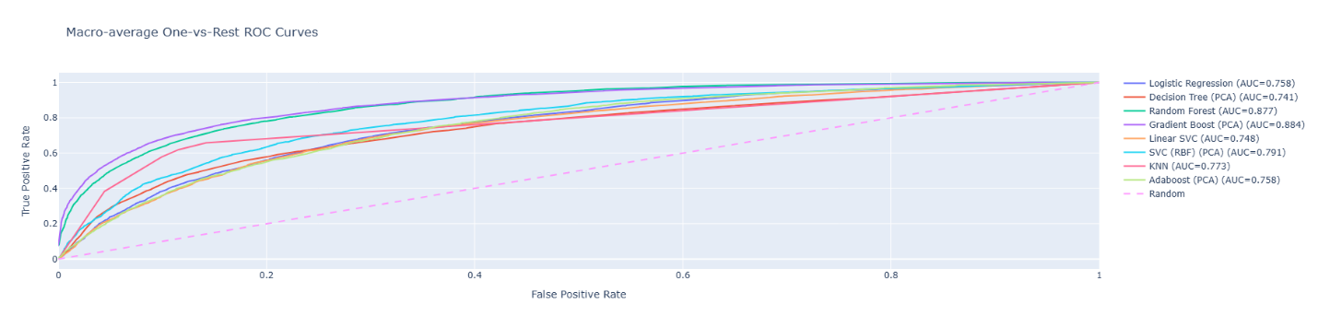
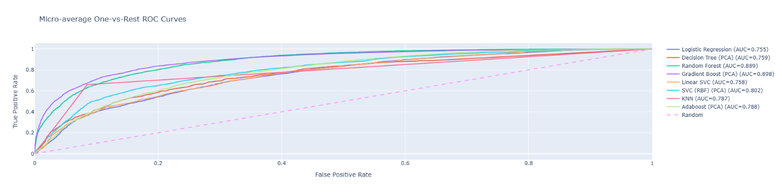

In [26]:
plot_per_class_roc(results, classes)
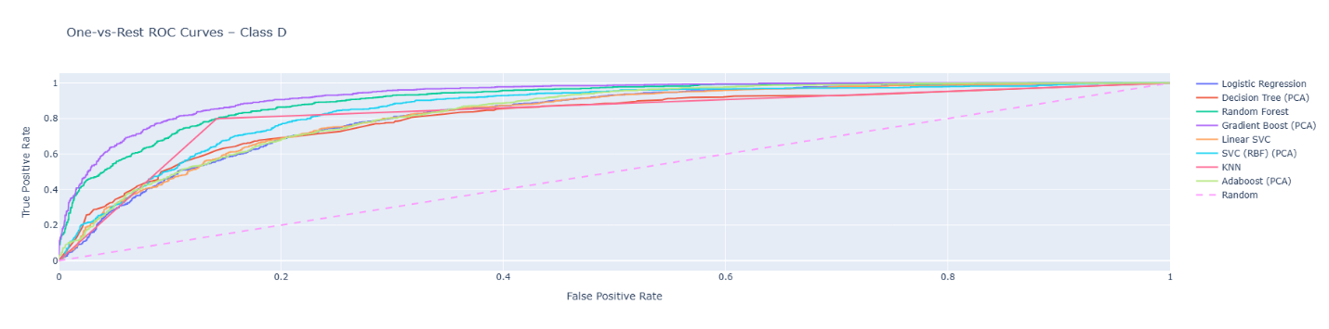
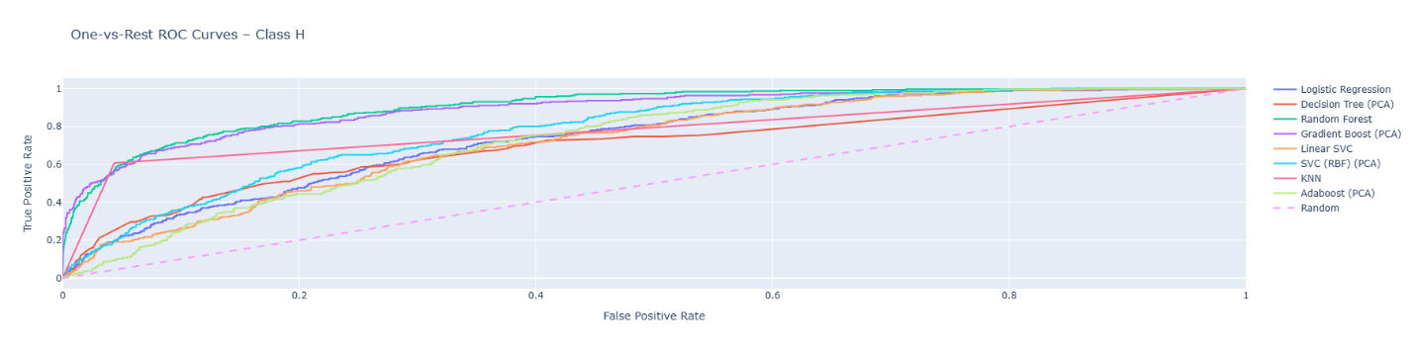
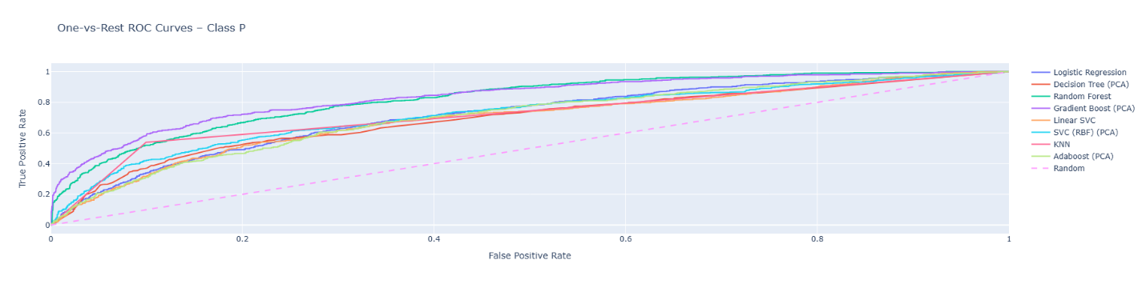
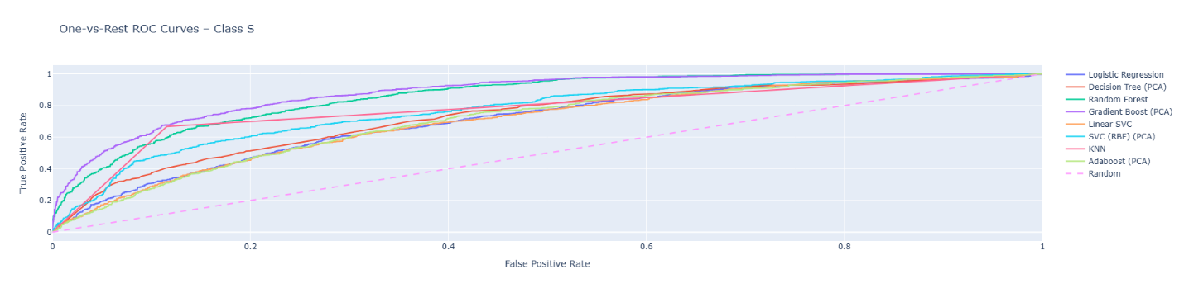
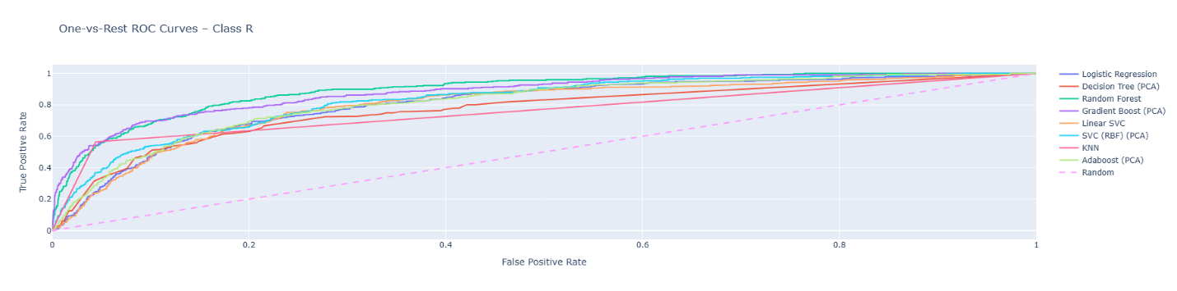

In [27]:
plot_confusion_matrices(results, classes)
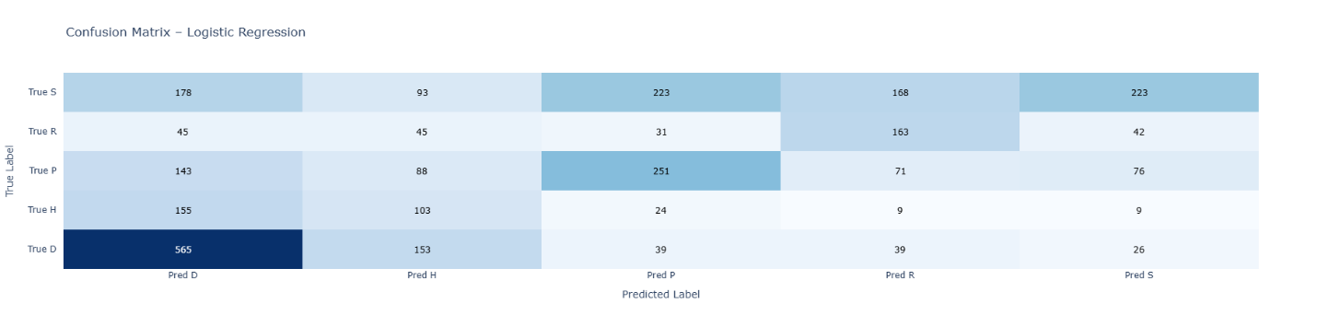
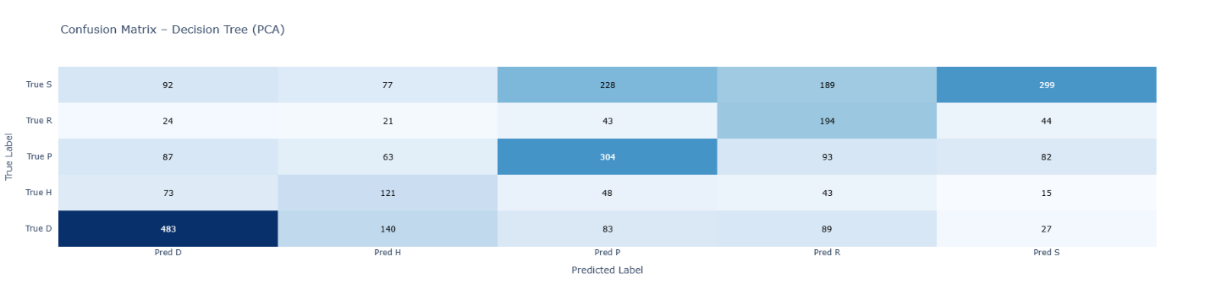
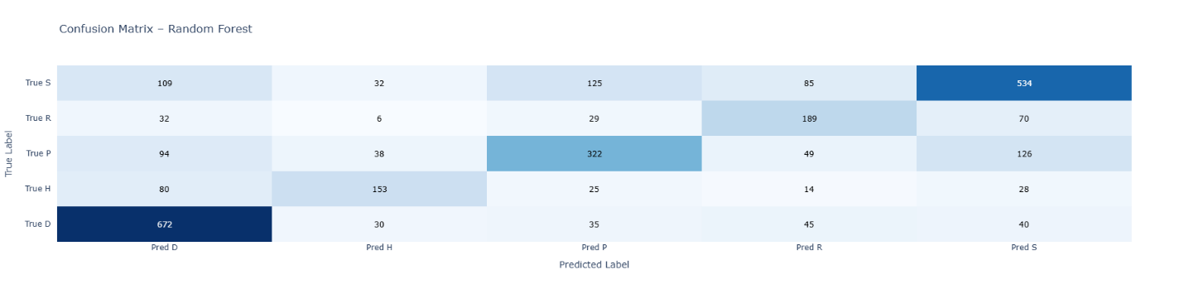
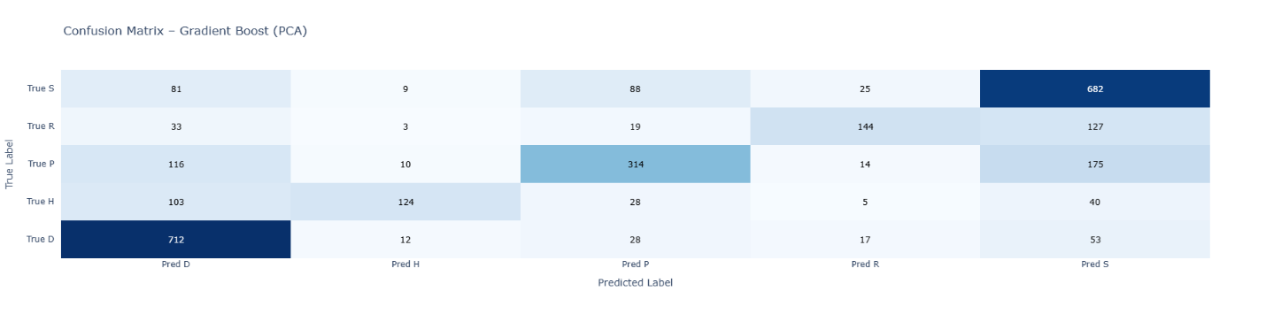
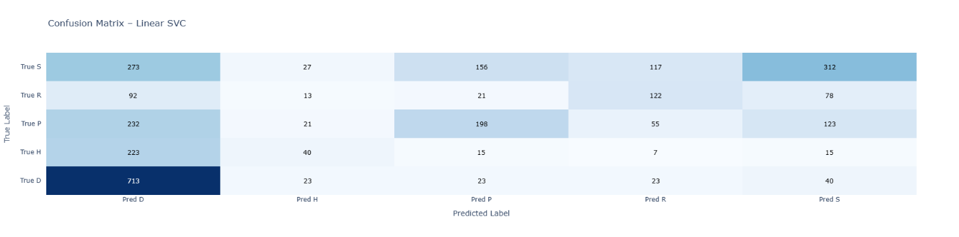
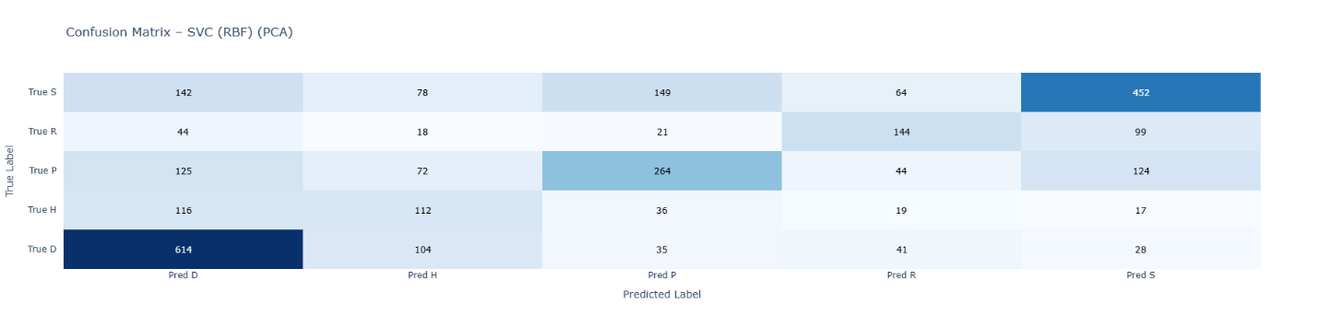
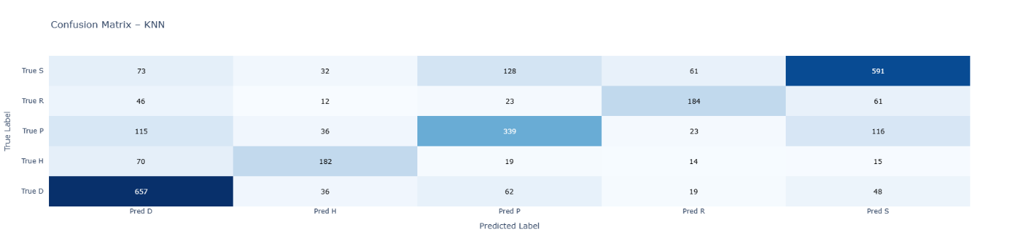
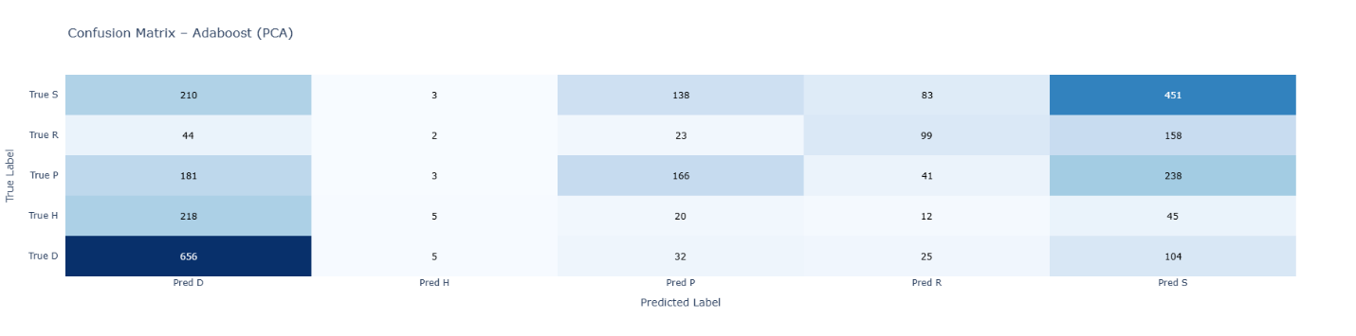

References (text)¶
- Logistic Regression without PCA cite: https://scikit-learn.org/stable/modules/linear_model.html#logistic-regression
- Decision Tree with PCA cite: https://scikit-learn.org/stable/modules/tree.html
- Random Forest without PCA cite: https://scikit-learn.org/stable/modules/ensemble.html
- Gradient Boost with PCA cite: https://scikit-learn.org/stable/modules/ensemble.html
- Linear SVM without PCA cite: https://scikit-learn.org/stable/modules/generated/sklearn.svm.LinearSVC.html
- RBF SVM with PCA cite: https://scikit-learn.org/stable/api/sklearn.svm.html
- KNN without PCA cite: https://scikit-learn.org/stable/modules/generated/sklearn.neighbors.KNeighborsClassifier.html
- Adaptive Boost with PCA cite: https://scikit-learn.org/stable/modules/generated/sklearn.ensemble.AdaBoostClassifier.html

