TDD Template
Contents
Variables: 2
Public: 2
Private: 2
Protected: 2
Getters and Setters: 2
Methods: 2
Public: 2
Private: 2
Protected: 2
Within Scriptable Objects: 2
Public: 2
Private: 3
Protected: 3
File Names: 3
Scripts: 3
Interfaces: 3
Textures: 3
Materials: 4
Models: 4
Animations: 4
Avatar Masks: 4
Prefabs: 4
Scriptable Objects: 4
Flow Graphs 5

Variables:

Public:
Transform SpawnPoint
float score
float start time
text Clock
float time passed
float totaltime
int minutes
int seconds

Private:
int lit
Rigidbody2D rb
transform PlayerPoint

Methods:

Public:
Start()
Update()
OnTriggerEnter2D()
FormatTime()
ScoreBoard()

File Names:

Duplicate objects:
Blade(1)
Blade(2)
Blade(3)
multiple Platforms
Multiple Spicks
Multiple Walls

Scripts:
Player
KeepScore

Sprites:
currently all boxes but will be
Player
Player_Move
Player_Up
Wall
Back
Spikes
Blade
Torch_Out
Torch_Lit

Animations:
variations on BladeMove (caused me some problems for some reason)
player jump?
player move?

Flow Graphs:
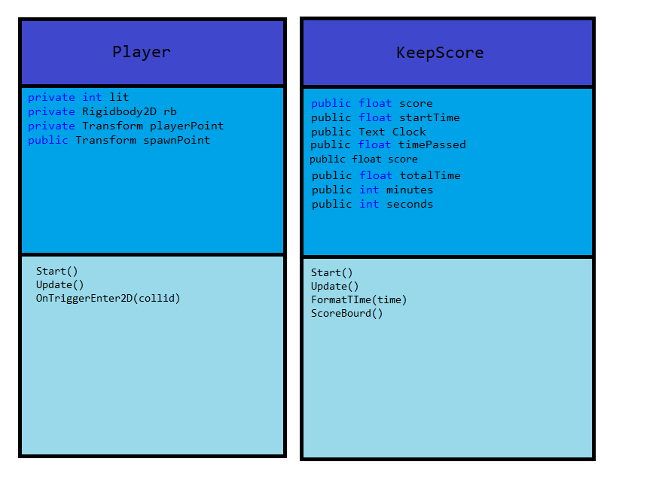
I accidentally put score on there twice.

