

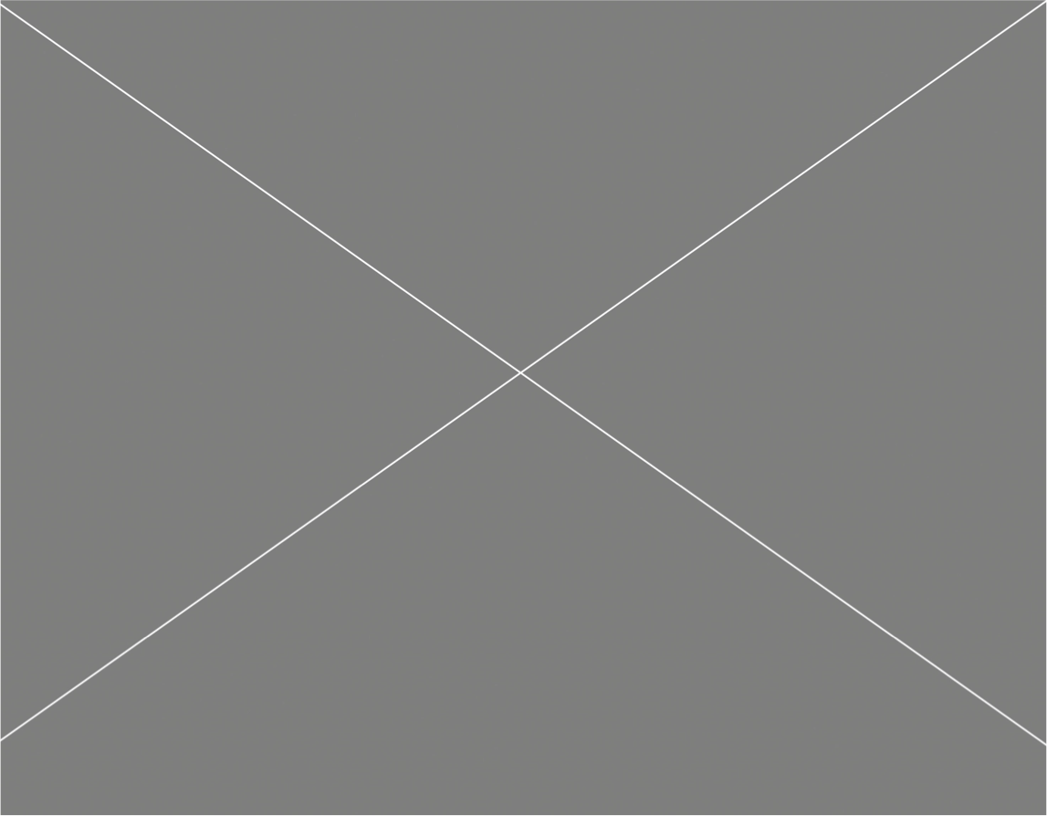





**Game Analysis 3**

**Mission Statement 3**

**Genre 3**

**Platforms 3**

**Target Audience 3**

**Storyline & Characters 4**

**Gameplay 5**

**Overview of Gameplay 5**

**Player Experience 5**

**Gameplay Guidelines 5**

**Game Objectives & Rewards 5**

**Gameplay Mechanics 5**

**Level Design 6**

**Control Scheme 7**

**Game Aesthetics & User Interface 7**

**Schedule & Tasks 8**

# Game Analysis

Shooting gallery is a first person shooter set in a wired carnaval where all the game booths come to life and fight back.( is in haunted, is it some death trap set up by a lunatic, is it just in the main character's mind, who knows). The player shoots and kills the enemies before they can kill them.

# Mission Statement

(It's the same as the analysis)

Shooting gallery is a first person shooter set in a wired carnaval where all the game booths come to life and fight back.( is in haunted, is it some death trap set up by a lunatic, is it just in the main character's mind, who knows). The player shoots and kills the enemies before they can kill them.

# Genre

Carnival, Shoot em up

# Platforms

PC

# Target Audience

The target would be fans of carnival games and possible horror( i don't think there would be enough horror elements in it to be considered a horror game but the setting and idea/permaise could easily be changed to one.

# Storyline & Characters

Some guy finds himself in a weird carnaval/fair setting and makes a wrong turn to the shooting gallery , a long line of stacked boths of the usual shooting games but this time they shoot at you. It's the protagonist's job to kill all the enemies by reaching the one hit kill gun and getting rid of them.

| Character | Description | Characteristics | Misc. Info |
| --- | --- | --- | --- |
| Player | Some guy was trying to enjoy a carnaval but took a wrong turn. | some dude with a gun  (The gun on him does 1 damage. once he picks up gun on the other side he does 5 damage) | players heath has them take up to 20 shots before dying/ level restart |
| Ducks | the weakest enemy to kill. | Yellow, moves the same as the player but stuck behind booth | 1 shot kills |
| Targets | medium level threat. | red and whit, moves the same as the player but stuck behind booth  (red) | 2 shot kills |
| Clowns | Bosses | polka dots, moves the same as the player but stuck behind booth  (blue) | 4 shot kills |

# Gameplay

## Overview of Gameplay

It's an action game with some horror elements.(note mostly to self: it would look more horror with actual models instead of just the basic shapes). I don't think there are any games that have carnival games coming alive.

## Player Experience

The player will start off in a safe zone where enemies can not see them but once they step closer into their field of vision they will have to dodge bullets from both sides and try to take out as much as they can. Once they reach the other side and pick up the one kit kill gun, it will be extremely easy to get rid of the rest and win the game.

## Gameplay Guidelines

NO bad language, no explicit content, the only violence is the shooting.

## Game Objectives & Rewards

| Rewards | Penalties | Difficulty Levels |
| --- | --- | --- |
| -One you make it to the other side you get a gun that will one shoot kill the bosses | Three types of enemies that shoot at you on sight.  If your health goes to zero the level restarts. | Mostly easy. |

## Gameplay Mechanics

| **Character Attributes** |  |
| --- | --- |
| **Character** | **Movement Abilities / Actions Available** |
| Guy | wasd movement  click to fire |
|  |  |
| **Game Modes** |  |
| Normal | three eniy types showing at you ( 10 in total) |
| **Scoring System** |  |
| **Points/Coins/Stars/Grades/Etc.** | **How it’s Awarded & Benefits** |
| kills | Kill all the enemies, win the game |

## Level Design

| **Levels** |  |
| --- | --- |
| Level 1/ Shooting Ally | a wall of two stacked booths with enemies inside shooting at the player as the player tries to reach the other side. |

# Control Scheme

| **Button/ Touch Input** | **Action it Performs** |
| --- | --- |
| Wasd | player moves around |
| mouse click | shoot |

# Game Aesthetics & User Interface

As of now it will be basic shapes. If I were to continue with its own assets, It will look stylized. It would look similar to dark deception. It would be a combination of “this is ridiculous” and creepy.

# Schedule & Tasks

| Task | Is it done? |
| --- | --- |
| Level layout | yes |
| Player | yes |
| Enemies | no |
| Shooting | no |
| new gun | no |
| UI | ½ it's in place but the text does not change when health changes |
| heathpack | yes |
| GDD | yes |
| TDD | no ( in progress as I continue) |
| One Sheet | yes |

Things to fix

* Enemy script is broken
* gun script is broken
* Health text does not update
* win and lose