PROJECT SUBMISSION REPORT
Computer Organization (BSC/ITE 104)
Project 1: CPU instruction execution
Image brightness processing
Student Name:
Student ID: | Khin Thant Zin (2512220004)  Wai Yan Min Thu (2512220006)
Course Code: | BSC/ITE 104 – Computer Organization
Instructor: | Dr. Surekha Lanka
Submission Date:

Grading Rubric
Total Points: 100
Component | Excellent (90-100%) | Good (80-89%) | Satisfactory (70-79%) | Needs Improvement (<70%)
Simulator Usage (20 pts) | Comprehensive experiments; clear screenshots; excellent scope documentation | Good variety of experiments; clear screenshots; good documentation | Adequate experiments; acceptable screenshots; basic documentation | Limited experiments; unclear screenshots; poor documentation
Data Collection (10 pts) | Complete data set; well-organized table; all metrics documented; clear units | Good data collection; organized; most metrics documented | Adequate data; some organization issues; metrics mostly clear | Incomplete data; poor organization; unclear metrics
Analysis Quality (40 pts) | In-depth analysis; excellent insights; clear graphs; strong explanations | Good analysis; useful insights; adequate graphs; clear explanations | Adequate analysis; some insights; basic graphs; acceptable explanations | Superficial analysis; limited insights; poor graphs; weak explanations
Trade-Off Analysis (20 pts) | Thorough trade-off comparisons; excellent data support; clear conclusions | Good trade-off analysis; adequate data support; clear conclusions | Adequate trade-off discussion; some data support; acceptable conclusions | Limited trade-off analysis; weak data support; unclear conclusions
Presentation (10 pts) | Excellent formatting; clear structure; professional writing; no errors | Good formatting; clear structure; mostly professional; few errors | Acceptable formatting; adequate structure; some writing issues | Poor formatting; unclear structure; multiple writing errors

Project Deliverables

1. Simulator Experiments & Screenshots (20 points)
Nine selected simulator experiments are documented below. E1–E4 cover the four required input patterns with complete recorded traces. E5 repeats the clustered case with the fixed benchmark input list. E6–E9 test four changed instruction programs on Best Case. Each has its own screenshot and explanation.
The repeatability study also contains 40 executions per program and case: five programs × four cases × 40 = 800 measurements. Repetitions are kept separate from the nine illustrated experiments. A screenshot shows one execution, not a mean. Appendix C includes every benchmark record so the statistical comparisons can be checked within this document.
ID | Program | Input case | Captured cycles
E1 | Baseline | Best | 366
E2 | Baseline | Worst | 378
E3 | Baseline | Real 1 | 451
E4 | Baseline | Real 2 | 397
E5 | Baseline | Real 2 | 429
E6 | Branch-free | Best | 367
E7 | Unrolled | Best | 365
E8 | Loop-test | Best | 382
E9 | Combined | Best | 272
All experiments process 16 pixels. Dark inputs below 128 receive +32; other inputs receive −8. The original random-cache and prediction rules are retained. The changed programs use the stated instruction-cost assumptions in Section 3.

Experiment E1: Baseline, Best
All inputs were zero. The ADD path costs 13 base cycles per pixel. Three cache misses and one wrong brightness prediction raised the total to 366 cycles.
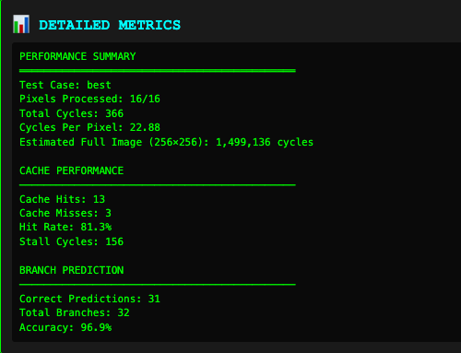
Figure 1. Recorded final metrics for E1: 366 cycles, 13 hits, 3 misses, 31/32 correct predictions and 156 stall cycles. Unscaled crop from the captured simulator display.
Check: 210 base + 3 × 47 + 1 × 15 = 366 cycles. Final PC: 0x34; pixels complete: 16/16.

Experiment E2: Baseline, Worst
Inputs alternated between 64 and 192. This capture drew only one cache miss, so seven wrong brightness predictions caused more delay than memory access. Its low total is a random outcome, not proof that alternating inputs are usually fastest.
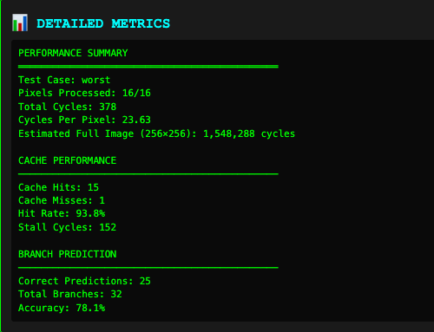
Figure 2. Recorded final metrics for E2: 378 cycles, 15 hits, 1 misses, 25/32 correct predictions and 152 stall cycles. Unscaled crop from the captured simulator display.
Check: 226 base + 1 × 47 + 7 × 15 = 378 cycles. Final PC: 0x34; pixels complete: 16/16.

Experiment E3: Baseline, Real 1
The indoor-photo list contained 11 dark and five bright pixels. Three misses and six wrong brightness predictions produced 451 cycles. The first pixel changed from 35 to 67.
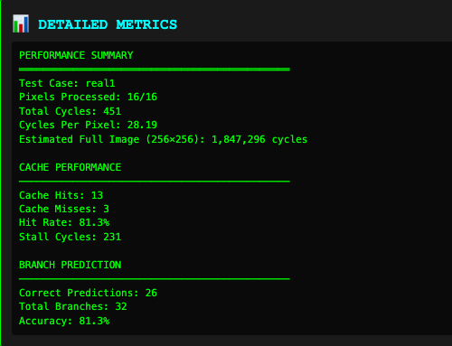
Figure 3. Recorded final metrics for E3: 451 cycles, 13 hits, 3 misses, 26/32 correct predictions and 231 stall cycles. Unscaled crop from the captured simulator display.
Check: 220 base + 3 × 47 + 6 × 15 = 451 cycles. Final PC: 0x34; pixels complete: 16/16.

Experiment E4: Baseline, Real 2
Eight bright inputs were followed by eight dark inputs. The first pixel changed from 232 to 224; the last changed from 92 to 124. The model chooses prediction probabilities by case label rather than learning the bright-to-dark transition.
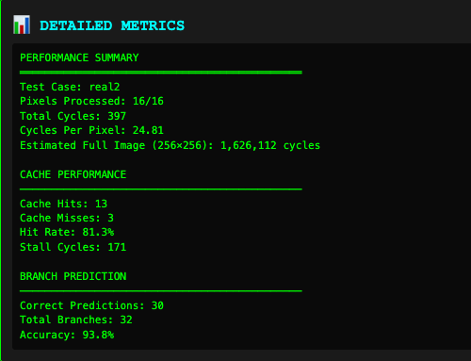
Figure 4. Recorded final metrics for E4: 397 cycles, 13 hits, 3 misses, 30/32 correct predictions and 171 stall cycles. Unscaled crop from the captured simulator display.
Check: 226 base + 3 × 47 + 2 × 15 = 397 cycles. Final PC: 0x34; pixels complete: 16/16.

Experiment E5: Baseline, Real 2
This repeat uses the fixed clustered input list used throughout the optimization benchmark. It differs from E4 in input values. Four misses and one wrong prediction produced 429 cycles; the matching 40-run baseline mean is 415.35 cycles.
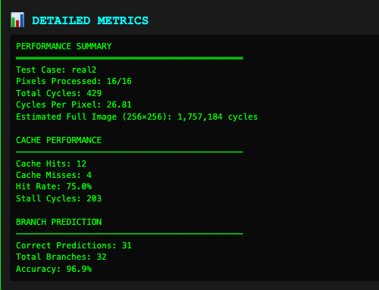
Figure 5. Recorded final metrics for E5: 429 cycles, 12 hits, 4 misses, 31/32 correct predictions and 203 stall cycles. Unscaled crop from the captured simulator display.
Check: 226 base + 4 × 47 + 1 × 15 = 429 cycles. Final PC: 0x34; pixels complete: 16/16.

Experiment E6: Branch-free, Best
Both brightness candidates are calculated, then CSEL chooses the result. No brightness branches remain. This capture used 367 cycles, while the repeated Best Case mean is 376.40: 3.8% slower than its 40-run baseline because selection adds work.
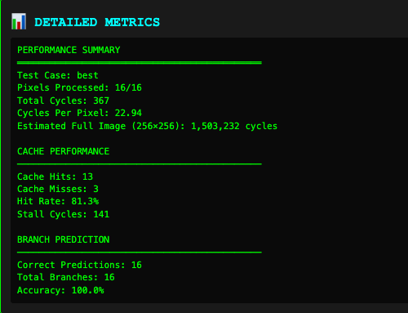
Figure 6. Recorded final metrics for E6: 367 cycles, 13 hits, 3 misses, 16/16 correct predictions and 141 stall cycles. Unscaled crop from the captured simulator display.
Check: 226 base + 3 × 47 + 0 × 15 = 367 cycles. Final PC: 0x30; pixels complete: 16/16.

Experiment E7: Unrolled, Best
Four pixels are processed before the loop-control instructions repeat. Loop branches fall from 16 to four, although the 16 brightness branches remain. This capture used 365 cycles; the 40-run Best Case mean is 316.45 cycles, a 12.8% reduction.
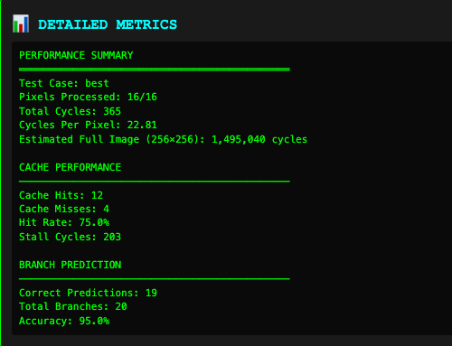
Figure 7. Recorded final metrics for E7: 365 cycles, 12 hits, 4 misses, 19/20 correct predictions and 203 stall cycles. Unscaled crop from the captured simulator display.
Check: 162 base + 4 × 47 + 1 × 15 = 365 cycles. Final PC: 0x88; pixels complete: 16/16.

Experiment E8: Loop-test, Best
The pointer is compared with address 1040 instead of incrementing a separate pixel counter. This saves 16 base cycles. R0 remains zero because it no longer controls the loop; the pixel counter still confirms 16 completed pixels. The capture used 382 cycles; the repeated mean is 352.50.
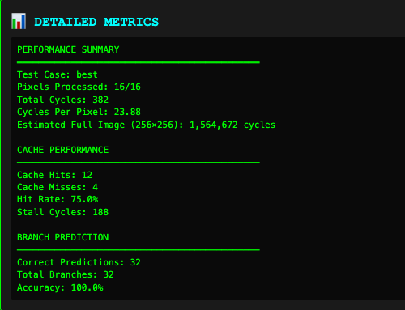
Figure 8. Recorded final metrics for E8: 382 cycles, 12 hits, 4 misses, 32/32 correct predictions and 188 stall cycles. Unscaled crop from the captured simulator display.
Check: 194 base + 4 × 47 + 0 × 15 = 382 cycles. Final PC: 0x30; pixels complete: 16/16.

Experiment E9: Combined, Best
Branch-free selection is combined with four-pixel unrolling. Only four loop branches remain. Two misses and no wrong predictions gave 272 cycles in this capture. The 40-run Best Case mean is 342.50; this single favorable capture must not replace the repeated comparison.
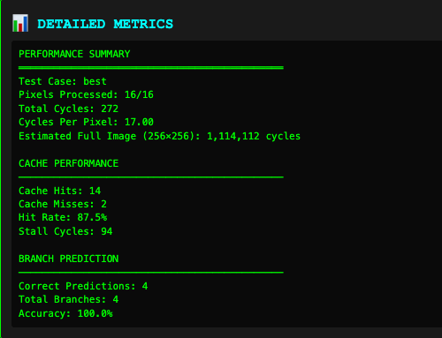
Figure 9. Recorded final metrics for E9: 272 cycles, 14 hits, 2 misses, 4/4 correct predictions and 94 stall cycles. Unscaled crop from the captured simulator display.
Check: 178 base + 2 × 47 + 0 × 15 = 272 cycles. Final PC: 0x78; pixels complete: 16/16.

2. Performance Data Collection (10 points)
Tables 1 and 2 contain the counters and rates for all nine illustrated experiments. CPP = total cycles / 16. Cache rates use 16 pixel loads; stores are not counted by the cache counter. Prediction rates use all conditional branches, including the loop checks. Spill count is zero from instruction inspection; the simulator has no measured spill counter.
Table 1. Individual captured results. Cycles and stalls are CPU-cycle counts.
ID | Cycles | CPP | Hits / misses | Stalls | Final PC
E1 | 366 | 22.88 | 13 / 3 | 156 | 0x34
E2 | 378 | 23.63 | 15 / 1 | 152 | 0x34
E3 | 451 | 28.19 | 13 / 3 | 231 | 0x34
E4 | 397 | 24.81 | 13 / 3 | 171 | 0x34
E5 | 429 | 26.81 | 12 / 4 | 203 | 0x34
E6 | 367 | 22.94 | 13 / 3 | 141 | 0x30
E7 | 365 | 22.81 | 12 / 4 | 203 | 0x88
E8 | 382 | 23.88 | 12 / 4 | 188 | 0x30
E9 | 272 | 17.00 | 14 / 2 | 94 | 0x78
Table 2. Prediction counts, cache rates, overall prediction error and spills.
ID | Correct / branches | Hit % | Miss % | Wrong % | Spills
E1 | 31 / 32 | 81.25 | 18.75 | 3.13 | 0
E2 | 25 / 32 | 93.75 | 6.25 | 21.88 | 0
E3 | 26 / 32 | 81.25 | 18.75 | 18.75 | 0
E4 | 30 / 32 | 81.25 | 18.75 | 6.25 | 0
E5 | 31 / 32 | 75.00 | 25.00 | 3.13 | 0
E6 | 16 / 16 | 81.25 | 18.75 | 0.00 | 0
E7 | 19 / 20 | 75.00 | 25.00 | 5.00 | 0
E8 | 32 / 32 | 75.00 | 25.00 | 0.00 | 0
E9 | 4 / 4 | 87.50 | 12.50 | 0.00 | 0
All nine captures finished 16/16 pixels. The full-image estimate shown by the simulator equals each captured cycle total × 4,096. Baseline brightness-only accuracy can be calculated as (correct branches − 16) / 16; the 16 loop predictions are always counted as correct.

2. Performance Data Collection: repeated measurements
Table 3. Mean cycles per 16 pixels across 40 independent repetitions per cell. These means, rather than isolated screenshots, determine the optimization recommendations.
Case | Baseline | Branch-free | Unrolled | Loop-test | Combined
Best | 362.73 | 376.40 | 316.45 | 352.50 | 342.50
Worst | 502.93 | 389.33 | 460.25 | 468.63 | 329.58
Real 1 | 439.83 | 376.40 | 390.10 | 404.63 | 337.80
Real 2 | 415.35 | 372.88 | 385.53 | 400.75 | 335.45
Appendix C records cycles, misses and wrong predictions for all 800 executions. With the base costs below, those values determine hits, correct predictions and stalls as well. Every benchmark output check passed.
Table 4. Base cycles and conditional-branch counts used in the benchmark.
Program | Best | Worst | Real 1 | Real 2 | Branches
Baseline | 210 | 226 | 220 | 226 | 32
Branch-free | 226 | 226 | 226 | 226 | 16
Unrolled | 162 | 178 | 172 | 178 | 20
Loop-test | 194 | 210 | 204 | 210 | 32
Combined | 178 | 178 | 178 | 178 | 4

The original baseline executes seven live register roles, with R5 unused; the branch-free programs use R5 for the second candidate. No program includes stack spill/reload instructions. Code inspection supports zero spills within the model, not a claim about a real compiler.

3. Analysis Report (40 points)

Executive Summary
This study examines a 16-pixel brightness loop using nine illustrated experiments and an 800-execution repeatability study. The four complete baseline traces took 366, 378, 451 and 397 cycles. Cache misses caused the largest delay in three of those four traces; the exception was the alternating case, which drew only one miss. Across repeated tests, branch-free selection combined with four-pixel unrolling gave the lowest mean for Worst Case and both realistic cases, reducing cycles by 34.5%, 23.2% and 19.2%. Unrolling alone had the lowest Best Case mean, although its lead over the combined program was uncertain. Outputs stayed correct. The cost projection needs one processor under the stated workload assumptions, so reduced cycles improve capacity without automatically reducing a fixed 24-hour electricity bill.

Methodology
The baseline cases were all-zero inputs, alternating 64/192 inputs, an indoor list with 11 dark and five bright pixels, and eight bright values followed by eight dark values. An automated driver advanced the supplied simulator one instruction at a time and captured its state. Appendix B prints every instruction and event from the four traced runs. Figures 1–9 show the selected experiment counters; Appendix D gives their pixel inputs and outputs.
The benchmark tested the baseline plus branch-free selection, four-pixel unrolling, pointer-based loop testing and the combined program. Each program ran 40 times on each case with output checks. Real Case 2 was pinned to one input list for fair comparisons. Cache and branch draws were independent across repeats and programs. The animation delay controls display speed only; it is separate from cycle accounting.

3. Analysis Report: Findings
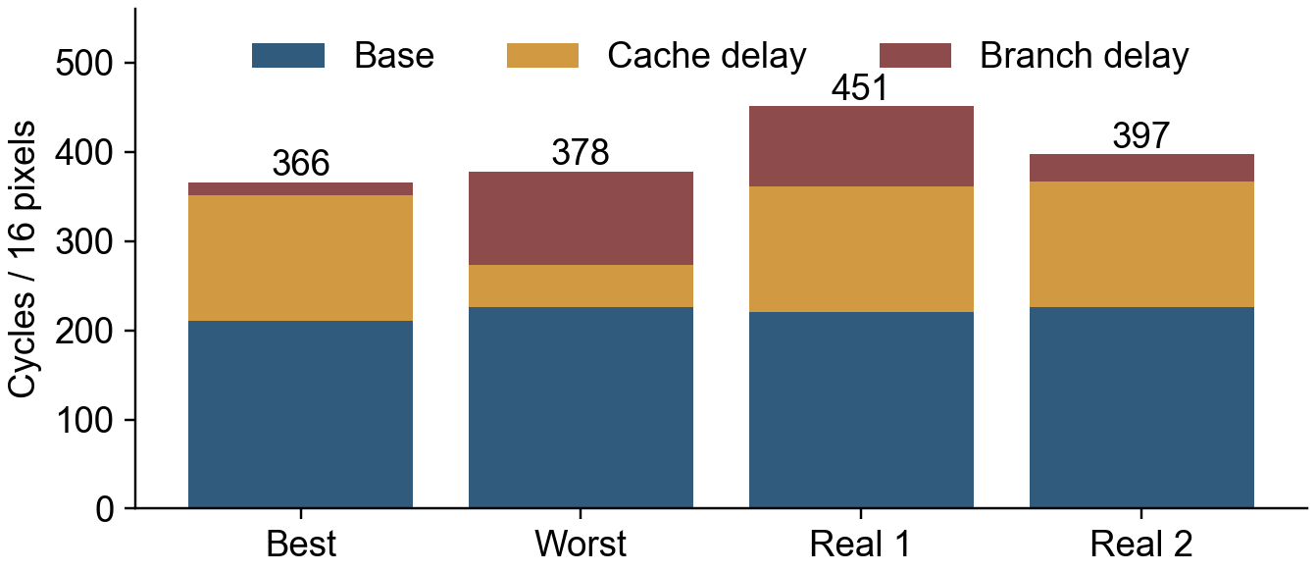
Chart 1. Cycle breakdown of the four recorded baseline traces (E1–E4). Each bar is one run, not a case average.
A dark iteration costs 13 base cycles, and a bright iteration costs 15 because it also executes a two-cycle jump. Two setup instructions give baseline totals of 210, 226, 220 and 226 before random delays. A load costs three cycles on a hit or 50 on a miss, so a miss adds 47. A wrong brightness prediction adds 15. Stores always cost three cycles; HALT is displayed but never charged.
For E3, the exact result is 220 + 3 × 47 + 6 × 15 = 451 cycles. E2 uses more base cycles than E3 but finishes sooner: 226 + 1 × 47 + 7 × 15 = 378. Its low miss count outweighs its extra branch delay. A case label therefore does not guarantee the ordering of individual runs.
The miss mechanism draws about 20% misses per load, giving 3.2 expected misses per 16-pixel run. It has no cache lines, capacity replacement or prefetch logic. The brightness predictor draws 95% correctness for Best, 50% for Worst and 80% for both real cases. All loop predictions are counted as correct, which makes overall accuracy higher than brightness-only accuracy.

3. Analysis Report: Analysis
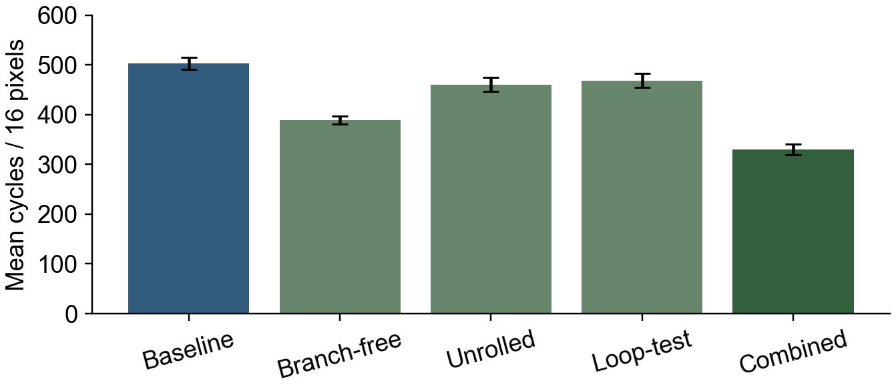
Chart 2. Worst Case mean cycles across 40 runs per program. Error bars show one standard error of the mean.
The combined program reduces the Worst Case mean from 502.93 to 329.58 cycles, a 34.5% reduction. Its base cost falls from 226 to 178; removing brightness branches also removes their misprediction delays. Unrolling alone keeps those branches, so its mean remains 460.25. Loop testing saves one counter increment per pixel and reaches 468.63. Branch-free selection without unrolling reaches 389.33.
These are executions of modified teaching-model programs. CSEL is assumed to cost one cycle; four-pixel pointer increments and offset addressing are also assumed available. Existing operation costs and random-event probabilities are retained. These assumptions are explicit, because the simulator cannot establish timings on a particular physical ARM processor.
The scenario targets CPP below five and cache hit rate above 95%. Even the delay-free baseline needs 210/16 = 13.125 CPP, so it cannot reach the CPP target. None of the four traced baseline runs meets the cache target. These gaps follow from the supplied cost model. A reported target or illustrative example cannot replace the recorded counters.

3. Analysis Report: Visualizations and interpretation
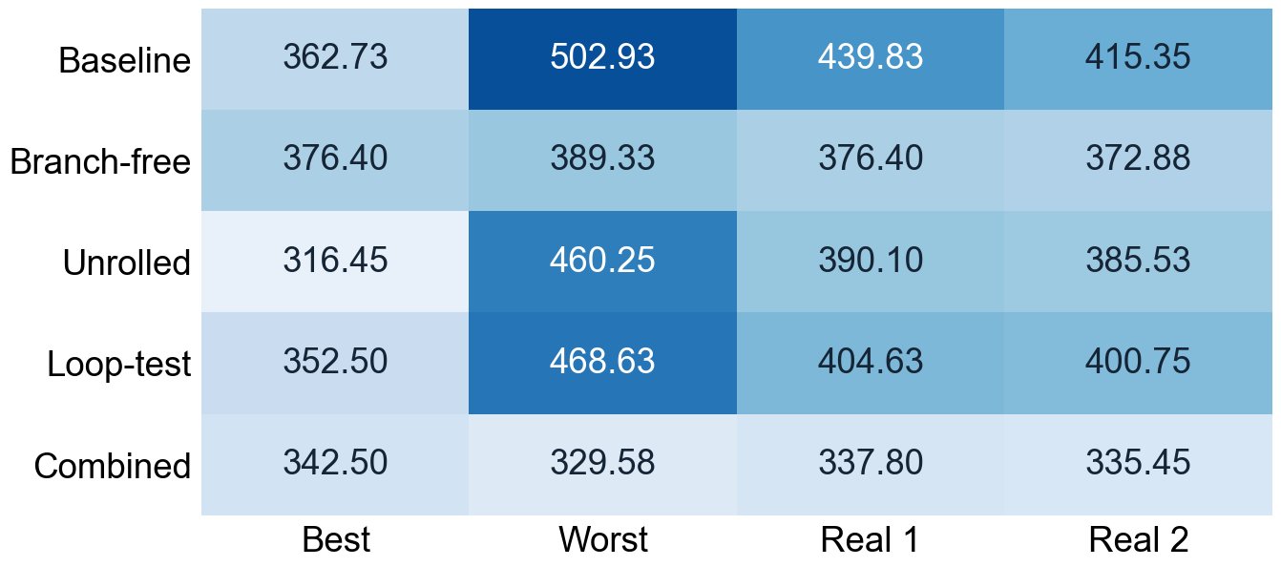
Chart 3. Mean cycles per 16 pixels for all programs and cases (40 repetitions per cell). Darker cells mean more cycles, not better performance.
The combined program has the lowest mean for Worst Case, Real Case 1 and Real Case 2. Best Case differs: unrolling averages 316.45 cycles, while the combined program averages 342.50. Their 26.05-cycle gap is only about 1.7 standard errors of the difference. It is a tentative ranking, not strong evidence that unrolling always wins.
Unrolling has a 16-cycle base advantage over the combined program in Best Case, while the combined program avoids about 15 expected branch-delay cycles. The expected totals are therefore close, and different cache draws can move the measured means. Standard error is sample standard deviation divided by the square root of 40; for independent means, the error of a difference is the square root of the sum of their squared standard errors.
Prefetching and loop tiling target cache behavior that this simulator does not model. They were not presented as measured successes. For example, removing every baseline Worst Case cache delay would give an upper-bound estimate of 349.01 cycles, while leaving one miss gives 396.01, both assuming no extra instructions. A real cache-aware implementation would need separate tests.

4. Trade-Off Analysis (20 points)

Speed vs. Accuracy
Output correctness is mandatory for image processing. Prediction accuracy is a timing metric: a wrong prediction adds delay but the simulator still executes the correct arithmetic path. Every one of the 800 benchmark executions passed all 16 output checks. Faster variants therefore did not gain speed by accepting incorrect pixels.
Branch-free selection removes brightness-prediction failures at a cost: it computes both candidate outputs and selects one. On Best Case, its mean rises from 362.73 to 376.40 cycles (+3.8%). On Worst Case, it falls from 502.93 to 389.33 (−22.6%). Removing a branch is worthwhile when the avoided delays cover that extra work. Report both accuracy and total cycles; 100% loop-prediction accuracy alone is not evidence of the fastest program.

Size vs. Performance
The scenario describes a 32 KB L1 cache, but the teaching simulator has no cache-capacity model. Changing a stated cache size would not establish a measured speed effect. Tiling and larger-cache claims therefore remain hypotheses. The sequential 16-pixel sample is also too small to demonstrate production working-set behavior.
There is a measurable instruction-program trade-off. Including the displayed HALT entry, the baseline lists 14 instructions, branch-free 13, unrolled 35, loop-test 13 and combined 31. These are model instruction counts, not compiled binary sizes. Unrolling expands the program while reducing loop branches from 16 to four. Total conditional branches fall only from 32 to 20, because all 16 brightness branches remain. A real compiler could add spills or instruction-cache pressure; neither is charged by this model.

4. Trade-Off Analysis: Latency vs. Throughput
The projection treats one image as a 256 × 256 chunk (65,536 pixels), uses 2,000,000 processed images/day, a 2.4 GHz processor per server, and a four-hour batch deadline. The whole daily batch is assumed to arrive together. Each image needs 4,096 copies of the 16-pixel workload. For this Word submission, projections use the exact 40-run baseline means in Table 3 to reduce dependence on isolated random draws.
Case | Cycles / image | Daily cycles (×10¹²) | CPU s/day | Servers
Best | 1485722 | 2.971443 | 1238.10 | 1
Worst | 2059981 | 4.119962 | 1716.65 | 1
Real 1 | 1801523 | 3.603046 | 1501.27 | 1
Real 2 | 1701274 | 3.402547 | 1417.73 | 1

For Real Case 1, the processor needs 1501.27 seconds/day against a 14,400-second deadline, so one server suffices. A 20% cycle reduction saves 300.25 seconds/day and increases fixed-clock throughput by 1/0.8 = 1.25, or 25%. The integer server count stays one.
At 8 W, $0.12/kWh and 24-hour operation, daily electricity is 0.008 × 24 × 0.12 = $0.02304; annual cost is $8.4096. Finishing sooner saves $0 at constant power. If the full 8 W is avoided during the saved Real Case 1 processing time, the 20% reduction saves approximately $0.029225/year. Idle power was not supplied, so that is conditional.
The scenario also says only half of uploads need adjustment. At 1,000,000 processed images/day, cycles and active time halve; the constant-power electricity bill and rounded server count do not. Actual photographs can contain many chunks. Decoding, transfer, contention and whole-server power are excluded, so these are brightness-stage estimates rather than a production capacity guarantee.

5. Recommendations & Conclusions (10 points)

Optimization suggestions based on the analysis
Use the combined branch-free and four-pixel-unrolled program as the first candidate for mixed and alternating inputs in this model. The measured reductions are 34.5% for Worst Case, 23.2% for Real Case 1 and 19.2% for Real Case 2. Those comparisons use a separate 40-run baseline for each case, identical input lists and the same cost rules. Output correctness was checked throughout.
For all-dark data, keep unrolling alone as a candidate rather than assuming the combined method is best. It has the lowest observed mean, 316.45 cycles compared with 342.50 for combined and 362.73 for baseline. However, the small margin over combined is uncertain. Collect more independent repetitions or use controlled paired random trials before choosing between these two for a workload dominated by dark pixels.
Prioritize memory behavior in a more realistic follow-up. Chart 1 shows that cache delay exceeds branch delay in three of the four complete traces. Each missed load adds 47 cycles, compared with 15 for a wrong prediction. That makes a cache-aware experiment a reasonable next step, but the current random-hit model cannot establish a benefit from prefetching, tiling or a larger cache.
Keep the simpler pointer-loop method available where program size matters. It removes one counter increment per pixel without fourfold loop-body expansion. In the Best Case benchmark it reduces the mean by 2.8%; the combined and unrolled programs offer larger reductions in other cases at the cost of longer instruction listings. A deployment decision should include compiled code size and register usage, which were not measured here.

5. Recommendations & Conclusions: applications and learning

Real-world applications
The method applies to small image-processing loops on edge devices: first verify the output rule, count base work and delays separately, then compare changes on representative inputs. The four cases show why one screenshot cannot stand in for a workload. E2, called Worst Case, happened to finish faster than E3 because it drew fewer misses. Repeated measurements give a more useful basis for decisions.
Use cycle reductions to plan processing capacity, and estimate electricity separately. The four-hour calculation needs one processor under the supplied assumptions. A hypothetical 20% cycle reduction raises throughput by 25%, but it does not remove a server or reduce an 8 W all-day bill. A real cost estimate needs image dimensions, the number of chunks, total server power and the active-to-idle power difference. The supplied figures do not support a million-dollar saving.

What this project demonstrates
The instruction traces connect program state to timing. A pixel load changes R3, arithmetic writes R4, the store updates output memory, and loop control advances the pointer and returns the PC. Misses and wrong predictions change the cycle count without changing the brightness rule. Separating those effects explains both repeated-run variation and the different optimization results.
The analysis also shows the limits of the tool. Prediction outcomes are random draws selected by case label, not evidence that a predictor learned an image pattern. Zero spills follows from the instruction programs, not a hardware spill counter. The added operation costs are assumptions. The measured rankings are useful within this model; a real compiler and processor should be tested before treating the percentages as deployment results.
The practical conclusion is to retain correctness checks, use repeated measurements, and choose the optimization for the input pattern and implementation constraints. The report contains the screenshots, numerical records, formulas and full baseline traces needed to examine that conclusion without opening separate project files.

Supporting evidence and calculation appendices
The following supporting material is separate from the four-page Analysis Report and two-page Recommendations & Conclusions sections. It provides detailed observations for checking the main text.

Appendix A. Baseline instructions and registers
PC (hex) | Instruction | Base cycles
00 | LOAD R0, #0 | 1
04 | LOAD R1, #1024 | 1
08 | LOAD R3, [R1] | 3
0C | CMP R3, R2 | 1
10 | BLT DARK | 1
14 | SUB R4, R3, R7 | 1
18 | JMP STORE | 2
1C | ADD R4, R3, R6 | 1
20 | STORE R4, [R1] | 3
24 | INC R1, #1 | 1
28 | INC R0, #1 | 1
2C | CMP R0, #16 | 1
30 | BNE LOOP | 1
34 | HALT | 0
Dark path: 08 → 0C → 10 → 1C → 20 → 24 → 28 → 2C → 30 = 13 cycles. Bright path: 08 → 0C → 10 → 14 → 18 → 20 → 24 → 28 → 2C → 30 = 15 cycles. Baseline total = 2 + 13 × dark + 15 × bright + 47 × misses + 15 × wrong predictions.
R0 counts completed pixels; R1 is the pointer starting at 1024; R2 is threshold 128; R3 is the input; R4 is the output; R5 is unused by baseline; R6 is 32; R7 holds positive 8 for subtraction. The baseline uses seven of the eight displayed registers. The scenario describes 32 registers, but that fuller processor is not simulated.

Appendix B.1. Complete trace for E1 (Best)
The panels below show the same run after setup, after pixel 1, and at completion. Status boxes are arranged above the register panel for readability. Each panel uses a single captured screenshot; existing clipping is retained. Current PC is the next instruction, while the execution trace lists the instruction just executed.
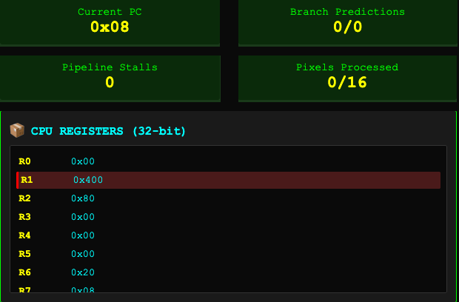
Figure B1.setup. E1: after setup.
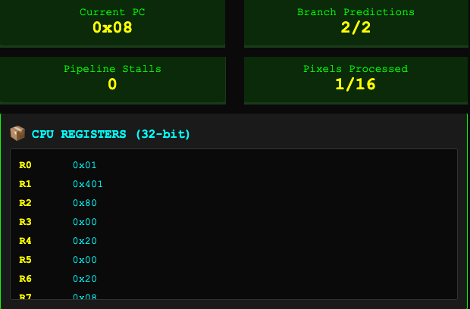
Figure B1.pixel1_done. E1: after pixel 1.
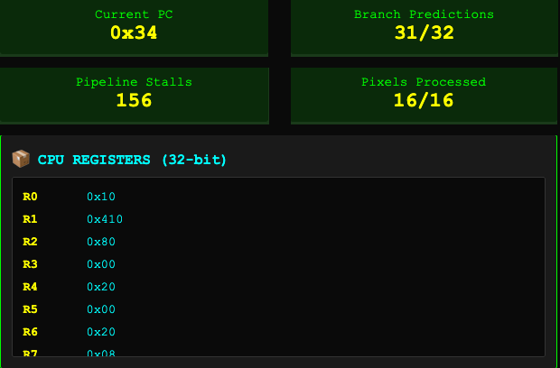
Figure B1.final. E1: final state.

Appendix B.1. Pixel events for E1
Pixel | Input | Output | Cache | BLT | Base | Delay | Total
1 | 0 | 32 | HIT | Right | 13 | 0 | 15
2 | 0 | 32 | HIT | Right | 13 | 0 | 28
3 | 0 | 32 | HIT | Right | 13 | 0 | 41
4 | 0 | 32 | HIT | Right | 13 | 0 | 54
5 | 0 | 32 | HIT | Right | 13 | 0 | 67
6 | 0 | 32 | HIT | Right | 13 | 0 | 80
7 | 0 | 32 | MISS | Right | 13 | 47 | 140
8 | 0 | 32 | HIT | Right | 13 | 0 | 153
9 | 0 | 32 | HIT | Right | 13 | 0 | 166
10 | 0 | 32 | HIT | Right | 13 | 0 | 179
11 | 0 | 32 | HIT | Wrong | 13 | 15 | 207
12 | 0 | 32 | HIT | Right | 13 | 0 | 220
13 | 0 | 32 | MISS | Right | 13 | 47 | 280
14 | 0 | 32 | MISS | Right | 13 | 47 | 340
15 | 0 | 32 | HIT | Right | 13 | 0 | 353
16 | 0 | 32 | HIT | Right | 13 | 0 | 366
Base is instruction cost before delays. Delay = 47 × load misses + 15 × wrong brightness predictions. The running total includes the two setup cycles. All input/output values are recorded from the trace except Best Case zeros, which are defined by the test setup.

Appendix B.1. All 146 instruction steps for E1
PC values are hexadecimal. A step ending at total T with increment d occupies counted cycles T − d + 1 through T. The last next-PC is HALT; HALT contributes no charged step. BNE predictions are always counted as correct.
Step | PC | Next PC | Added cycles | Total cycles | Event
1 | 0x00 | 0x04 | 1 | 1 | —
2 | 0x04 | 0x08 | 1 | 2 | —
3 | 0x08 | 0x0C | 3 | 5 | Hit
4 | 0x0C | 0x10 | 1 | 6 | —
5 | 0x10 | 0x1C | 1 | 7 | BLT right
6 | 0x1C | 0x20 | 1 | 8 | —
7 | 0x20 | 0x24 | 3 | 11 | —
8 | 0x24 | 0x28 | 1 | 12 | —
9 | 0x28 | 0x2C | 1 | 13 | —
10 | 0x2C | 0x30 | 1 | 14 | —
11 | 0x30 | 0x08 | 1 | 15 | BNE right
12 | 0x08 | 0x0C | 3 | 18 | Hit
13 | 0x0C | 0x10 | 1 | 19 | —
14 | 0x10 | 0x1C | 1 | 20 | BLT right
15 | 0x1C | 0x20 | 1 | 21 | —
16 | 0x20 | 0x24 | 3 | 24 | —
17 | 0x24 | 0x28 | 1 | 25 | —
18 | 0x28 | 0x2C | 1 | 26 | —
19 | 0x2C | 0x30 | 1 | 27 | —
20 | 0x30 | 0x08 | 1 | 28 | BNE right
21 | 0x08 | 0x0C | 3 | 31 | Hit
22 | 0x0C | 0x10 | 1 | 32 | —
23 | 0x10 | 0x1C | 1 | 33 | BLT right
24 | 0x1C | 0x20 | 1 | 34 | —
25 | 0x20 | 0x24 | 3 | 37 | —
26 | 0x24 | 0x28 | 1 | 38 | —
27 | 0x28 | 0x2C | 1 | 39 | —
28 | 0x2C | 0x30 | 1 | 40 | —
29 | 0x30 | 0x08 | 1 | 41 | BNE right
30 | 0x08 | 0x0C | 3 | 44 | Hit
31 | 0x0C | 0x10 | 1 | 45 | —
32 | 0x10 | 0x1C | 1 | 46 | BLT right
33 | 0x1C | 0x20 | 1 | 47 | —
34 | 0x20 | 0x24 | 3 | 50 | —
35 | 0x24 | 0x28 | 1 | 51 | —
36 | 0x28 | 0x2C | 1 | 52 | —
37 | 0x2C | 0x30 | 1 | 53 | —
38 | 0x30 | 0x08 | 1 | 54 | BNE right
39 | 0x08 | 0x0C | 3 | 57 | Hit
40 | 0x0C | 0x10 | 1 | 58 | —
41 | 0x10 | 0x1C | 1 | 59 | BLT right
42 | 0x1C | 0x20 | 1 | 60 | —
43 | 0x20 | 0x24 | 3 | 63 | —
44 | 0x24 | 0x28 | 1 | 64 | —
45 | 0x28 | 0x2C | 1 | 65 | —
46 | 0x2C | 0x30 | 1 | 66 | —
47 | 0x30 | 0x08 | 1 | 67 | BNE right
48 | 0x08 | 0x0C | 3 | 70 | Hit
49 | 0x0C | 0x10 | 1 | 71 | —
50 | 0x10 | 0x1C | 1 | 72 | BLT right
51 | 0x1C | 0x20 | 1 | 73 | —
52 | 0x20 | 0x24 | 3 | 76 | —
53 | 0x24 | 0x28 | 1 | 77 | —
54 | 0x28 | 0x2C | 1 | 78 | —
55 | 0x2C | 0x30 | 1 | 79 | —
56 | 0x30 | 0x08 | 1 | 80 | BNE right
57 | 0x08 | 0x0C | 50 | 130 | Miss
58 | 0x0C | 0x10 | 1 | 131 | —
59 | 0x10 | 0x1C | 1 | 132 | BLT right
60 | 0x1C | 0x20 | 1 | 133 | —
61 | 0x20 | 0x24 | 3 | 136 | —
62 | 0x24 | 0x28 | 1 | 137 | —
63 | 0x28 | 0x2C | 1 | 138 | —
64 | 0x2C | 0x30 | 1 | 139 | —
65 | 0x30 | 0x08 | 1 | 140 | BNE right
66 | 0x08 | 0x0C | 3 | 143 | Hit
67 | 0x0C | 0x10 | 1 | 144 | —
68 | 0x10 | 0x1C | 1 | 145 | BLT right
69 | 0x1C | 0x20 | 1 | 146 | —
70 | 0x20 | 0x24 | 3 | 149 | —
71 | 0x24 | 0x28 | 1 | 150 | —
72 | 0x28 | 0x2C | 1 | 151 | —
73 | 0x2C | 0x30 | 1 | 152 | —
74 | 0x30 | 0x08 | 1 | 153 | BNE right
75 | 0x08 | 0x0C | 3 | 156 | Hit
76 | 0x0C | 0x10 | 1 | 157 | —
77 | 0x10 | 0x1C | 1 | 158 | BLT right
78 | 0x1C | 0x20 | 1 | 159 | —
79 | 0x20 | 0x24 | 3 | 162 | —
80 | 0x24 | 0x28 | 1 | 163 | —
81 | 0x28 | 0x2C | 1 | 164 | —
82 | 0x2C | 0x30 | 1 | 165 | —
83 | 0x30 | 0x08 | 1 | 166 | BNE right
84 | 0x08 | 0x0C | 3 | 169 | Hit
85 | 0x0C | 0x10 | 1 | 170 | —
86 | 0x10 | 0x1C | 1 | 171 | BLT right
87 | 0x1C | 0x20 | 1 | 172 | —
88 | 0x20 | 0x24 | 3 | 175 | —
89 | 0x24 | 0x28 | 1 | 176 | —
90 | 0x28 | 0x2C | 1 | 177 | —
91 | 0x2C | 0x30 | 1 | 178 | —
92 | 0x30 | 0x08 | 1 | 179 | BNE right
93 | 0x08 | 0x0C | 3 | 182 | Hit
94 | 0x0C | 0x10 | 1 | 183 | —
95 | 0x10 | 0x1C | 16 | 199 | BLT wrong
96 | 0x1C | 0x20 | 1 | 200 | —
97 | 0x20 | 0x24 | 3 | 203 | —
98 | 0x24 | 0x28 | 1 | 204 | —
99 | 0x28 | 0x2C | 1 | 205 | —
100 | 0x2C | 0x30 | 1 | 206 | —
101 | 0x30 | 0x08 | 1 | 207 | BNE right
102 | 0x08 | 0x0C | 3 | 210 | Hit
103 | 0x0C | 0x10 | 1 | 211 | —
104 | 0x10 | 0x1C | 1 | 212 | BLT right
105 | 0x1C | 0x20 | 1 | 213 | —
106 | 0x20 | 0x24 | 3 | 216 | —
107 | 0x24 | 0x28 | 1 | 217 | —
108 | 0x28 | 0x2C | 1 | 218 | —
109 | 0x2C | 0x30 | 1 | 219 | —
110 | 0x30 | 0x08 | 1 | 220 | BNE right
111 | 0x08 | 0x0C | 50 | 270 | Miss
112 | 0x0C | 0x10 | 1 | 271 | —
113 | 0x10 | 0x1C | 1 | 272 | BLT right
114 | 0x1C | 0x20 | 1 | 273 | —
115 | 0x20 | 0x24 | 3 | 276 | —
116 | 0x24 | 0x28 | 1 | 277 | —
117 | 0x28 | 0x2C | 1 | 278 | —
118 | 0x2C | 0x30 | 1 | 279 | —
119 | 0x30 | 0x08 | 1 | 280 | BNE right
120 | 0x08 | 0x0C | 50 | 330 | Miss
121 | 0x0C | 0x10 | 1 | 331 | —
122 | 0x10 | 0x1C | 1 | 332 | BLT right
123 | 0x1C | 0x20 | 1 | 333 | —
124 | 0x20 | 0x24 | 3 | 336 | —
125 | 0x24 | 0x28 | 1 | 337 | —
126 | 0x28 | 0x2C | 1 | 338 | —
127 | 0x2C | 0x30 | 1 | 339 | —
128 | 0x30 | 0x08 | 1 | 340 | BNE right
129 | 0x08 | 0x0C | 3 | 343 | Hit
130 | 0x0C | 0x10 | 1 | 344 | —
131 | 0x10 | 0x1C | 1 | 345 | BLT right
132 | 0x1C | 0x20 | 1 | 346 | —
133 | 0x20 | 0x24 | 3 | 349 | —
134 | 0x24 | 0x28 | 1 | 350 | —
135 | 0x28 | 0x2C | 1 | 351 | —
136 | 0x2C | 0x30 | 1 | 352 | —
137 | 0x30 | 0x08 | 1 | 353 | BNE right
138 | 0x08 | 0x0C | 3 | 356 | Hit
139 | 0x0C | 0x10 | 1 | 357 | —
140 | 0x10 | 0x1C | 1 | 358 | BLT right
141 | 0x1C | 0x20 | 1 | 359 | —
142 | 0x20 | 0x24 | 3 | 362 | —
143 | 0x24 | 0x28 | 1 | 363 | —
144 | 0x28 | 0x2C | 1 | 364 | —
145 | 0x2C | 0x30 | 1 | 365 | —
146 | 0x30 | 0x34 | 1 | 366 | BNE right

Appendix B.2. Complete trace for E2 (Worst)
The panels below show the same run after setup, after pixel 1, and at completion. Status boxes are arranged above the register panel for readability. Each panel uses a single captured screenshot; existing clipping is retained. Current PC is the next instruction, while the execution trace lists the instruction just executed.
Figure B2.setup. E2: after setup.
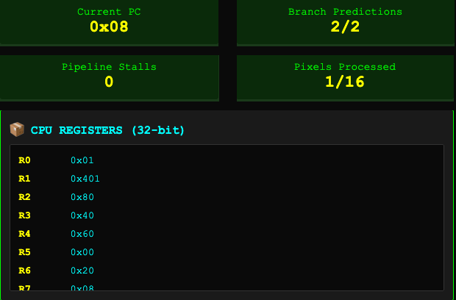
Figure B2.pixel1_done. E2: after pixel 1.
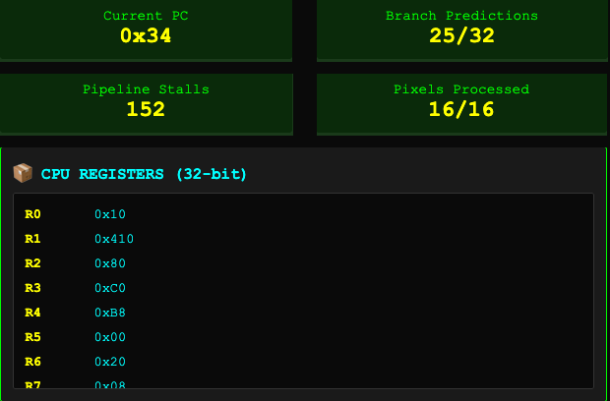
Figure B2.final. E2: final state.

Appendix B.2. Pixel events for E2
Pixel | Input | Output | Cache | BLT | Base | Delay | Total
1 | 64 | 96 | HIT | Right | 13 | 0 | 15
2 | 192 | 184 | HIT | Wrong | 15 | 15 | 45
3 | 64 | 96 | HIT | Right | 13 | 0 | 58
4 | 192 | 184 | HIT | Right | 15 | 0 | 73
5 | 64 | 96 | HIT | Right | 13 | 0 | 86
6 | 192 | 184 | HIT | Wrong | 15 | 15 | 116
7 | 64 | 96 | HIT | Wrong | 13 | 15 | 144
8 | 192 | 184 | HIT | Right | 15 | 0 | 159
9 | 64 | 96 | HIT | Right | 13 | 0 | 172
10 | 192 | 184 | MISS | Wrong | 15 | 62 | 249
11 | 64 | 96 | HIT | Wrong | 13 | 15 | 277
12 | 192 | 184 | HIT | Right | 15 | 0 | 292
13 | 64 | 96 | HIT | Wrong | 13 | 15 | 320
14 | 192 | 184 | HIT | Right | 15 | 0 | 335
15 | 64 | 96 | HIT | Right | 13 | 0 | 348
16 | 192 | 184 | HIT | Wrong | 15 | 15 | 378
Base is instruction cost before delays. Delay = 47 × load misses + 15 × wrong brightness predictions. The running total includes the two setup cycles. All input/output values are recorded from the trace except Best Case zeros, which are defined by the test setup.

Appendix B.2. All 154 instruction steps for E2
PC values are hexadecimal. A step ending at total T with increment d occupies counted cycles T − d + 1 through T. The last next-PC is HALT; HALT contributes no charged step. BNE predictions are always counted as correct.
Step | PC | Next PC | Added cycles | Total cycles | Event
1 | 0x00 | 0x04 | 1 | 1 | —
2 | 0x04 | 0x08 | 1 | 2 | —
3 | 0x08 | 0x0C | 3 | 5 | Hit
4 | 0x0C | 0x10 | 1 | 6 | —
5 | 0x10 | 0x1C | 1 | 7 | BLT right
6 | 0x1C | 0x20 | 1 | 8 | —
7 | 0x20 | 0x24 | 3 | 11 | —
8 | 0x24 | 0x28 | 1 | 12 | —
9 | 0x28 | 0x2C | 1 | 13 | —
10 | 0x2C | 0x30 | 1 | 14 | —
11 | 0x30 | 0x08 | 1 | 15 | BNE right
12 | 0x08 | 0x0C | 3 | 18 | Hit
13 | 0x0C | 0x10 | 1 | 19 | —
14 | 0x10 | 0x14 | 16 | 35 | BLT wrong
15 | 0x14 | 0x18 | 1 | 36 | —
16 | 0x18 | 0x20 | 2 | 38 | —
17 | 0x20 | 0x24 | 3 | 41 | —
18 | 0x24 | 0x28 | 1 | 42 | —
19 | 0x28 | 0x2C | 1 | 43 | —
20 | 0x2C | 0x30 | 1 | 44 | —
21 | 0x30 | 0x08 | 1 | 45 | BNE right
22 | 0x08 | 0x0C | 3 | 48 | Hit
23 | 0x0C | 0x10 | 1 | 49 | —
24 | 0x10 | 0x1C | 1 | 50 | BLT right
25 | 0x1C | 0x20 | 1 | 51 | —
26 | 0x20 | 0x24 | 3 | 54 | —
27 | 0x24 | 0x28 | 1 | 55 | —
28 | 0x28 | 0x2C | 1 | 56 | —
29 | 0x2C | 0x30 | 1 | 57 | —
30 | 0x30 | 0x08 | 1 | 58 | BNE right
31 | 0x08 | 0x0C | 3 | 61 | Hit
32 | 0x0C | 0x10 | 1 | 62 | —
33 | 0x10 | 0x14 | 1 | 63 | BLT right
34 | 0x14 | 0x18 | 1 | 64 | —
35 | 0x18 | 0x20 | 2 | 66 | —
36 | 0x20 | 0x24 | 3 | 69 | —
37 | 0x24 | 0x28 | 1 | 70 | —
38 | 0x28 | 0x2C | 1 | 71 | —
39 | 0x2C | 0x30 | 1 | 72 | —
40 | 0x30 | 0x08 | 1 | 73 | BNE right
41 | 0x08 | 0x0C | 3 | 76 | Hit
42 | 0x0C | 0x10 | 1 | 77 | —
43 | 0x10 | 0x1C | 1 | 78 | BLT right
44 | 0x1C | 0x20 | 1 | 79 | —
45 | 0x20 | 0x24 | 3 | 82 | —
46 | 0x24 | 0x28 | 1 | 83 | —
47 | 0x28 | 0x2C | 1 | 84 | —
48 | 0x2C | 0x30 | 1 | 85 | —
49 | 0x30 | 0x08 | 1 | 86 | BNE right
50 | 0x08 | 0x0C | 3 | 89 | Hit
51 | 0x0C | 0x10 | 1 | 90 | —
52 | 0x10 | 0x14 | 16 | 106 | BLT wrong
53 | 0x14 | 0x18 | 1 | 107 | —
54 | 0x18 | 0x20 | 2 | 109 | —
55 | 0x20 | 0x24 | 3 | 112 | —
56 | 0x24 | 0x28 | 1 | 113 | —
57 | 0x28 | 0x2C | 1 | 114 | —
58 | 0x2C | 0x30 | 1 | 115 | —
59 | 0x30 | 0x08 | 1 | 116 | BNE right
60 | 0x08 | 0x0C | 3 | 119 | Hit
61 | 0x0C | 0x10 | 1 | 120 | —
62 | 0x10 | 0x1C | 16 | 136 | BLT wrong
63 | 0x1C | 0x20 | 1 | 137 | —
64 | 0x20 | 0x24 | 3 | 140 | —
65 | 0x24 | 0x28 | 1 | 141 | —
66 | 0x28 | 0x2C | 1 | 142 | —
67 | 0x2C | 0x30 | 1 | 143 | —
68 | 0x30 | 0x08 | 1 | 144 | BNE right
69 | 0x08 | 0x0C | 3 | 147 | Hit
70 | 0x0C | 0x10 | 1 | 148 | —
71 | 0x10 | 0x14 | 1 | 149 | BLT right
72 | 0x14 | 0x18 | 1 | 150 | —
73 | 0x18 | 0x20 | 2 | 152 | —
74 | 0x20 | 0x24 | 3 | 155 | —
75 | 0x24 | 0x28 | 1 | 156 | —
76 | 0x28 | 0x2C | 1 | 157 | —
77 | 0x2C | 0x30 | 1 | 158 | —
78 | 0x30 | 0x08 | 1 | 159 | BNE right
79 | 0x08 | 0x0C | 3 | 162 | Hit
80 | 0x0C | 0x10 | 1 | 163 | —
81 | 0x10 | 0x1C | 1 | 164 | BLT right
82 | 0x1C | 0x20 | 1 | 165 | —
83 | 0x20 | 0x24 | 3 | 168 | —
84 | 0x24 | 0x28 | 1 | 169 | —
85 | 0x28 | 0x2C | 1 | 170 | —
86 | 0x2C | 0x30 | 1 | 171 | —
87 | 0x30 | 0x08 | 1 | 172 | BNE right
88 | 0x08 | 0x0C | 50 | 222 | Miss
89 | 0x0C | 0x10 | 1 | 223 | —
90 | 0x10 | 0x14 | 16 | 239 | BLT wrong
91 | 0x14 | 0x18 | 1 | 240 | —
92 | 0x18 | 0x20 | 2 | 242 | —
93 | 0x20 | 0x24 | 3 | 245 | —
94 | 0x24 | 0x28 | 1 | 246 | —
95 | 0x28 | 0x2C | 1 | 247 | —
96 | 0x2C | 0x30 | 1 | 248 | —
97 | 0x30 | 0x08 | 1 | 249 | BNE right
98 | 0x08 | 0x0C | 3 | 252 | Hit
99 | 0x0C | 0x10 | 1 | 253 | —
100 | 0x10 | 0x1C | 16 | 269 | BLT wrong
101 | 0x1C | 0x20 | 1 | 270 | —
102 | 0x20 | 0x24 | 3 | 273 | —
103 | 0x24 | 0x28 | 1 | 274 | —
104 | 0x28 | 0x2C | 1 | 275 | —
105 | 0x2C | 0x30 | 1 | 276 | —
106 | 0x30 | 0x08 | 1 | 277 | BNE right
107 | 0x08 | 0x0C | 3 | 280 | Hit
108 | 0x0C | 0x10 | 1 | 281 | —
109 | 0x10 | 0x14 | 1 | 282 | BLT right
110 | 0x14 | 0x18 | 1 | 283 | —
111 | 0x18 | 0x20 | 2 | 285 | —
112 | 0x20 | 0x24 | 3 | 288 | —
113 | 0x24 | 0x28 | 1 | 289 | —
114 | 0x28 | 0x2C | 1 | 290 | —
115 | 0x2C | 0x30 | 1 | 291 | —
116 | 0x30 | 0x08 | 1 | 292 | BNE right
117 | 0x08 | 0x0C | 3 | 295 | Hit
118 | 0x0C | 0x10 | 1 | 296 | —
119 | 0x10 | 0x1C | 16 | 312 | BLT wrong
120 | 0x1C | 0x20 | 1 | 313 | —
121 | 0x20 | 0x24 | 3 | 316 | —
122 | 0x24 | 0x28 | 1 | 317 | —
123 | 0x28 | 0x2C | 1 | 318 | —
124 | 0x2C | 0x30 | 1 | 319 | —
125 | 0x30 | 0x08 | 1 | 320 | BNE right
126 | 0x08 | 0x0C | 3 | 323 | Hit
127 | 0x0C | 0x10 | 1 | 324 | —
128 | 0x10 | 0x14 | 1 | 325 | BLT right
129 | 0x14 | 0x18 | 1 | 326 | —
130 | 0x18 | 0x20 | 2 | 328 | —
131 | 0x20 | 0x24 | 3 | 331 | —
132 | 0x24 | 0x28 | 1 | 332 | —
133 | 0x28 | 0x2C | 1 | 333 | —
134 | 0x2C | 0x30 | 1 | 334 | —
135 | 0x30 | 0x08 | 1 | 335 | BNE right
136 | 0x08 | 0x0C | 3 | 338 | Hit
137 | 0x0C | 0x10 | 1 | 339 | —
138 | 0x10 | 0x1C | 1 | 340 | BLT right
139 | 0x1C | 0x20 | 1 | 341 | —
140 | 0x20 | 0x24 | 3 | 344 | —
141 | 0x24 | 0x28 | 1 | 345 | —
142 | 0x28 | 0x2C | 1 | 346 | —
143 | 0x2C | 0x30 | 1 | 347 | —
144 | 0x30 | 0x08 | 1 | 348 | BNE right
145 | 0x08 | 0x0C | 3 | 351 | Hit
146 | 0x0C | 0x10 | 1 | 352 | —
147 | 0x10 | 0x14 | 16 | 368 | BLT wrong
148 | 0x14 | 0x18 | 1 | 369 | —
149 | 0x18 | 0x20 | 2 | 371 | —
150 | 0x20 | 0x24 | 3 | 374 | —
151 | 0x24 | 0x28 | 1 | 375 | —
152 | 0x28 | 0x2C | 1 | 376 | —
153 | 0x2C | 0x30 | 1 | 377 | —
154 | 0x30 | 0x34 | 1 | 378 | BNE right

Appendix B.3. Complete trace for E3 (Real 1)
The panels below show the same run after setup, after pixel 1, and at completion. Status boxes are arranged above the register panel for readability. Each panel uses a single captured screenshot; existing clipping is retained. Current PC is the next instruction, while the execution trace lists the instruction just executed.
Figure B3.setup. E3: after setup.
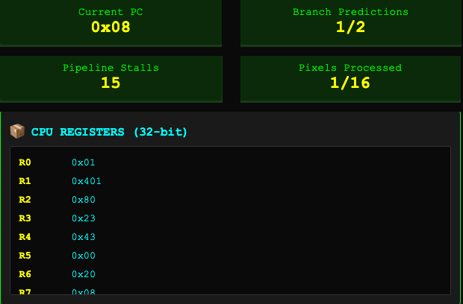
Figure B3.pixel1_done. E3: after pixel 1.
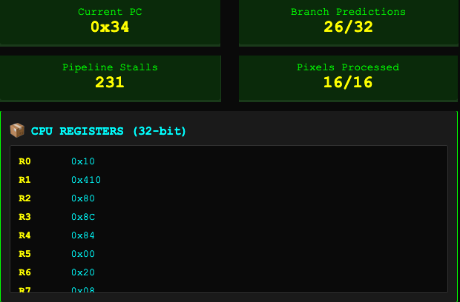
Figure B3.final. E3: final state.

Appendix B.3. Pixel events for E3
Pixel | Input | Output | Cache | BLT | Base | Delay | Total
1 | 35 | 67 | HIT | Wrong | 13 | 15 | 30
2 | 180 | 172 | HIT | Wrong | 15 | 15 | 60
3 | 42 | 74 | MISS | Right | 13 | 47 | 120
4 | 60 | 92 | HIT | Right | 13 | 0 | 133
5 | 210 | 202 | MISS | Right | 15 | 47 | 195
6 | 88 | 120 | HIT | Right | 13 | 0 | 208
7 | 50 | 82 | MISS | Right | 13 | 47 | 268
8 | 115 | 147 | HIT | Right | 13 | 0 | 281
9 | 230 | 222 | HIT | Right | 15 | 0 | 296
10 | 45 | 77 | HIT | Right | 13 | 0 | 309
11 | 72 | 104 | HIT | Right | 13 | 0 | 322
12 | 195 | 187 | HIT | Wrong | 15 | 15 | 352
13 | 30 | 62 | HIT | Wrong | 13 | 15 | 380
14 | 95 | 127 | HIT | Right | 13 | 0 | 393
15 | 80 | 112 | HIT | Wrong | 13 | 15 | 421
16 | 140 | 132 | HIT | Wrong | 15 | 15 | 451
Base is instruction cost before delays. Delay = 47 × load misses + 15 × wrong brightness predictions. The running total includes the two setup cycles. All input/output values are recorded from the trace except Best Case zeros, which are defined by the test setup.

Appendix B.3. All 151 instruction steps for E3
PC values are hexadecimal. A step ending at total T with increment d occupies counted cycles T − d + 1 through T. The last next-PC is HALT; HALT contributes no charged step. BNE predictions are always counted as correct.
Step | PC | Next PC | Added cycles | Total cycles | Event
1 | 0x00 | 0x04 | 1 | 1 | —
2 | 0x04 | 0x08 | 1 | 2 | —
3 | 0x08 | 0x0C | 3 | 5 | Hit
4 | 0x0C | 0x10 | 1 | 6 | —
5 | 0x10 | 0x1C | 16 | 22 | BLT wrong
6 | 0x1C | 0x20 | 1 | 23 | —
7 | 0x20 | 0x24 | 3 | 26 | —
8 | 0x24 | 0x28 | 1 | 27 | —
9 | 0x28 | 0x2C | 1 | 28 | —
10 | 0x2C | 0x30 | 1 | 29 | —
11 | 0x30 | 0x08 | 1 | 30 | BNE right
12 | 0x08 | 0x0C | 3 | 33 | Hit
13 | 0x0C | 0x10 | 1 | 34 | —
14 | 0x10 | 0x14 | 16 | 50 | BLT wrong
15 | 0x14 | 0x18 | 1 | 51 | —
16 | 0x18 | 0x20 | 2 | 53 | —
17 | 0x20 | 0x24 | 3 | 56 | —
18 | 0x24 | 0x28 | 1 | 57 | —
19 | 0x28 | 0x2C | 1 | 58 | —
20 | 0x2C | 0x30 | 1 | 59 | —
21 | 0x30 | 0x08 | 1 | 60 | BNE right
22 | 0x08 | 0x0C | 50 | 110 | Miss
23 | 0x0C | 0x10 | 1 | 111 | —
24 | 0x10 | 0x1C | 1 | 112 | BLT right
25 | 0x1C | 0x20 | 1 | 113 | —
26 | 0x20 | 0x24 | 3 | 116 | —
27 | 0x24 | 0x28 | 1 | 117 | —
28 | 0x28 | 0x2C | 1 | 118 | —
29 | 0x2C | 0x30 | 1 | 119 | —
30 | 0x30 | 0x08 | 1 | 120 | BNE right
31 | 0x08 | 0x0C | 3 | 123 | Hit
32 | 0x0C | 0x10 | 1 | 124 | —
33 | 0x10 | 0x1C | 1 | 125 | BLT right
34 | 0x1C | 0x20 | 1 | 126 | —
35 | 0x20 | 0x24 | 3 | 129 | —
36 | 0x24 | 0x28 | 1 | 130 | —
37 | 0x28 | 0x2C | 1 | 131 | —
38 | 0x2C | 0x30 | 1 | 132 | —
39 | 0x30 | 0x08 | 1 | 133 | BNE right
40 | 0x08 | 0x0C | 50 | 183 | Miss
41 | 0x0C | 0x10 | 1 | 184 | —
42 | 0x10 | 0x14 | 1 | 185 | BLT right
43 | 0x14 | 0x18 | 1 | 186 | —
44 | 0x18 | 0x20 | 2 | 188 | —
45 | 0x20 | 0x24 | 3 | 191 | —
46 | 0x24 | 0x28 | 1 | 192 | —
47 | 0x28 | 0x2C | 1 | 193 | —
48 | 0x2C | 0x30 | 1 | 194 | —
49 | 0x30 | 0x08 | 1 | 195 | BNE right
50 | 0x08 | 0x0C | 3 | 198 | Hit
51 | 0x0C | 0x10 | 1 | 199 | —
52 | 0x10 | 0x1C | 1 | 200 | BLT right
53 | 0x1C | 0x20 | 1 | 201 | —
54 | 0x20 | 0x24 | 3 | 204 | —
55 | 0x24 | 0x28 | 1 | 205 | —
56 | 0x28 | 0x2C | 1 | 206 | —
57 | 0x2C | 0x30 | 1 | 207 | —
58 | 0x30 | 0x08 | 1 | 208 | BNE right
59 | 0x08 | 0x0C | 50 | 258 | Miss
60 | 0x0C | 0x10 | 1 | 259 | —
61 | 0x10 | 0x1C | 1 | 260 | BLT right
62 | 0x1C | 0x20 | 1 | 261 | —
63 | 0x20 | 0x24 | 3 | 264 | —
64 | 0x24 | 0x28 | 1 | 265 | —
65 | 0x28 | 0x2C | 1 | 266 | —
66 | 0x2C | 0x30 | 1 | 267 | —
67 | 0x30 | 0x08 | 1 | 268 | BNE right
68 | 0x08 | 0x0C | 3 | 271 | Hit
69 | 0x0C | 0x10 | 1 | 272 | —
70 | 0x10 | 0x1C | 1 | 273 | BLT right
71 | 0x1C | 0x20 | 1 | 274 | —
72 | 0x20 | 0x24 | 3 | 277 | —
73 | 0x24 | 0x28 | 1 | 278 | —
74 | 0x28 | 0x2C | 1 | 279 | —
75 | 0x2C | 0x30 | 1 | 280 | —
76 | 0x30 | 0x08 | 1 | 281 | BNE right
77 | 0x08 | 0x0C | 3 | 284 | Hit
78 | 0x0C | 0x10 | 1 | 285 | —
79 | 0x10 | 0x14 | 1 | 286 | BLT right
80 | 0x14 | 0x18 | 1 | 287 | —
81 | 0x18 | 0x20 | 2 | 289 | —
82 | 0x20 | 0x24 | 3 | 292 | —
83 | 0x24 | 0x28 | 1 | 293 | —
84 | 0x28 | 0x2C | 1 | 294 | —
85 | 0x2C | 0x30 | 1 | 295 | —
86 | 0x30 | 0x08 | 1 | 296 | BNE right
87 | 0x08 | 0x0C | 3 | 299 | Hit
88 | 0x0C | 0x10 | 1 | 300 | —
89 | 0x10 | 0x1C | 1 | 301 | BLT right
90 | 0x1C | 0x20 | 1 | 302 | —
91 | 0x20 | 0x24 | 3 | 305 | —
92 | 0x24 | 0x28 | 1 | 306 | —
93 | 0x28 | 0x2C | 1 | 307 | —
94 | 0x2C | 0x30 | 1 | 308 | —
95 | 0x30 | 0x08 | 1 | 309 | BNE right
96 | 0x08 | 0x0C | 3 | 312 | Hit
97 | 0x0C | 0x10 | 1 | 313 | —
98 | 0x10 | 0x1C | 1 | 314 | BLT right
99 | 0x1C | 0x20 | 1 | 315 | —
100 | 0x20 | 0x24 | 3 | 318 | —
101 | 0x24 | 0x28 | 1 | 319 | —
102 | 0x28 | 0x2C | 1 | 320 | —
103 | 0x2C | 0x30 | 1 | 321 | —
104 | 0x30 | 0x08 | 1 | 322 | BNE right
105 | 0x08 | 0x0C | 3 | 325 | Hit
106 | 0x0C | 0x10 | 1 | 326 | —
107 | 0x10 | 0x14 | 16 | 342 | BLT wrong
108 | 0x14 | 0x18 | 1 | 343 | —
109 | 0x18 | 0x20 | 2 | 345 | —
110 | 0x20 | 0x24 | 3 | 348 | —
111 | 0x24 | 0x28 | 1 | 349 | —
112 | 0x28 | 0x2C | 1 | 350 | —
113 | 0x2C | 0x30 | 1 | 351 | —
114 | 0x30 | 0x08 | 1 | 352 | BNE right
115 | 0x08 | 0x0C | 3 | 355 | Hit
116 | 0x0C | 0x10 | 1 | 356 | —
117 | 0x10 | 0x1C | 16 | 372 | BLT wrong
118 | 0x1C | 0x20 | 1 | 373 | —
119 | 0x20 | 0x24 | 3 | 376 | —
120 | 0x24 | 0x28 | 1 | 377 | —
121 | 0x28 | 0x2C | 1 | 378 | —
122 | 0x2C | 0x30 | 1 | 379 | —
123 | 0x30 | 0x08 | 1 | 380 | BNE right
124 | 0x08 | 0x0C | 3 | 383 | Hit
125 | 0x0C | 0x10 | 1 | 384 | —
126 | 0x10 | 0x1C | 1 | 385 | BLT right
127 | 0x1C | 0x20 | 1 | 386 | —
128 | 0x20 | 0x24 | 3 | 389 | —
129 | 0x24 | 0x28 | 1 | 390 | —
130 | 0x28 | 0x2C | 1 | 391 | —
131 | 0x2C | 0x30 | 1 | 392 | —
132 | 0x30 | 0x08 | 1 | 393 | BNE right
133 | 0x08 | 0x0C | 3 | 396 | Hit
134 | 0x0C | 0x10 | 1 | 397 | —
135 | 0x10 | 0x1C | 16 | 413 | BLT wrong
136 | 0x1C | 0x20 | 1 | 414 | —
137 | 0x20 | 0x24 | 3 | 417 | —
138 | 0x24 | 0x28 | 1 | 418 | —
139 | 0x28 | 0x2C | 1 | 419 | —
140 | 0x2C | 0x30 | 1 | 420 | —
141 | 0x30 | 0x08 | 1 | 421 | BNE right
142 | 0x08 | 0x0C | 3 | 424 | Hit
143 | 0x0C | 0x10 | 1 | 425 | —
144 | 0x10 | 0x14 | 16 | 441 | BLT wrong
145 | 0x14 | 0x18 | 1 | 442 | —
146 | 0x18 | 0x20 | 2 | 444 | —
147 | 0x20 | 0x24 | 3 | 447 | —
148 | 0x24 | 0x28 | 1 | 448 | —
149 | 0x28 | 0x2C | 1 | 449 | —
150 | 0x2C | 0x30 | 1 | 450 | —
151 | 0x30 | 0x34 | 1 | 451 | BNE right

Appendix B.4. Complete trace for E4 (Real 2)
The panels below show the same run after setup, after pixel 1, and at completion. Status boxes are arranged above the register panel for readability. Each panel uses a single captured screenshot; existing clipping is retained. Current PC is the next instruction, while the execution trace lists the instruction just executed.
Figure B4.setup. E4: after setup.
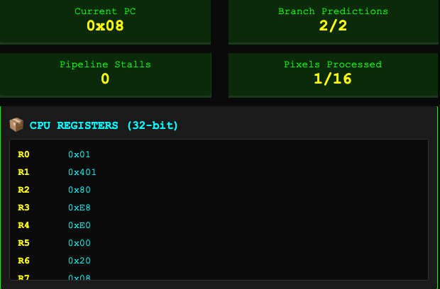
Figure B4.pixel1_done. E4: after pixel 1.
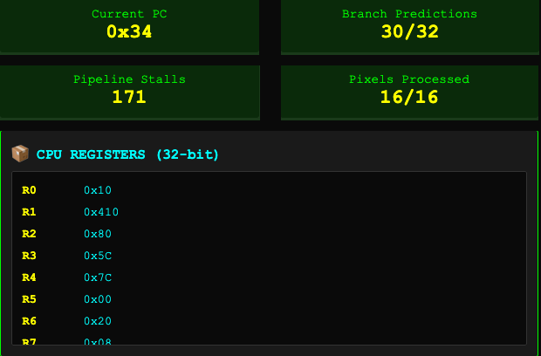
Figure B4.final. E4: final state.

Appendix B.4. Pixel events for E4
Pixel | Input | Output | Cache | BLT | Base | Delay | Total
1 | 232 | 224 | HIT | Right | 15 | 0 | 17
2 | 244 | 236 | HIT | Wrong | 15 | 15 | 47
3 | 227 | 219 | HIT | Right | 15 | 0 | 62
4 | 247 | 239 | MISS | Right | 15 | 47 | 124
5 | 211 | 203 | HIT | Right | 15 | 0 | 139
6 | 231 | 223 | HIT | Right | 15 | 0 | 154
7 | 254 | 246 | HIT | Right | 15 | 0 | 169
8 | 225 | 217 | HIT | Right | 15 | 0 | 184
9 | 1 | 33 | MISS | Right | 13 | 47 | 244
10 | 23 | 55 | HIT | Right | 13 | 0 | 257
11 | 16 | 48 | HIT | Right | 13 | 0 | 270
12 | 65 | 97 | HIT | Right | 13 | 0 | 283
13 | 56 | 88 | HIT | Wrong | 13 | 15 | 311
14 | 94 | 126 | HIT | Right | 13 | 0 | 324
15 | 96 | 128 | HIT | Right | 13 | 0 | 337
16 | 92 | 124 | MISS | Right | 13 | 47 | 397
Base is instruction cost before delays. Delay = 47 × load misses + 15 × wrong brightness predictions. The running total includes the two setup cycles. All input/output values are recorded from the trace except Best Case zeros, which are defined by the test setup.

Appendix B.4. All 154 instruction steps for E4
PC values are hexadecimal. A step ending at total T with increment d occupies counted cycles T − d + 1 through T. The last next-PC is HALT; HALT contributes no charged step. BNE predictions are always counted as correct.
Step | PC | Next PC | Added cycles | Total cycles | Event
1 | 0x00 | 0x04 | 1 | 1 | —
2 | 0x04 | 0x08 | 1 | 2 | —
3 | 0x08 | 0x0C | 3 | 5 | Hit
4 | 0x0C | 0x10 | 1 | 6 | —
5 | 0x10 | 0x14 | 1 | 7 | BLT right
6 | 0x14 | 0x18 | 1 | 8 | —
7 | 0x18 | 0x20 | 2 | 10 | —
8 | 0x20 | 0x24 | 3 | 13 | —
9 | 0x24 | 0x28 | 1 | 14 | —
10 | 0x28 | 0x2C | 1 | 15 | —
11 | 0x2C | 0x30 | 1 | 16 | —
12 | 0x30 | 0x08 | 1 | 17 | BNE right
13 | 0x08 | 0x0C | 3 | 20 | Hit
14 | 0x0C | 0x10 | 1 | 21 | —
15 | 0x10 | 0x14 | 16 | 37 | BLT wrong
16 | 0x14 | 0x18 | 1 | 38 | —
17 | 0x18 | 0x20 | 2 | 40 | —
18 | 0x20 | 0x24 | 3 | 43 | —
19 | 0x24 | 0x28 | 1 | 44 | —
20 | 0x28 | 0x2C | 1 | 45 | —
21 | 0x2C | 0x30 | 1 | 46 | —
22 | 0x30 | 0x08 | 1 | 47 | BNE right
23 | 0x08 | 0x0C | 3 | 50 | Hit
24 | 0x0C | 0x10 | 1 | 51 | —
25 | 0x10 | 0x14 | 1 | 52 | BLT right
26 | 0x14 | 0x18 | 1 | 53 | —
27 | 0x18 | 0x20 | 2 | 55 | —
28 | 0x20 | 0x24 | 3 | 58 | —
29 | 0x24 | 0x28 | 1 | 59 | —
30 | 0x28 | 0x2C | 1 | 60 | —
31 | 0x2C | 0x30 | 1 | 61 | —
32 | 0x30 | 0x08 | 1 | 62 | BNE right
33 | 0x08 | 0x0C | 50 | 112 | Miss
34 | 0x0C | 0x10 | 1 | 113 | —
35 | 0x10 | 0x14 | 1 | 114 | BLT right
36 | 0x14 | 0x18 | 1 | 115 | —
37 | 0x18 | 0x20 | 2 | 117 | —
38 | 0x20 | 0x24 | 3 | 120 | —
39 | 0x24 | 0x28 | 1 | 121 | —
40 | 0x28 | 0x2C | 1 | 122 | —
41 | 0x2C | 0x30 | 1 | 123 | —
42 | 0x30 | 0x08 | 1 | 124 | BNE right
43 | 0x08 | 0x0C | 3 | 127 | Hit
44 | 0x0C | 0x10 | 1 | 128 | —
45 | 0x10 | 0x14 | 1 | 129 | BLT right
46 | 0x14 | 0x18 | 1 | 130 | —
47 | 0x18 | 0x20 | 2 | 132 | —
48 | 0x20 | 0x24 | 3 | 135 | —
49 | 0x24 | 0x28 | 1 | 136 | —
50 | 0x28 | 0x2C | 1 | 137 | —
51 | 0x2C | 0x30 | 1 | 138 | —
52 | 0x30 | 0x08 | 1 | 139 | BNE right
53 | 0x08 | 0x0C | 3 | 142 | Hit
54 | 0x0C | 0x10 | 1 | 143 | —
55 | 0x10 | 0x14 | 1 | 144 | BLT right
56 | 0x14 | 0x18 | 1 | 145 | —
57 | 0x18 | 0x20 | 2 | 147 | —
58 | 0x20 | 0x24 | 3 | 150 | —
59 | 0x24 | 0x28 | 1 | 151 | —
60 | 0x28 | 0x2C | 1 | 152 | —
61 | 0x2C | 0x30 | 1 | 153 | —
62 | 0x30 | 0x08 | 1 | 154 | BNE right
63 | 0x08 | 0x0C | 3 | 157 | Hit
64 | 0x0C | 0x10 | 1 | 158 | —
65 | 0x10 | 0x14 | 1 | 159 | BLT right
66 | 0x14 | 0x18 | 1 | 160 | —
67 | 0x18 | 0x20 | 2 | 162 | —
68 | 0x20 | 0x24 | 3 | 165 | —
69 | 0x24 | 0x28 | 1 | 166 | —
70 | 0x28 | 0x2C | 1 | 167 | —
71 | 0x2C | 0x30 | 1 | 168 | —
72 | 0x30 | 0x08 | 1 | 169 | BNE right
73 | 0x08 | 0x0C | 3 | 172 | Hit
74 | 0x0C | 0x10 | 1 | 173 | —
75 | 0x10 | 0x14 | 1 | 174 | BLT right
76 | 0x14 | 0x18 | 1 | 175 | —
77 | 0x18 | 0x20 | 2 | 177 | —
78 | 0x20 | 0x24 | 3 | 180 | —
79 | 0x24 | 0x28 | 1 | 181 | —
80 | 0x28 | 0x2C | 1 | 182 | —
81 | 0x2C | 0x30 | 1 | 183 | —
82 | 0x30 | 0x08 | 1 | 184 | BNE right
83 | 0x08 | 0x0C | 50 | 234 | Miss
84 | 0x0C | 0x10 | 1 | 235 | —
85 | 0x10 | 0x1C | 1 | 236 | BLT right
86 | 0x1C | 0x20 | 1 | 237 | —
87 | 0x20 | 0x24 | 3 | 240 | —
88 | 0x24 | 0x28 | 1 | 241 | —
89 | 0x28 | 0x2C | 1 | 242 | —
90 | 0x2C | 0x30 | 1 | 243 | —
91 | 0x30 | 0x08 | 1 | 244 | BNE right
92 | 0x08 | 0x0C | 3 | 247 | Hit
93 | 0x0C | 0x10 | 1 | 248 | —
94 | 0x10 | 0x1C | 1 | 249 | BLT right
95 | 0x1C | 0x20 | 1 | 250 | —
96 | 0x20 | 0x24 | 3 | 253 | —
97 | 0x24 | 0x28 | 1 | 254 | —
98 | 0x28 | 0x2C | 1 | 255 | —
99 | 0x2C | 0x30 | 1 | 256 | —
100 | 0x30 | 0x08 | 1 | 257 | BNE right
101 | 0x08 | 0x0C | 3 | 260 | Hit
102 | 0x0C | 0x10 | 1 | 261 | —
103 | 0x10 | 0x1C | 1 | 262 | BLT right
104 | 0x1C | 0x20 | 1 | 263 | —
105 | 0x20 | 0x24 | 3 | 266 | —
106 | 0x24 | 0x28 | 1 | 267 | —
107 | 0x28 | 0x2C | 1 | 268 | —
108 | 0x2C | 0x30 | 1 | 269 | —
109 | 0x30 | 0x08 | 1 | 270 | BNE right
110 | 0x08 | 0x0C | 3 | 273 | Hit
111 | 0x0C | 0x10 | 1 | 274 | —
112 | 0x10 | 0x1C | 1 | 275 | BLT right
113 | 0x1C | 0x20 | 1 | 276 | —
114 | 0x20 | 0x24 | 3 | 279 | —
115 | 0x24 | 0x28 | 1 | 280 | —
116 | 0x28 | 0x2C | 1 | 281 | —
117 | 0x2C | 0x30 | 1 | 282 | —
118 | 0x30 | 0x08 | 1 | 283 | BNE right
119 | 0x08 | 0x0C | 3 | 286 | Hit
120 | 0x0C | 0x10 | 1 | 287 | —
121 | 0x10 | 0x1C | 16 | 303 | BLT wrong
122 | 0x1C | 0x20 | 1 | 304 | —
123 | 0x20 | 0x24 | 3 | 307 | —
124 | 0x24 | 0x28 | 1 | 308 | —
125 | 0x28 | 0x2C | 1 | 309 | —
126 | 0x2C | 0x30 | 1 | 310 | —
127 | 0x30 | 0x08 | 1 | 311 | BNE right
128 | 0x08 | 0x0C | 3 | 314 | Hit
129 | 0x0C | 0x10 | 1 | 315 | —
130 | 0x10 | 0x1C | 1 | 316 | BLT right
131 | 0x1C | 0x20 | 1 | 317 | —
132 | 0x20 | 0x24 | 3 | 320 | —
133 | 0x24 | 0x28 | 1 | 321 | —
134 | 0x28 | 0x2C | 1 | 322 | —
135 | 0x2C | 0x30 | 1 | 323 | —
136 | 0x30 | 0x08 | 1 | 324 | BNE right
137 | 0x08 | 0x0C | 3 | 327 | Hit
138 | 0x0C | 0x10 | 1 | 328 | —
139 | 0x10 | 0x1C | 1 | 329 | BLT right
140 | 0x1C | 0x20 | 1 | 330 | —
141 | 0x20 | 0x24 | 3 | 333 | —
142 | 0x24 | 0x28 | 1 | 334 | —
143 | 0x28 | 0x2C | 1 | 335 | —
144 | 0x2C | 0x30 | 1 | 336 | —
145 | 0x30 | 0x08 | 1 | 337 | BNE right
146 | 0x08 | 0x0C | 50 | 387 | Miss
147 | 0x0C | 0x10 | 1 | 388 | —
148 | 0x10 | 0x1C | 1 | 389 | BLT right
149 | 0x1C | 0x20 | 1 | 390 | —
150 | 0x20 | 0x24 | 3 | 393 | —
151 | 0x24 | 0x28 | 1 | 394 | —
152 | 0x28 | 0x2C | 1 | 395 | —
153 | 0x2C | 0x30 | 1 | 396 | —
154 | 0x30 | 0x34 | 1 | 397 | BNE right

Appendix C. All 800 benchmark records
Each cell below gives cycles / cache misses / wrong predictions. Each column has 40 executions per case. Rows across different programs do not share random draws. These triplets, together with Table 4, determine the other counters: hits = 16 − misses; stalls = 47 × misses + 15 × wrong; correct branches = branch count − wrong. Every output check passed. The selected screenshots in Section 1 are separate individual captures and need not equal the last repeat or the mean.

Best: 40 repetitions per program
Repeat | Baseline | Branch-free | Unrolled | Loop-test | Combined
1 | 492 / 6 / 0 | 508 / 6 / 0 | 303 / 3 / 0 | 397 / 4 / 1 | 366 / 4 / 0
2 | 445 / 5 / 0 | 461 / 5 / 0 | 286 / 2 / 2 | 382 / 4 / 0 | 225 / 1 / 0
3 | 413 / 4 / 1 | 414 / 4 / 0 | 380 / 4 / 2 | 335 / 3 / 0 | 413 / 5 / 0
4 | 351 / 3 / 0 | 461 / 5 / 0 | 427 / 5 / 2 | 444 / 5 / 1 | 225 / 1 / 0
5 | 351 / 3 / 0 | 461 / 5 / 0 | 192 / 0 / 2 | 365 / 3 / 2 | 366 / 4 / 0
6 | 492 / 6 / 0 | 226 / 0 / 0 | 271 / 2 / 1 | 241 / 1 / 0 | 366 / 4 / 0
7 | 287 / 1 / 2 | 414 / 4 / 0 | 271 / 2 / 1 | 303 / 2 / 1 | 366 / 4 / 0
8 | 460 / 5 / 1 | 320 / 2 / 0 | 271 / 2 / 1 | 476 / 6 / 0 | 272 / 2 / 0
9 | 304 / 2 / 0 | 414 / 4 / 0 | 256 / 2 / 0 | 350 / 3 / 1 | 366 / 4 / 0
10 | 319 / 2 / 1 | 414 / 4 / 0 | 271 / 2 / 1 | 335 / 3 / 0 | 272 / 2 / 0
11 | 319 / 2 / 1 | 320 / 2 / 0 | 303 / 3 / 0 | 256 / 1 / 1 | 319 / 3 / 0
12 | 304 / 2 / 0 | 273 / 1 / 0 | 350 / 4 / 0 | 382 / 4 / 0 | 413 / 5 / 0
13 | 460 / 5 / 1 | 320 / 2 / 0 | 397 / 5 / 0 | 429 / 5 / 0 | 272 / 2 / 0
14 | 398 / 4 / 0 | 461 / 5 / 0 | 256 / 2 / 0 | 288 / 2 / 0 | 366 / 4 / 0
15 | 257 / 1 / 0 | 367 / 3 / 0 | 412 / 5 / 1 | 335 / 3 / 0 | 225 / 1 / 0
16 | 257 / 1 / 0 | 367 / 3 / 0 | 303 / 3 / 0 | 397 / 4 / 1 | 319 / 3 / 0
17 | 460 / 5 / 1 | 367 / 3 / 0 | 286 / 2 / 2 | 271 / 1 / 2 | 413 / 5 / 0
18 | 366 / 3 / 1 | 367 / 3 / 0 | 412 / 5 / 1 | 256 / 1 / 1 | 413 / 5 / 0
19 | 351 / 3 / 0 | 414 / 4 / 0 | 271 / 2 / 1 | 412 / 4 / 2 | 460 / 6 / 0
20 | 413 / 4 / 1 | 414 / 4 / 0 | 412 / 5 / 1 | 288 / 2 / 0 | 319 / 3 / 0
21 | 351 / 3 / 0 | 414 / 4 / 0 | 318 / 3 / 1 | 365 / 3 / 2 | 225 / 1 / 0
22 | 351 / 3 / 0 | 367 / 3 / 0 | 397 / 5 / 0 | 318 / 2 / 2 | 413 / 5 / 0
23 | 413 / 4 / 1 | 414 / 4 / 0 | 303 / 3 / 0 | 350 / 3 / 1 | 366 / 4 / 0
24 | 257 / 1 / 0 | 414 / 4 / 0 | 256 / 2 / 0 | 350 / 3 / 1 | 319 / 3 / 0
25 | 304 / 2 / 0 | 320 / 2 / 0 | 286 / 2 / 2 | 382 / 4 / 0 | 272 / 2 / 0
26 | 304 / 2 / 0 | 367 / 3 / 0 | 427 / 5 / 2 | 241 / 1 / 0 | 319 / 3 / 0
27 | 257 / 1 / 0 | 414 / 4 / 0 | 286 / 2 / 2 | 350 / 3 / 1 | 413 / 5 / 0
28 | 396 / 3 / 3 | 320 / 2 / 0 | 365 / 4 / 1 | 271 / 1 / 2 | 319 / 3 / 0
29 | 351 / 3 / 0 | 273 / 1 / 0 | 271 / 2 / 1 | 491 / 6 / 1 | 319 / 3 / 0
30 | 304 / 2 / 0 | 273 / 1 / 0 | 412 / 5 / 1 | 647 / 9 / 2 | 366 / 4 / 0
31 | 319 / 2 / 1 | 320 / 2 / 0 | 303 / 3 / 0 | 365 / 3 / 2 | 319 / 3 / 0
32 | 398 / 4 / 0 | 508 / 6 / 0 | 224 / 1 / 1 | 256 / 1 / 1 | 272 / 2 / 0
33 | 381 / 3 / 2 | 367 / 3 / 0 | 254 / 1 / 3 | 241 / 1 / 0 | 319 / 3 / 0
34 | 351 / 3 / 0 | 367 / 3 / 0 | 303 / 3 / 0 | 335 / 3 / 0 | 319 / 3 / 0
35 | 492 / 6 / 0 | 461 / 5 / 0 | 224 / 1 / 1 | 335 / 3 / 0 | 554 / 8 / 0
36 | 287 / 1 / 2 | 367 / 3 / 0 | 365 / 4 / 1 | 476 / 6 / 0 | 413 / 5 / 0
37 | 319 / 2 / 1 | 320 / 2 / 0 | 256 / 2 / 0 | 194 / 0 / 0 | 460 / 6 / 0
38 | 272 / 1 / 1 | 367 / 3 / 0 | 365 / 4 / 1 | 365 / 3 / 2 | 319 / 3 / 0
39 | 554 / 7 / 1 | 320 / 2 / 0 | 380 / 4 / 2 | 303 / 2 / 1 | 366 / 4 / 0
40 | 349 / 2 / 3 | 320 / 2 / 0 | 333 / 3 / 2 | 523 / 7 / 0 | 272 / 2 / 0
Column means: Baseline 362.73 cycles; Branch-free 376.40 cycles; Unrolled 316.45 cycles; Loop-test 352.50 cycles; Combined 342.50 cycles.

Worst: 40 repetitions per program
Repeat | Baseline | Branch-free | Unrolled | Loop-test | Combined
1 | 534 / 4 / 8 | 367 / 3 / 0 | 561 / 4 / 13 | 518 / 4 / 8 | 319 / 3 / 0
2 | 551 / 5 / 6 | 414 / 4 / 0 | 315 / 1 / 6 | 330 / 0 / 8 | 272 / 2 / 0
3 | 519 / 4 / 7 | 414 / 4 / 0 | 439 / 3 / 8 | 409 / 2 / 7 | 319 / 3 / 0
4 | 346 / 0 / 8 | 320 / 2 / 0 | 405 / 1 / 12 | 392 / 1 / 9 | 272 / 2 / 0
5 | 442 / 3 / 5 | 320 / 2 / 0 | 456 / 4 / 6 | 456 / 3 / 7 | 507 / 7 / 0
6 | 566 / 5 / 7 | 273 / 1 / 0 | 486 / 4 / 8 | 347 / 1 / 6 | 272 / 2 / 0
7 | 581 / 5 / 8 | 414 / 4 / 0 | 488 / 5 / 5 | 332 / 1 / 5 | 366 / 4 / 0
8 | 472 / 3 / 7 | 414 / 4 / 0 | 548 / 5 / 9 | 471 / 3 / 8 | 413 / 5 / 0
9 | 579 / 4 / 11 | 508 / 6 / 0 | 582 / 7 / 5 | 565 / 5 / 8 | 272 / 2 / 0
10 | 440 / 2 / 8 | 320 / 2 / 0 | 627 / 7 / 8 | 285 / 0 / 5 | 366 / 4 / 0
11 | 423 / 1 / 10 | 414 / 4 / 0 | 469 / 3 / 10 | 471 / 3 / 8 | 366 / 4 / 0
12 | 502 / 3 / 9 | 461 / 5 / 0 | 533 / 5 / 8 | 531 / 3 / 12 | 225 / 1 / 0
13 | 457 / 3 / 6 | 414 / 4 / 0 | 300 / 1 / 5 | 580 / 5 / 9 | 272 / 2 / 0
14 | 549 / 4 / 9 | 367 / 3 / 0 | 424 / 3 / 7 | 550 / 5 / 7 | 319 / 3 / 0
15 | 442 / 3 / 5 | 461 / 5 / 0 | 518 / 5 / 7 | 381 / 3 / 2 | 272 / 2 / 0
16 | 562 / 3 / 13 | 414 / 4 / 0 | 345 / 1 / 8 | 439 / 2 / 9 | 272 / 2 / 0
17 | 534 / 4 / 8 | 367 / 3 / 0 | 439 / 3 / 8 | 582 / 6 / 6 | 413 / 5 / 0
18 | 393 / 1 / 8 | 320 / 2 / 0 | 377 / 2 / 7 | 597 / 6 / 7 | 366 / 4 / 0
19 | 457 / 3 / 6 | 414 / 4 / 0 | 390 / 1 / 11 | 394 / 2 / 6 | 319 / 3 / 0
20 | 485 / 2 / 11 | 461 / 5 / 0 | 424 / 3 / 7 | 409 / 2 / 7 | 413 / 5 / 0
21 | 549 / 4 / 9 | 367 / 3 / 0 | 332 / 2 / 4 | 456 / 3 / 7 | 413 / 5 / 0
22 | 455 / 2 / 9 | 461 / 5 / 0 | 454 / 3 / 9 | 422 / 1 / 11 | 366 / 4 / 0
23 | 532 / 3 / 11 | 367 / 3 / 0 | 424 / 3 / 7 | 612 / 6 / 8 | 225 / 1 / 0
24 | 442 / 3 / 5 | 414 / 4 / 0 | 627 / 7 / 8 | 377 / 1 / 8 | 319 / 3 / 0
25 | 442 / 3 / 5 | 320 / 2 / 0 | 642 / 7 / 9 | 518 / 4 / 8 | 272 / 2 / 0
26 | 470 / 2 / 10 | 461 / 5 / 0 | 595 / 6 / 9 | 471 / 3 / 8 | 319 / 3 / 0
27 | 641 / 5 / 12 | 414 / 4 / 0 | 392 / 2 / 8 | 469 / 2 / 11 | 413 / 5 / 0
28 | 517 / 3 / 10 | 367 / 3 / 0 | 486 / 4 / 8 | 518 / 4 / 8 | 366 / 4 / 0
29 | 519 / 4 / 7 | 320 / 2 / 0 | 439 / 3 / 8 | 473 / 4 / 5 | 319 / 3 / 0
30 | 536 / 5 / 5 | 414 / 4 / 0 | 514 / 3 / 13 | 362 / 1 / 7 | 272 / 2 / 0
31 | 566 / 5 / 7 | 414 / 4 / 0 | 471 / 4 / 7 | 441 / 3 / 6 | 319 / 3 / 0
32 | 613 / 6 / 7 | 367 / 3 / 0 | 345 / 1 / 8 | 597 / 6 / 7 | 225 / 1 / 0
33 | 376 / 0 / 10 | 414 / 4 / 0 | 345 / 1 / 8 | 580 / 5 / 9 | 460 / 6 / 0
34 | 457 / 3 / 6 | 367 / 3 / 0 | 454 / 3 / 9 | 488 / 4 / 6 | 319 / 3 / 0
35 | 549 / 4 / 9 | 414 / 4 / 0 | 439 / 3 / 8 | 473 / 4 / 5 | 366 / 4 / 0
36 | 502 / 3 / 9 | 414 / 4 / 0 | 518 / 5 / 7 | 627 / 6 / 9 | 366 / 4 / 0
37 | 502 / 3 / 9 | 414 / 4 / 0 | 394 / 3 / 5 | 488 / 4 / 6 | 272 / 2 / 0
38 | 720 / 7 / 11 | 320 / 2 / 0 | 394 / 3 / 5 | 394 / 2 / 6 | 272 / 2 / 0
39 | 440 / 2 / 8 | 367 / 3 / 0 | 563 / 5 / 10 | 441 / 3 / 6 | 413 / 5 / 0
40 | 455 / 2 / 9 | 320 / 2 / 0 | 456 / 4 / 6 | 499 / 2 / 13 | 272 / 2 / 0
Column means: Baseline 502.93 cycles; Branch-free 389.33 cycles; Unrolled 460.25 cycles; Loop-test 468.63 cycles; Combined 329.58 cycles.

Real 1: 40 repetitions per program
Repeat | Baseline | Branch-free | Unrolled | Loop-test | Combined
1 | 344 / 2 / 2 | 367 / 3 / 0 | 358 / 3 / 3 | 484 / 5 / 3 | 319 / 3 / 0
2 | 421 / 3 / 4 | 320 / 2 / 0 | 281 / 2 / 1 | 405 / 3 / 4 | 272 / 2 / 0
3 | 485 / 5 / 2 | 414 / 4 / 0 | 386 / 2 / 8 | 454 / 5 / 1 | 225 / 1 / 0
4 | 498 / 4 / 6 | 320 / 2 / 0 | 390 / 4 / 2 | 360 / 3 / 1 | 319 / 3 / 0
5 | 436 / 3 / 5 | 320 / 2 / 0 | 328 / 3 / 1 | 469 / 5 / 2 | 272 / 2 / 0
6 | 359 / 2 / 3 | 320 / 2 / 0 | 559 / 6 / 7 | 422 / 4 / 2 | 413 / 5 / 0
7 | 500 / 5 / 3 | 273 / 1 / 0 | 514 / 6 / 4 | 390 / 3 / 3 | 460 / 6 / 0
8 | 453 / 4 / 3 | 461 / 5 / 0 | 358 / 3 / 3 | 420 / 3 / 5 | 366 / 4 / 0
9 | 500 / 5 / 3 | 320 / 2 / 0 | 405 / 4 / 3 | 439 / 5 / 0 | 507 / 7 / 0
10 | 483 / 4 / 5 | 320 / 2 / 0 | 405 / 4 / 3 | 484 / 5 / 3 | 225 / 1 / 0
11 | 468 / 4 / 4 | 367 / 3 / 0 | 638 / 8 / 6 | 484 / 5 / 3 | 272 / 2 / 0
12 | 423 / 4 / 1 | 367 / 3 / 0 | 311 / 2 / 3 | 516 / 6 / 2 | 272 / 2 / 0
13 | 468 / 4 / 4 | 320 / 2 / 0 | 341 / 2 / 5 | 313 / 2 / 1 | 413 / 5 / 0
14 | 406 / 3 / 3 | 320 / 2 / 0 | 405 / 4 / 3 | 281 / 1 / 2 | 507 / 7 / 0
15 | 376 / 3 / 1 | 367 / 3 / 0 | 578 / 8 / 2 | 499 / 5 / 4 | 366 / 4 / 0
16 | 374 / 2 / 4 | 414 / 4 / 0 | 266 / 2 / 0 | 373 / 2 / 5 | 319 / 3 / 0
17 | 532 / 6 / 2 | 414 / 4 / 0 | 373 / 3 / 4 | 405 / 3 / 4 | 319 / 3 / 0
18 | 344 / 2 / 2 | 273 / 1 / 0 | 343 / 3 / 2 | 420 / 3 / 5 | 413 / 5 / 0
19 | 391 / 3 / 2 | 273 / 1 / 0 | 328 / 3 / 1 | 358 / 2 / 4 | 319 / 3 / 0
20 | 406 / 3 / 3 | 367 / 3 / 0 | 386 / 2 / 8 | 313 / 2 / 1 | 366 / 4 / 0
21 | 391 / 3 / 2 | 414 / 4 / 0 | 467 / 5 / 4 | 422 / 4 / 2 | 272 / 2 / 0
22 | 592 / 6 / 6 | 320 / 2 / 0 | 328 / 3 / 1 | 482 / 4 / 6 | 366 / 4 / 0
23 | 391 / 3 / 2 | 461 / 5 / 0 | 390 / 4 / 2 | 531 / 6 / 3 | 272 / 2 / 0
24 | 376 / 3 / 1 | 367 / 3 / 0 | 499 / 6 / 3 | 390 / 3 / 3 | 366 / 4 / 0
25 | 470 / 5 / 1 | 367 / 3 / 0 | 279 / 1 / 4 | 390 / 3 / 3 | 319 / 3 / 0
26 | 421 / 3 / 4 | 508 / 6 / 0 | 437 / 5 / 2 | 360 / 3 / 1 | 366 / 4 / 0
27 | 498 / 4 / 6 | 508 / 6 / 0 | 422 / 5 / 1 | 501 / 6 / 1 | 366 / 4 / 0
28 | 421 / 3 / 4 | 414 / 4 / 0 | 328 / 3 / 1 | 467 / 4 / 5 | 272 / 2 / 0
29 | 468 / 4 / 4 | 461 / 5 / 0 | 516 / 7 / 1 | 249 / 0 / 3 | 413 / 5 / 0
30 | 453 / 4 / 3 | 367 / 3 / 0 | 407 / 5 / 0 | 375 / 3 / 2 | 366 / 4 / 0
31 | 609 / 7 / 4 | 508 / 6 / 0 | 356 / 2 / 6 | 467 / 4 / 5 | 319 / 3 / 0
32 | 391 / 3 / 2 | 367 / 3 / 0 | 264 / 1 / 3 | 296 / 1 / 3 | 272 / 2 / 0
33 | 637 / 6 / 9 | 320 / 2 / 0 | 296 / 2 / 2 | 343 / 2 / 3 | 413 / 5 / 0
34 | 374 / 2 / 4 | 367 / 3 / 0 | 358 / 3 / 3 | 313 / 2 / 1 | 178 / 0 / 0
35 | 329 / 2 / 1 | 414 / 4 / 0 | 435 / 4 / 5 | 281 / 1 / 2 | 272 / 2 / 0
36 | 466 / 3 / 7 | 508 / 6 / 0 | 373 / 3 / 4 | 390 / 3 / 3 | 413 / 5 / 0
37 | 438 / 4 / 2 | 273 / 1 / 0 | 390 / 4 / 2 | 407 / 4 / 1 | 413 / 5 / 0
38 | 485 / 5 / 2 | 555 / 7 / 0 | 484 / 6 / 2 | 437 / 4 / 3 | 272 / 2 / 0
39 | 327 / 1 / 4 | 226 / 0 / 0 | 311 / 2 / 3 | 420 / 3 / 5 | 272 / 2 / 0
40 | 389 / 2 / 5 | 414 / 4 / 0 | 311 / 2 / 3 | 375 / 3 / 2 | 366 / 4 / 0
Column means: Baseline 439.83 cycles; Branch-free 376.40 cycles; Unrolled 390.10 cycles; Loop-test 404.63 cycles; Combined 337.80 cycles.

Real 2: 40 repetitions per program
Repeat | Baseline | Branch-free | Unrolled | Loop-test | Combined
1 | 350 / 2 / 2 | 367 / 3 / 0 | 458 / 5 / 3 | 304 / 2 / 0 | 319 / 3 / 0
2 | 489 / 4 / 5 | 414 / 4 / 0 | 302 / 2 / 2 | 319 / 2 / 1 | 319 / 3 / 0
3 | 365 / 2 / 3 | 367 / 3 / 0 | 334 / 3 / 1 | 240 / 0 / 2 | 319 / 3 / 0
4 | 476 / 5 / 1 | 320 / 2 / 0 | 473 / 5 / 4 | 443 / 4 / 3 | 460 / 6 / 0
5 | 412 / 3 / 3 | 320 / 2 / 0 | 426 / 4 / 4 | 443 / 4 / 3 | 272 / 2 / 0
6 | 320 / 2 / 0 | 414 / 4 / 0 | 441 / 4 / 5 | 597 / 6 / 7 | 319 / 3 / 0
7 | 382 / 3 / 1 | 414 / 4 / 0 | 379 / 3 / 4 | 287 / 1 / 2 | 272 / 2 / 0
8 | 442 / 3 / 5 | 414 / 4 / 0 | 349 / 3 / 2 | 458 / 4 / 4 | 366 / 4 / 0
9 | 333 / 1 / 4 | 273 / 1 / 0 | 302 / 2 / 2 | 428 / 4 / 2 | 554 / 8 / 0
10 | 506 / 5 / 3 | 508 / 6 / 0 | 426 / 4 / 4 | 379 / 2 / 5 | 366 / 4 / 0
11 | 410 / 2 / 6 | 414 / 4 / 0 | 379 / 3 / 4 | 287 / 1 / 2 | 366 / 4 / 0
12 | 506 / 5 / 3 | 367 / 3 / 0 | 334 / 3 / 1 | 349 / 2 / 3 | 319 / 3 / 0
13 | 333 / 1 / 4 | 320 / 2 / 0 | 364 / 3 / 3 | 443 / 4 / 3 | 319 / 3 / 0
14 | 491 / 5 / 2 | 461 / 5 / 0 | 396 / 4 / 2 | 428 / 4 / 2 | 319 / 3 / 0
15 | 395 / 2 / 5 | 461 / 5 / 0 | 347 / 2 / 5 | 428 / 4 / 2 | 272 / 2 / 0
16 | 412 / 3 / 3 | 555 / 7 / 0 | 426 / 4 / 4 | 396 / 3 / 3 | 366 / 4 / 0
17 | 506 / 5 / 3 | 273 / 1 / 0 | 287 / 2 / 1 | 428 / 4 / 2 | 319 / 3 / 0
18 | 521 / 5 / 4 | 273 / 1 / 0 | 475 / 6 / 1 | 522 / 6 / 2 | 366 / 4 / 0
19 | 365 / 2 / 3 | 555 / 7 / 0 | 426 / 4 / 4 | 490 / 5 / 3 | 460 / 6 / 0
20 | 444 / 4 / 2 | 273 / 1 / 0 | 441 / 4 / 5 | 317 / 1 / 4 | 319 / 3 / 0
21 | 320 / 2 / 0 | 367 / 3 / 0 | 334 / 3 / 1 | 443 / 4 / 3 | 272 / 2 / 0
22 | 600 / 7 / 3 | 320 / 2 / 0 | 255 / 1 / 2 | 270 / 0 / 4 | 225 / 1 / 0
23 | 350 / 2 / 2 | 273 / 1 / 0 | 302 / 2 / 2 | 552 / 6 / 4 | 178 / 0 / 0
24 | 459 / 4 / 3 | 273 / 1 / 0 | 364 / 3 / 3 | 456 / 3 / 7 | 366 / 4 / 0
25 | 335 / 2 / 1 | 226 / 0 / 0 | 443 / 5 / 2 | 428 / 4 / 2 | 272 / 2 / 0
26 | 350 / 2 / 2 | 320 / 2 / 0 | 599 / 8 / 3 | 364 / 2 / 4 | 413 / 5 / 0
27 | 506 / 5 / 3 | 414 / 4 / 0 | 332 / 2 / 4 | 319 / 2 / 1 | 272 / 2 / 0
28 | 444 / 4 / 2 | 320 / 2 / 0 | 473 / 5 / 4 | 381 / 3 / 2 | 319 / 3 / 0
29 | 476 / 5 / 1 | 320 / 2 / 0 | 317 / 2 / 3 | 255 / 0 / 3 | 366 / 4 / 0
30 | 365 / 2 / 3 | 508 / 6 / 0 | 302 / 2 / 2 | 411 / 3 / 4 | 319 / 3 / 0
31 | 444 / 4 / 2 | 367 / 3 / 0 | 501 / 4 / 9 | 366 / 3 / 1 | 272 / 2 / 0
32 | 444 / 4 / 2 | 367 / 3 / 0 | 381 / 4 / 1 | 426 / 3 / 5 | 225 / 1 / 0
33 | 459 / 4 / 3 | 367 / 3 / 0 | 317 / 2 / 3 | 304 / 2 / 0 | 460 / 6 / 0
34 | 348 / 1 / 5 | 320 / 2 / 0 | 332 / 2 / 4 | 396 / 3 / 3 | 366 / 4 / 0
35 | 335 / 2 / 1 | 367 / 3 / 0 | 317 / 2 / 3 | 285 / 0 / 5 | 413 / 5 / 0
36 | 288 / 1 / 1 | 414 / 4 / 0 | 364 / 3 / 3 | 381 / 3 / 2 | 413 / 5 / 0
37 | 412 / 3 / 3 | 414 / 4 / 0 | 505 / 6 / 3 | 428 / 4 / 2 | 319 / 3 / 0
38 | 536 / 5 / 5 | 320 / 2 / 0 | 473 / 5 / 4 | 599 / 7 / 4 | 319 / 3 / 0
39 | 350 / 2 / 2 | 461 / 5 / 0 | 334 / 3 / 1 | 366 / 3 / 1 | 319 / 3 / 0
40 | 335 / 2 / 1 | 414 / 4 / 0 | 411 / 4 / 3 | 614 / 7 / 5 | 319 / 3 / 0
Column means: Baseline 415.35 cycles; Branch-free 372.88 cycles; Unrolled 385.53 cycles; Loop-test 400.75 cycles; Combined 335.45 cycles.

Appendix D. Pixel inputs and outputs
For E1–E4, each cell gives input → output. Pixel numbers run left to right and top to bottom in the screenshot grid.
Pixel | E1 | E2 | E3 | E4
1 | 0 → 32 | 64 → 96 | 35 → 67 | 232 → 224
2 | 0 → 32 | 192 → 184 | 180 → 172 | 244 → 236
3 | 0 → 32 | 64 → 96 | 42 → 74 | 227 → 219
4 | 0 → 32 | 192 → 184 | 60 → 92 | 247 → 239
5 | 0 → 32 | 64 → 96 | 210 → 202 | 211 → 203
6 | 0 → 32 | 192 → 184 | 88 → 120 | 231 → 223
7 | 0 → 32 | 64 → 96 | 50 → 82 | 254 → 246
8 | 0 → 32 | 192 → 184 | 115 → 147 | 225 → 217
9 | 0 → 32 | 64 → 96 | 230 → 222 | 1 → 33
10 | 0 → 32 | 192 → 184 | 45 → 77 | 23 → 55
11 | 0 → 32 | 64 → 96 | 72 → 104 | 16 → 48
12 | 0 → 32 | 192 → 184 | 195 → 187 | 65 → 97
13 | 0 → 32 | 64 → 96 | 30 → 62 | 56 → 88
14 | 0 → 32 | 192 → 184 | 95 → 127 | 94 → 126
15 | 0 → 32 | 64 → 96 | 80 → 112 | 96 → 128
16 | 0 → 32 | 192 → 184 | 140 → 132 | 92 → 124
E5 and the repeated Real Case 2 benchmark use the fixed input list below. For E6–E9 and every repeated Best Case benchmark, all sixteen inputs are zero and all outputs are 32. Repeated Worst and Real Case 1 benchmarks use the same input lists as E2 and E3.
Pixel | E5 / benchmark input | Required output
1 | 215 | 207
2 | 210 | 202
3 | 254 | 246
4 | 221 | 213
5 | 231 | 223
6 | 244 | 236
7 | 220 | 212
8 | 236 | 228
9 | 39 | 71
10 | 27 | 59
11 | 41 | 73
12 | 71 | 103
13 | 80 | 112
14 | 92 | 124
15 | 8 | 40
16 | 55 | 87

Sources and measurement basis
Course materials: Project 1: CPU Instruction Execution, image brightness processing scenario; and How to Use Project 1 Simulator. The former supplies the brightness rule, test cases and workload assumptions. The latter supplies the observation workflow. Timing behavior was checked against the supplied simulator. E1–E4 are the recorded baseline traces; E5–E9 are captured states of the baseline and modified programs. All supporting values used here are printed in this document.

Submission Checklist
The template checklist is reproduced below. Student information is intentionally left blank as requested; that item remains incomplete until it is entered.
☐ Student name and ID filled in on title page
☐ All 5 sections completed and filled with content
☐ 5–10 simulator experiments with screenshots (nine documented)
☐ Performance data table included
☐ Analysis is 3–5 pages with graphs/charts (four planned pages; three charts)
☐ Trade-off analysis uses data from experiments
☐ Recommendations are realistic and data-supported
☐ All text is clear, professional, and proofread
☐ No placeholder text remains in document; requested identity fields are blank
☐ Document formatted with 12pt font, 1.5 spacing
The analysis and recommendations have explicit page breaks for four and two pages respectively. Word may repaginate if printer settings, fonts or page setup are changed.

