Features:

This Windows Forms application written in C# has the following features:

* A tabbed view for each feature, making it easy to add features later.
* Changing the slider:
  + Custom behavior: the mouse click sets the slider value directly, and a key press left/right moves the value -1/+1.
  + The value is reported to the label above, which updates the value and color of the text based on the value itself. A low value is green, a middle value is an orangish yellow, and a high value is red.
* Debug Log:
  + A log that shows the debug text output. Helpful in finding and solving issues with the application.
* Diagnostic:
  + A panel that has some useful self-diagnosing feature of the application, such as an internet connection test and server connection test.

Screenshots:

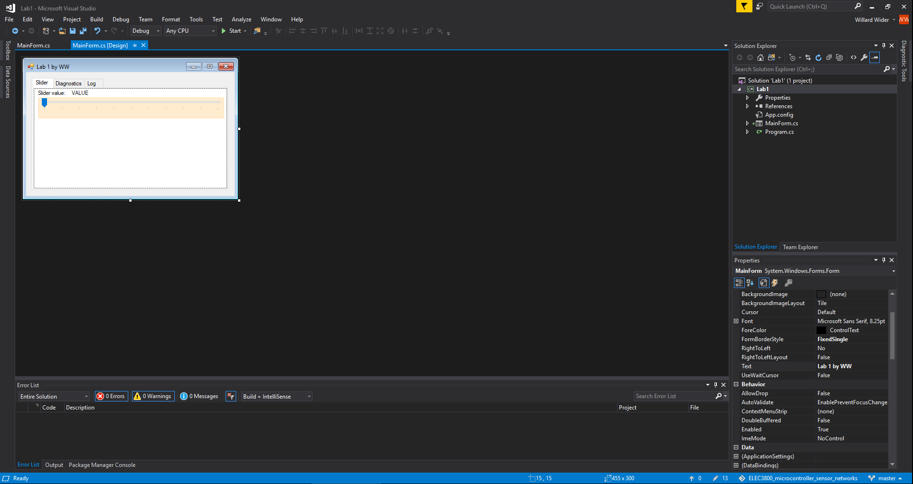

Screenshot 1: the designer view of the application. It allows you to create the application completely from scratch.

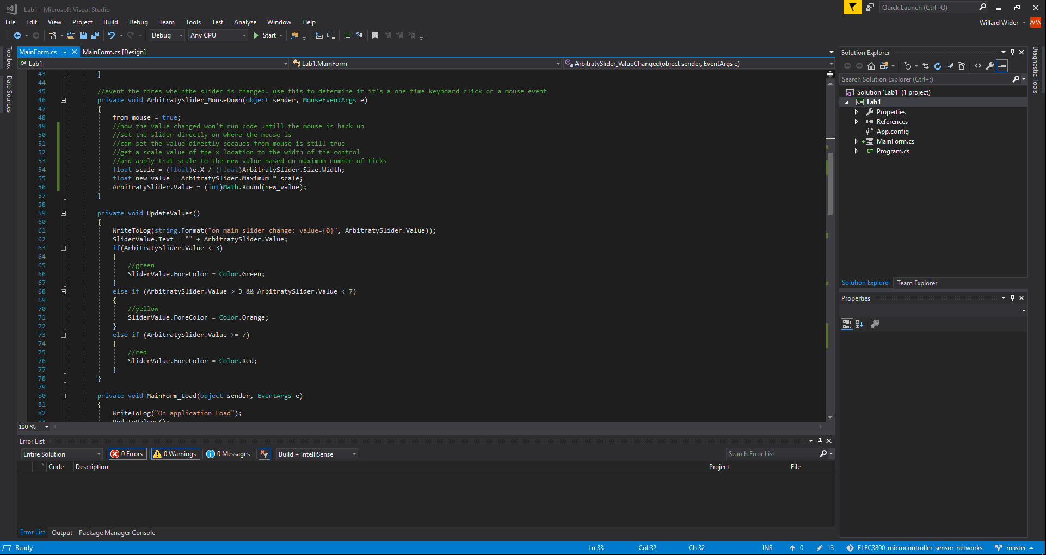Screenshot 2: Code view (replaces block view). Shows the C# code used in the form.

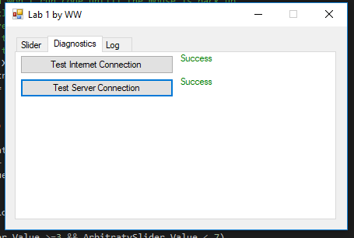

Screenshot 3: Running application on the diagnostics tab page

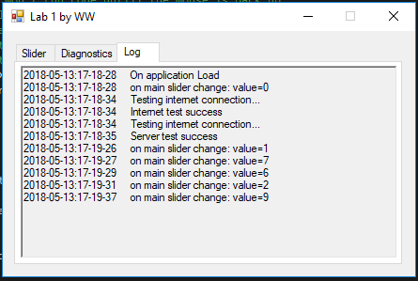

Screenshot 4: Running application on the log tab page