As we talked about on 7/29/2018, you are allowing me to make these windows 10 IoT labs in place of the current lab assignments

**Lab 2: Enabling the Lightning DMAP drivers**

**Part 1 – Enabling the drivers in the Raspberry Pi**

1. Read about the Lighning DMAP drivers here: <https://docs.microsoft.com/en-us/windows/iot-core/develop-your-app/lightningsetup>
2. Make sure the device is connected to the network can run a ping to make sure you can connect to it.
3. Open your browser to the following URL: <http://minwinpc:8080>
4. Log into the device using the following credentials:
   1. Username is Administrator
   2. Password is the password you set when creating the image in the previous lab. Default suggested password was password
5. Click on the Devices tab, and change the “Inbox Driver” to “Direct Memory Mapped Driver”

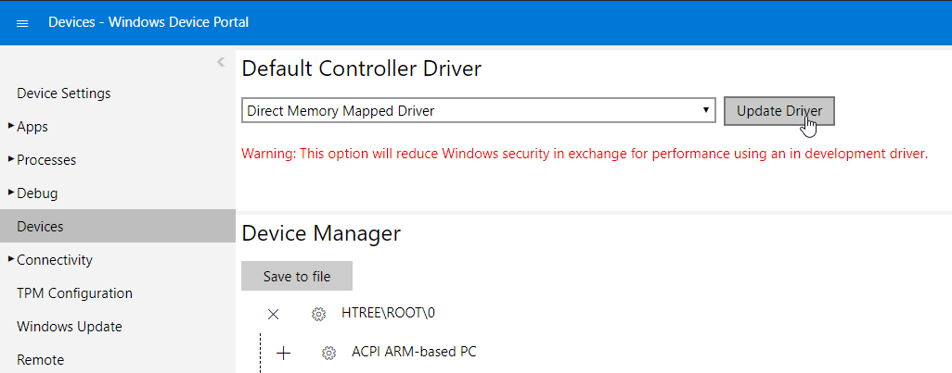

1. Click “Update Driver”, and after a driver change success message wait for the device to reboot.

**Part 2 – Making an app that uses the DMAP drivers**

1. Read about the procedure here: <https://docs.microsoft.com/en-us/windows/iot-core/develop-your-app/lightningproviders>
2. Either make a new project, following the steps from the previous lab, or make a copy of the previous project, and rename it to “Lightning_Test_Wider”. Change to your last name.
3. Add the Lightning API packages to the solution
   1. Go to Tools->NuGet Package Mangaer->Manage NuGet packages for solution
   2. From Browse, type “Lightning” and select “Microsoft.IoT.Lightning”
   3. Select the project on the right (our project) that we want to install it to, and click Install, then OK

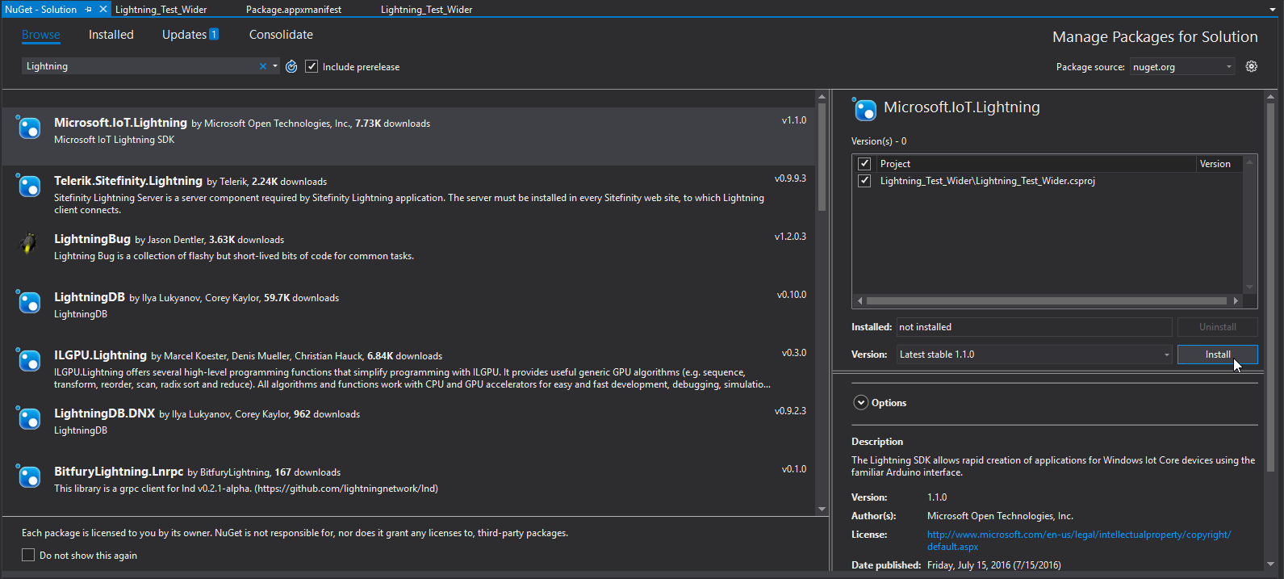

1. Enable the Lightning Capabilities in the package manifest
   1. Right Click on the Package.appxmanifest file and choose, view code
   2. Verify that the attribute xmlns:iot=<http://schemas.microsoft.com/appx/manifest/iot/windows10> and IgnorableNamespaces="uap mp iot" Exists in line 2 of the Package Node.
   3. Verify that the node <iot:Capability Name="lowLevelDevices" /> Exists inside the Capabilities node.
   4. Add the node <DeviceCapability Name="109b86ad-f53d-4b76-aa5f-821e2ddf2141"/> Inside the Capabiltier node.

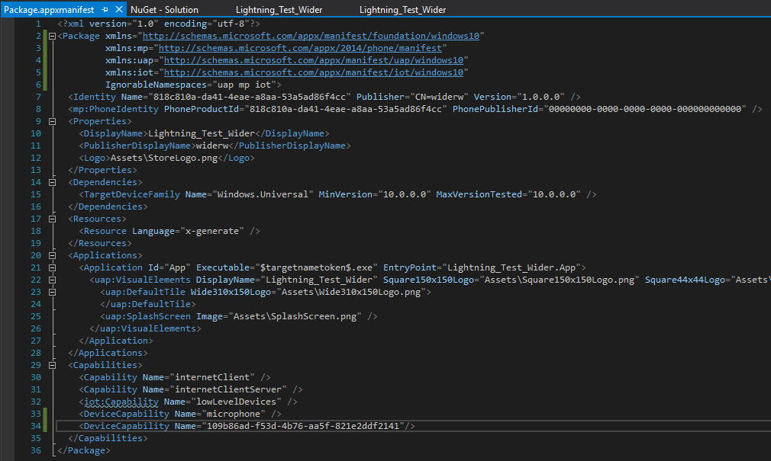

1. Write a simple UI to display if the drivers are enabled
   1. Open the Mainpage.xaml file to invoke the editor
   2. Make a TextBlock (or some other text display) that serves as a header, saying something like “Lightning Driver Status”
   3. Make a TextBlock (or some other text display) that serves as the method to display if they are enabled or not. Use the properties field to give it a name that you can use in the *.cs file (formally called code-behind)

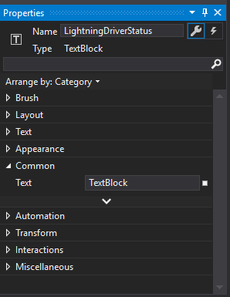

1. Write the Code-Behind to check on startup if the drivers are enabled
   1. Open the MainPage.xaml.cs file and type “this.Loa” (auto-complete, an excellent feature of Visual Studio, will complete it with “Loaded”. Press enter to confirm selection

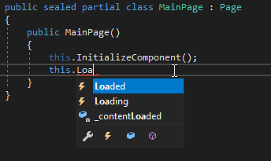

* 1. Type “+=” and another auto complete box will apprear. It is asking if you wish to make a method that subscribes to the event when the application is loaded on start. Press tab to confirm.

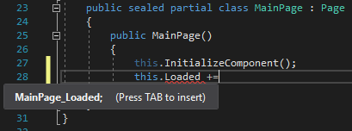

* 1. It then highlights the name of the new method and asks you to name it. Any name will do, as long as it follows the convention of Starting with a capital letter.

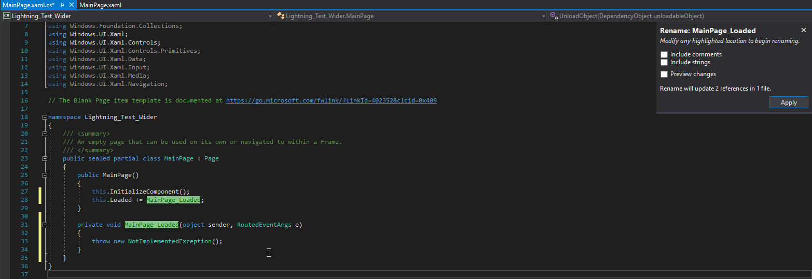

* 1. Append the following two using statements to the list of usings:

using Microsoft.IoT.Lightning.Providers;

using Windows.Devices;

These are similar to include statements

* 1. Add the following if-else block

//check if the Lighning drivers are detected by the application

if (LightningProvider.IsLightningEnabled)

{

//Set the default provider of control devices to be from the lightning drivers

LowLevelDevicesController.DefaultProvider = LightningProvider.GetAggregateProvider();

//tell the user that the drivers were detected

//write code here...

}

else

{

//tell the user that the drivers were not detected

//write more code here

}

* 1. The result at this point should look similar to this:

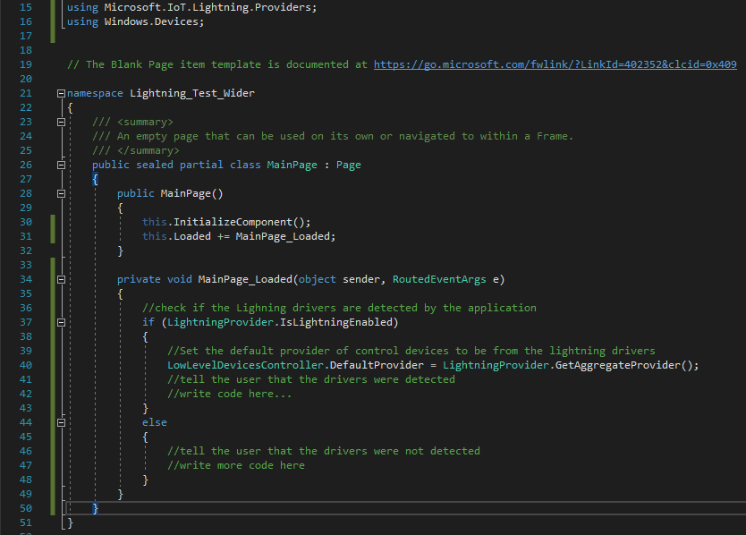

* 1. In the “write code here” sections, reference the textblock you made earlier. Look at the previous lab for more info about changing text for a TextBlock
  2. Build and deploy the solution. Verify the drivers are in fact enabled
     1. If you made a new project, Visual Studio may fail deploy, you need to reboot the application.
     2. Additionally, you can use the debugger to “step into” the if statement to verify

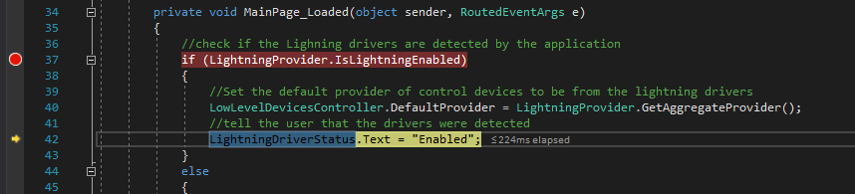

1. The device has successfully been enabled to use the Lightning drivers, and the application was able to use them Demo this to your instructor.

**What to hand in**

* **Screenshot of either debugger showing the lightning drivers if statement being reached OR picture of the result from the Pi display**
* **MainPage.xaml**
* **MainPage.xaml.cs**

**Submit to BB in a single word document**