Php script to send the value:

<http://memes.relhaxmodpack.com/SchoolProjects/ELEC3800_WebApp/set_scrollbar_value.php?wrVal=3>

Php script to read the value:

<http://memes.relhaxmodpack.com/SchoolProjects/ELEC3800_WebApp/read_scrollbar_value.php>

**Php file set_scrollbar_value.php:**

<html>

<head>

<title>Write passed in scrollbar value to file</title>

</head>

<body>

<?php

//useful script stuff

ini_set( 'display_errors', true );//set the value to display all errors, helpfull for debugging

error_reporting( E_ALL );//report all errors

set_time_limit(0);//infinite timeout

date_default_timezone_set('America/New_York'); /* notwendig ab PHP 5.3, sonst Warnung */

//starting the script...

//echo "script is started (" . date("d.m.Y H:i:s") . ")<br /><br />";

printf("<p>script is started (\"%s\")</p>",date("d.m.Y H:i:s"));

$base = "/home/eueijvmj/memes.relhaxmodpack.com/SchoolProjects/ELEC3800_WebApp";

//printf("<p>DEBUG: parsed \$base as %s</p>",$base);

$file_to_write = $base."/sliderValue.txt";

//printf("<p>DEBUG: parsed \$file_to_write as %s</p>",$file_to_write);

//get the value passed into this HTTP GET request

$wrVal=$_GET["wrVal"];

printf("<p>parsed wrVal as %d</p>",$wrVal);

//write a value to the file

printf("writing value to disk...");

$bytesWrote = file_put_contents($file_to_write,$wrVal);

printf("<p>wrote %d bytes to store %f in the file %s </p>", $bytesWrote, $wrVal, $file_to_write );

printf("<p>script is done (\"%s\")</p>",date("d.m.Y H:i:s"));

?>

</body>

</html>

**Php file read_scrollbar_value.php:**

<html>

<head>

<title>Read xml scrollbar value</title>

</head>

<body>

<?php

//useful script stuff

ini_set( 'display_errors', true );//set the value to display all errors, helpfull for debugging

error_reporting( E_ALL );//report all errors

set_time_limit(0);//infinite timeout

date_default_timezone_set('America/New_York'); /* notwendig ab PHP 5.3, sonst Warnung */

//starting the script...

//echo "script is started (" . date("d.m.Y H:i:s") . ")<br /><br />";

printf("<p>script is started (\"%s\")</p>",date("d.m.Y H:i:s"));

$base = "/home/eueijvmj/memes.relhaxmodpack.com/SchoolProjects/ELEC3800_WebApp";

//printf("<p>DEBUG: parsed \$base as %s</p>",$base);

$file = $base."/sliderValue.txt";

//printf("<p>DEBUG: parsed \$file as %s</p>",$file);

// Get the old count value

$fileDataLst = file($file);

$count = (float) $fileDataLst[0];

printf("<p><xml><scrollbarValue>%f</scrollbarValue></xml></p>", $count);

?>

</body>

</html>

**Sample output from read_scrollbar_value.php:**

<html>

<head>

<title>Read xml scrollbar value</title>

</head>

<body>

<p>script is started (\"13.05.2018 19:58:28\")</p>

<p>

<xml>

<scrollbarValue>8.000000</scrollbarValue>

</xml>

</p>

</body>

</html>

Screenshot of the designer:

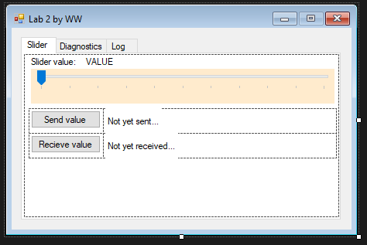

Screenshot of some of the code:

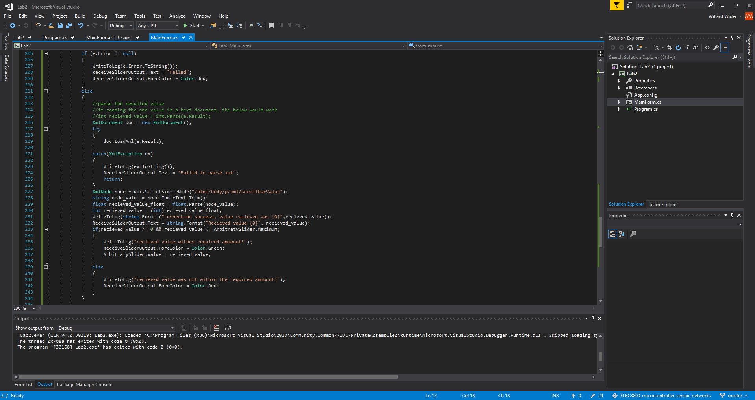

Screenshot before application is read or sent and values

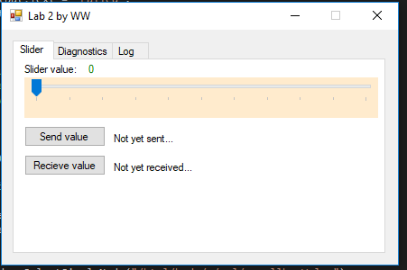

Screenshot after sending value

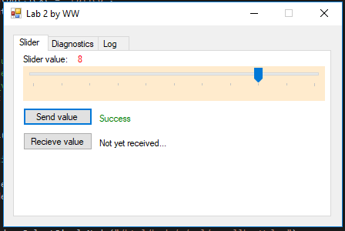

Screenshot showing the received value from the server

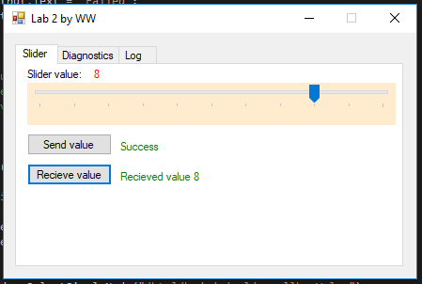

Screenshot of log proving application send and received value

