Code (also answers question 3)

#######################

#Willard Wider

#7/19/18

#ELEC4400

#HW4

#######################

import matplotlib.pyplot as plt

import numpy as np

#specify the stype of the plot to use

plt.style.use('ggplot')

#problem 1

x_index = np.linspace(-10,10,500)

HW_1_sine_part = np.sin(x_index*5)*(25*(x_index*x_index)-2)

HW_1_cos_part = np.cos(x_index*5)*(10*x_index)

HW_1_combo = HW_1_cos_part+HW_1_sine_part

HW_1_coef = 2/(np.power(x_index,3))

HW_1 = HW_1_coef*HW_1_combo

plt.plot(x_index,HW_1)

plt.title('HW4 problem 1')

plt.show()

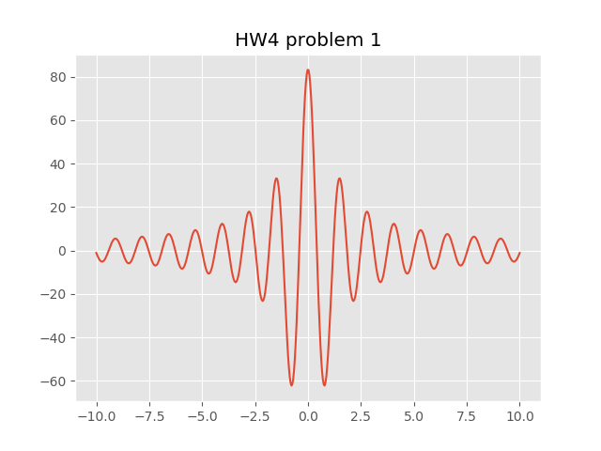

plt.close()

#problem 2

#uses same x index...

#used a=2

HW_2_P1_1 = 1/(2-x_index)

HW_2_P1_2 = np.sin(8*np.pi - 4*x_index*np.pi)

HW_2_P2_1 = 1/(2+x_index)

HW_2_P2_2 = np.sin(8*np.pi + x_index*4*np.pi)

HW_2 = (HW_2_P1_1*HW_2_P1_2) + (HW_2_P2_1*HW_2_P2_2)

plt.plot(x_index,HW_2)

plt.title('HW4 problem 2')

plt.show()

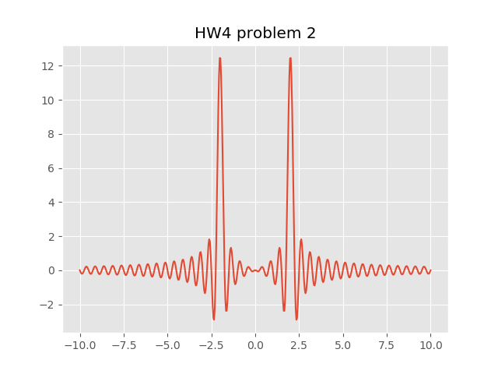

plt.close()

#3 - modify a

#let's try it...

HW_2_P1_1 = 1/(6-x_index)

HW_2_P1_2 = np.sin(24*np.pi - 4*x_index*np.pi)

HW_2_P2_1 = 1/(6+x_index)

HW_2_P2_2 = np.sin(24*np.pi + x_index*4*np.pi)

HW_2 = (HW_2_P1_1*HW_2_P1_2) + (HW_2_P2_1*HW_2_P2_2)

plt.plot(x_index,HW_2)

plt.title('HW4 problem 2: new a = 6')

plt.show()

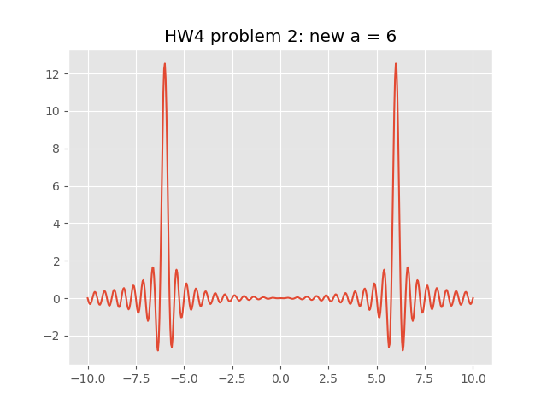

plt.close()

#modifying the a (frequency) paremeter changes where the frequency of the function is

#therefore, on a function on frequency to amplitude, changing the frequency changes where the amplitude is on the x axis

#the sampling time does matter, if you don't sample fast enough, you may loose the original function