Python code:

#######################

#Willard Wider

#7/20/18

#ELEC4400

#Lab 10

#######################

import matplotlib.pyplot as plt

import numpy as np

from scipy.fftpack import fft, ifft

from scipy.signal import lfilter, freqz

#specify the stype of the plot to use

plt.style.use('ggplot')

#problem 1 - FFT and IFFT

#make the time domain signal. 1000 data points, 2 seconds in duration

x_index = np.linspace(0,2,1000)

#define the input signal (xt)

input_singal = np.cos(2*np.pi*10*x_index) + np.cos(2*np.pi*100*x_index) + np.cos(2*np.pi*200*x_index)

#the fft of the input signal

x_index_frequency = np.linspace(0,500,1000)

fft_input_out = fft(input_singal)

#the inverse fft of the fft (meta)

i_fft_input_out = ifft(fft_input_out)

#create three graphs for plotting

#graph of first plot

f,xarr = plt.subplots(3)

plt.tight_layout()

xarr[0].set_title('noisy signal')

xarr[0].plot(x_index,input_singal)

#graph of fft of first

xarr[1].set_title('fft out')

#https://stackoverflow.com/questions/15858192/how-to-set-xlim-and-ylim-for-a-subplot-in-matplotlib

xarr[1].set_xlim([0,250])

xarr[1].plot(x_index_frequency,np.abs(fft_input_out))

#graph of inverse of fftr

xarr[2].set_title('ifft')

xarr[2].plot(x_index,i_fft_input_out)

#https://stackoverflow.com/questions/13228254/subplots-are-overlapping-axis-labels

plt.tight_layout()

plt.show()

#problem 2 - time domain filtering

N = 15

b = (1/N)*np.ones(N)

#input_singal=xt

filtered_output = lfilter(b,1,input_singal)

p2_f,p2_xarr = plt.subplots(2)

#signal first

p2_xarr[0].set_title('noisy signal')

p2_xarr[0].plot(x_index,input_singal)

p2_xarr[1].set_title('filtered signal')

p2_xarr[1].plot(x_index, filtered_output)

plt.tight_layout()

plt.show()

#probmel 3 - frequency domain filtering

#check for sampled rate

hz,H = freqz(b,1,worN=x_index_frequency*2*np.pi/500)

hzTrue = hz*500/(2*np.pi)

fft_input_out_filtered = fft_input_out*H

#create three graphs for plotting

#graph of first plot

p3_f,p3_xarr = plt.subplots(3)

p3_xarr[0].set_title('noisy fft signal')

p3_xarr[0].set_xlim([0,250])

p3_xarr[0].plot(x_index_frequency,np.abs(fft_input_out))

#graph of filter frequency response

p3_xarr[1].set_title('filter frequency response')

p3_xarr[1].set_xlim([0,250])

p3_xarr[1].plot(hzTrue,H)

#graph result of frequncy domain filtering

p3_xarr[2].set_title('frequency domain filtered signal')

p3_xarr[2].set_xlim([0,250])

#xarr[1].plot(x_index_frequency,np.abs(fft_input_out))

p3_xarr[2].plot(x_index_frequency,np.abs(fft_input_out_filtered))

plt.tight_layout()

plt.show()

#problem 4 - Prestige

p4_f,p4_xarr = plt.subplots(4)

#graph of time domain filtering method

p4_xarr[0].set_title('time domain filtering, time domain')

p4_xarr[0].plot(x_index, filtered_output)

#graph of fft of time domain filter

p4_xarr[1].set_title('time domain filtering, frequency domain')

time_domain_fft = fft(filtered_output)

p4_xarr[1].set_xlim([0,250])

p4_xarr[1].plot(x_index_frequency, np.abs(time_domain_fft))

#graph of frequency domain filter, feqeucncy domain

p4_xarr[2].set_title('frequency domain filtering, frequency domain')

p4_xarr[2].set_xlim([0,250])

p4_xarr[2].plot(x_index_frequency,np.abs(fft_input_out_filtered))

#graph of frequency domain filter, time domain

p4_xarr[3].set_title('frequency domain filtering, time domain')

time_domain_ifft = ifft(fft_input_out_filtered)

p4_xarr[3].plot(x_index,time_domain_ifft)

plt.tight_layout()

plt.show()

plots:

Plot 1

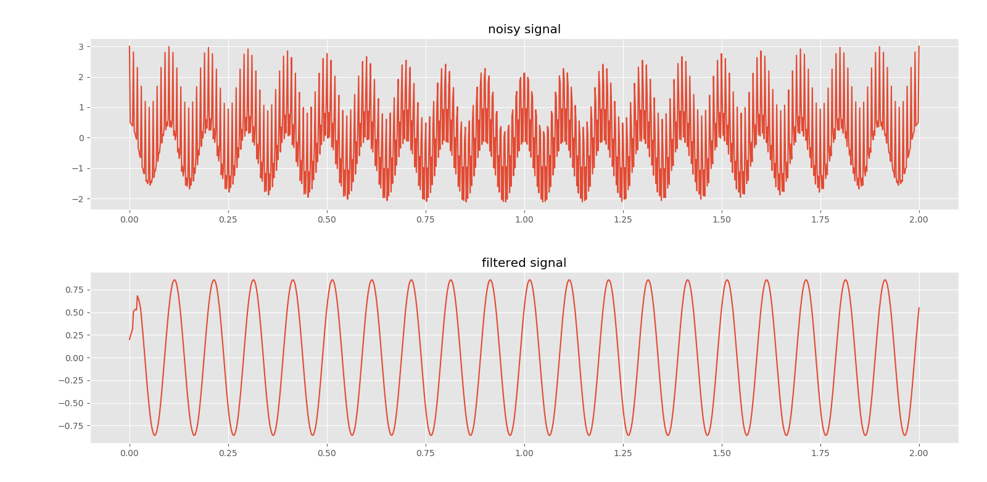Plot 2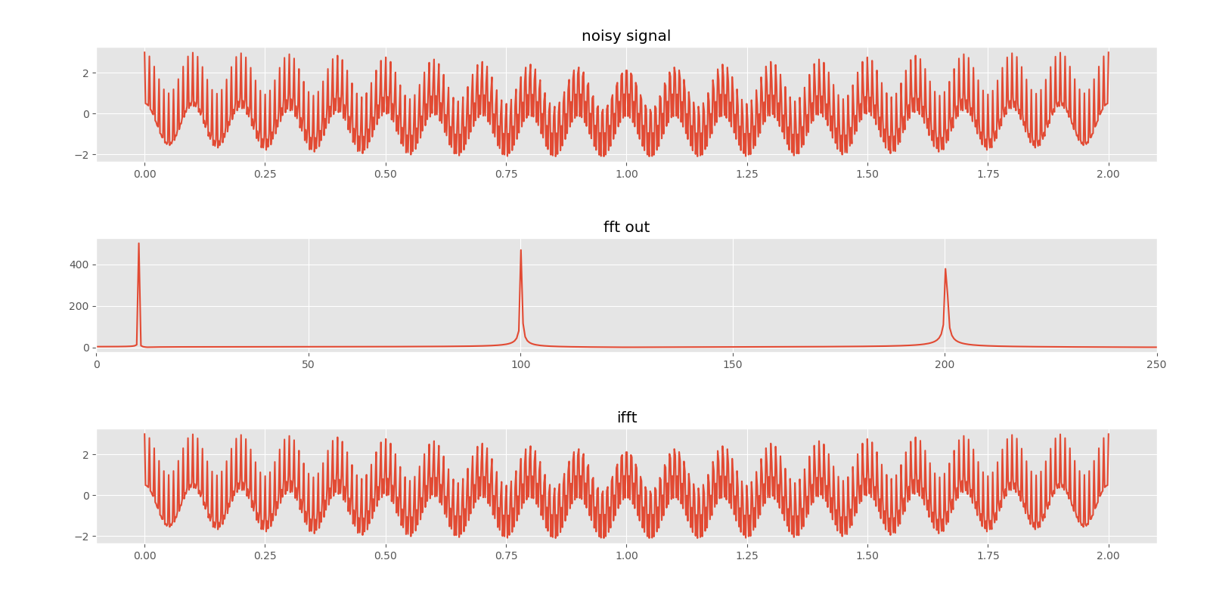

Plot 3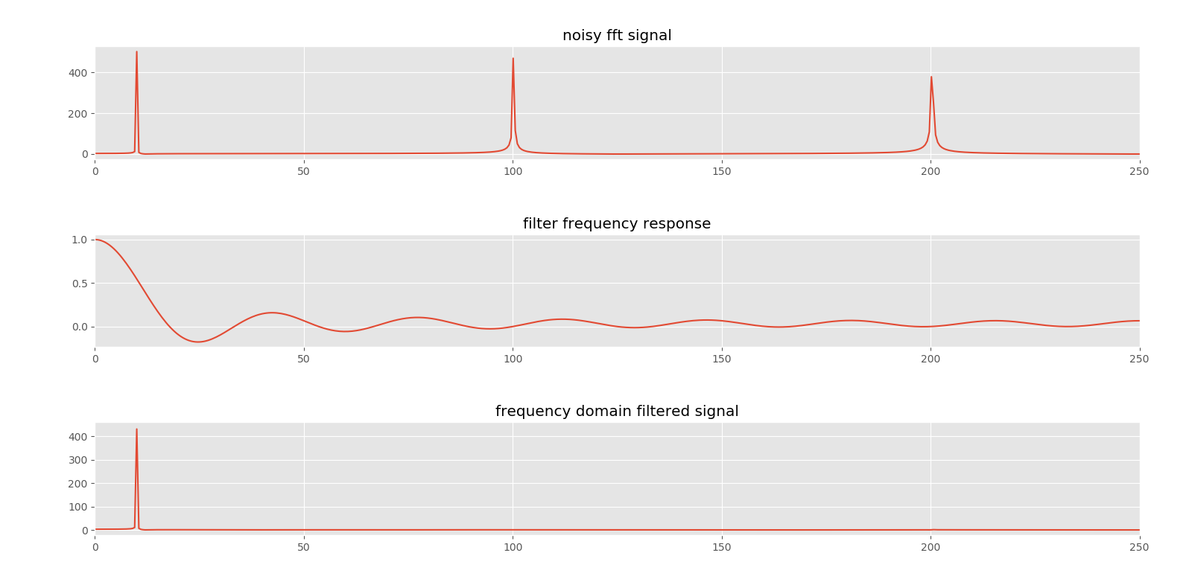

Plot 4