Python code:

#######################

#Willard Wider

#6/27/18

#ELEC4400

#Lab 8

#######################

import matplotlib.pyplot as plt

import numpy as np

from scipy.fftpack import fft

from scipy.io import wavfile

def function_name(file_name):

#https://stackoverflow.com/questions/2060628/reading-wav-files-in-python

fs, data = wavfile.read(file_name)

#fast fourier transform of the data

fftOut = fft(data)

#total ammount of time in the recording

length = len(data) / fs

#a list of sample indicies, probably audio frames

n = np.arange(len(data))

#fs the the sampling frequency, the number of samples per second

#we need the duration of time between samples

#time between is 1 (sec) divided by frequency

total_frequencies = n / length

plt.plot(total_frequencies,np.abs(fftOut))

#limit the plot

plt.xlim(([0,4186]))

plt.title("Piano Note Analysis")

plt.xlabel("frequency (Hz)")

plt.ylabel("amplitude (Db)")

plt.show()

return

if __name__ == "__main__":

#function_name('kpt.wav')

#question 1: to convince myself, the amplitude is the intensity (loudness)

#of the sound at that frequency, and it would stand to reason

#that louder sounds at that frequency tend to exist more in the file

#

#frequencies - notes

#233 - A3#

#310 - D4#

#392 - G4

#

#pause...

function_name('hkp.wav')

#

#frequencies - notes

#392 - G4

#465 - A4#

#621 - D5#

#

#pause...

#my analysis was core-rekt

Picture of first (lower key) notes:

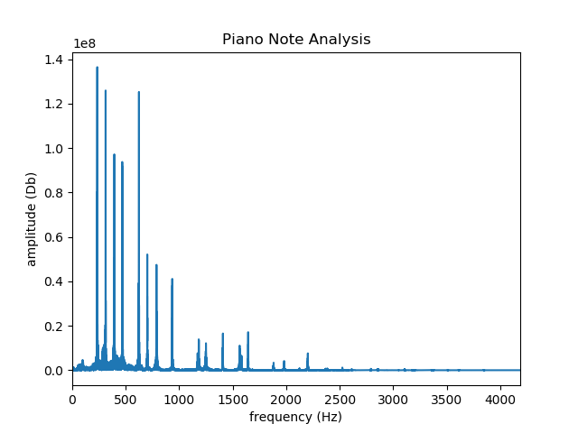

Picture of second (higher key) notes:

