# Oil & Gas Well Data Quality Dashboard

Stakeholder Report

## Project Summary

This report outlines the development and purpose of a data quality dashboard built to simulate and assess oil & gas well production data integrity. The dashboard is designed to profile common data issues such as missing values, negative volumes, and date anomalies, using SQL queries and visualization through Power BI.  
  
The system provides a clear, interactive interface to track data quality trends and ensure clean, reliable reporting for downstream analytics and decision-making.

## Project Objectives

- Detect and flag common data quality issues  
- Provide visibility into data completeness and accuracy  
- Create stakeholder-friendly visualizations and metrics  
- Simulate metadata documentation (Alation-style)

## Data Overview

Source: Simulated oil & gas production data stored in SQLite  
Records: 5 well entries across multiple operators and states  
Fields Captured: Well ID, Name, Location, Spud Date, Production Start/End, Volume Produced, Operator, Status

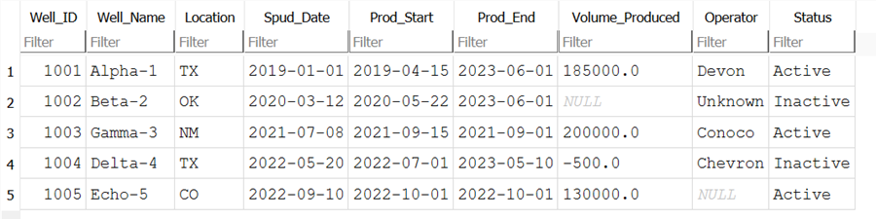

## Data Quality Rules Applied

|  |  |
| --- | --- |
| Rule Description | SQL Condition |
| Missing Volume or Operator | Volume_Produced IS NULL OR Operator IS NULL |
| Negative Production Volume | Volume_Produced < 0 |
| Production End Before Start Date | Prod_End < Prod_Start |
| Duplicate Well IDs | GROUP BY Well_ID HAVING COUNT(*) > 1 |

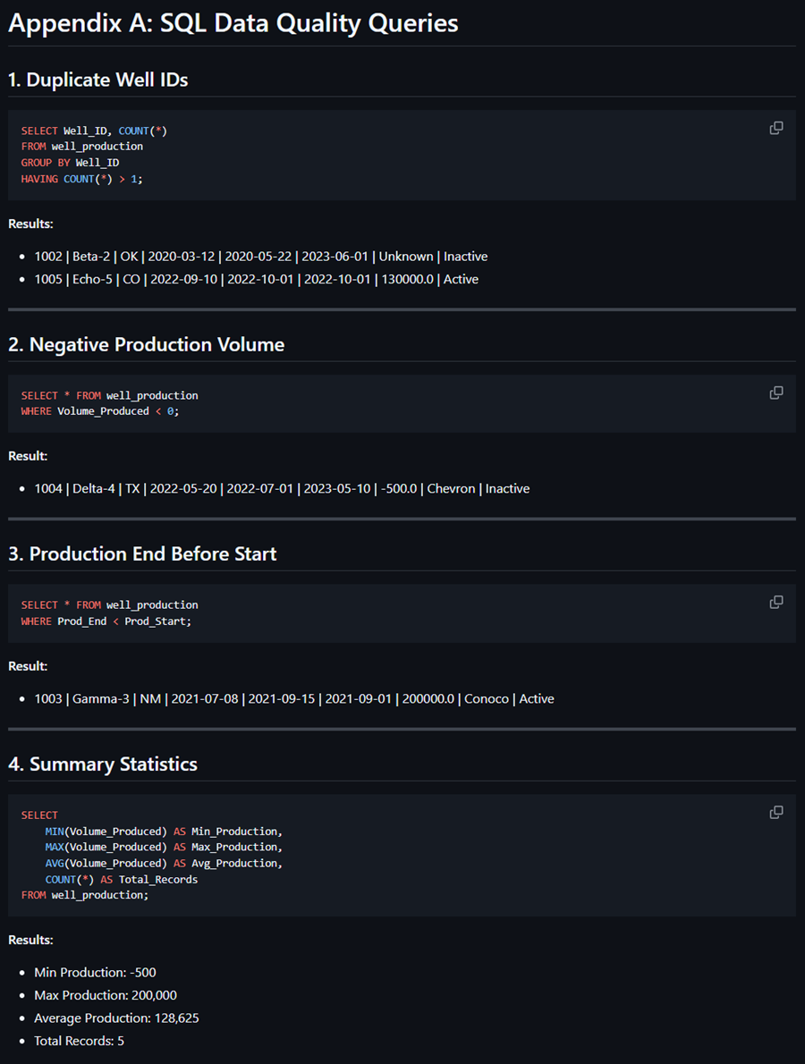

## Dashboard KPIs

|  |  |
| --- | --- |
| KPI | Value |
| Total Wells | 5 |
| Min Production Volume | -500 |
| Max Production Volume | 200,000 |
| Average Production Volume | 128,625 |
| Records with Issues | 3 (60%) |

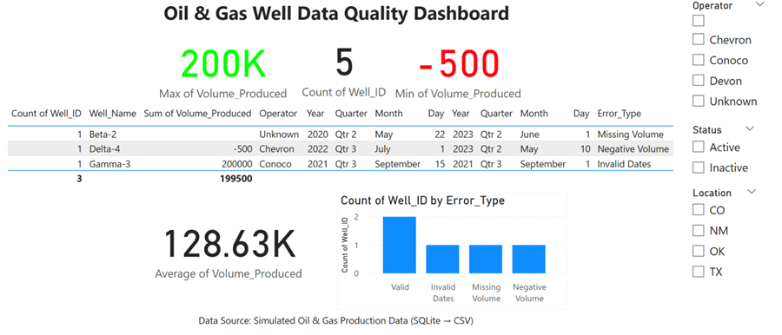

## Simulated Metadata Documentation

Simulated Alation-style documentation was developed to represent how data stewardship might be captured in a production data catalog:  
- Business Term Definitions  
- Field Descriptions  
- Data Flow Narrative  
- Entry Validation Guidelines

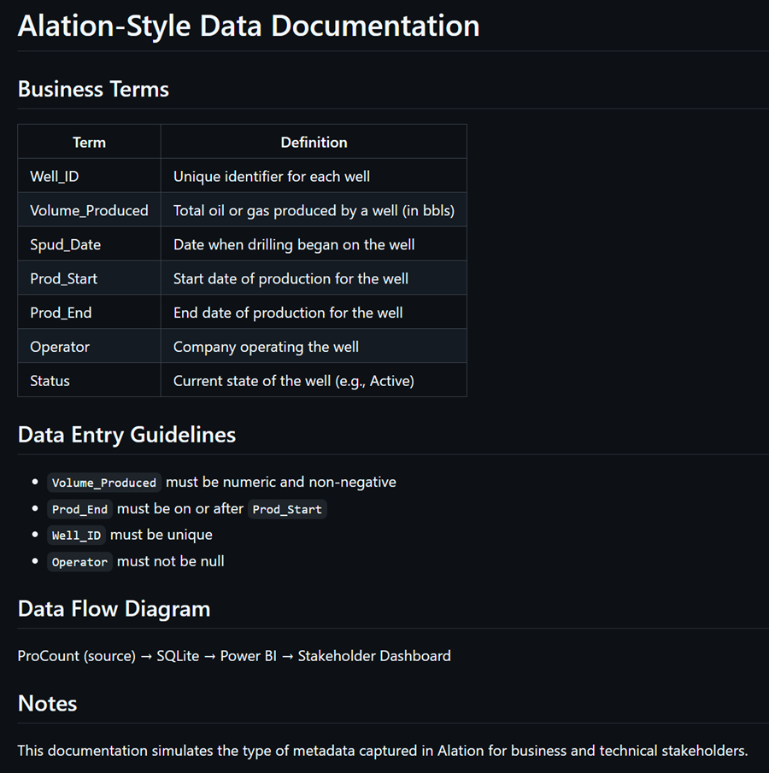

## Conclusion

This dashboard provides clear, actionable insights into data quality issues for oil & gas well production. Its modular SQL logic and interactive visualizations make it adaptable for use in real-world data stewardship workflows.  
  
Further improvements can include expanding the dataset, implementing automated profiling scripts, and incorporating additional KPIs or time-series metrics.

## Contact

Will Thompson  
📧 Will.j.Thompson@outlook.com  
🌐 github.com/Willthompson99