**Jellium Hartree-Fock Modeling**

Jason Codrington, Edwin Elias, Kimberly Fernando, Juan Leiva

Physical Chemistry II Spring 2017 Project

Dr. Jonathan J. Foley IV

Spring 2017

**Abstract**

The main objective for this project is to be able to express the advancement of the Hartree-Fock theory into solving the Time Independent Schrödinger’s equation, for the reason of the exclusion of the electron repulsion via mean-field theory on previous research work. As well as to incorporate a Jellium model into our calculations for an arbitrary metal nanoparticle system, where the electrons are distributed in a uniform manner, forming a unique basis set. Our results convey that we have successfully built a Hartree-Fock program for determining the upper bound of energy provided kinetic and potential integrals for water.9

**Background**

A new phenomenon arises from recent nanophotonic research, which is known as “Scattering Mediated Absorption” (SMA), it is composed of a dielectric core decorated with small metal nanoparticles.8 By combining both of these metals, an emergent property is created which causes scattering mediated absorption. The visible light entering the dielectric core is scattered inside of its structure, and this allows the small metal nanoparticles that’s embedded on the surface to absorb the light strongly. SMA has proven to have a greater efficiency in the generation of hot electrons/hot holes, as compared to Localized Surface Plasmon Resonance (LSPR). LSPR occurs in plasmonic metals, it is the collective oscillations of hot electrons in metal nanoparticles.8 Despite the triumphant of this hybrid nanostructure, this model neglects electron correlation effects. Therefore, this promotes one in the advancement of the Hartree-Fock theory. The many-body electron Time Independent Schrödinger’s Equation (TISE), has no known exact solutions. Hence, an approximation method is needed.

The Hartree-Fock (HF) theory provides a dependable systematic approximation of the wavefunction, to solve the TISE. The Hartree-Fock theory is a molecular orbital theory, where each electron’s motion can be described by a single-particle function, which does not directly depend on the immediate motions of the other electrons.5 The Hartree-Fock theory gives a starting point for complex theoretical methods which are better approximations to the electronic Schrodinger equation, after invoking the Born-Oppenheimer approximation.5

The description of the physical properties of many interacting particle systems has been one of the most important goals of solid state physics for many years. The problem is, from the laws of quantum mechanics, to derive the properties of many particle systems.3 As we know the simplest system we can find is hydrogen, with a single proton and a single electron, the Schrödinger equation for the hydrogen atom has an exact analytical solution, where the orbitals (wavefunctions) are exact eigenfunctions of the full electronic Hamiltonian. The last applying also for system made of only one electron like He+.4

However, when another electron is added to the system, as in the case of hydronium, the case becomes more complicated, since in a system of two or more electrons, these become indistinguishable, and are fundamentally identical. So, one cannot track the temporal dynamics of each electron separately when it is in the company of another.3

It was D. R. Hartree who came up with the first idea of getting Self Consistent Field (SCF) solutions to a many-electron problem as a strategy to break the “Catch-22” state. Hartree introduced the Self-consistent field method (SCF), which he came by Intuitive and model-based physical arguments Bohr atomic structure.3

The first step was to consider that electrons do not interact with each other. In this case, the wavefunction resulting from these electrons would be separable, and the total electronic wavefunction would be product of two hydrogen atom wavefunctions.5

Image1.png

The above assumption will lead us to the following wavefunction, which is known as the Hartree product.

Image2.png

In 1930, Fock pointed out that Hartree’s wavefunction was invalid as it did not satisfy the Pauli exclusion principle 7, which is a consequence of the antisymmetry principle, which states that a wavefuncion describing fermions should be antisymmetric5.

In the case of the 2 electrons system example. The wavefuncion will be:

Image3.png

If we swap the coordinates of electron 1 with those of electron 2 we will get:

Image4.png

The only way that we get the negative of the original wavefunction is if our last result is the negative of the first result obtained, which will not be true in general.

Fock also demonstrated that Hartree’s product could be made antisymmetric appropriately by adding and subtracting all possible permutations of Hartree's product.

To include this restriction, we add an abstraction: the spin-orbital wavefunction. Thus, our many-body system wave function will now become a sum of products between single-electron wavefunctions. Later, Slater demonstrated that the resulting spin-orbital wavefunction is simply the determinant of a matrix, called Slater determinant.4

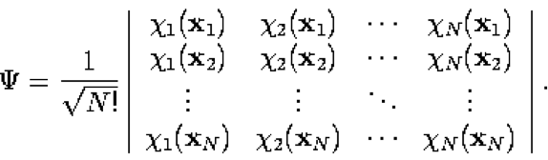

An interesting consequence of this functional form is that the electrons are all indistinguishable, consistent with the strange results of quantum mechanics. Each electron is associated with every orbital. Instead of determining interaction of one electron with each other electron, instead an electron just feels an average interaction with the entire field of electrons. In this way, we get valid solutions that inherently fulfill Pauli's exclusion principle.5

As mentioned above, Hartree-Fock approximates an N-electron wave function as an anti-symmetrized product of N one-electron functions, or molecular orbitals, where N is any number of electrons. We define these molecular orbitals as linear combinations of atomic orbitals (LCAOs). A LCAO is a quantum superposition of atomic orbitals, and a technique used in quantum chemistry to calculate molecular orbitals.

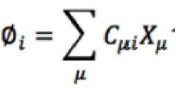

Where X is the atomic orbital and C is some coefficient associated with that atomic orbital.

Recalling the variational principle, the lowest energy expectation value can be obtained by adjusting the parameters that define the wavefunction. In our case, the coefficients associated with their respective atomic orbitals are adjusted, as they result in the molecular orbitals; it is those molecular orbitals when minimized that provide the upper bound for the energy, and therefore, the best approximation via HF to the true properties of our many-body system.

Thus, we will use an exact Hamiltonian, which explicitly describes the movement of each electron and its interactions of Coulomb with all the other particles of the system, whereas we will approximate the wave function of all the different components of the system.1

In our project the Hamiltonian have the following form:

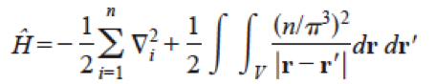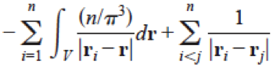

where V indicates the region within the cube. The first term arises from the kinetic energy of the electrons, the second from the self-interaction of the positive charge, the third from the attraction between the positive charge and the electrons, and the fourth from interelectronic repulsions. The

self-interaction term does not depend on the electron coordinates and, like the nuclear repulsion energy in a molecular calculation, can be treated as a constant.1

In order to explore the Hartree-Fock method, following the guidance of Daniel Crawford and co-authors’ tutorial instruction, custom code was developed during the course of the semester.9 The steps in our Hartree Fock process are as follows:

1. We run our integration for the kinetic energy integrals, nuclear attraction integrals, electron repulsion integrals, and nuclear repulsion constant, and then our overlap matrix.

2. We build the Core Hamiltonian of our system, which consists of the kinetic energy, nuclear-attraction integrals, and nuclear repulsion constant.

**3.** We diagonalize the overlap matrix in order to have an orthogonal basis to work with. We do this via Lowdin’s symmetric orthogonalization.

a. Diagonalize the overlap matrix **S** results in the eigenvectors and eigenvalues **s** associated with that matrix.

b. The inverse square root of eigenvalues **s** results in a symmetric orthogonalization matrix. This results in orthonormal functions that we can work with.

c. We then assume the initial Fock matrix to be the core Hamiltonian, and use the symmetric orthogonalization matrix to change the also provide orthonormal functions for the Fock matrix.

d. This Fock matrix that we now diagonalize, provides its respective eigenvectors (the molecular orbitals) and eigenvalues (the molecular orbital energies).

4. The C matrix provides the molecular orbitals as a linear combination of the orthonormalized basis functions, but we want to retrieve the linear combination of atomic orbital basis functions, so we back transform the C to the original atomic orbital basis.

5. From here, we are able to build the density matrix using the molecular orbitals occupied by the number of electrons we specify.

6. From here, we are able to obtain the initial energy expectation value.

7. From here, the Self-Containment Field method begins, where a new Fock matrix is built using the prior density matrix. The new Fock matrix is the Hamiltonian and the sum of the density matrix iterated with the two-electron repulsion integrals.

8. With the new Fock matrix, the process is repeated, with providing its’ orthonormal functions, diagonalizing that to obtain its eigenvectors and eigenvalues, retrieving the molecular orbital matrix and back transforming it to build the density matrix and determine the expected energy.

9. This process continues until the energy expectation and density matrix changes between each iteration fall below some value, in which you imagine them to converge, and the lowest energy expectation value to be found. This represents the upper bound of the energy of the system.

Afterwards, given the atomic orbital overlap matrix and Hamiltonian, we go through the Hartree Fock process to determine the energy expectation value, which is either greater than or equal to the respective ground energy of an arbitrary system. The wavefunction we use in Hartree Fock to describe the system is known as a Slater determinant.6

The Hartree-Fock equation as described earlier is a method of approximation for the determination of the wave function and the energy of a quantum many-body system in a stationary state.1 After adjusting the parameters of the Hartree-Fock equation that define the wave function, which in our case, are the coefficients that are associated with their respective atomic orbitals this will give us the energies of the molecular orbitals that can now be used to run a water simulation. As a result of the simulation of water, we were able to obtain a line graph (figure 2), which resulted from the iterations done to find the lowest energy expectation value which will give us the upper bound for the energy and therefore, the best approximation from the HF to the true properties of our many-body problem. The numerical output that came from the numerous iterations performed can be seen on figure 1, which was used to produce the line graph. In figure 1, each of the iterations is associated with a given Restricted Hartree-Fock Energy (RHF Energy), change in energy (ΔE), and change in density (ΔDD). To start, the first iteration done did not have the electron-to-electron repulsion integral. The next iterations and so on all contained the electron-to-electron repulsion integral. The results with this can be seen in the second column of figure 1, which provides us with the energy associated with the specific iteration. In the third column of figure 1 gives us the change in energy between each of the iteration to the original one and so on. In the same manner as in the 2nd and 3rd column we see in the 4th column, which gives us the change in density between the very first iteration and the one being observed. Focusing on figure 2 now we can see a physical representation of the calculated numbers seen in figure 1. Taking a look at the purple line in figure 2 we see the numbers go from very negative when the electron-to-electron repulsion integral was not incorporated to a leveling off half way as the electron-to-electron integral were calculated. Seeing very little changes to where it is not as significant and can be stopped which represents the lowest energy expectation value of our system. In figure 2 the green line is the energy change and as we see the first iteration to the rest of the iterations we see a large energy to little energy change to change that is not as significant because changes are not as significant anymore. This green line ultimately represents the threshold of the system from a given parameter with have set. The light blue line shows us the change of density as we go through the iterations. Overall from the graph we can approximate that the lowest energy expectation value is around -74.942.

In the beginning our group started off trying to solve the Hartree-Fock calculations for a spherical model but as we encountered difficulties with this we switched to solving the RHF for a cubic model. In order to calculate these numbers certain equations were needed to make the calculations a little more manageable and one of these was the use of trig. Identity (figure 3) which was used in order to reduce the unit self-interaction energy, the kinetic energy integral, and the two electron integrals to form linear combinations of integrals (figure 4). The importance of doing this because in the case when we calculate for the one electron, the x, y, and z will go to zero and as they go to zero it will result in having Cos (0)=1 making it easier to deal with because now we are just dealing with Px, Py, and Pz for the attraction integrals.6 By doing this the self-interaction energy will result in going to 1 making it a constant. Which now can be put into the Hartree-Fock equation for the approximation of the wave function and energy of the system.6

When considering a model system it is known that a system consist of nuclei scattered throughout space with varying distances between each other which will have differences in charge that is dependent on the distance. When considering a system such as this it can be a difficult task to try and calculate the lowest energy ground state of system because there is an infinite amount of interactions going on making it almost impossible to calculate and for this reason the Jellium Model is used. The jellium model allows one to focus on the effects in solids that occur due to the quantum nature of electrons and their mutual repulsive interactions (due to like charge) without explicit introduction of the atomic lattice and structure making up a real material. Its limitation comes from the representation of an actual system yet there are used in many different applications giving insight of the system being studied.

The jellium model can be used in the investigation of electronic structure and photoionization of metal nanoclusters. As in a research conducted by Polozkov et. al. and his team were using the jellium model to understand the characteristic feature of small metal clusters.1 Polozkov et. al. took a further look at the electronic shell structure and valence electrons moving in the field created by themselves and by positively charged ionic core.1 Even though jellium model refers to a neutral system it can also be applied to the charged system as well. The small metal clusters being looked at in this paper was sodium clusters. Another area where the spherical jellium model is being used to understand the stability and reactivity of two classes of gas-phase aluminum-iodine clusters. In this paper Bergeron et. al. used the jellium model to come up with stable configurations of electrons for the gas-phase aluminum-iodine cluster to determine with of the two classes were either more stable and more reactive than the other.2 Overall the jellium model can be used a variety of applications which will mostly need some adjustments to provide you with the information that is needed for the further understanding of the system being studied.

**Results:**

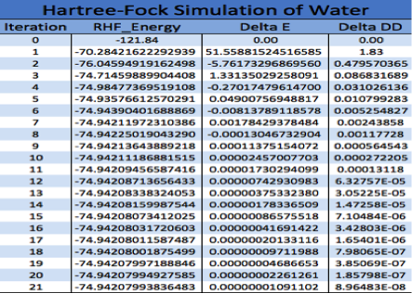

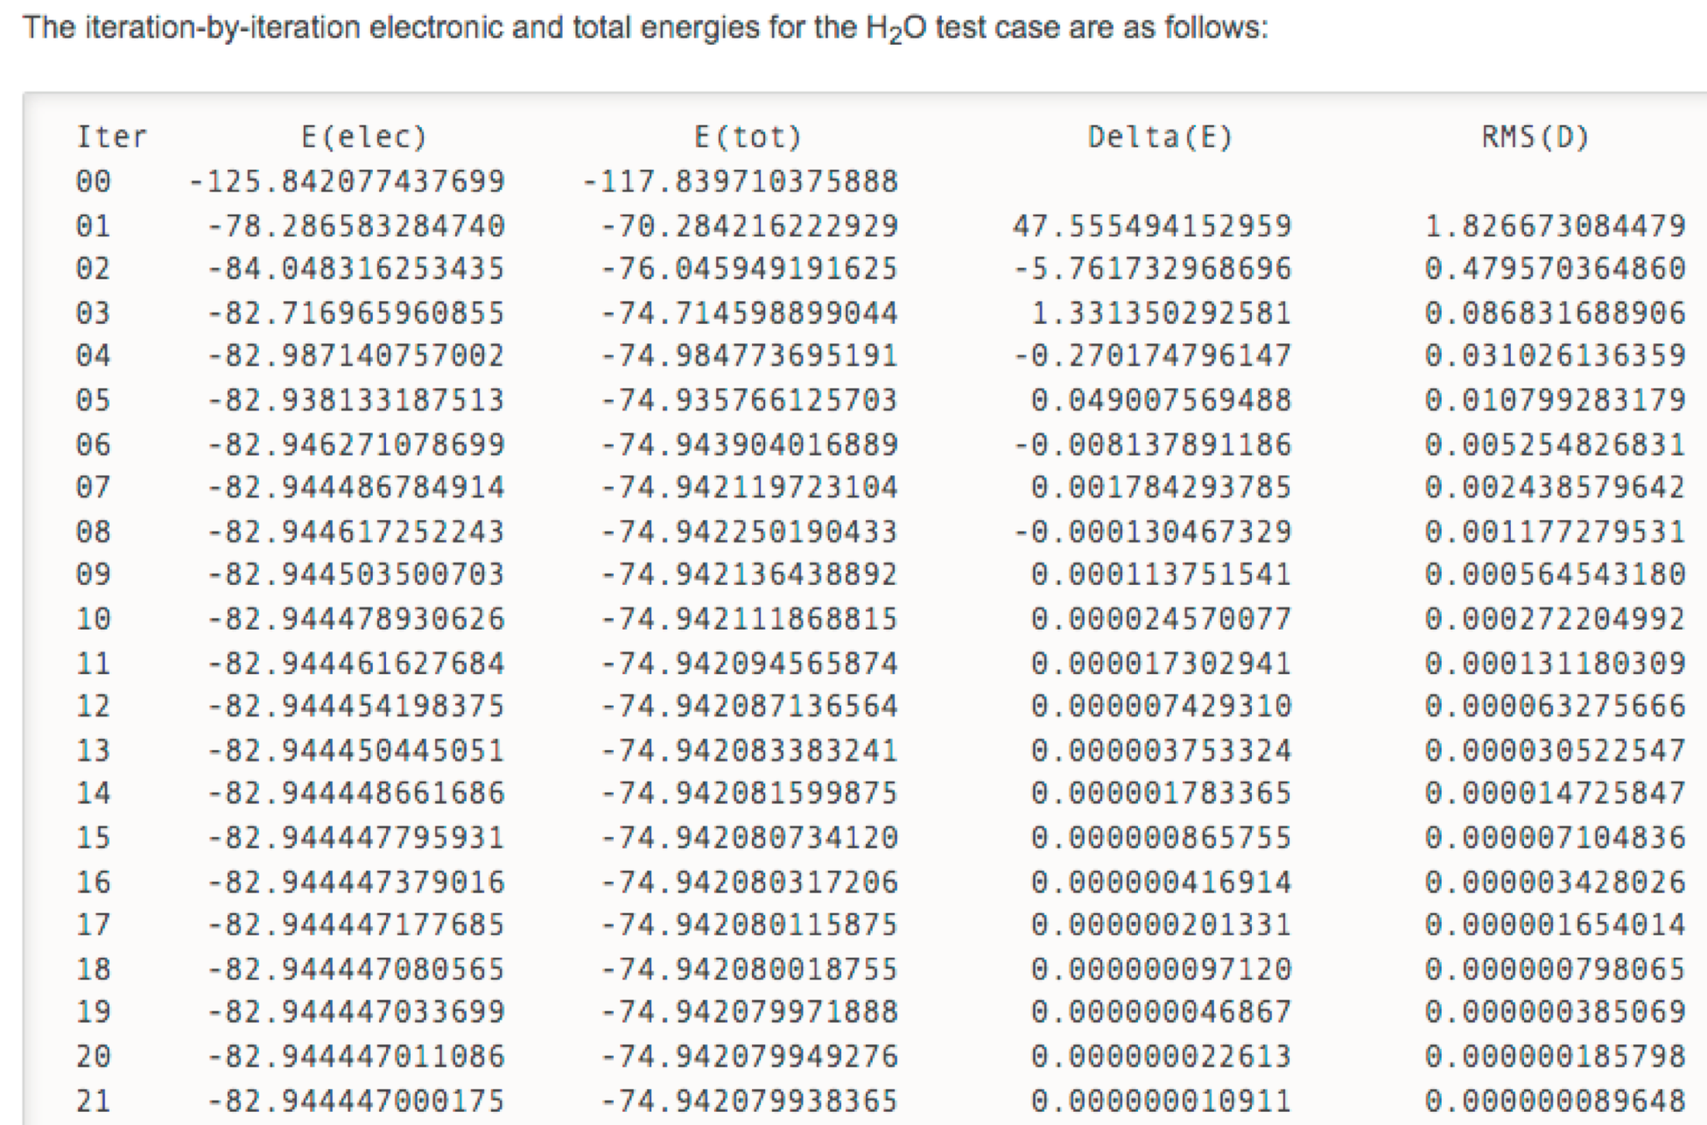

Figure 1A & 1B: Hartree-Fock calculated results for the identification of the lowest energy expectation value. RHF Energy corresponds to SCF energy for each iteration. Delta E is change in energy in each iteration. Delta DD is change in density matrix in each iteration. 1B: Below 1A are the validated Hartree-Fock results via Crawdad tutorial, in agreement with our results.

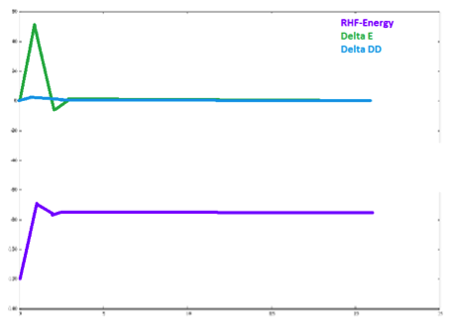

Figure 2: RHF Iterations of the water simulation. X-axis represents iterations processed in Hartree-Fock method. Y-axis non-specific numerical values.

Trig.png

Figure 3: Trigonometric Identity for the incorporation into the coulomb integral

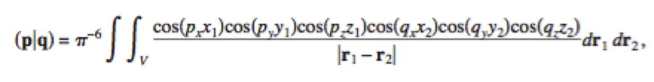

Figure 4: The incorporation of the trig, identity to form a linear combination of canonical integrals

While we have been able to achieve a working Hartree-Fock simulation and in addition, successfully calculate the necessary potential and kinetic integrals to integrate a jellium-based system into these calculations, there are still issues with our model. Initially, we sought to explore electron repulsion effects in a particle in a sphere model. However, electron repulsion integrals proved difficult to tackle in the course of a semester, and Peter Gill and co-authors had literature and equations readily available in their work. Hence, we modified our project to address the HF-Jellium model in a particle in a cubic basis. Further work needs to be done for PIS. In addition, there is potentially an issue with our integral calculations themselves, as when injected into our HF code, did not produce results that corroborate with those found in the literature provided by Gill. Future work would hope to resolve the issues with integral calculations, expand this to include a PIS model, and potentially explore post Hartree Fock methods for the inclusion of electron correlation effects for a more complex model.

**References**

1 Polozkov. G. R., Ivanov. K. V., **New Applications of the Jellium Model for the study of Atomic Clusters**. Journal of Physics.

2 Bergerson E. D., Roach. J. P., **Al Clusters Superatoms as Halogens in Polyhalides and as Alkaline Earths in Iodide Salts**. ScienceMag. 307. 2005

3 **Many–Particle Systems. Notes on Quantum Mechanics**. 239.K. Schulten. Department of Physics and Beckman Institute. University of Illinois. Apr 2000

4 **Helium Atom, Many-Electron Atoms, Variational Principle, Approximate Methods, Spin.** Douglas J. Doren. Division of Physical Chemistry.Department of Chemistry and Biochemistry. Apr 2011.

5 **An Introduction to Hartree-Fock Molecular Orbital Theory.** C. David Sherrill. School of Chemistry and Biochemistry. Georgia Institute of Technology. June 2000; http://vergil.chemistry.gatech.edu/notes/hf-intro/hf-intro.html

6 **Finite jellium models. I. Restricted Hartree–Fock calculations.** Sankha Ghosh, and Peter M. W. Gill. The Journal of Chemical Physics 122, 154108 (2005); <http://doi.org/10.1063/1.1873552>

7 M. Towler, Cavendish Laboratory, University of Cambridge, “Exchange, antisymmetry and Pauli repulsion” (2010) <http://www.tcm.phy.cam.ac.uk/~mdt26/>

8 **Unique Hot Carrier Distributions from Scattering Mediated Absorption.**

Fernando Kimberly, Codrington Jason, Eldabagh Noor, and Dr. Jonathan J. Foley IV. ACS Photonics 4 (3), 552-559 (2017); <http://pubs.acs.org/doi/abs/10.1021/acsphotonics.6b00773>

9 D. ‘Crawdad’ Crawford, Virginia Tech, (2016), **“Programming Project #3: The Hartree-Fock Self-Consistent Field Method”** http://sirius.chem.vt.edu/wiki/doku.php?id=crawdad:programming:project3