Freight Pricing Dataset
Data Quality Assessment, Pipeline & Baseline Results

Prepared for: Ascent Global Logistics Team
Date: March 26, 2026
Objective: Predict winning_bid_price
Version: 1.1 (Updated with actual pipeline results)

1. Executive Summary
This document presents the complete data quality assessment, cleaning pipeline architecture, and baseline model results for the Ascent Freight Pricing dataset. The goal is to predict winning_bid_price using shipment characteristics.
Key Outcome: A reusable data pipeline was built that cleans raw data and trains baseline models. The pipeline reduced 9,991 raw rows to 9,934 clean rows (99.4% retention). The Random Forest baseline achieved R-squared = 0.5746 with MAE of $662.19, while Linear Regression performed poorly (R-squared = -0.36), confirming non-linear relationships in the data.
Decision: Feature engineering is intentionally deferred to a future iteration. The baseline uses raw numeric features and one-hot encoded categoricals only. This establishes a performance floor before adding complexity.

2. Dataset Overview
Metric | Value | Notes
Total Rows | 9,991 | Including 1 duplicate header row
Total Columns | 11 | 1 target + 10 features
Target Variable | winning_bid_price | Continuous numeric (regression)
Date Range | 2024 - 2025 | Mixed formats across rows
Price Mean / Median | $1,749.75 / $1,056.78 | Right-skewed distribution

2.1 Column Descriptions
Column | Expected Type | Nulls | Description
shipment_id | String | 0 | Unique identifier for each shipment
shipment_date | Date | 8 | Date of shipment (3 mixed formats)
origin_region | Categorical | 8 | Origin region code (e.g., MW-1, WC-2)
destination_region | Categorical | 8 | Destination region code
equipment_type | Categorical | 8 | Type of transport equipment (32 messy variants)
weight_lbs | Numeric | 328 | Shipment weight in pounds (has garbage values)
cubic_feet | Numeric | 517 | Shipment volume in cubic feet (has garbage values)
lead_time_hours | Numeric | 207 | Hours of lead time before shipment
num_carrier_bids | Numeric | 395 | Number of carrier bids received
lane_volume | Numeric | 8 | Historical volume on the shipping lane
winning_bid_price | Numeric | 8 | TARGET: Winning carrier bid price ($)

3. Data Quality Issues Identified
The following critical issues were found during data profiling. All columns were read as object (string) type due to embedded garbage values.
Issue | Details | Impact
All columns read as object | Garbage values (TBD, pending, #REF!, -) prevent type inference | High
Duplicate header row | 1 row repeats column names as values | Low
equipment_type inconsistencies | 32 variants for 7 types (case, abbreviations, HTML tags) | High
Missing values | weight: 328, cubic_feet: 517, lead_time: 207, bids: 395 | High
Invalid target values | 33 zero prices, 15 negative prices (min: -4,504) | High
Outliers | weight: 1M lbs, price: 63K, lead_time: 9,999 hrs | Medium
Mixed date formats | YYYY-MM-DD (6,082), MM/DD/YYYY (1,912), with time (1,011) | Medium
Negative lead_time_hours | 4 rows with negative values | Low

3.1 Equipment Type Variants (32 found)
Canonical Type | Variants Found
Cargo Van | Cargo Van, cargo van, CARGO VAN, CV, Cargo Van, <b>Cargo Van</b>
Sprinter Van | Sprinter Van, sprinter van, SPRINTER VAN, Sprinter
Small Straight | Small Straight, small straight, Sm Straight, Small Str
Large Straight | Large Straight, LARGE STRAIGHT, Large Str, Lg Straight
Tractor Trailer | Tractor Trailer, tractor trailer, Tractor, TT
Flatbed | Flatbed, flatbed, FLATBED, Flat Bed
Reefer | Reefer, reefer, REEFER, Refrigerated

3.2 Non-Numeric Garbage Values
- weight_lbs: TBD (3), - (2), #REF! (2), pending (1)
- cubic_feet: pending (5), #REF! (3)
- lead_time_hours, num_carrier_bids, lane_volume: 1 row each with column header as value

4. Reusable Pipeline Architecture
A modular, reusable pipeline was built so new data can be processed without rework. The pipeline is configured via config.py and can be run end-to-end or step-by-step.

4.1 Project Structure
- config.py - Central configuration (paths, mappings, thresholds)
- pipeline/clean.py - 9 cleaning functions + orchestrator
- pipeline/features.py - Feature matrix preparation (minimal for baseline)
- pipeline/model.py - Model training, evaluation, plotting
- run_pipeline.py - Main entry point with CLI arguments

4.2 Usage
python run_pipeline.py # Full pipeline: clean + model
python run_pipeline.py --step clean # Only cleaning
python run_pipeline.py --step model # Only modeling
python run_pipeline.py --input new_data.csv # Run on new data

4.3 Cleaning Pipeline Steps
- drop_header_rows() - Remove embedded header rows
- drop_null_rows() - Remove fully null rows
- standardize_equipment_type() - Map 32 variants to 7 canonical types, strip HTML
- coerce_numeric_columns() - Convert to numeric, garbage becomes NaN
- remove_invalid_targets() - Drop zero/negative prices
- parse_dates() - Unify 3 date formats into datetime
- cap_outliers() - Cap extreme values at configurable thresholds
- impute_missing() - Median imputation for numeric columns

5. Data Cleaning Results (Actual)
The pipeline was executed on the raw dataset. Below are the actual results from each cleaning step.

5.1 Row Impact Summary
Step | Rows Removed | Remaining
Original dataset | - | 9,991
Drop duplicate header row | 1 | 9,990
Drop fully null rows | 8 | 9,982
Standardize equipment_type | 25 | 9,957
Remove invalid targets (<=0) | 23 | 9,934
FINAL CLEANED DATASET | 57 total removed | 9,934 rows (99.4%)

5.2 Outlier Capping Applied
Column | Threshold | Values Capped | Action
weight_lbs | 100,000 lbs | 10 | Capped at threshold
cubic_feet | 5,000 cu ft | 4 | Capped at threshold
lead_time_hours | 500 hrs | 3 | Capped at threshold
winning_bid_price | $50,000 | 1 | Capped at threshold
lead_time_hours | < 0 | 4 | Set to NaN (imputed)

5.3 Missing Value Imputation
Column | Missing Count | Strategy | Fill Value
weight_lbs | 328 | Median | 1,111.95
cubic_feet | 517 | Median | 8.80
lead_time_hours | 203 | Median | 13.70
num_carrier_bids | 387 | Median | 4.00

6. Baseline Model Results (Actual)
Note: Feature engineering was intentionally deferred for this baseline. Models use raw numeric features (weight_lbs, cubic_feet, lead_time_hours, num_carrier_bids, lane_volume) and one-hot encoded categoricals (origin_region, destination_region, equipment_type). Total features: 59.

Train/test split: 80/20 (7,947 train, 1,987 test). Random seed: 42.

6.1 Performance Comparison
Model | MAE | RMSE | R-squared
Linear Regression | $831.49 | $2,457.21 | -0.3609
Random Forest | $662.19 | $1,373.84 | 0.5746

6.2 Analysis
- Linear Regression: Negative R-squared indicates the model performs worse than predicting the mean. This confirms non-linear relationships between features and price.
- Random Forest: Explains 57.5% of variance with MAE of $662. This is a reasonable baseline given no feature engineering.
- The large gap between MAE ($662) and RMSE ($1,374) for Random Forest suggests some large prediction errors on high-value shipments.

6.3 Actual vs Predicted
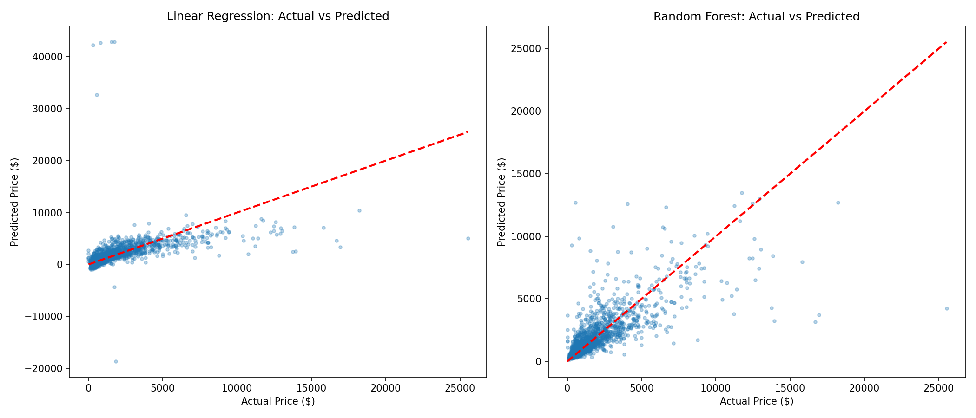

6.4 Residual Analysis
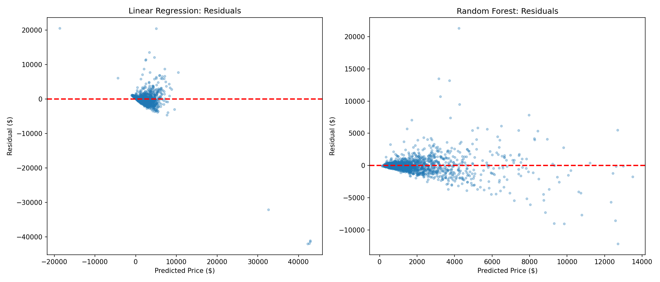

6.5 Feature Importance (Random Forest)
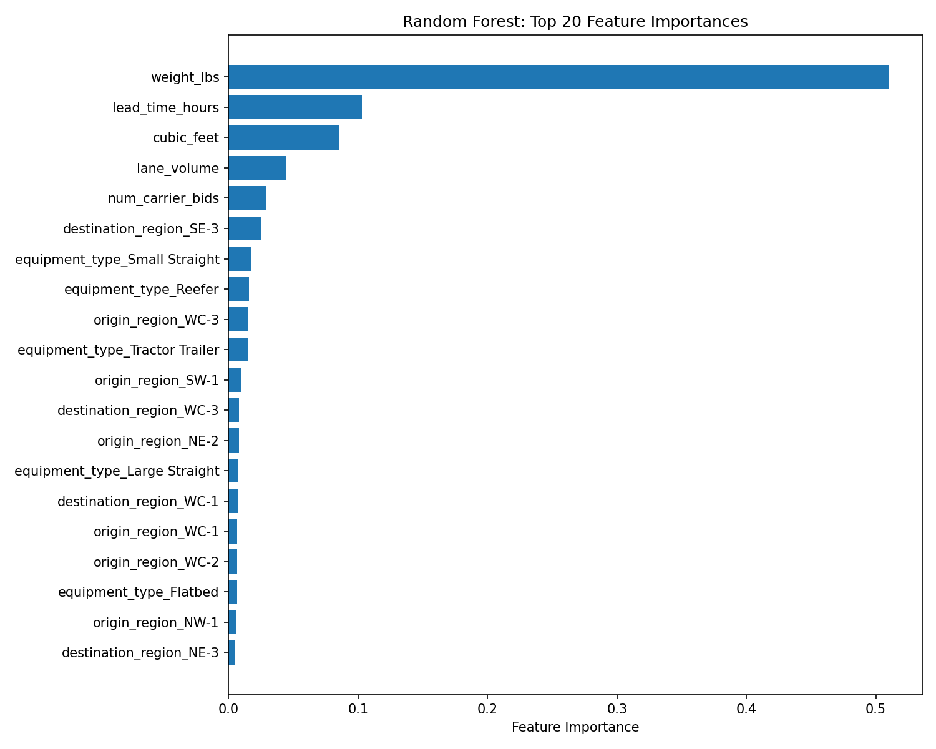

7. Decision Log
This section captures key decisions made during the project, along with rationale and status.

Date | Decision | Rationale | Status
2026-03-26 | Build reusable pipeline instead of one-off notebooks | Avoid rework when new data arrives. Pipeline is configurable via config.py and can be run via CLI. | Implemented
2026-03-26 | Defer feature engineering to future iteration | Establish baseline performance first. Current model uses raw features + one-hot encoding only. | Deferred
2026-03-26 | Cap outliers instead of removing them | Preserves data volume. Extreme values (weight=1M, lead_time=9999) capped at configurable thresholds. | Implemented
2026-03-26 | Use median imputation for missing values | Robust to outliers. Configurable in config.py (can switch to mean). | Implemented
2026-03-26 | Remove rows with winning_bid_price <= 0 | Zero and negative prices are invalid for a bid price prediction task. 48 rows removed. | Implemented
2026-03-26 | Document all conversations and decisions in this living document | Enables team visibility. Document is updated after each phase with actual results. | Ongoing

8. Next Steps

8.1 Feature Engineering (Deferred)
- Extract date features: month, day_of_week, day_of_month from shipment_date
- Feature scaling/normalization for linear models
- Interaction features (e.g., weight * distance proxy)
- Lane-level aggregations (historical avg price per lane)

8.2 Model Improvements
- Hyperparameter tuning for Random Forest (n_estimators, max_depth, min_samples_split)
- Try Gradient Boosting (XGBoost/LightGBM) for potential improvement
- Cross-validation instead of single train/test split
- Investigate high-error predictions (likely high-value shipments)

8.3 Data Quality Improvements
- Investigate root cause of garbage values (TBD, #REF!, pending) at the data source
- Validate equipment_type mapping completeness when new data arrives
- Consider time-based train/test split instead of random split

