Freight Pricing Dataset
Baseline vs Strict Cleaning: Model Comparison & Data Guide

Date: March 26, 2026
Version: 2.0 - Comparison Report

1. Executive Summary
This document compares two data cleaning approaches for the Ascent Freight Pricing prediction task and serves as a data guide for anyone reviewing this project.
Baseline Pipeline: Caps outliers at thresholds and imputes missing values with median. Retains 9,934 of 9,991 rows (99.4%). Random Forest R-squared = 0.5746.
Strict Pipeline: Removes all garbage data, negative values, invalid dates, NaN rows, and IQR outliers. Retains 6,028 of 9,991 rows (60.3%). Linear Regression R-squared = 0.5671, nearly matching Random Forest.
Key Finding: Removing outliers dramatically improved Linear Regression (from R-squared = -0.36 to 0.57) — proving the baseline model was severely impacted by dirty data. Both models now perform comparably, with cleaner residuals and much lower error magnitudes.

2. Data Guide: Understanding the Raw Dataset
This section provides a comprehensive overview of the raw data for anyone new to this project.

2.1 Dataset At a Glance
Property | Value
Source File | ascent freight pricing dataset.csv
Total Rows | 9,991 (includes 1 duplicate header row)
Total Columns | 11 (1 ID + 1 date + 4 categorical + 5 numeric + 1 target)
Target Variable | winning_bid_price (continuous, USD)
Date Range | Jan 2024 - Dec 2026 (with some invalid dates up to 2099)
Task Type | Regression: predict the winning carrier bid price for a shipment

2.2 Column Dictionary
Complete reference for every column in the dataset:
Column | Type | Nulls | Description & Notes
shipment_id | ID | 0 | Unique shipment identifier (format: SHP-XXXXXX). No duplicates found.
shipment_date | Date | 8 | Shipment date. WARNING: 3 mixed formats (YYYY-MM-DD, MM/DD/YYYY, YYYY-MM-DD HH:MM:SS). Some dates go up to year 2099 (invalid).
origin_region | Categorical | 8 | Origin region code (26 unique values, e.g., MW-1, WC-2, SE-3). Format: Region-Number.
destination_region | Categorical | 8 | Destination region code (24 unique values). Same format as origin_region.
equipment_type | Categorical | 8 | Type of transport equipment. MAJOR ISSUE: 32 messy variants for 7 real types. See Equipment Type section below.
weight_lbs | Numeric | 328 | Shipment weight in pounds. Contains garbage values (TBD, #REF!, pending, -). Range: -500 to 1,000,000 after coercion.
cubic_feet | Numeric | 517 | Shipment volume in cubic feet. Contains garbage values (pending, #REF!). Some negative values.
lead_time_hours | Numeric | 207 | Hours between booking and shipment. Contains negatives and extreme values (max: 9,999 hrs = 416 days).
num_carrier_bids | Numeric | 395 | Number of carrier bids received. Expect 1-20 typical range. Max found: 999 (likely data error).
lane_volume | Numeric | 8 | Historical shipment volume on this lane. Higher = more frequently used route.
winning_bid_price | Numeric | 8 | TARGET: Winning carrier bid price in USD. Contains 33 zeros and 15 negatives (invalid). Mean: $1,750, Median: $1,057.

2.3 Equipment Type Reference
The 7 canonical equipment types and their raw data variants:
Canonical Name | Count (Raw) | Variants in Data
Small Straight | 2,480 | Small Straight, small straight, Sm Straight, Small Str
Sprinter Van | 2,002 | Sprinter Van, sprinter van, SPRINTER VAN, Sprinter
Large Straight | 1,769 | Large Straight, LARGE STRAIGHT, Large Str, Lg Straight
Cargo Van | 1,530 | Cargo Van, cargo van, CARGO VAN, CV, Cargo Van, <b>Cargo Van</b>
Tractor Trailer | 1,021 | Tractor Trailer, tractor trailer, Tractor, TT
Flatbed | 672 | Flatbed, flatbed, FLATBED, Flat Bed
Reefer | 483 | Reefer, reefer, REEFER, Refrigerated

Additionally: 25 rows with 'Test Equipment' and 1 row with literal 'equipment_type' header value are dropped.

2.4 Known Data Quality Issues
- Garbage values in numeric columns: TBD, pending, #REF!, - (total: 18 values across weight and cubic_feet)
- Negative values: weight_lbs (-500), cubic_feet (-10), lead_time_hours (4 rows), num_carrier_bids (-1)
- Extreme outliers: weight up to 1,000,000 lbs, lead_time up to 9,999 hrs, num_bids up to 999
- Invalid dates: some dates in year 2099 (8 rows with dates outside 2023-2026 range)
- Zero/negative target prices: 33 zeros + 15 negatives = 48 invalid target rows
- High missingness: cubic_feet (517 nulls, 5.2%), num_carrier_bids (395, 4.0%), weight_lbs (328, 3.3%)
- 1 duplicate header row embedded in the data

3. Cleaning Approaches Compared

3.1 Baseline Pipeline (Cap + Impute)
Conservative approach: caps outliers at thresholds, fills missing values with median. Maximizes data retention.
Step | Rows Removed | Remaining
Drop header row | 1 | 9,990
Drop null rows | 8 | 9,982
Standardize equipment_type | 25 | 9,957
Remove invalid targets | 23 | 9,934
Cap outliers | 0 (capped) | 9,934
Impute missing (median) | 0 (filled) | 9,934
TOTAL | 57 removed | 9,934 (99.4%)

3.2 Strict Pipeline (Remove + No Imputation)
Aggressive approach: removes all garbage, negative values, invalid dates, NaN rows, and IQR outliers. No imputation — only verified clean data.
Step | Rows Removed | Remaining
Drop header row | 1 | 9,990
Drop null rows | 8 | 9,982
Standardize equipment_type | 25 | 9,957
Remove invalid targets | 23 | 9,934
Remove negative values | 11 | 9,923
Remove invalid dates (outside 2023-2026) | 8 | 9,915
Drop rows with any NaN | 1,346 | 8,569
Remove IQR outliers (1.5x) | 2,541 | 6,028
TOTAL | 3,963 removed | 6,028 (60.3%)

3.3 IQR Outlier Removal Details (Strict)
Column | Q1 | Q3 | Lower Bound | Upper Bound | Removed
weight_lbs | 513.7 | 2,234.6 | -2,067.7 | 4,816.0 | 626
cubic_feet | 3.7 | 15.1 | -13.4 | 32.2 | 382
lead_time_hours | 6.5 | 23.5 | -19.0 | 49.0 | 864
num_carrier_bids | 2.0 | 6.0 | -4.0 | 12.0 | 64
lane_volume | 74.0 | 198.0 | -112.0 | 384.0 | 180
winning_bid_price | 563.3 | 1,731.6 | -1,189.3 | 3,484.2 | 425

4. Strict Cleaned Data Profile
After strict cleaning, the dataset is free of nulls, negatives, and statistical outliers.

4.1 Numeric Feature Distributions (Post-Cleaning)
Column | Min | Q1 | Median | Q3 | Max | Mean | Std
weight_lbs | 0.1 | 435.3 | 880.2 | 1,549.6 | 4,813.2 | 1,119.4 | 882.6
cubic_feet | 0.0 | 3.4 | 6.9 | 12.4 | 32.1 | 8.8 | 6.9
lead_time_hrs | 0.0 | 6.1 | 12.0 | 20.1 | 49.0 | 14.7 | 11.0
num_bids | 0.0 | 2.0 | 4.0 | 6.0 | 12.0 | 4.4 | 2.6
lane_volume | 0.0 | 73.0 | 121.0 | 196.0 | 372.0 | 140.0 | 83.9
bid_price | 0.0 | 538.2 | 913.4 | 1,513.9 | 3,479.7 | 1,120.4 | 755.8

4.2 Equipment Type Distribution (Strict)
Equipment Type | Count | Percentage
Small Straight | 1,678 | 27.8%
Sprinter Van | 1,449 | 24.0%
Large Straight | 1,170 | 19.4%
Cargo Van | 1,118 | 18.5%
Flatbed | 257 | 4.3%
Reefer | 214 | 3.5%
Tractor Trailer | 142 | 2.4%

Note: Tractor Trailer and Flatbed had more outliers removed proportionally (heavy/high-value shipments), reducing their share.

5. Model Results Comparison

5.1 Performance Summary
 | MAE | RMSE | R-sq | MAE | RMSE | R-sq
 | BASELINE |  |  | STRICT
Linear Regression | $831 | $2,457 | -0.36 | $355 | $495 | 0.567
Random Forest | $662 | $1,374 | 0.575 | $360 | $502 | 0.554

5.2 Key Observations
- Linear Regression improved dramatically: R-squared went from -0.36 (worse than mean) to 0.567 (meaningful). This proves outliers were severely distorting the linear model.
- Both models now perform comparably (~0.55-0.57 R-squared). In clean data, the relationship is more linear than expected.
- MAE dropped from $662-$831 to $355-$360 — prediction errors are now roughly half the size.
- RMSE dropped even more (from $1,374-$2,457 to $495-$502) — eliminating large-error outliers was the main driver.
- The gap between MAE and RMSE is now much smaller, indicating fewer extreme prediction errors.

5.3 Trade-Off Analysis
Aspect | Baseline (Cap + Impute) | Strict (Remove Outliers)
Rows | 9,934 (99.4%) | 6,028 (60.3%)
Data Loss | Minimal — only truly invalid rows | Significant — 40% of data removed
Data Quality | Contains capped values + imputed medians | Only verified, clean data points
LR R-sq | -0.3609 (broken) | 0.5671 (usable)
RF R-sq | 0.5746 | 0.5541
Best For | When data volume matters most | When model reliability matters most

6. Visual Comparison

6.1 Actual vs Predicted: Baseline
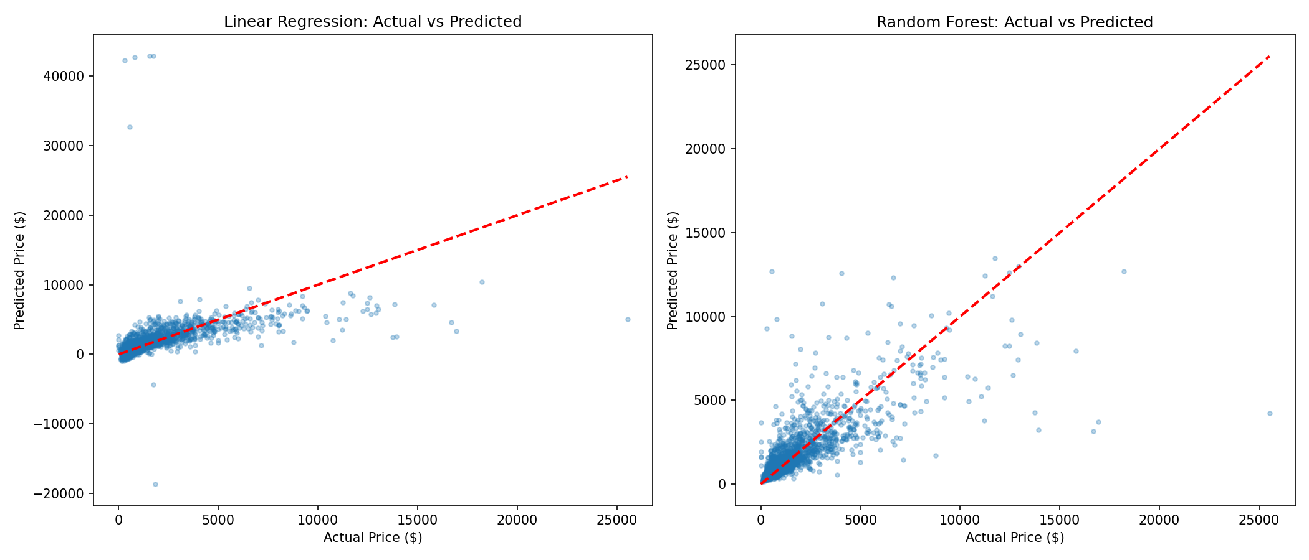

6.2 Actual vs Predicted: Strict
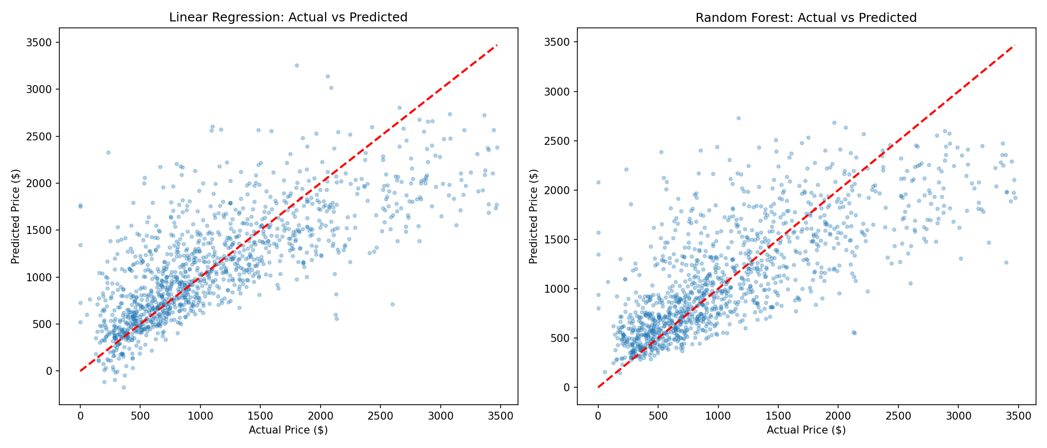

6.3 Residuals: Baseline
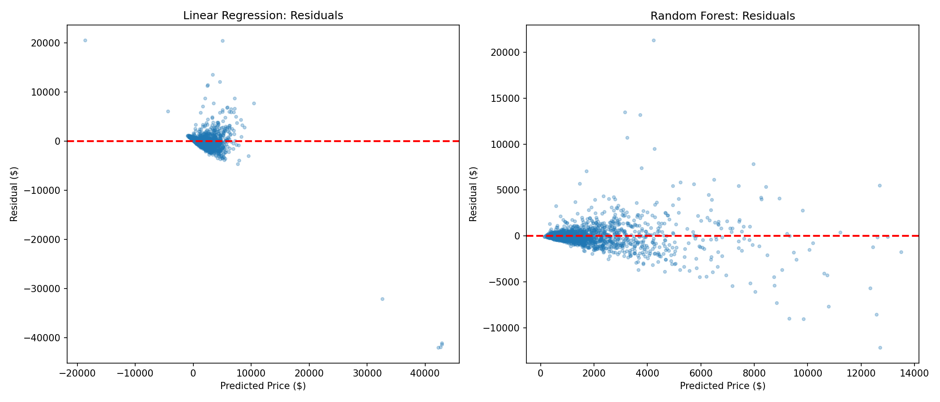

6.4 Residuals: Strict
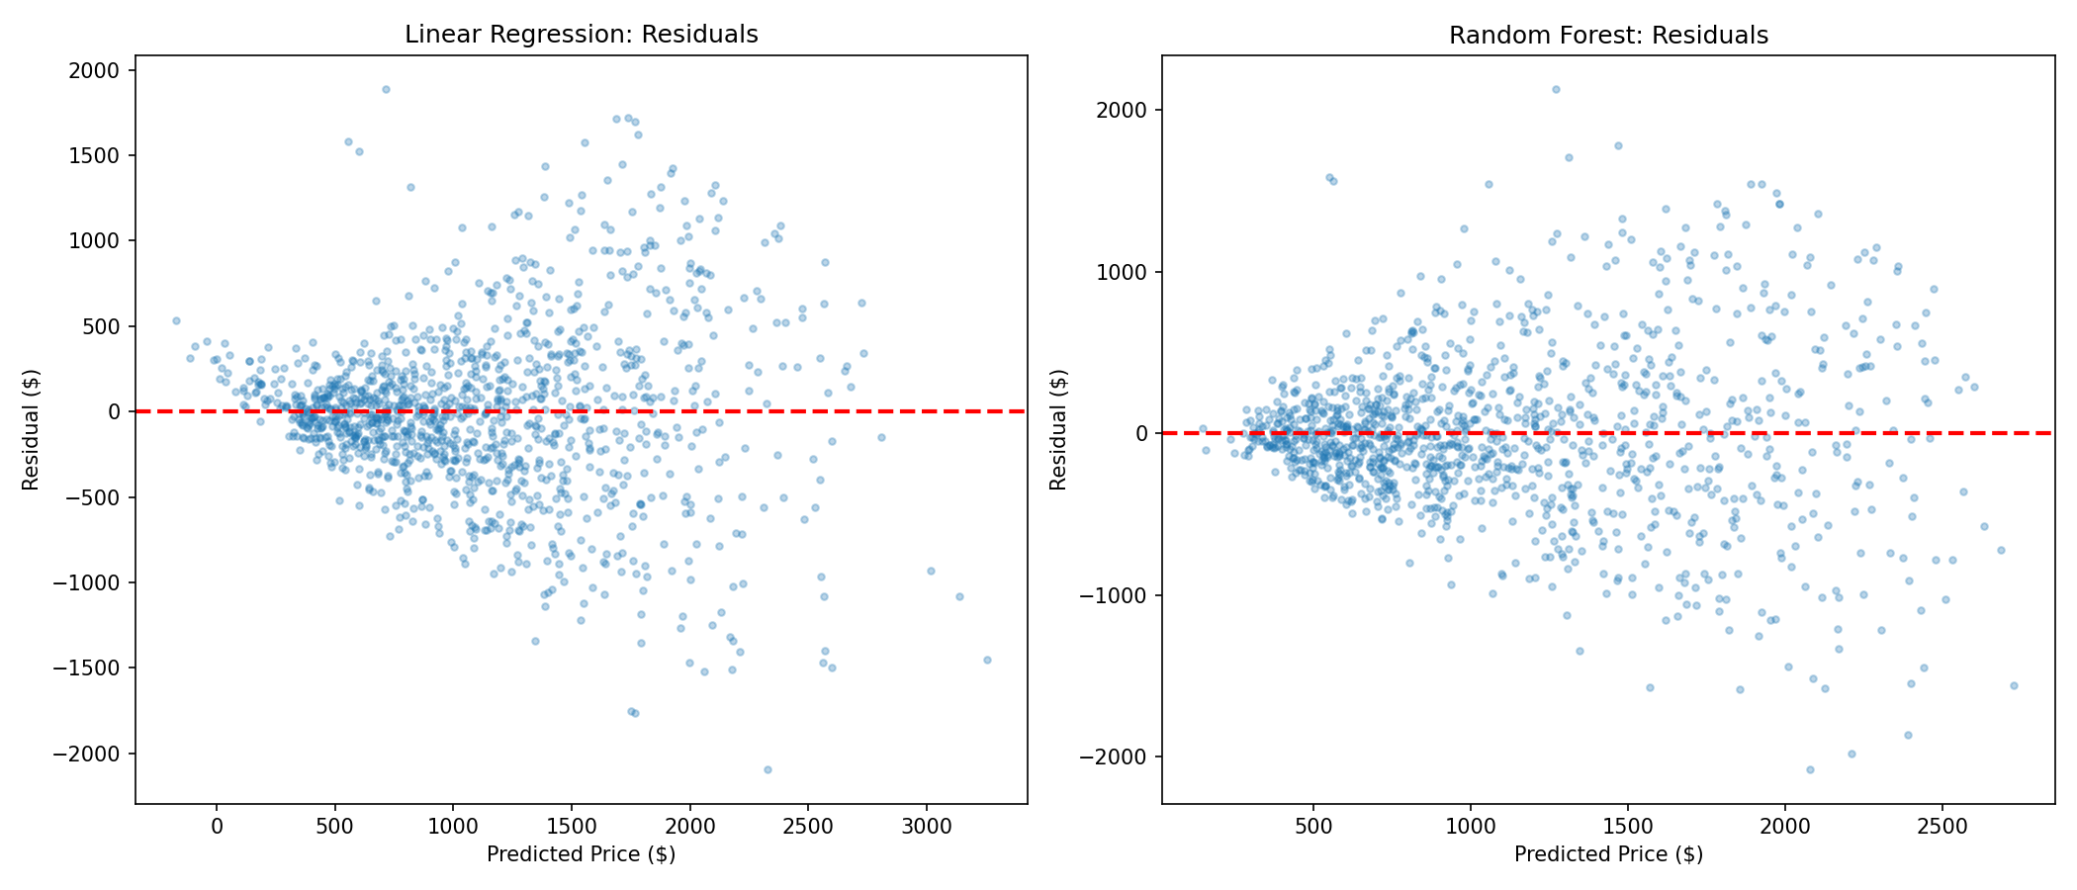

6.5 Feature Importance: Baseline (Random Forest)
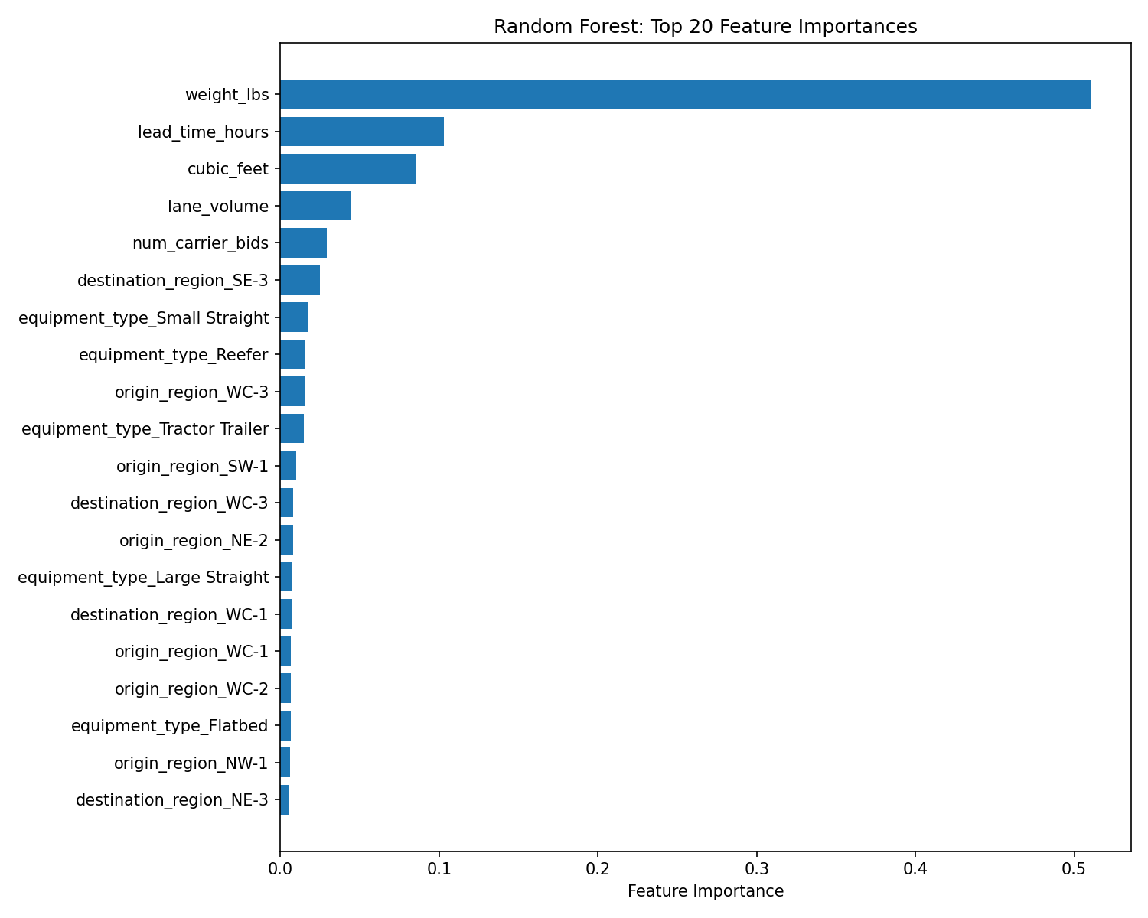

6.6 Feature Importance: Strict (Random Forest)
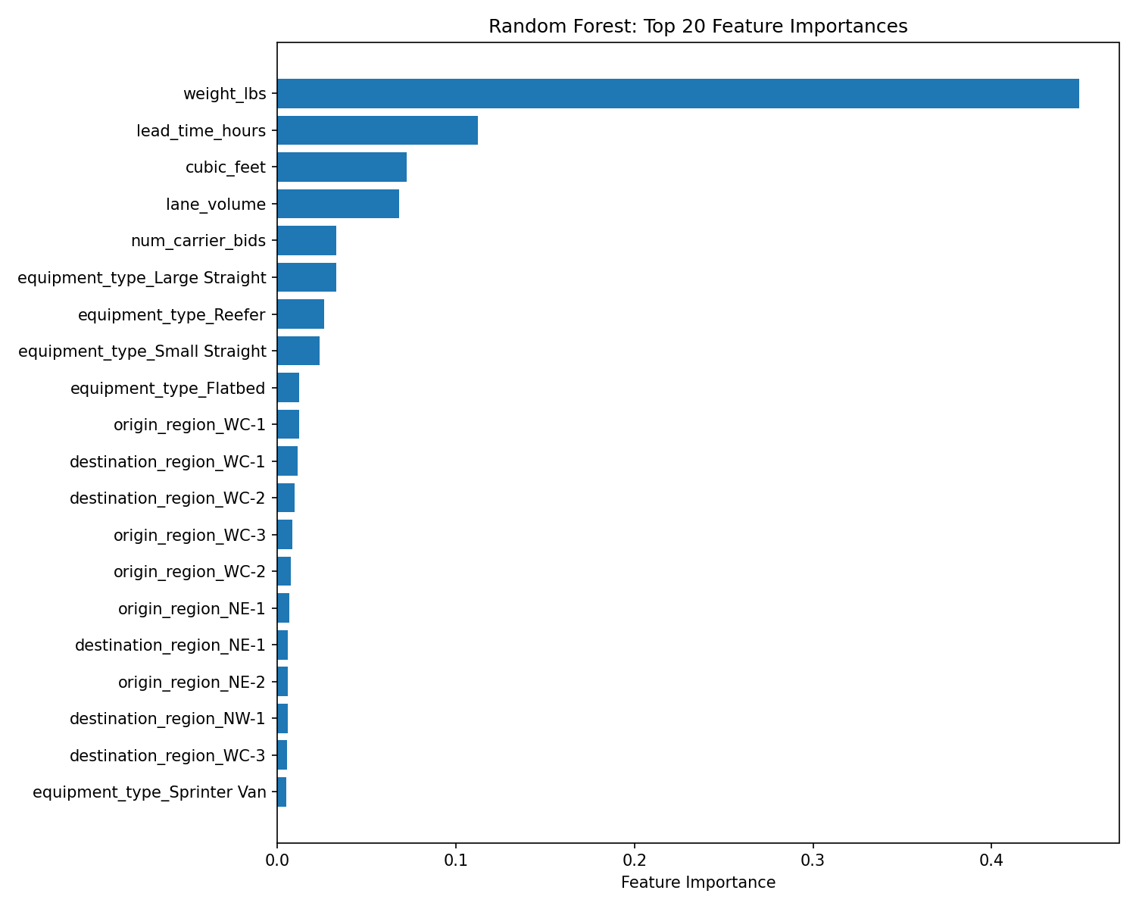

7. Decision Log
Date | Decision | Rationale | Status
2026-03-26 | Build reusable pipeline | Avoid rework for new data. CLI-driven with config.py. | Implemented
2026-03-26 | Defer feature engineering | Establish baseline first, then add complexity. | Deferred
2026-03-26 | Create two cleaning modes | Baseline (cap+impute) vs Strict (remove). Comparison reveals data quality impact. | Implemented
2026-03-26 | Remove outliers via IQR (1.5x) | Standard statistical method. Removes extreme values that distort models. | Implemented
2026-03-26 | No imputation in strict mode | Only use verified data points. Avoids bias from synthetic median values. | Implemented
2026-03-26 | Remove invalid dates (>2026) | Dates like 2099-01-01 are clearly data entry errors. | Implemented
2026-03-26 | Document all decisions | Living document for team visibility. Updated each phase. | Ongoing

8. Recommendations & Next Steps

8.1 Recommended Approach
Use the strict pipeline as the primary model training dataset. The dramatic improvement in Linear Regression proves that data quality is the primary driver of model performance, not model complexity. Clean data with a simple model outperforms dirty data with a complex model.

8.2 Immediate Next Steps
- Investigate the 1,346 rows with NaN values — can they be recovered from the source system?
- Review the IQR bounds with domain experts — some removed shipments may be valid edge cases (e.g., heavy Tractor Trailer loads)
- Add feature engineering: date features, weight-per-cubic-foot density, lane-level price history
- Try Gradient Boosting (XGBoost/LightGBM) on the strict cleaned data

8.3 Data Source Improvements
- Fix garbage values at source: TBD, #REF!, pending should not enter the dataset
- Validate equipment_type at data entry to prevent free-text variants
- Add date validation to prevent future dates (2099)
- Add range validation for weight, lead_time, and bid counts

8.4 Pipeline Usage
python run_pipeline.py --mode baseline # Conservative (cap + impute)
python run_pipeline.py --mode strict # Aggressive (remove outliers)
python run_pipeline.py --mode strict --input new_data.csv

