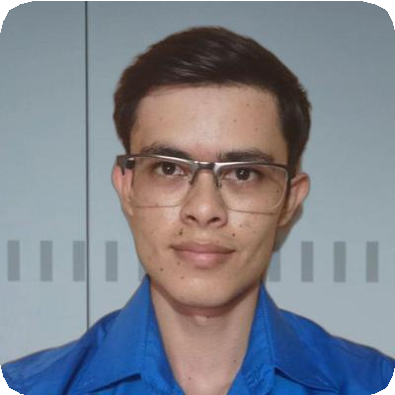Wilmer López Céspedes

Front-End Developer

# Profile

Front-End Developer from Costa Rica, in love with React, Next.js and Laravel. I'm usually pretty good at the front-end, but I also like to broaden my knowledge in the back-end.

If I'm not coding or watching any technology courses or videos related to it, I do activities like exercising or listening to music.

# Experience

## Junior Full Stack Developer, Intership at Createc Solutions, Alajuela

August 2022 — December 2022

Develop a web portal to automate and optimize different processes and activities through the use of different web services linked to the company's internal platform.

*Responsibilities:*

* Propose various technologies and approaches to meet the specific needs of the project, considering factors such as scalability, performance and security.
* Work closely with the development team and clients to understand their needs and translate them into high-quality designs.
* Development and consumption of external web services to integrate data and additional functionalities in the application, using technologies such as REST and SOAP.
* Developed the user interface and the different functionalities of a web application to query, manipulate and manage data from a REST API, using technologies such as React and Redux.

*Tech Stack:*

React: 18.2.0 React Router: 6.3.0 Tailwind CSS: 3.1.8 React Redux:

8.0.2 Laravel: 9.0

*Tools:*

Design: Figma, Code: Visual Studio Code, API testing: Postman, Git, GutHub

## Details

Cartago, La Unión, San Diego Costa Rica

+506 84360071

[wilmerlopezcespedes@gmail.com](mailto:wilmerlopezcespedes@gmail.com)

**Links** [LinkedIn](https://www.linkedin.com/in/wilmer-lopez-cespedes/) [GitHub](https://github.com/WilmerL2000) [Webpage](https://wilmerlc.com/)

## Languages

Spanish

English

# Education

## Bachelor of Business Computing, Universidad de Costa Rica, Golfito

March 2019 — March 2023

Graduated with honours