Linux Access Control Lab Portfolio
User, Group, Permission, and ACL Administration on Linux

Prepared by | Wilson Nhlanhla Radebe
Project type | Linux System Administration lab
Repository use | GitHub Portfolio
Status | Final Portfolio

Prepared for a public GitHub repository and interview review.

1. Executive Summary
This lab demonstrates practical Linux access control in a multi-user environment. The work covers account creation, group management, directory ownership, permission hardening, ACL-based traversal access, and final access validation. The outcome is a clean departmental structure where security staff and finance staff can reach only the directories intended for them.

2. Lab Objectives
• Create standard user accounts for separate access paths.
• Create dedicated groups for security and finance operations.
• Build a shared /srv directory with departmental subdirectories.
• Apply ownership and permissions to restrict unauthorized access.
• Use setgid so new content inherits the correct group context.
• Grant minimal ACL access for traversal where needed.
• Verify the final configuration by testing access as different users.

3. Environment and Tools
Category | Details
Operating system | Linux desktop environment
Shell | bash
Utilities used | adduser, addgroup, usermod, mkdir, touch, chown, chmod, setfacl, getfacl, su, ls
Working path | /home/willyonazure/srv

4. Implementation Summary

4.1 User creation
The first step was creating the user account john with adduser. The account was initialized with a home directory, password, and standard user metadata. A second account, jane, was then created using the same process so the finance side of the lab could be tested independently.

4.2 Directory structure
A working directory named srv was created under the main account home path. Two departmental subdirectories were then created inside it: security_directory and finance_directory. Test files were created in each folder to represent controlled departmental content.

4.3 Groups, ownership, and permissions
Two groups were created to separate access: security_group and finance_group. The directories were assigned to root with the matching departmental group. Permissions were tightened so that only the owner and the correct group could access the directories. The setgid bit was also applied to preserve group inheritance for new content.

4.4 ACL traversal access
ACL entries were added to the parent home directory so john and jane could traverse into the lab environment without exposing broader access than necessary. This is the right model: grant only the minimum access required for the task.

4.5 Validation
The last stage tested access from root, john, and jane. The results confirmed the intended separation. Root was blocked from direct directory traversal after permissions were tightened, john could access the security directory and read logs.txt, and jane could access the finance directory and read expenditure.txt.

5. Results
• User creation completed successfully for john and jane.
• The srv folder structure was created and organized by department.
• Ownership and permission settings restricted each directory to the correct group.
• ACLs allowed controlled traversal without opening the environment broadly.
• Access testing proved that the final security model behaved as intended.

6. Key Takeaways
This lab is basic on the surface, but it reflects real administrative discipline. Most permission mistakes in Linux come from sloppy group design, weak ownership planning, or giving away too much access too early. The structure here avoids that problem. It separates responsibilities cleanly and proves the setup with live testing.

7. Conclusion
The lab was completed successfully and demonstrates the full workflow for Linux access control at a small departmental scale. The final configuration provides the right balance of structure and restriction: users can reach what they need, and nothing more.

Appendix A. Evidence Log
Each figure below is presented in chronological order. The captions match the lab sequence and are ready for GitHub publication.
Figure 1. Creating the user account `john`.
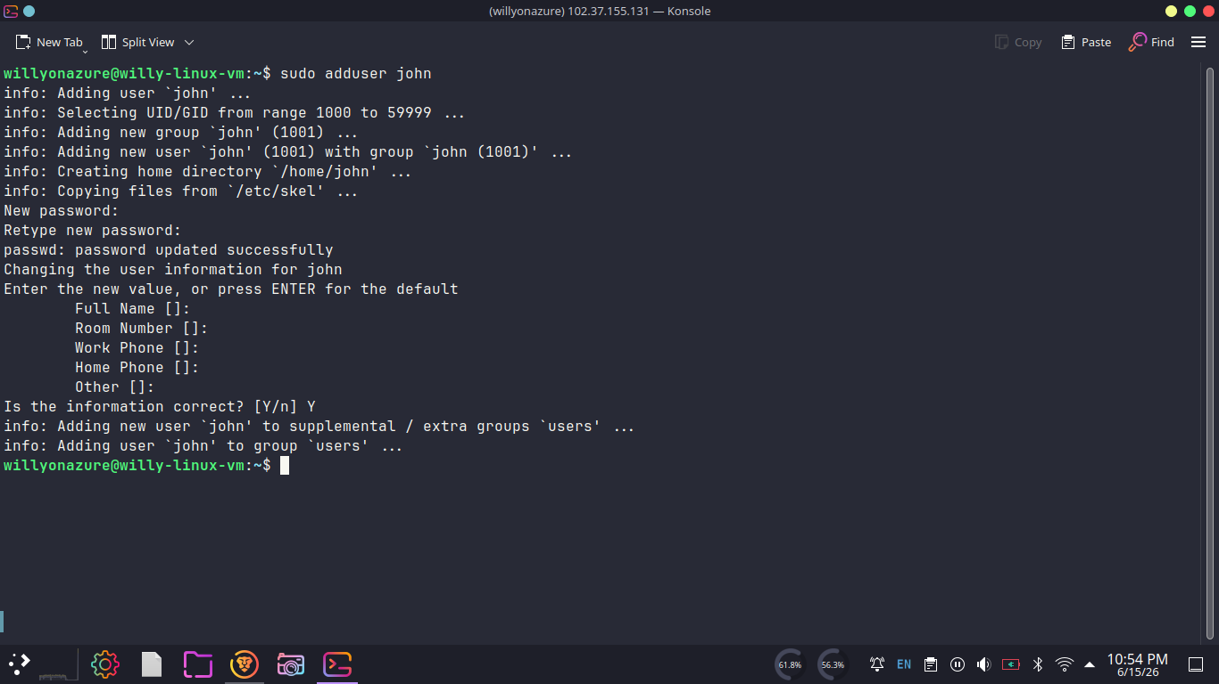
Source: ADDUSER JOHN.png

Figure 2. Creating the user account `jane`.
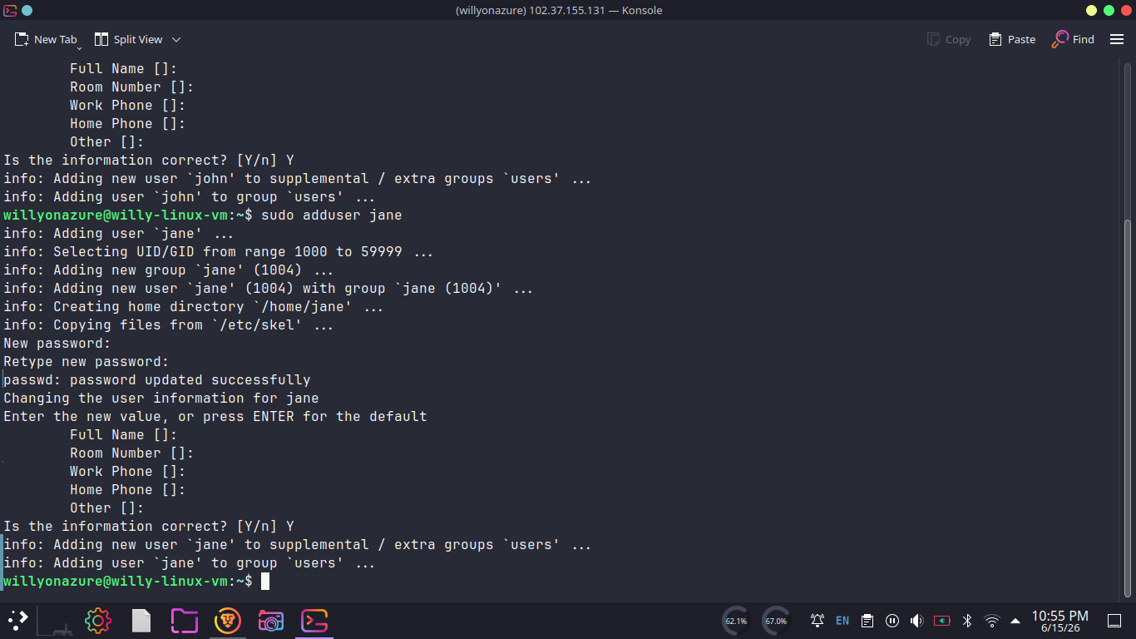
Source: ADDUSER JANE.png

Figure 3. Building the `/home/willyonazure/srv` structure and departmental files.
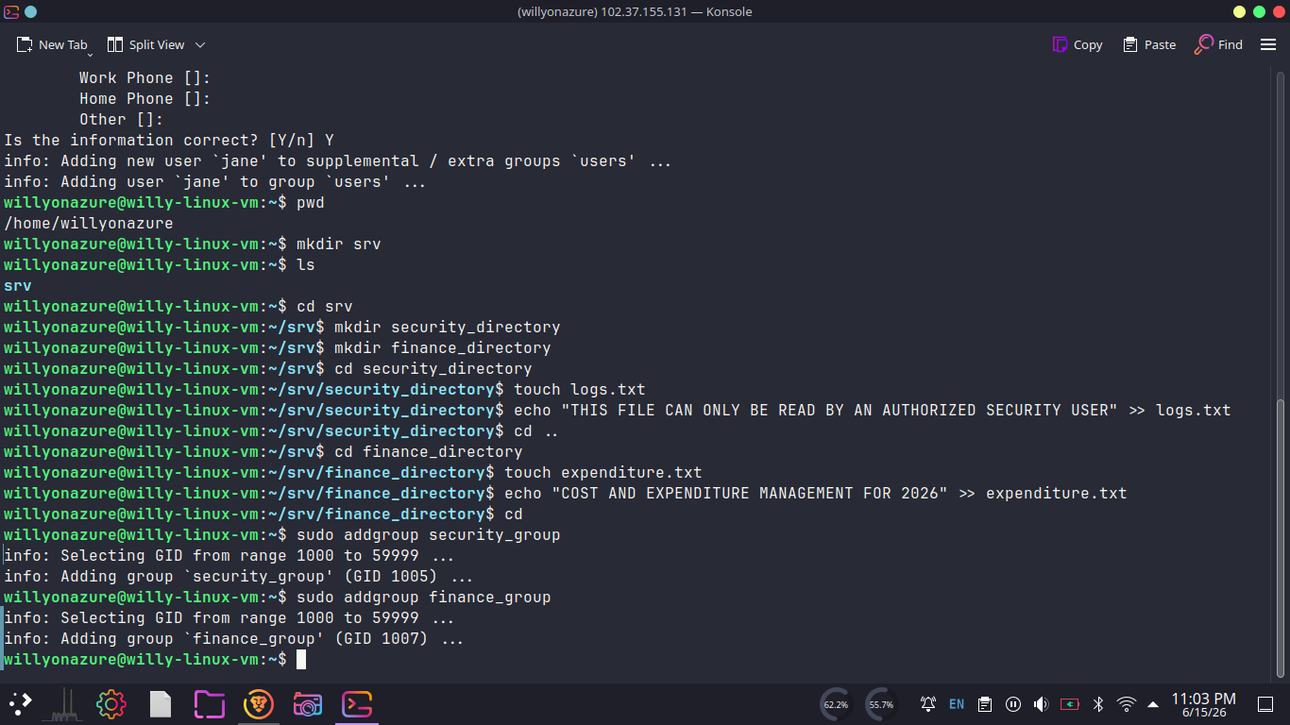
Source: MKDIR SRV AND SUBDIR.png

Figure 4. Applying ownership, group membership, and directory permissions.
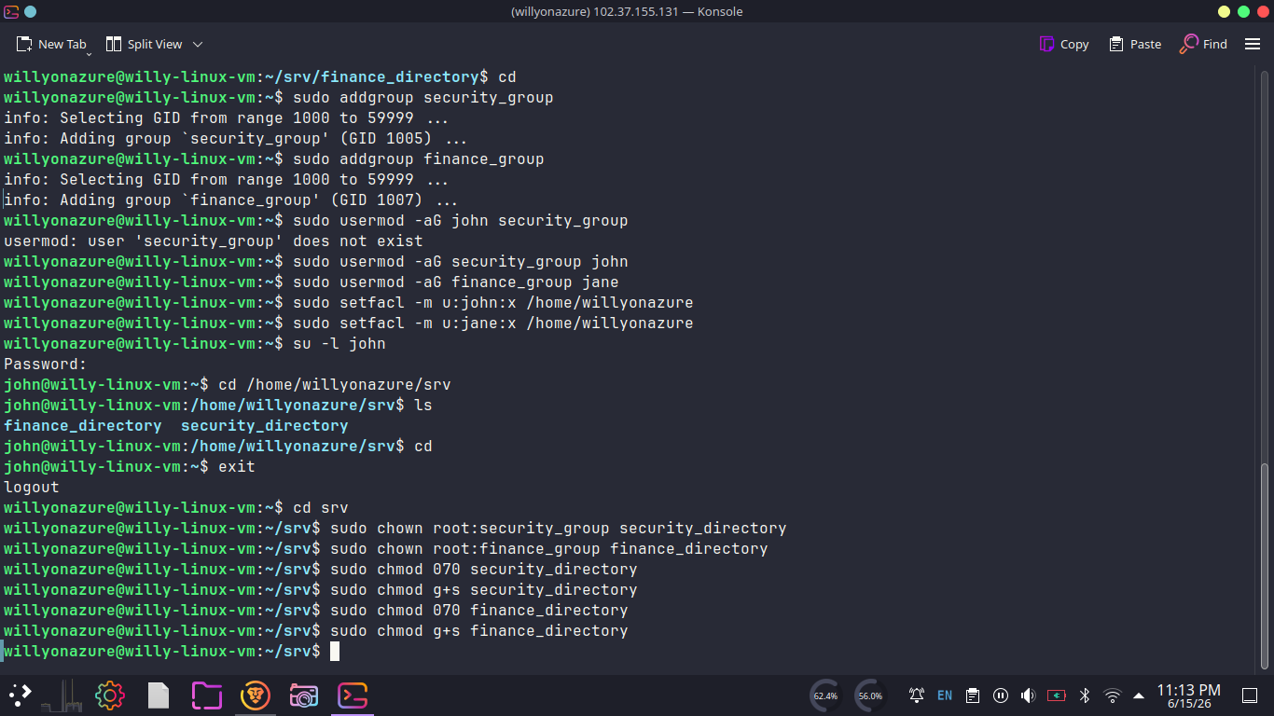
Source: CHOWN AND CHMOD OF DIR TO GROUPS.png

Figure 5. Verifying ACL and permission settings on the lab directories.
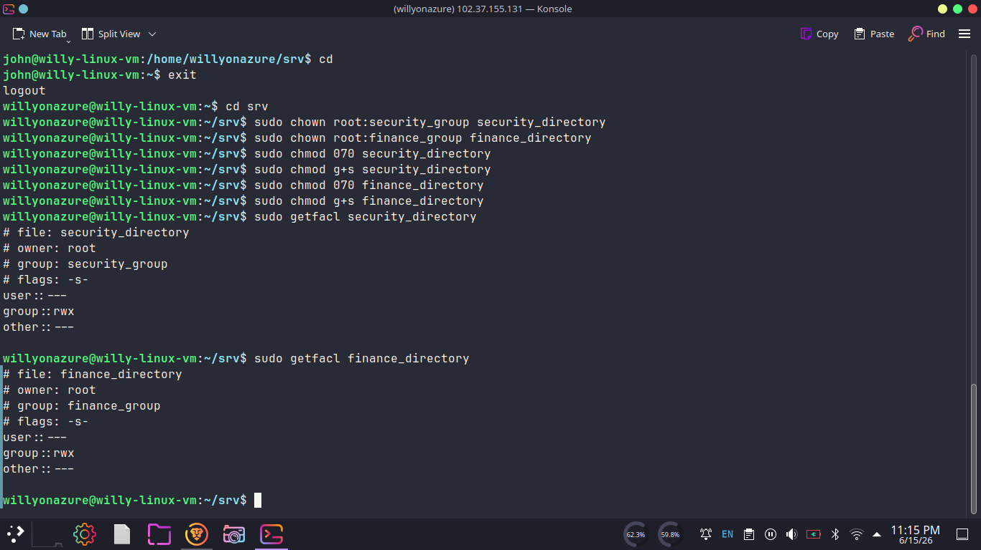
Source: GETFACL ON DIR.png

Figure 6. Additional ACL verification for `security_directory`.
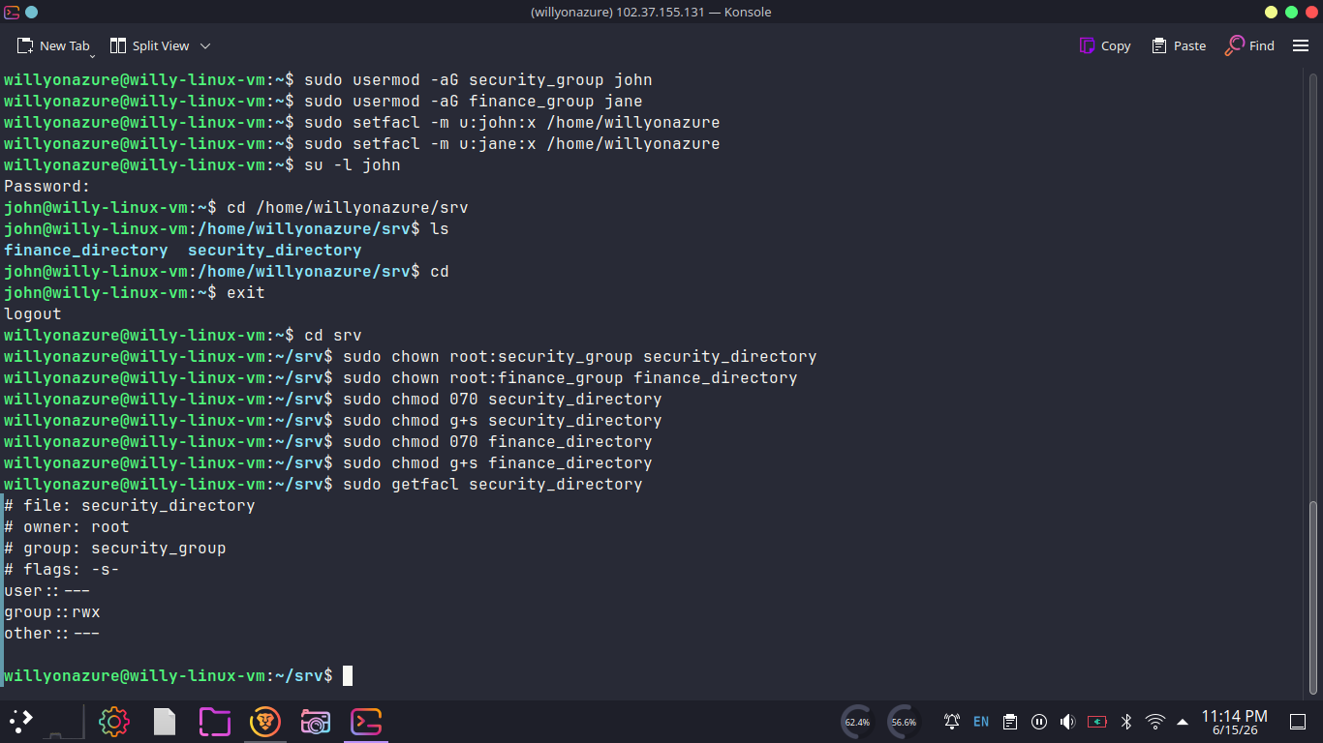
Source: GETFACL ON SECURITY_DIR.png

setgid Figure 7. Testing access as root, `john`, and `jane`.
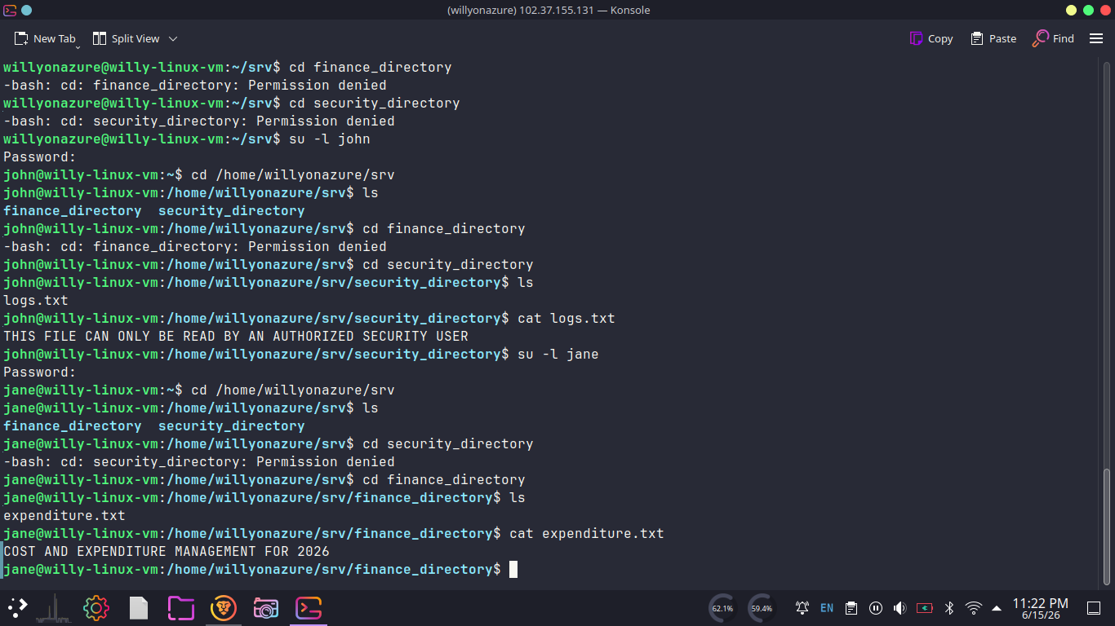
Source: TESTING PERMISSIONS FOR EVERY USER ON EVERY DIR.png

