

**ASSIGNMENT 1**

|  |  |
| --- | --- |
| Name: | Wilson Vidyut Doloy |
| Reg No: | 19BCE1603 |
| Subject: | CSE2003 Data Structures and Algorithms Lab |
| Slot: | L67+L68+L69 (Prof. Sandeep Kumar) |
| Date: | 18 July 2020 |

#include <stdio.h>  
  
int main()  
{  
 int ,sum,i,n;  
 printf("How many number: ");  
 scanf("%d", &n);

int x[n];  
 for(i=1;i<=n;i++)  
 {  
 printf("Give %dth number",i);  
 scanf("%d",&x[i]);  
 }  
 sum=0;  
 for(i=1;i<=n-1;i++)  
 sum=sum+x[i]*x[i+1];  
 printf("%d",sum);  
  
 return 0;  
}

Test Case 1:

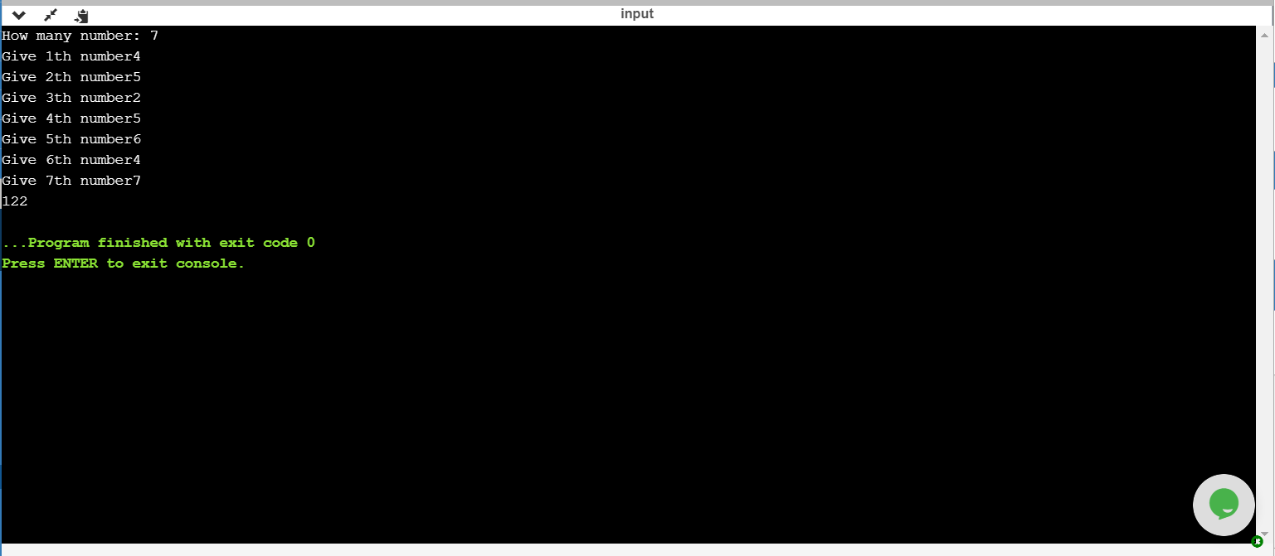

Test Case 2:

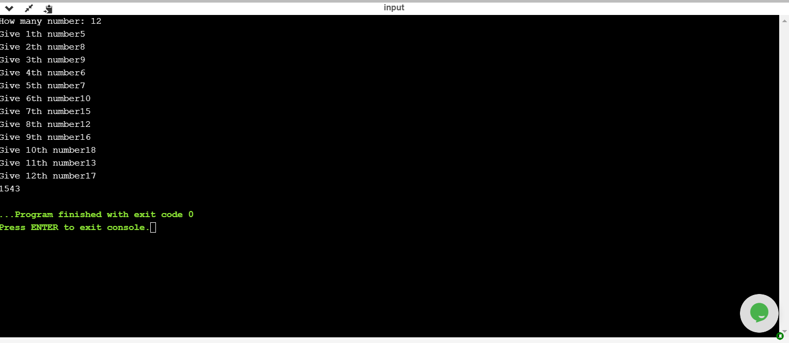

1.

#include <stdio.h>

int main()

{

int sum,i,n;

printf("How many number: ");

scanf("%d", &n);

int x[n];

for(i=1;i<=n;i++)

{

printf("Give %dth number: ",i);

scanf("%d",&x[i]);

}

sum=0;

for(i=1;i<=n-2;i++)

sum=sum+((x[i]+x[i+1])*x[i+2]);

printf("%d",sum);

return 0;

}

Test Case 1:

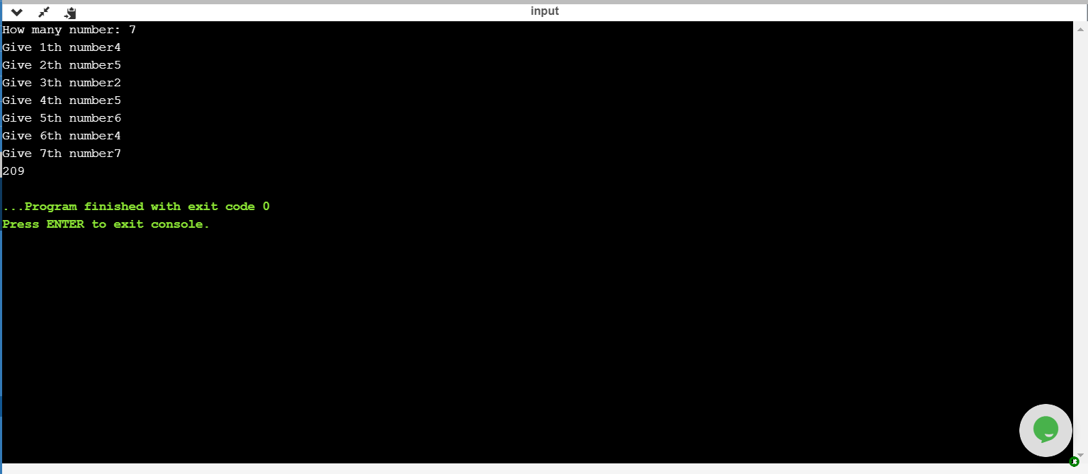

Test Case 2:

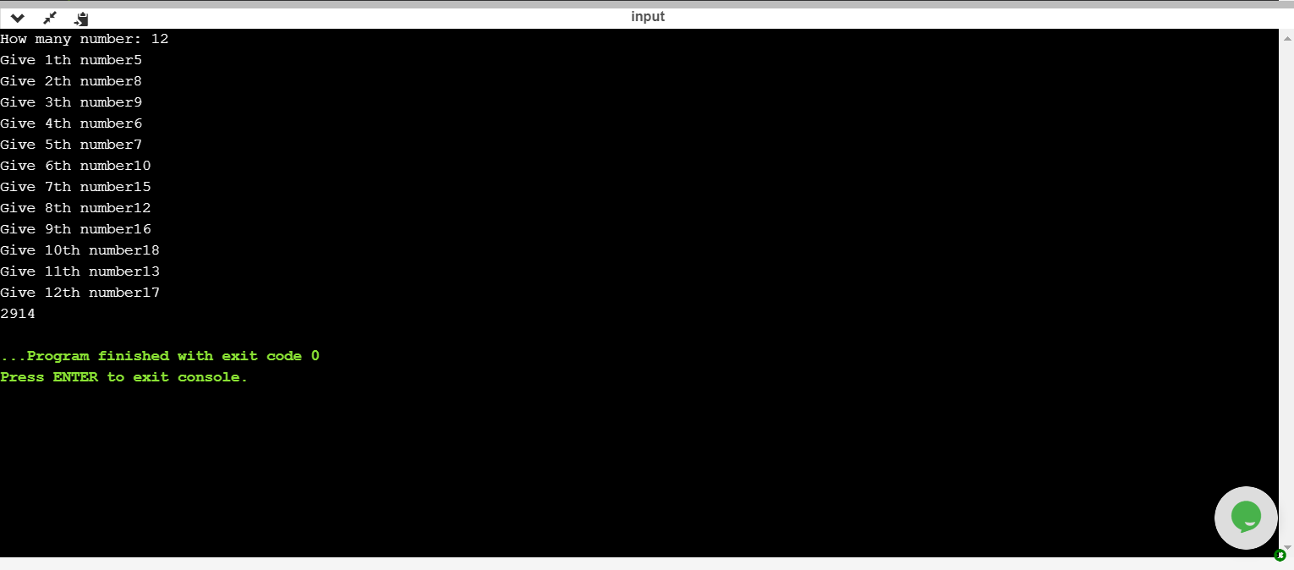

2.

#include <stdio.h>

int main()

{

int sum,i,n;

printf("How many number: ");

scanf("%d", &n);

int x[n];

for(i=1;i<=n;i++)

{

printf("Give %dth number: ",i);

scanf("%d",&x[i]);

}

sum=1;

for(i=1;i<=n-2;i++)

sum=sum*(x[i]+x[i+2]);

printf("%d",sum);

return 0;

}

Test Case 1:

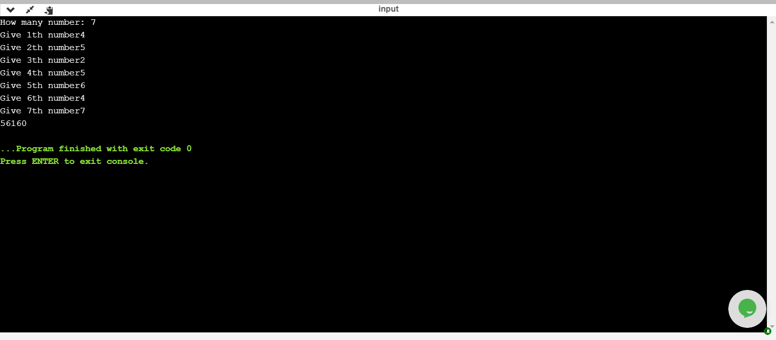

Test Case 2:

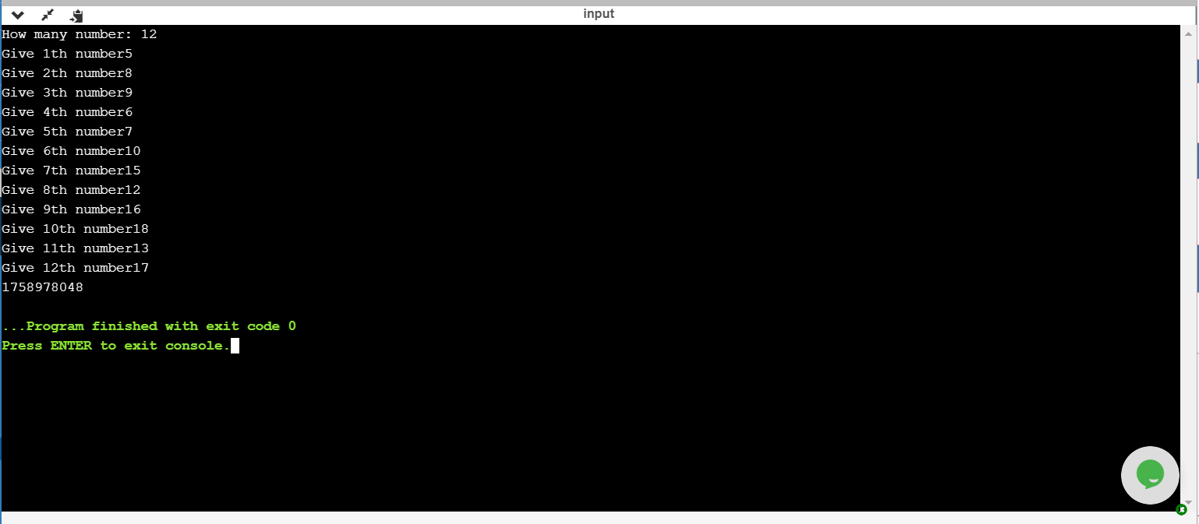

3.

#include <stdio.h>

int main()

{

int sum,i,n;

printf("How many number: ");

scanf("%d", &n);

int x[n];

for(i=1;i<=n;i++)

{

printf("Give %dth number: ",i);

scanf("%d",&x[i]);

}

sum=0;

for(i=1;i<=n-2;i++)

sum=sum+(x[i]-x[i+1])*(x[i+1]+x[i+2]);

printf("%d",sum);

return 0;

}

Test Case 1:

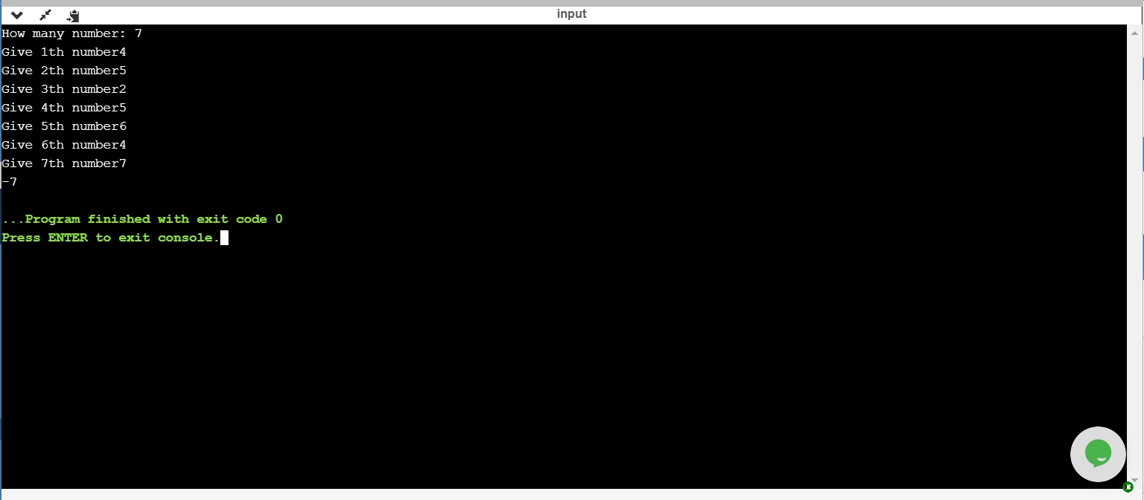

Test Case 2:

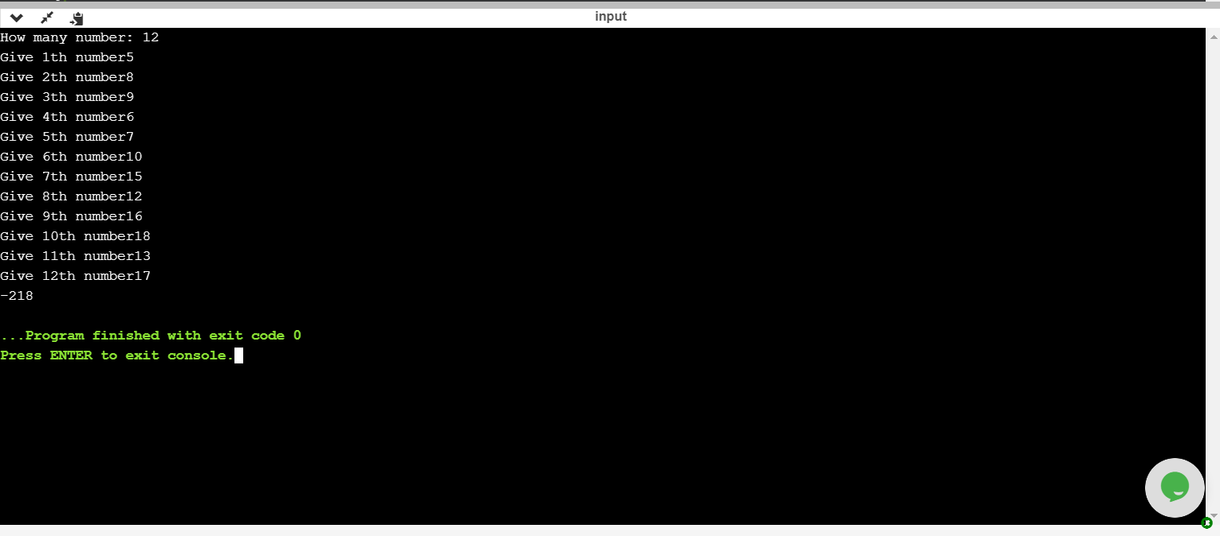

4.

#include <stdio.h>

int main()

{

int sum,i,n;

printf("How many number: ");

scanf("%d", &n);

int x[n];

for(i=1;i<=n;i++)

{

printf("Give %dth number: ",i);

scanf("%d",&x[i]);

}

for(i=1;i<=n-1;i++)

if(x[i+1]>x[i] && x[i+1]>x[i+2])

printf("%d ",x[i+1]);

printf("are the local maximums");

return 0;

}

Test Case 1:

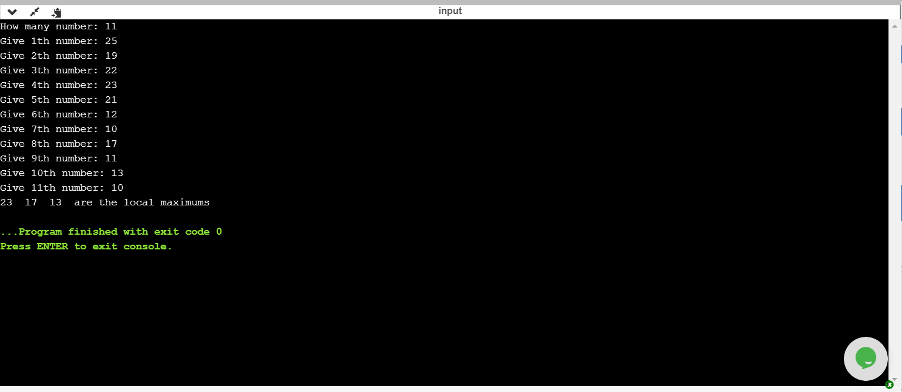

Test Case 2:

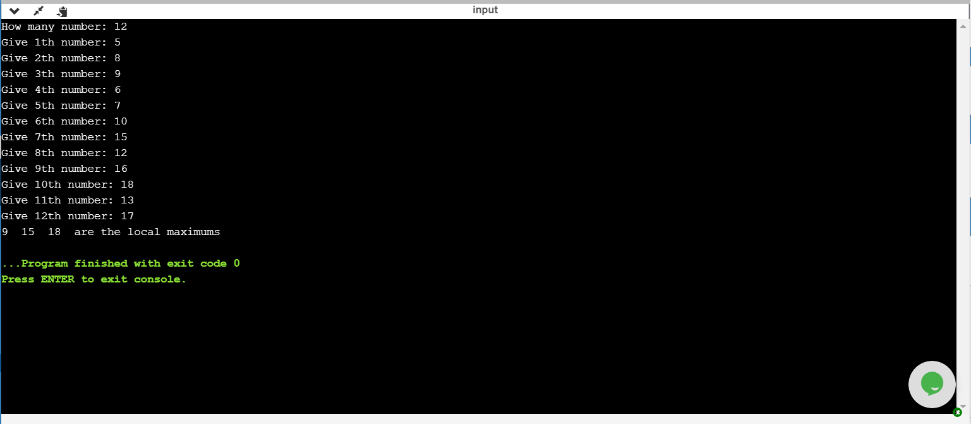

5.

#include <stdio.h>

int main()

{

int sum,i,n;

printf("How many number: ");

scanf("%d", &n);

int x[n];

for(i=1;i<=n;i++)

{

printf("Give %dth number: ",i);

scanf("%d",&x[i]);

}

for(i=1;i<=n;i++)

{

if(x[i]%2==0)

{

printf("%d ", i);

break;

}

else

continue;

}

return 0;

}

Test Case 1:

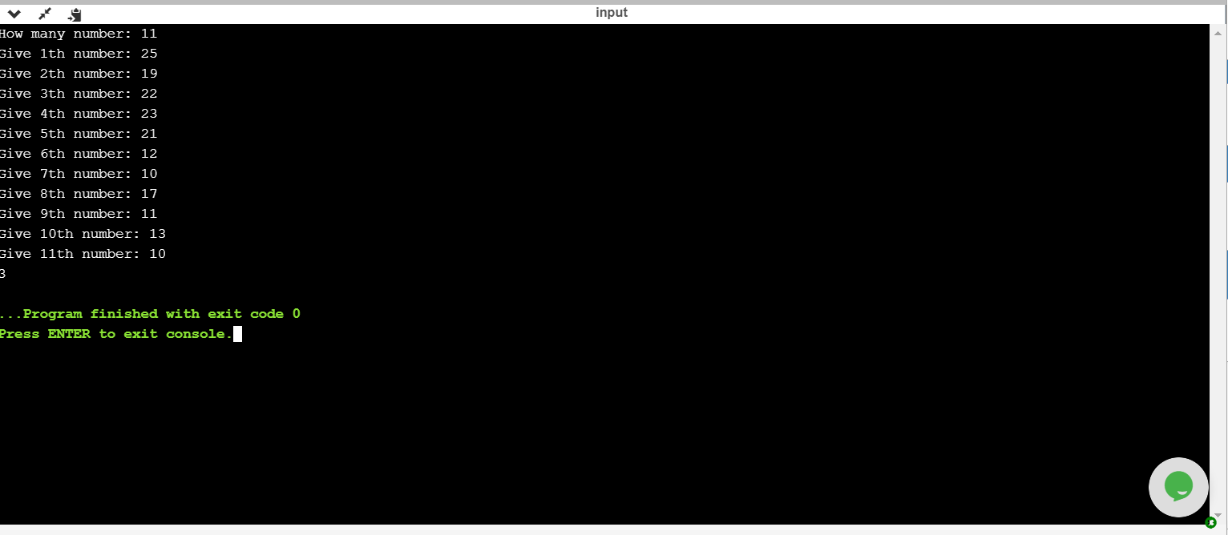

Test Case 2:

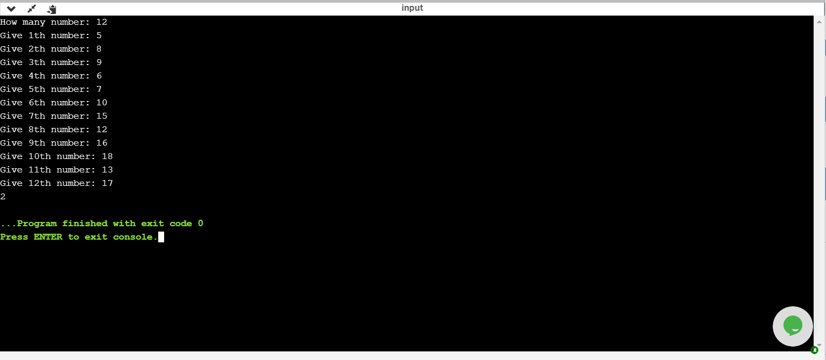

6.

#include <stdio.h>

int main()

{

int sum,i,n;

printf("How many number: ");

scanf("%d", &n);

int x[n];

for(i=1;i<=n;i++)

{

printf("Give %dth number: ",i);

scanf("%d",&x[i]);

}

for(i=1;i<=n-1;i++)

{

if(x[i]%2==0 && x[i+1]%2==0)

{

printf("%d ", i);

break;

}

else

continue;

}

return 0;

}

Test Case 1:

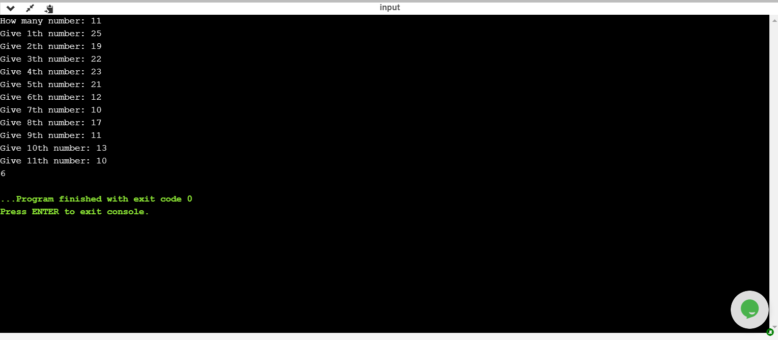

Test Case 2:

