ADSP HW2 R05943048 陳政文

(1) If the z-transform of *h*[*n*] is (20 scores)

(a) Determine the cepstrum of *h*[*n*].

(b) Convert the IIR filter into the minimum phase filter.

(a)(p.168)

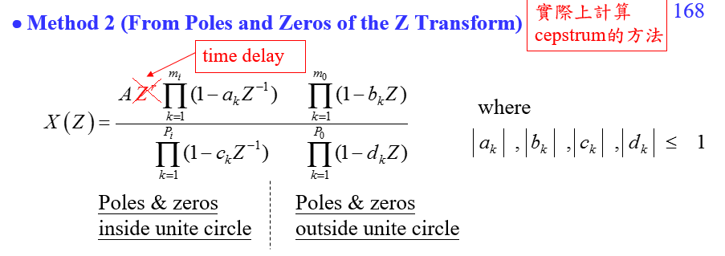

Hece we have A =4,

Time delay = z^(-1)

a1 = -0.5,

b1 = (1)/(-1+i),

b2 = (1)/(-1-i),

c1 = 0.5,

c2 =0.3

Because

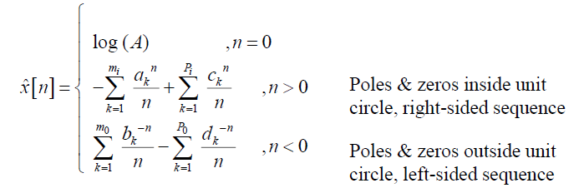

Hence,

(b)(P.119)

Because

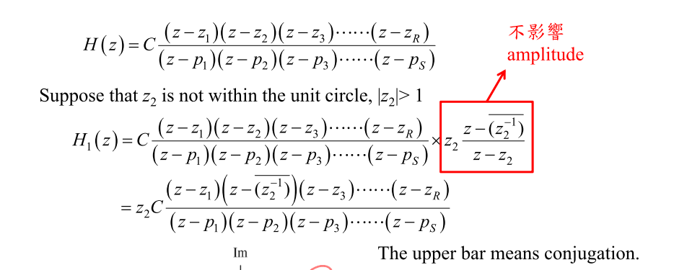

Hence,

(2) The following figures are the impulse responses of some filters. Which one is suitable for edge detection when (a) the SNR is high and (b) the SNR is low? Also illustrate the reasons. (10 scores)

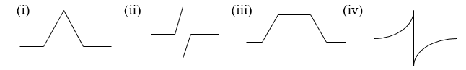

Because (p.141)

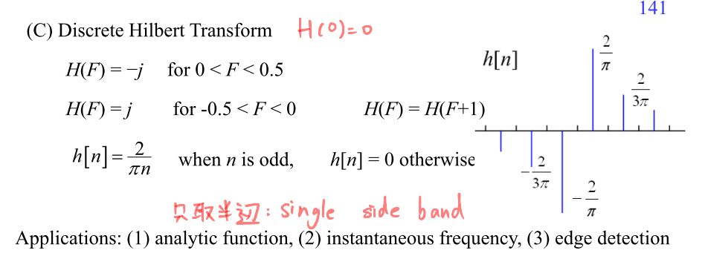

Hence, we choose (ii)&(iv) as edge detection filter.

(a) the SNR is high

Because SNR is high, the signal is clear and less noise, we can use (ii) as filter, which has **smaller range** and make the result clear.

(b) the SNR is low

Because SNR is low, the influence of noise is dominated, we can use (iv) as filter, which can calculate average of **larger range** and obtain more information.

(3)

(a) Why the cepstrum is more suitable for dealing with the multipath problem than the equalizer?

(b) Why the Mel-frequency cepstrum is more suitable for dealing with the acoustic signal than the original cepstrum? (15 scores)

(a) (p.177)

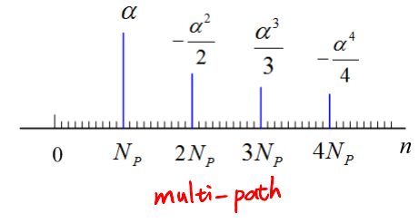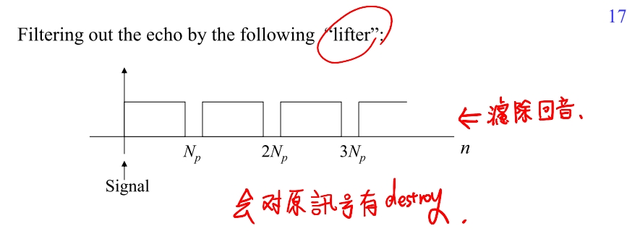

We can use cepstrum to fliter out the echo in multipath problem easily, but original equalizer will have problem of echo.

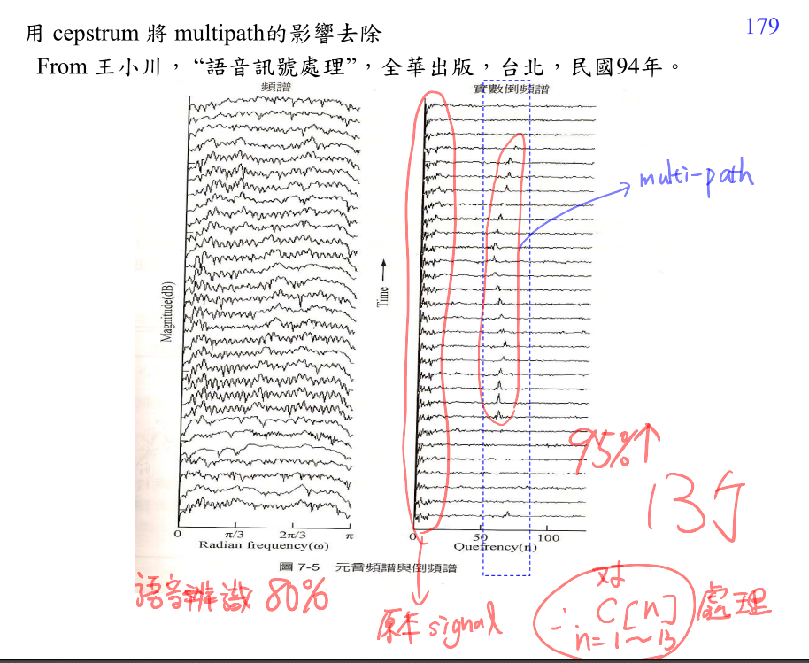

(b) (p.186)

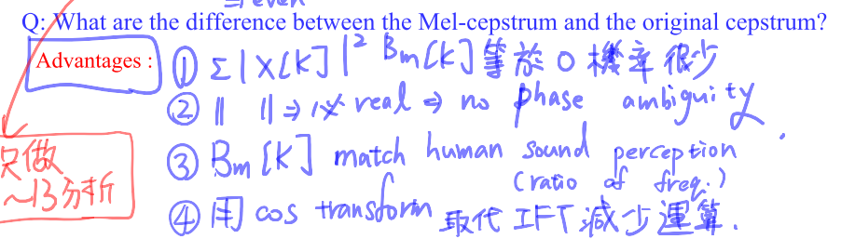

(4) What are the most important applications of (a) the matched filter and (b) the  
 Kalman filter in signal processing? (10 scores)

(a) the matched filter (p.145)

The matched filter is used for demodulation, similarity measurement, and pattern recognition

“Edge and corner detections” are special cases of pattern recognition.

(b) the Kalman filter (p.149)

Particle filter is used for system modeling or prediction.

When f( ) is a linear function and m[n] is a Gaussian noise, it becomes the Kalman filter.

(5) Suppose that the cepstrum of a signal x[n] is



Determine *x*[*n*]using the Z transform and exp( ). (10 scores)

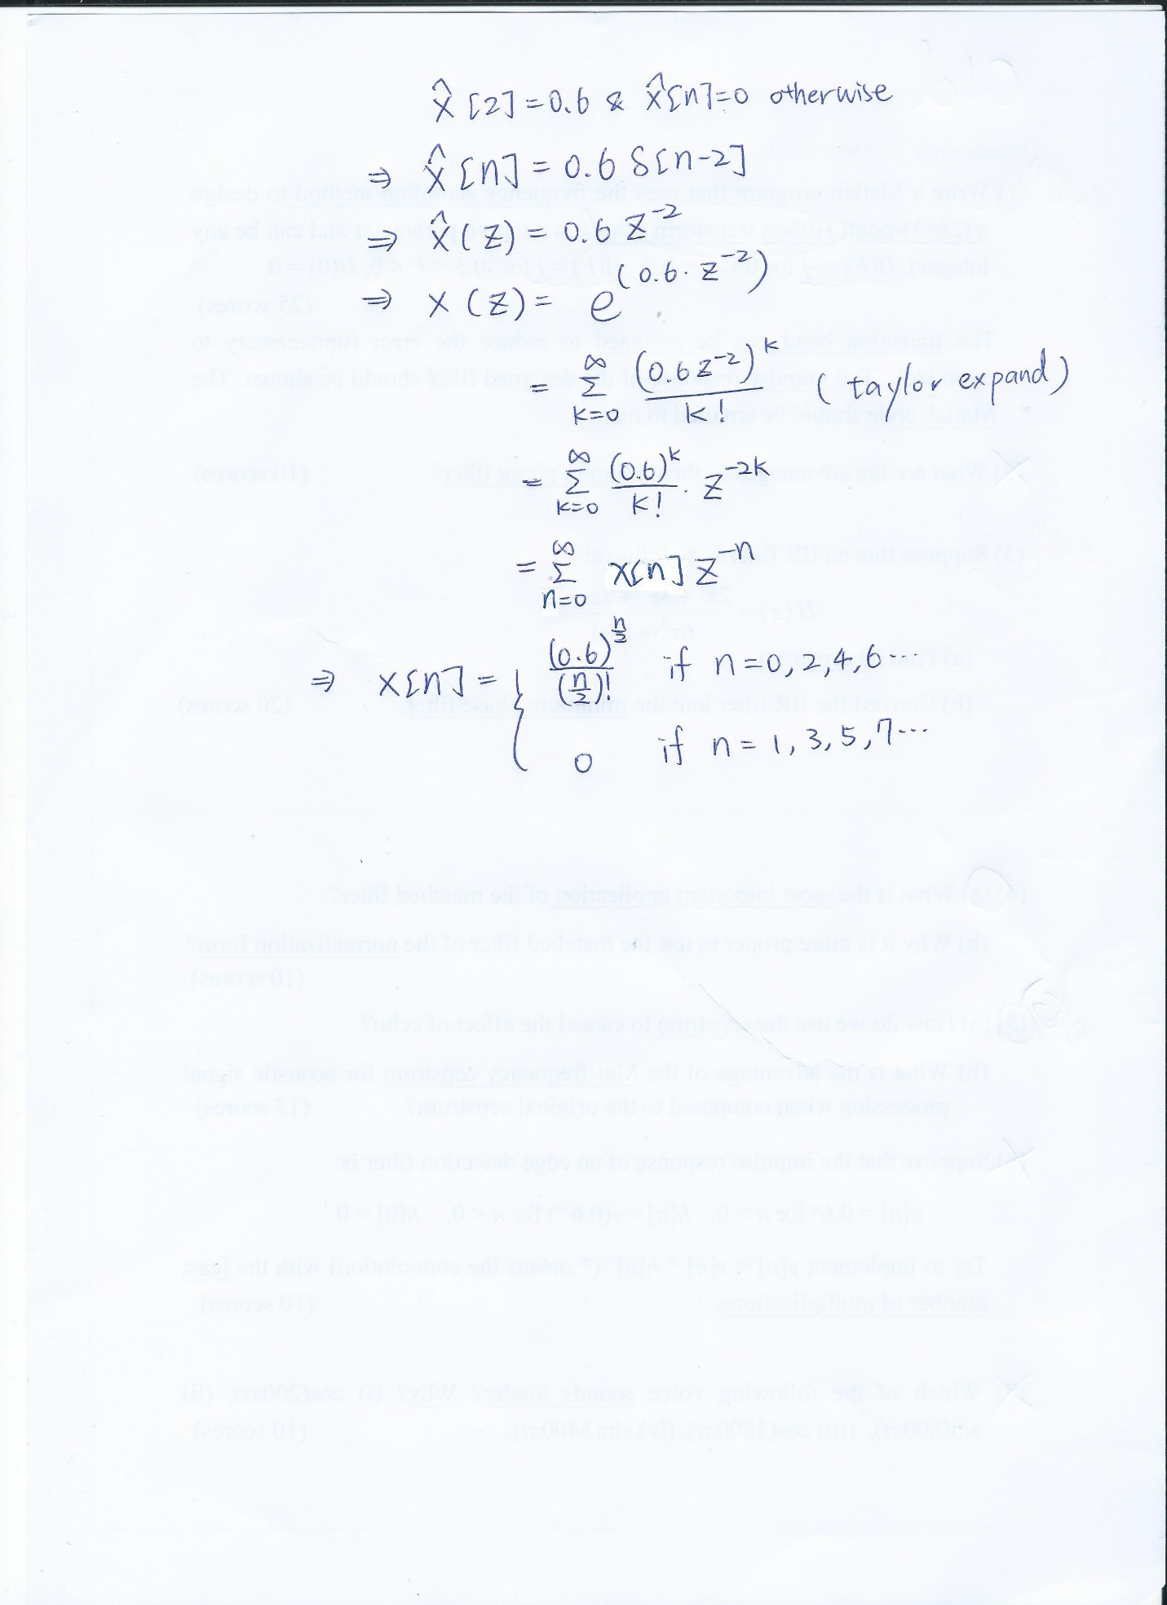

(6) What is the difference between the spectrums of a music signal and a speech signal? (10 scores) (p.212 & 224)

**the spectrums of a music signal**

The music signal will have phenomenon of chord, the spectrum will have f0 & 2 f0 & 3f0….Hz component.

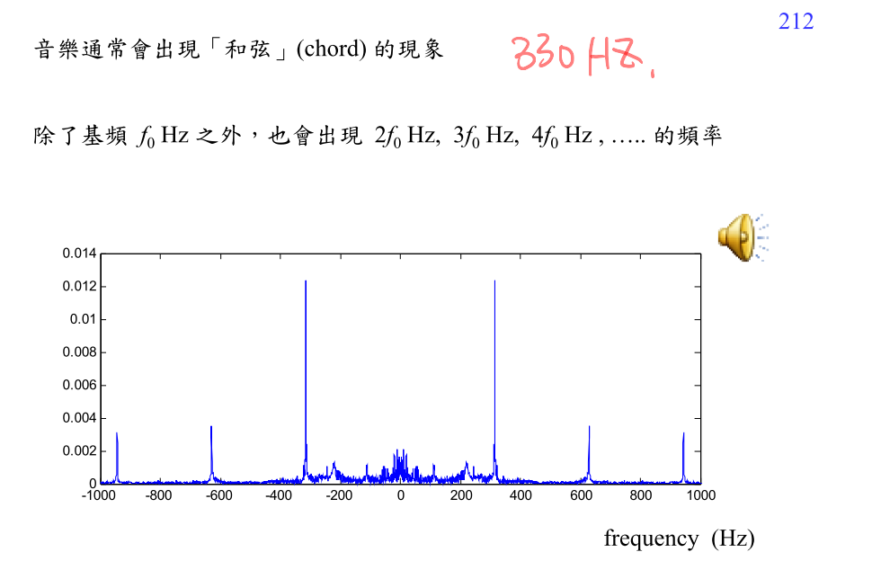

**the spectrums of a speech signal**

The speech signal will have several peaks, which can be indicators for recognition of different vowels.

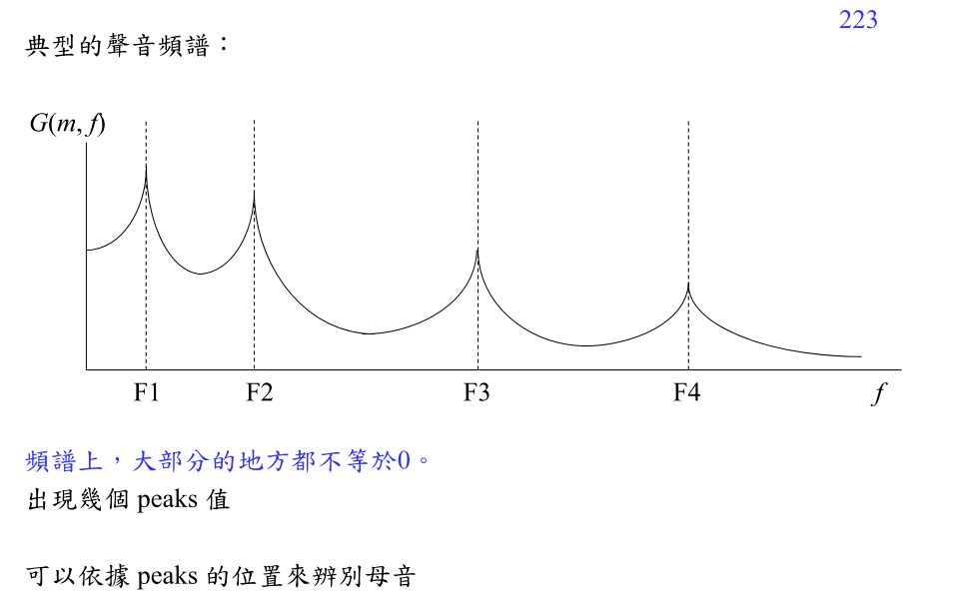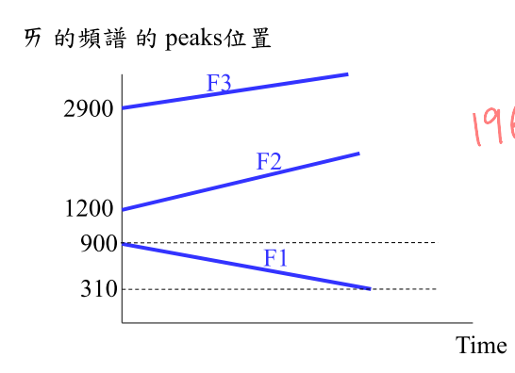

(7) (p.97)

**Write a Matlab program that uses the frequency sampling method to design   
a (2*k*+1)-point discrete differentiation filter *H*(*F*) = *j*2*πF* (*k* is an input parameter and can be any integer). (25 scores)**

*The transition band can be assigned to reduce the error (unnecessary to optimize).*

*The frequency response (DTFT of r[n], see pages 103 and 104) and the impulse response of the designed filter should be shown.*

*The Matlab code should be emailed to displab531@gmail.com*

K=10

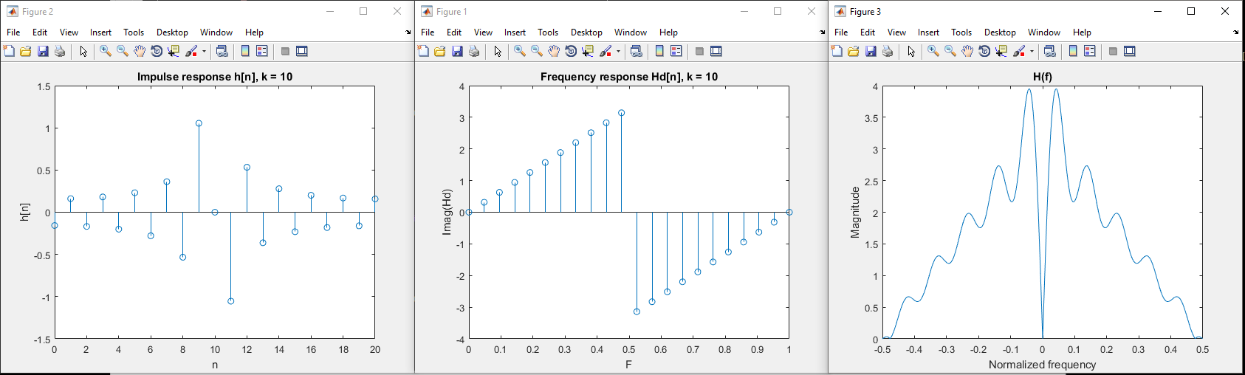

K=20

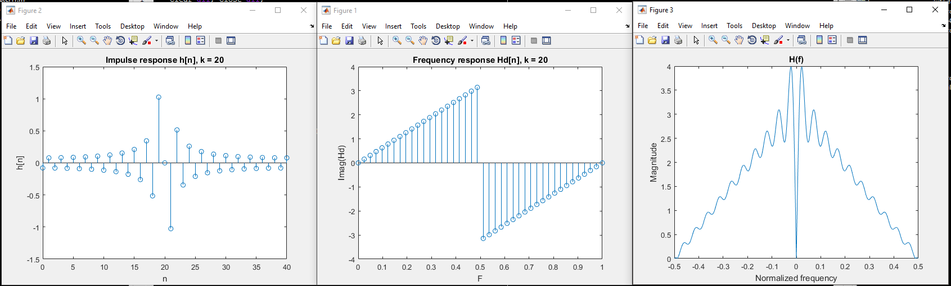

clear all; close all;

k=20;

Nfft = 1024;

N = 2*k+1;

F = zeros(1,N);

Hd = zeros(1,N);

h = zeros(1,N);

% F

F(1:k+1) = 0:0.5/(k+1-1):0.5;

F(k+2:end) = -0.5:-(-0.5-0)/(k):(-0.5-0)/(k);

% differentiation filter

Hd = 1i*2*pi*F;

%r[n]

r1 = ifft(Hd);

for m = 1:N

if m<k+1

h(m) = r1(m+k+1)

else

h(m) = r1(m-k)

end

end

H = fft(h,Nfft);

figure;

stem(0:(1-0)/(N+1-1):1,[imag(Hd) imag(Hd(1))]);

str = sprintf('Frequency response Hd[n], k = %d', k);

title(str);

xlabel('F');

ylabel('Imag(Hd)');

figure;

stem(0:N-1,h,'o');

str = sprintf('Impulse response h[n], k = %d', k);

title(str);

xlabel('n');

ylabel('h[n]');

figure;

plot(linspace(0,1-1/Nfft,Nfft)-0.5, abs(H));

title('H(f)');

xlabel('Normalized frequency');

ylabel('Magnitude');