ADSP hw2 林東農 r06921034

Matlab code

k=100;

N = 2\*k+1;

F = [0:1/N:1];

H = zeros(size(F));

H((0 < F) & (F < 0.5)) = -1j;

H((0.5 < F) & (F < 1)) = 1j;

h = ifft(H);

x = -1:2/N:1;

[a b] = size(h);

h2 = [h((b/2+1):b) h(1:b/2)];

%plot(x,h2,'r');

stem(x,h2);

%hold on;

%plot(x,h,'b');

figure;

plot(F,imag(H),'r');

hold on;

E = exp(-1j\*2\*pi\*(linspace(-b/2,b/2,b))'\*F);

size(E)

R = h2\*E;

plot(F,R,'b');

freqency response

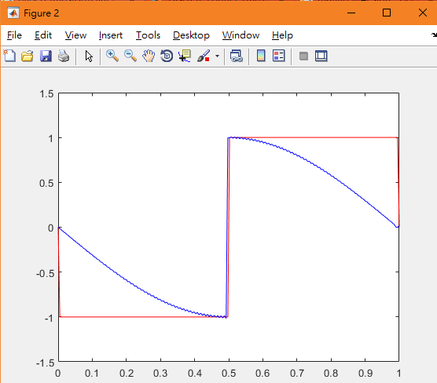

Impulse response

