TMHCC | Board Paper
Branding placeholder: Tokio Marine HCC / London Market professional lines

AI in PI, E&O and Media Liability
Board-ready final paper: UK-first exclusion-plus-write-back strategy for IT and technology, construction and built environment, and media, music, events, film and television
Date: 13 May 2026
Prepared for: TMHCC Board review
Document status: Board-ready working paper for legal, underwriting and product governance sign-off

Recommended decision
Approve a UK-first AI endorsement strategy that starts with IT and technology plus selected media/creative accounts, then extends to construction and built-environment professionals once the governance questionnaire, rating model and claims coding are operational.

Contents
1. Executive Summary 4
2. The Opportunity - Why Now 5
3. Target Sector Deep Dive: IT and Technology 6
3.1 Why AI creates PI/E&O exposure in IT and technology 6
3.2 Risk tier positioning for IT and technology 7
4. Target Sector Deep Dive: Construction and Built Environment 7
4.1 Why AI matters in design and project delivery 7
4.2 Risk tier positioning for construction and built environment 8
5. Target Sector Deep Dive: Media, Music, Events, Film and Television 8
5.1 Creative industry claim types 9
6. Market Size and Premium Opportunity 10
6.1 UK market base 11
6.2 UK scenarios 12
6.3 Global scenarios 12
7. What the Current Policies Actually Say 13
7.1 PMR Section 1 Media Liability 13
7.2 PI FTVA Content/Production Activities 14
8. The Product: Exclusion Plus Write-Back 14
8.1 Three risk tiers 15
8.2 Five core underwriting questions 15
8.3 Proposed AI exclusion and write-back wording for PMR Section 1 Media Liability 16
8.4 Proposed AI exclusion and write-back wording for PI FTVA Content/Production Activities 18
9. Implementation Plan 20
9.1 Pilot approach 20
9.2 AI governance form requirement 20
9.3 Renewal review triggers 21
10. Evidence Register 22
10.1 Veracity audit corrections applied 22
10.2 Source list retained from source paper 22
10.3 Additional sector sources used in this rebuild 25
10.4 Enhancements made in this rebuild 26

Important legal status
This is a wording, coverage and market analysis prepared from the supplied materials and public sources listed in the evidence register. It is not a signed legal opinion. Before binding risks or issuing endorsements, external coverage counsel should review the final endorsement wording, broker-facing disclosure and any Insurance Act 2015 contracting-out approach.

1. Executive Summary
AI is now being used at scale in IT and technology, construction and built environment, and media, music, events, film and television. These are not theoretical future exposures. They are already embedded in code generation, system design, CAD/BIM workflows, scripts, music, images, video, voice and audience communications. The current PI/E&O and media liability wordings reviewed for this paper are silent on AI. That silence creates real exposure now: broad cover may already respond to AI-assisted output claims, but the exposure is neither priced nor controlled.
The opportunity is to lead the market with a clear exclusion-plus-write-back product. This product converts silent AI exposure into priced, controlled cover for governed AI-assisted output. It gives brokers and insureds an answer they can sell: AI is not excluded outright, but it must be disclosed, governed, reviewed and recorded. The UK near-term incremental premium opportunity is modelled at GBP 3m-GBP 25m in a narrow-to-central launch, with GBP 100m as a wider medium-term upside. The global central case is USD 419m incremental annual premium, with a USD 1.16bn upside if adoption and broker demand accelerate.
The recommended action is to approve a UK-first endorsement strategy. Start with IT and technology accounts and selected media/creative accounts where AI-assisted output risk is visible, governable and commercially relevant. Bring construction and built-environment accounts into the pilot once the questionnaire and control framework can test design-verification and BIM-use controls properly. Require an AI governance questionnaire, an AI tool register, qualified human review, records of material outputs, and AI-specific claims coding before rollout.
Board question | Board-safe answer
What is the problem? | AI-assisted outputs are already within workflows, but the current wordings are silent. Silence creates unpriced defence cost, aggregation and coverage uncertainty.
What is the opportunity? | Sell affirmative, controlled write-back cover to accounts that can evidence AI governance. The first targets are IT and technology, construction and built environment, and media/creative accounts.
What must not be covered as standard? | Own AI model development, fine-tuning, scraping, unauthorised training data, autonomous professional advice, and unconsented digital replicas.
What should be approved now? | A UK-first pilot, broker feedback, underwriting questionnaire, claims coding and counsel-reviewed endorsement wording.

2. The Opportunity - Why Now
AI adoption has crossed the line from emerging risk to material underwriting issue. The strongest public UK evidence comes from DSIT: one in six UK businesses currently use AI, and adoption is materially higher in information and communication at 43%, business services and administration at 23%, and finance and real estate at 21% [S3]. Those sectors contain the highest concentration of professional services, content, data and technology workflows that can trigger PI/E&O and media liability claims.
The gap is simple. AI is being used faster than insurance wordings are being updated. IT developers use code assistants. Architects and engineers use design tools with AI features. Producers, agencies, musicians and event organisers use generative tools for content, marketing, voice, images, music and audience engagement. Current PI/E&O and media liability wordings were not drafted around AI-assisted work. That means AI claims may be covered now, but without pricing, controls or consistent claims data.
Broader professional-services evidence points the same way. A Thomson Reuters 2025 survey reported that about half of surveyed professional users across legal, tax, accounting, corporate risk/fraud and government use GenAI in some fashion [S5]. That is only a supporting indicator, not the target market. The commercial focus of this product remains IT and technology first, construction and built environment second, and media, music, events, film and television as the high-profile creative-sector opportunity.
This creates a rare underwriting moment. A blanket AI exclusion would reduce uncertainty but also remove cover that clients increasingly need. Doing nothing leaves silent exposure in the book. A priced write-back solves both problems. It protects the portfolio, creates broker-facing differentiation and turns a risk-control requirement into premium.
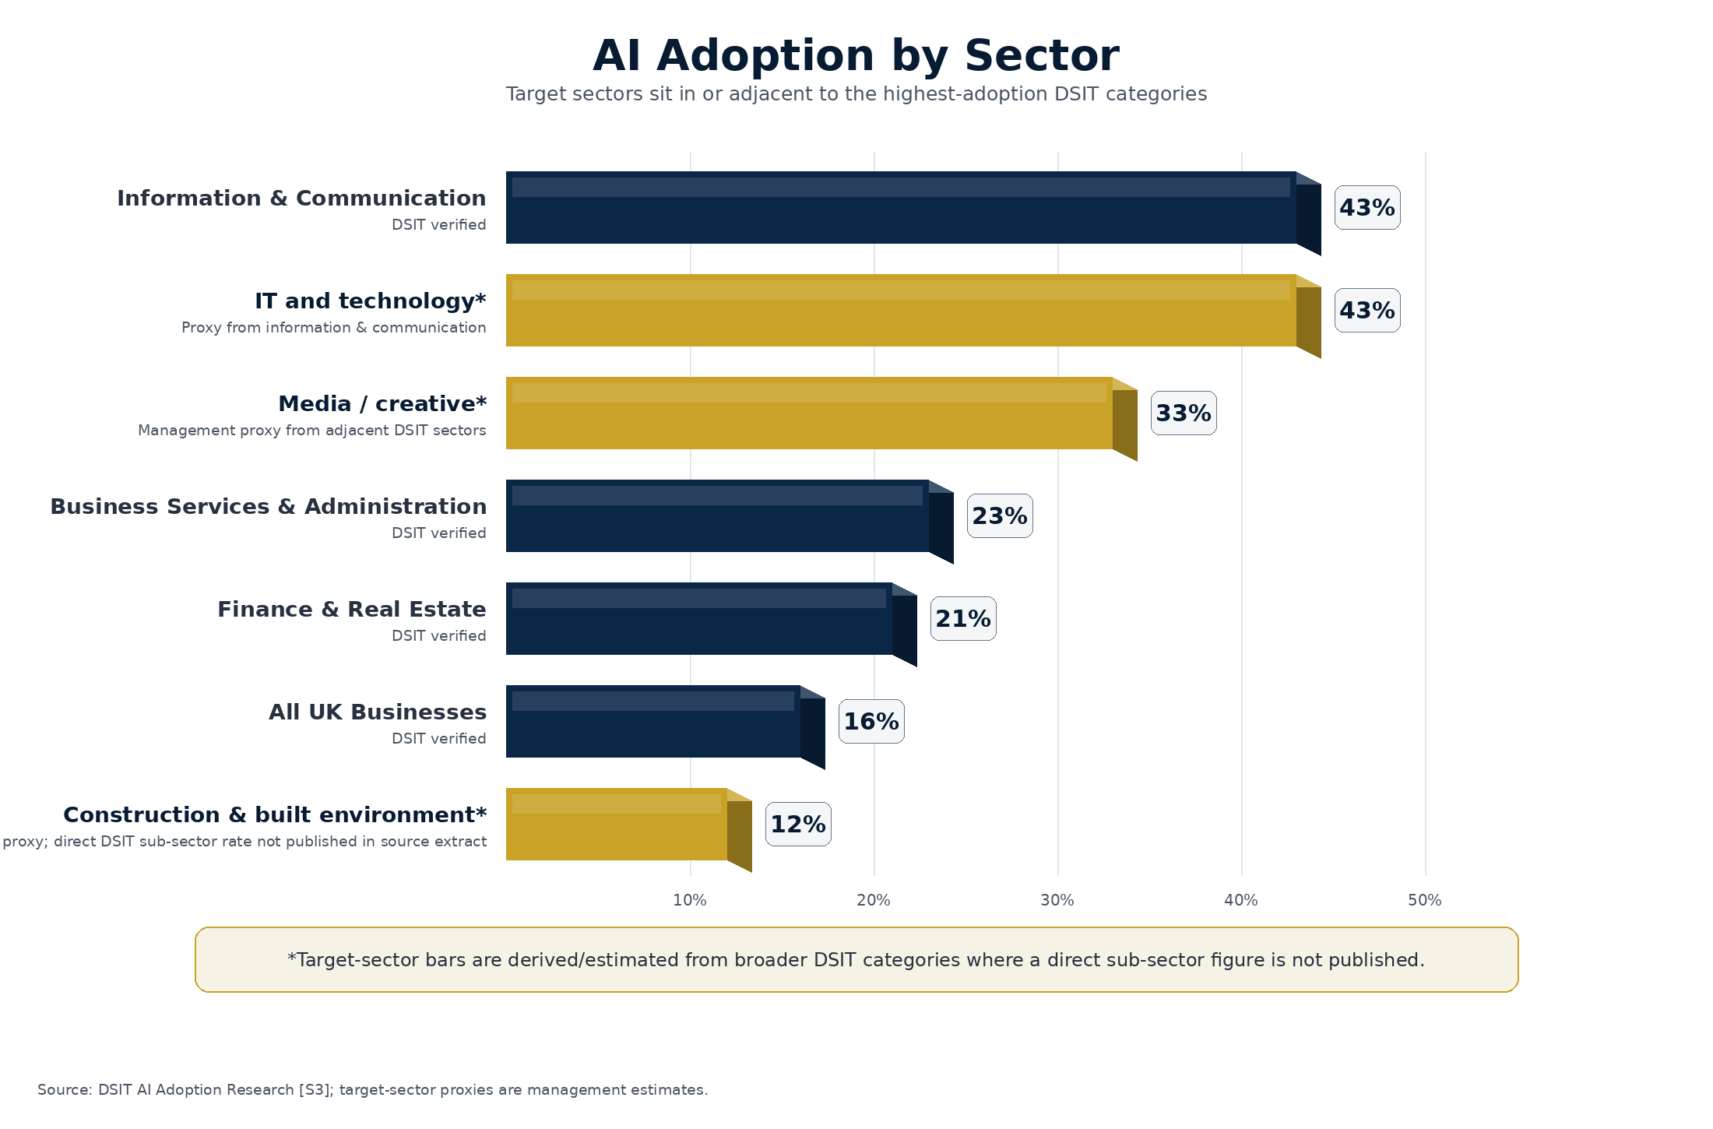
Chart 3 - AI Adoption by Sector
Source: DSIT AI Adoption Research [S3]; target-sector proxies are management estimates where no direct professional sub-sector rate is published.
Commercial headline
This product is not designed to insure AI as a technology in the abstract. It is designed to insure governed AI-assisted professional and media outputs in sectors where clients are already using AI to produce work for third parties.

3. Target Sector Deep Dive: IT and Technology
IT and technology is the highest-volume near-term opportunity. DSIT reports 43% AI adoption in the information and communication sector [S3]. That is the strongest official UK sector signal for the businesses most likely to be using Copilot, ChatGPT, Gemini, Claude and embedded AI features inside developer platforms. Gartner forecasts worldwide IT spending of USD 6.15tn in 2026, which underlines the scale of the technology services ecosystem [S24].
This sector includes managed service providers, SaaS providers, software houses, IT consultancies, DevOps teams, systems integrators, AI product developers using third-party models, cyber and cloud consultants, and platform implementation specialists. DSIT research into managed service providers identified 12,867 active MSPs in the UK as of March 2025 [S25]. This is a large, repeatable and broker-accessible professional-services base.

3.1 Why AI creates PI/E&O exposure in IT and technology
AI now sits inside the production chain for client deliverables. A developer may ask an AI tool to draft code, refactor a module, write unit tests, generate infrastructure scripts, document APIs or debug a production issue. A consultant may use AI to draft specifications, architecture options, migration plans, security policies or client-facing reports. These outputs can look authoritative even when they are wrong.
Many firms use AI tools before they have a governance framework. They may not maintain an approved-tool list, preserve prompts and outputs, prevent client data from entering public models, test AI-generated code, or disclose material AI use to clients. That creates the professional indemnity gap. The work is client-facing, but the policy does not say how AI-assisted work is treated.
Claim type | How it arises | Underwriting control
AI-generated code error | AI-generated code contains a critical flaw, insecure dependency or incorrect business logic that causes an outage or financial loss. | Require qualified code review, secure development controls, testing evidence and change-control records.
Software specification failure | AI-assisted specification misses a key integration requirement or misstates data flows, causing project delay and rework. | Require human sign-off by project owner and client approval of material specifications.
AI-assisted system malfunction | An AI-assisted implementation script or configuration recommendation breaks a client environment. | Require staging, rollback plans, peer review and no autonomous production deployment.
Data protection breach | Client personal or confidential data is pasted into a public AI tool and retained or reused. | Require approved enterprise tools, restricted-input rules, DPIA where needed and client data controls.
Confidentiality failure | AI output repeats client secrets, unreleased product details or proprietary code. | Require restricted-input controls, output review and records of material AI-assisted deliverables.

3.2 Risk tier positioning for IT and technology
Most ordinary IT professional-services accounts should sit in Tier 1 or Tier 2. Tier 1 applies where AI is used for drafting, debugging, summarisation or internal workflow with qualified human review and no own model training. Tier 2 applies where AI output is embedded in client deliverables, code, systems advice or high-volume support. Tier 3 should capture own AI model development, autonomous decisioning, dataset creation, fine-tuning or AI products sold as stand-alone systems.
Worked IT claim example
A software consultancy delivers an AI-assisted code module for a logistics client. The module contains a subtle concurrency error introduced by a code assistant. The client deploys it into a warehouse management system, causing a 36-hour outage and lost fulfilment revenue. The allegation is negligent professional services. The write-back should respond only if the consultancy used an approved tool, maintained a review/testing record, and the claim does not arise from prohibited autonomous deployment or own model development.

This sector represents the fastest near-term premium opportunity because the need is immediate and the exposure is easy to explain. Brokers already understand technology E&O and professional services. The product gives them a targeted AI answer without moving every account into a full AI developer or cyber product.

4. Target Sector Deep Dive: Construction and Built Environment
Construction and built-environment professionals are a primary target sector because the severity profile is different from ordinary professional-services output risk. A design or specification error can travel through an entire project lifecycle. The cost can appear months later as redesign, rework, delay, professional fees, loss of use, liquidated damages or third-party claims.
The target market includes architects, consulting engineers, structural engineers, civil engineers, project managers, quantity surveyors, cost consultants, building consultants, BIM specialists and design-and-build professional services. The IUA 2025 report identifies construction professional indemnity as a sub-category within London company-market professional lines, reporting GBP 0.037bn for that specific sub-category in 2024 [S1]. That figure is not the full UK construction PI market, but it is a useful London company-market anchor.

4.1 Why AI matters in design and project delivery
AI is now embedded in the tools built-environment professionals already use. Autodesk describes generative design as a way for practitioners to explore, optimise and make decisions on complex design problems [S26]. Bentley positions infrastructure AI around civil engineering, construction and generative design, with AI enhancements moving into existing engineering applications [S27]. This matters because insureds may be using AI functionality without treating it as a separate underwriting exposure.
The exposure is not limited to exotic AI tools. It can arise from AI-assisted structural calculations, specification drafting, clash detection, BIM model outputs, cost plans, planning submissions, building regulation narratives, design-option generation and automated drawing annotations. The professional duty remains with the insured even when AI contributes to the output.
Claim type | How it arises | Severity driver
Structural calculation error | AI-assisted load calculation or design check is wrong and not properly reviewed. | Remediation, delay and downstream contract claims can multiply quickly.
Specification inaccuracy | AI-generated specification includes unsuitable materials, outdated standards or missing performance requirements. | Error becomes embedded in procurement, site work and variation disputes.
BIM model reliance | BIM output or clash-detection recommendation is used without adequate professional review. | Multiple parties may rely on the same model, creating aggregation risk.
Planning or compliance submission error | AI-assisted planning statement or building regulation submission contains false or incomplete information. | Regulatory delay, redesign and professional negligence allegations.

4.2 Risk tier positioning for construction and built environment
Construction and built-environment accounts should usually be Tier 2 by default where AI touches design, specification, BIM, cost, programme or compliance deliverables. Tier 1 is appropriate only for low-risk internal use such as summarising notes, drafting non-technical correspondence or formatting reports. Tier 3 should apply to autonomous design generation, unreviewed structural calculations, AI tools trained on unauthorised client/project data, or tools marketed as safety-critical design decision systems.
Worked construction claim example
A consulting engineer uses an AI-assisted tool to produce a structural load assumption for a mixed-use development. The error is not identified during human review and is incorporated into drawings issued for construction. The issue is discovered on site, requiring redesign, steelwork changes, programme delay and claims from the contractor and developer. The write-back should be available only where the insured can show approved tool use, qualified engineering review, design-check records and no prohibited autonomous reliance.

Construction is not the fastest first-month premium opportunity, but it is strategically important. The severity profile justifies early product design now, because once AI is normalised in design platforms, silent cover becomes harder to defend and harder to price retrospectively.

5. Target Sector Deep Dive: Media, Music, Events, Film and Television
Media, music, events, film and television are the highest-profile creative-sector opportunity. AI is already used for script development, storyboarding, voice and likeness, image generation, video production, VFX, SFX, subtitling, dubbing, audience analytics, promotional content, event branding, logistics and risk assessment. These are precisely the workflows where PMR and PI FTVA wordings can already respond to output claims.
The product differentiation is clear. Existing media liability and content E&O wordings are broadly drafted around defamation, privacy, publicity, copyright, trade mark, plagiarism, confidentiality, negligent statements and other civil liability. If AI-assisted content triggers one of those allegations, the current silence creates a large real exposure now. The endorsement turns that silent exposure into governed cover.

5.1 Creative industry claim types
Sub-sector | AI use | Likely claim
Film and television | Script analysis, location scouting, budgeting, VFX/SFX, voice cloning, colour grading, audio mixing, subtitling. | Unconsented likeness, defamation, copyright infringement, confidentiality breach, credit/attribution disputes.
Music | Composition tools, mixing/mastering, synthetic vocals, promotional images, AI-generated songs in the style of a named artist. | Copyright infringement, passing off, publicity rights, performer consent disputes, misleading attribution.
Events | Promotional copy, personalised audience communications, event branding, AI-assisted logistics and risk assessment. | False advertising, IP infringement, privacy breach, negligent event communications.
Advertising / agencies | AI-generated images, copy, slogans, social campaigns, audience targeting and pitch materials. | Third-party IP claims, defamatory output, confidentiality breach, misleading statements.

Personality rights and digital replicas are the highest-severity creative risk. UK government materials recognise that AI makes it easier to create digital replicas of a person's voice or face, and that unpermitted replication can cause harm [S9]. SAG-AFTRA materials show the same issue in film and television through negotiated protections for digital replicas [S28]. The endorsement should therefore treat voice, likeness, performance, persona and synthetic people as a key differentiator and a core consent-control requirement.
Music deserves its own underwriting lens. PRS for Music reported that nearly 30% of surveyed members were already using AI in the creative process in 2023, with 55% planning to use it in the future [S30]. CISAC/PMP Strategy projects significant growth in generative AI music and audiovisual outputs and identifies creator revenue at risk in music and audiovisual [S29]. Those are not insurance premium statistics, but they show why music rights claims are commercially credible.
Worked film/TV claim example
A production company uses an AI-generated VFX sequence that recreates the likeness and voice of a performer who did not consent to that use. The performer alleges breach of publicity rights, misuse of likeness, breach of contract and reputational harm. The write-back should respond only if the producer obtained the required rights clearances and consents and retained an AI output record.

Worked music claim example
A music agency delivers an AI-assisted track for an advert. The track is alleged to reproduce protected elements of a well-known composition and to imitate the style of a named artist in a misleading way. The claim alleges copyright infringement, passing off and reputational harm. The write-back should be available only if the agency used an approved tool, maintained clearance records, and did not use unlicensed training or source material.

Risk tiering should be practical. Tier 1 is AI-assisted drafting or ideation with human clearance. Tier 2 is client-facing AI content, AI-generated images or music, and high-volume publication. Tier 3 is synthetic voice or likeness without consent, own model training on creative works, dataset creation, or AI production tools sold as a stand-alone service.
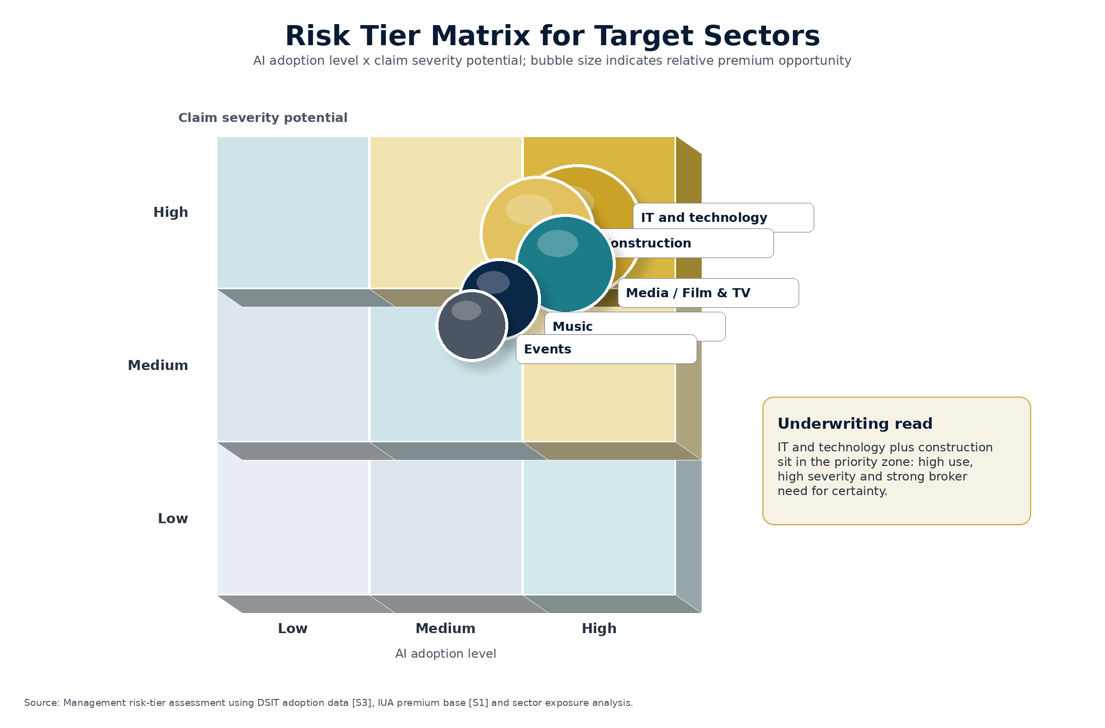
Chart 4 - Risk Tier Matrix for Target Sectors
Source: Management risk-tier assessment using DSIT adoption data [S3], IUA premium base [S1] and sector exposure analysis.

6. Market Size and Premium Opportunity
The most important correction to the previous board narrative is to separate three concepts: total premium base, AI-exposed premium and incremental write-back premium. Total premium is the existing market. AI-exposed premium is the part of that market where AI creates coverage uncertainty. Incremental write-back premium is the additional annual premium that could be charged for affirmative governed AI-assisted output cover.
The GBP 4bn opportunity headline should not be presented as near-term PI/E&O write-back premium. It is only supportable as a broad, multi-line, global exposed-premium or long-term product scenario. The board-safe central case is much stronger because it is narrower, sourced and actionable.

6.1 UK market base
Market base | Figure | Status | Use in model
IUA London company-market professional lines 2024 | GBP 4.594bn | Reported [S1] | Upper anchor for London company-market professional lines.
IUA London company-market PI/E&O 2024 | GBP 2.222bn | Reported [S1] | Line-of-business anchor for PI/E&O.
IUA UK/Ireland professional lines 2024 | GBP 3.046bn | Reported [S1] | Geographic anchor for UK/Ireland professional lines.
Inferred UK/Ireland PI/E&O | GBP 1.47bn | Management inference | UK/Ireland professional lines multiplied by PI/E&O share of professional lines; not a published statistic.
AI-exposed share | 20%-45% | Management estimate | Varies by sector mix and AI governance maturity.
Incremental write-back uplift | 5%-10% | Management estimate | Applied only to policies buying affirmative governed AI-assisted output cover.

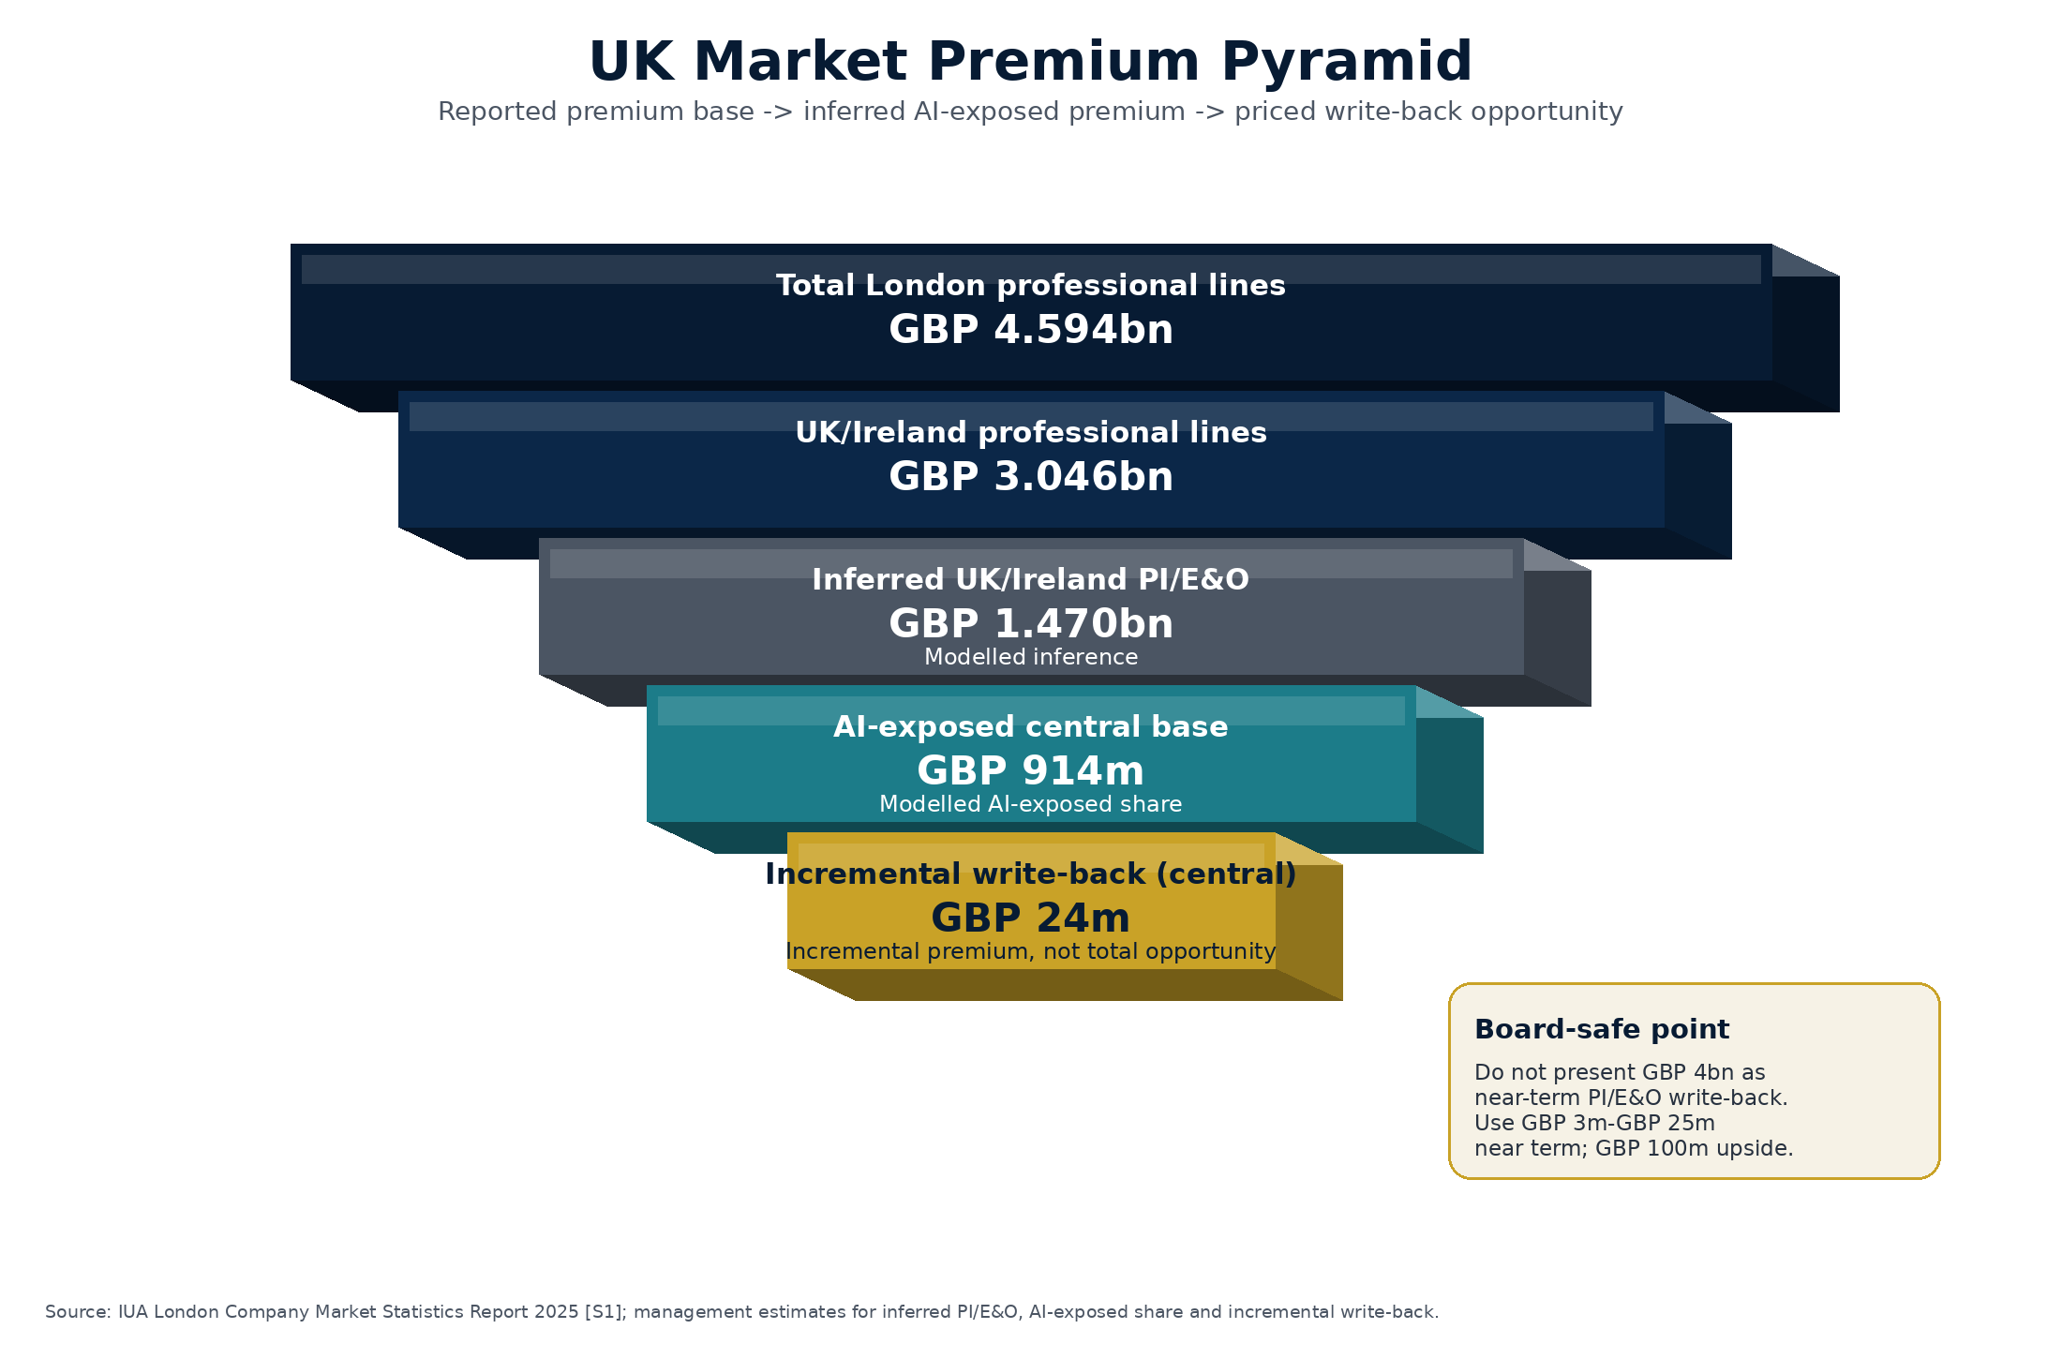
Chart 1 - UK Market Premium Pyramid
Source: IUA London Company Market Statistics Report 2025 [S1]; management estimates for inferred PI/E&O, AI-exposed share and incremental write-back.

6.2 UK scenarios
Scenario | Total premium base | AI-exposed premium | Incremental annual premium | Board use
Conservative narrow PI/E&O | GBP 1.47bn inferred UK/Ireland PI/E&O | GBP 294m | GBP 2.9m | Earliest-stage pilot.
Central UK/Ireland professional-lines approach | GBP 3.046bn reported UK/Ireland professional lines | GBP 914m | GBP 24.0m | Board planning case for selective rollout.
Upside broader London specialty/media/tech view | GBP 4.5bn management-estimate base | GBP 2.025bn | GBP 101.3m | Medium-term upside; requires broader portfolios and broker adoption.

6.3 Global scenarios
Allied Market Research values the global professional liability insurance market at USD 45.6bn in 2023 and projects USD 81.2bn by 2032 [S14]. That supports a global base in the low-to-mid USD 40bn range, but it does not mean the whole market is available as AI write-back premium. The current purchasable premium opportunity is the incremental uplift on the AI-exposed portion of the base.
Scenario | Total premium base | Coverage-uncertainty base | Incremental annual premium | Status
Conservative | USD 43.0bn | USD 8.6bn | USD 86m | Modelled early uptake.
Central | USD 45.6bn | USD 16.0bn | USD 419m | Most credible board planning case.
Upside PI/E&O | USD 46.5bn | USD 23.3bn | USD 1.16bn | Requires strong broker and client adoption.

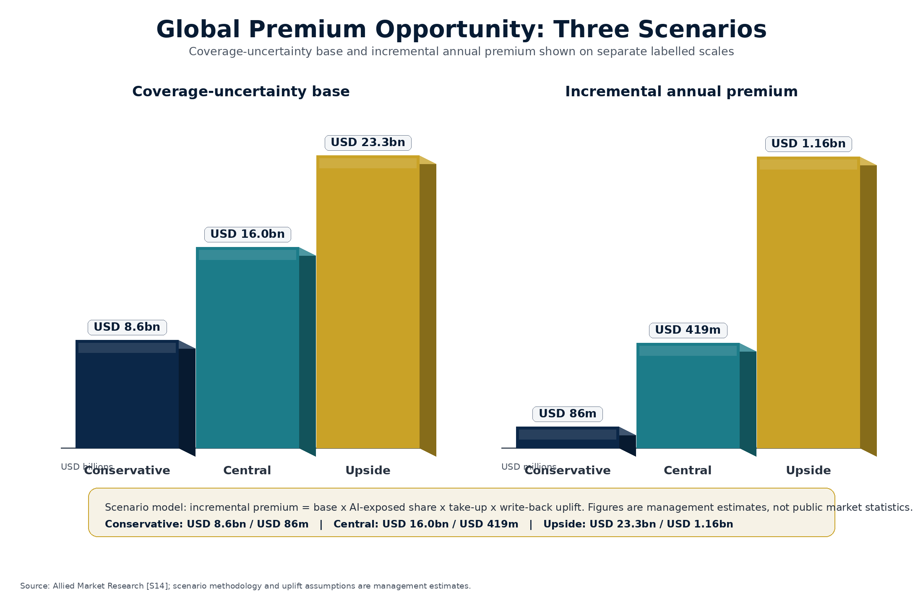
Chart 2 - Global Premium Opportunity: Three Scenarios
Source: Allied Market Research [S14]; scenario methodology and uplift assumptions are management estimates.
Board-safe treatment of the USD 28bn coverage-gap claim
Reframe it as an upside exposed-premium scenario, not as current purchasable premium. Exposed premium is not the same as incremental premium. The central global incremental write-back case is USD 419m.

7. What the Current Policies Actually Say
The current policy issue is not that AI is excluded. It is the opposite. The uploaded PMR and PI FTVA wordings appear to contain broad IP, privacy, defamation, confidentiality, negligent statement and civil liability hooks without AI-specific language. That creates silent cover for output claims where AI has been used as a production method.

7.1 PMR Section 1 Media Liability
PMR Section 1 indemnifies Claims arising from Media business services or associated Advertising activities. The key AI-relevant cover hooks are defamation/disparagement, privacy/confidentiality/publicity, unintentional IP infringement, professional duty/negligence and broad residual civil liability. AI-generated copy, adverts, scripts, images, articles or campaign materials can fall within those hooks if the allegation is about the output rather than the AI tool itself [W1].

7.2 PI FTVA Content/Production Activities
PI FTVA is a content/production E&O wording. It covers Claims arising from Content forming part of Production activities, including research, development, preparation, production, release, broadcast, advertising and distribution. The key AI-relevant hooks are defamation, privacy/publicity/confidentiality, IP infringement, misuse of restricted information, failure to give credit, breach of licence and negligent statements in Content [W2].
Output claim | Why it matters now | Current policy relevance
Defamation / disparagement | AI-generated words, scripts, marketing copy or factual content can be false or damaging. | PMR and PI FTVA both contain defamation-style cover hooks.
Copyright / trade mark / plagiarism | AI-generated images, music, copy, plots, slogans or artwork may reproduce protected elements. | Both wordings have broad IP/content clauses, subject to exclusions.
Privacy / publicity / likeness | Synthetic voices, faces, performances and personas can trigger consent and publicity claims. | The creative-sector severity sits inside existing privacy/publicity-style wording hooks.
Confidentiality / restricted data | Client data, unreleased content or private information can enter AI tools and resurface in outputs. | Existing confidentiality and restricted-information clauses may respond.
Negligent content / professional output | AI-assisted advice, code, technical reports or production content may be wrong. | The negligence hooks are broad enough to create silent exposure.

Plain-English coverage conclusion
The existing wordings are broadly drafted enough to respond to many AI-assisted output claims. That is commercially useful, but unsafe if left silent. The product should not remove core cover; it should price and control it.

8. The Product: Exclusion Plus Write-Back
The product architecture is deliberately simple. The base endorsement excludes AI risk where it has not been underwritten. The write-back then restores cover for governed AI-assisted output where the insured can demonstrate approved tools, qualified human review, records, data controls, rights clearance and disclosure where required.
This is better than a blanket AI exclusion. A blanket exclusion removes value and invites broker resistance. It also ignores the reality that AI is now a production method in target sectors. The write-back gives the market a positive answer while protecting TMHCC from own-model, training-data and prohibited-use risk.
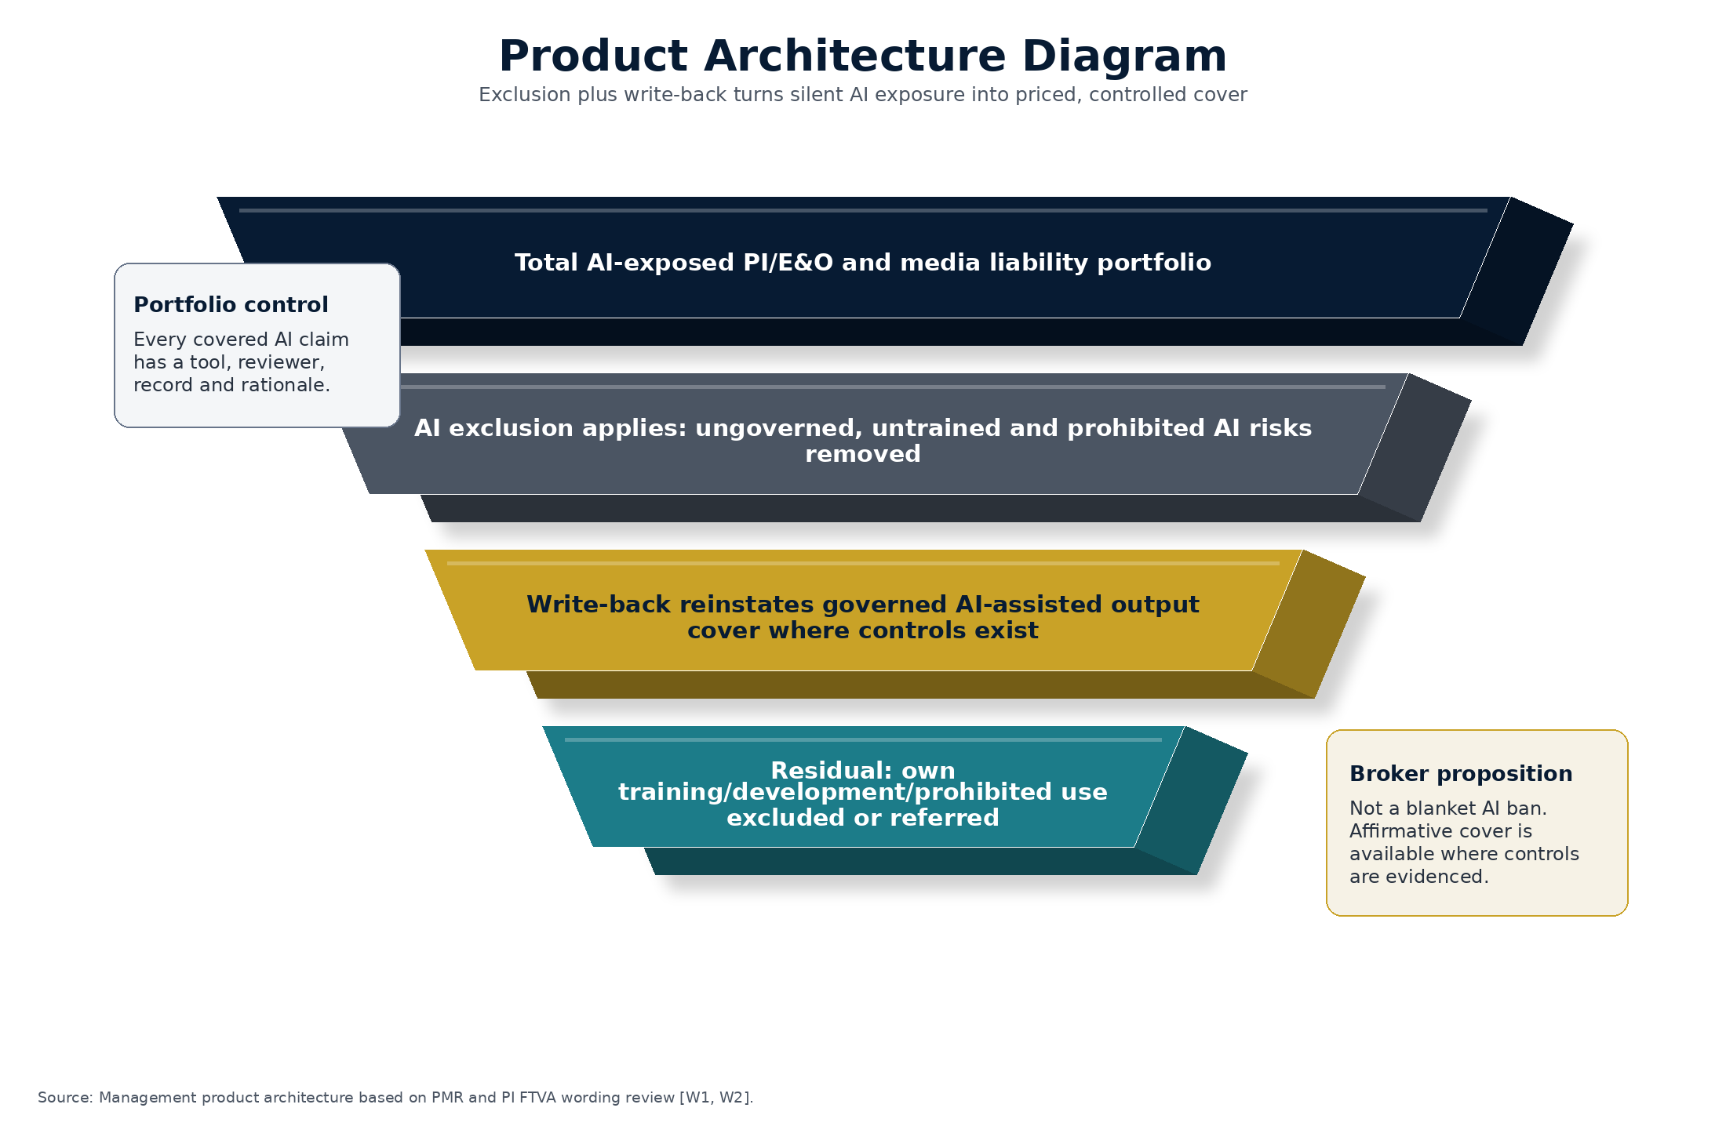
Chart 5 - Product Architecture Diagram
Source: Management product architecture based on PMR and PI FTVA wording review [W1, W2].

8.1 Three risk tiers
Tier | Sector examples | Recommended cover
Tier 1 - Governed assistive use | IT drafting and debugging with code review; construction report formatting; media first drafts and ideation. | Offer write-back up to scheduled sublimit, often 25%-50% of policy limit subject to cap.
Tier 2 - Client-facing AI-assisted output | AI-assisted code, specifications, BIM outputs, scripts, images, music, campaign copy or high-volume content. | Offer lower sublimit, higher deductible, stronger controls, records and claims cooperation.
Tier 3 - Prohibited or specialist AI risk | Own model development, fine-tuning, scraping, autonomous design/advice, digital replicas without consent, dataset licensing. | Decline, exclude or refer to bespoke technology E&O, cyber or specialist IP underwriting.

8.2 Five core underwriting questions
Question | Reason
Which AI tools are used, by whom, for what services and under what licence terms? | Identifies approved tools, commercial-use rights and uncontrolled public-tool use.
Are AI tools used to create, alter, approve, publish or deliver client-facing outputs? | Separates low-risk internal use from covered professional output risk.
Does the insured train, fine-tune, scrape, crawl, label, store or create datasets for any AI system? | Flags Tier 3 risk that should be excluded or separately underwritten.
What restricted data, client data, personal data or third-party proprietary material can enter AI tools? | Tests data protection, confidentiality and rights-control exposure.
What qualified human review, records, client disclosure and rights clearance apply before output is delivered or published? | Tests whether the account can qualify for the write-back.

8.3 Proposed AI exclusion and write-back wording for PMR Section 1 Media Liability
Drafting note: This endorsement is drafted to sit within PMR MAC Add 0220, Section 1 - Media Liability. It uses the policy terms Claim, Damages, Defence costs and expenses, Media business services and Advertising activities. It should be scheduled with a sublimit, deductible/retention and any approved or prohibited tools. The wording below is included in full and should be reviewed by external coverage counsel before use.
ENDORSEMENT AI-ML 01 - ARTIFICIAL INTELLIGENCE EXCLUSION AND AI-ASSISTED MEDIA LIABILITY EXTENSION
Applicable to: Section 1 - Media Liability only.
The terms, conditions, limitations and exclusions of the Policy remain unchanged except as amended by this endorsement.
A. Additional definitions
AI System means a machine-based system which, for explicit or implicit objectives, infers from inputs how to generate outputs including content, text, images, audio, video, software code, predictions, recommendations, analysis or decisions. AI System includes generative AI, large language models, machine-learning systems, deep-learning systems, natural-language processing systems, computer-vision systems and analogous systems.
Generative AI Tool means any AI System which creates, selects, combines, translates, summarises, adapts or materially modifies content, text, images, audio, video, software code, analysis, recommendations or other material in response to prompts, instructions, data or other inputs.
AI Output means any content, text, image, audio, video, software code, analysis, recommendation, decision, instruction, data, metadata or other output generated, selected, combined, translated, summarised, adapted or materially modified by a Generative AI Tool.
AI-Assisted Media Business Services means Media business services or associated Advertising activities in which AI Output is incorporated into, relied upon in, or used to create, select, approve, publish, distribute or display any material supplied to a client, the public or any third party.
Approved AI Tool means a Generative AI Tool recorded in the Insured's AI tool register and approved by the Insured for the relevant use, provided that: (a) the Insured has reasonable grounds to believe that the tool's licence permits the relevant commercial use; (b) the tool is used in accordance with its licence, terms and acceptable-use restrictions; and (c) where Restricted Input Data is used, the tool is configured so that such data is not used by the provider to train or improve a public model unless the Insured has lawful authority to permit that use.
Qualified Human Review means review by a natural person with appropriate competence, authority and time to assess the AI Output for accuracy, professional judgment, legal/rights clearance, confidentiality, privacy, defamation, infringement, misleading content and suitability for the relevant Media business services or Advertising activities. Merely pressing approve, publish or accept without substantive review is not Qualified Human Review.
AI Output Record means a written or electronic record retained by the Insured identifying, so far as reasonably practicable: the Approved AI Tool used; the date of use; the nature of the prompt or instruction; the type of input data; the material AI Output used; the reviewer; the clearance steps; any client disclosure/approval; and any licence, consent or source material relied upon.
Restricted Input Data means personal data, special category data, criminal-offence data, confidential information, trade secrets, non-public client information, unreleased Content, third-party proprietary material or material subject to contractual, statutory or professional restrictions on disclosure or use.
Unauthorised Training Data means any copyright work, database, trade mark material, image, voice, likeness, performance, personal data, confidential information, trade secret or other protected material used to train, fine-tune, adapt, test or validate an AI System where the Insured does not have: (a) an express licence or written consent for that use; (b) a written legal opinion reasonably supporting that use; or (c) a clearly applicable statutory exception.
Ordinary Business Software means software used for spelling, grammar, formatting, indexing, search, file management, resizing, compression, transcription, translation, security scanning, accessibility, accounting, billing or similar administrative purposes, provided that the software is not used to create or materially modify substantive content, advice, analysis, recommendations or decisions supplied to a client, the public or any third party.
Prohibited AI Use means: (a) using an AI System to provide autonomous professional advice or make a final professional judgment without Qualified Human Review; (b) using an AI System to impersonate a person or create a synthetic voice, likeness, performance, signature or persona without all required consents and rights clearances; (c) using an AI System to generate unlawful, defamatory, discriminatory or intentionally misleading material; (d) using an AI System in breach of a client instruction, contract, law, regulation, professional rule or legal advice; (e) using an AI System to train, fine-tune, adapt or validate any AI System using Unauthorised Training Data; or (f) using any AI System after the Insured knew or ought reasonably to have known that the relevant use was likely to infringe rights, breach confidentiality or breach data protection law.
B. Additional exclusion - Artificial Intelligence
The following exclusion is added to Section 1 - Exclusions:
Artificial Intelligence
This Section does not cover any Claim, Damages, claimant's costs, Defence costs and expenses or any other amount arising out of, based upon or attributable to:
(a) the design, development, training, fine-tuning, adaptation, testing, validation, deployment, operation, maintenance, licensing, sale, supply or making available of any AI System by or on behalf of any Insured;
(b) the use, publication, communication, distribution, display, supply or reliance upon any AI Output as part of the Media business services or associated Advertising activities;
(c) any allegation that AI Output infringes copyright, database right, moral right, trade mark, trade dress, title, slogan, passing off, plagiarism, format right, character right, music right, artwork right, publicity right, privacy right, confidentiality right or any analogous right;
(d) any allegation that AI Output is defamatory, disparaging, false, misleading, inaccurate, negligent or otherwise wrongful;
(e) the input, upload, disclosure or use of Restricted Input Data in or with any AI System;
(f) any failure to disclose the use of an AI System or AI Output where disclosure was required by law, regulation, professional rule, contract, client instruction or written legal advice; or
(g) any Prohibited AI Use.
This exclusion shall not apply:
(i) solely because the Insured used Ordinary Business Software in a manner that did not create or materially modify substantive content, advice, analysis, recommendations or decisions supplied to a client, the public or any third party;
(ii) to the extent cover is provided by the AI-Assisted Media Liability Extension below; or
(iii) where the use of an AI System was wholly incidental and did not cause or materially contribute to the Claim.
C. AI-Assisted Media Liability Extension
Notwithstanding the Artificial Intelligence exclusion above, the Insurer will indemnify the Insured under Section 1 for Damages, claimant's costs and Defence costs and expenses in respect of a Claim first made against the Insured during the Period of insurance and notified in accordance with the Policy, arising out of AI-Assisted Media Business Services, but only to the extent that the Claim would have been covered under Insuring Clauses 1(b), 1(c), 1(d), 1(e), 1(j), 1(k) or 1(m) of Section 1 had the Artificial Intelligence exclusion not applied.
The maximum amount payable under this Extension is the AI-Assisted Media Liability Sublimit shown in the Schedule. If no sublimit is shown, the sublimit shall be GBP 250,000 any one Claim and in the aggregate. This sublimit is part of, and not in addition to, the Indemnity limit.
Cover under this Extension applies only where all of the following requirements are satisfied:
(1) the AI Output was generated using an Approved AI Tool;
(2) the AI Output was subject to Qualified Human Review before publication, distribution, display, supply to a client or other third-party reliance;
(3) the Insured retained an AI Output Record;
(4) the Insured disclosed the material use of AI to the client or other relevant person where such disclosure was required by law, regulation, professional rule, contract, client instruction or written legal advice, or where the AI use was material to the nature of the services supplied;
(5) the Insured did not use Restricted Input Data unless the Insured had lawful authority and any required consent, contractual permission or professional authority to do so, and used reasonable data-minimisation and security measures;
(6) the Insured complied with any content clearance, rights clearance or legal advice applicable to the relevant Media business services or associated Advertising activities; and
(7) the Claim does not arise out of Prohibited AI Use.
For the purpose of this Extension, requirements (1), (2) and (7) are part of the scope of the cover granted by this Extension. The Insurer shall not rely on non-compliance with requirements (3), (4), (5) or (6) to decline cover for a Claim if the Insured proves that the non-compliance could not have increased the risk of the loss which actually occurred, unless the Policy validly contracts out of section 11 of the Insurance Act 2015 in accordance with applicable law.
D. Training-data defence costs sublimit
Subject always to the Policy terms, the Insurer will pay Defence costs and expenses up to the AI Training Data Defence Costs Sublimit shown in the Schedule where a Claim alleges that the Insured's use of an Approved AI Tool caused infringement solely because the tool provider, and not the Insured, used copyright works, databases or other protected material to train, fine-tune, test or validate the tool.
No cover is provided under this training-data defence costs sublimit for: (a) Damages, royalties, licence fees, restitution, disgorgement, account of profits, settlement sums or claimant's costs; (b) any AI System trained, fine-tuned, adapted, tested or validated by or on behalf of the Insured; (c) any use of Unauthorised Training Data by or on behalf of the Insured; or (d) any circumstance where, before the relevant AI Output was used, the Insured knew or ought reasonably to have known that the relevant tool or dataset was likely to infringe rights.
E. Drafting note for PMR
The PMR write-back should not be attached without a Schedule specifying the AI-Assisted Media Liability Sublimit, AI Training Data Defence Costs Sublimit, applicable deductible/retention, approved/prohibited use categories, and any jurisdictional restrictions. The Schedule is also the place to list tools or classes of tools if underwriting wants to do so.

8.4 Proposed AI exclusion and write-back wording for PI FTVA Content/Production Activities
Drafting note: PI FTVA is a content/production E&O wording. The endorsement below uses the policy terms Content, Production activities, Advertising, Claim, Damages and Defence costs and expenses. It should be attached only to the content/production wording and is not a substitute for separate technology E&O or AI developer cover.
ENDORSEMENT AI-CONTENT 01 - ARTIFICIAL INTELLIGENCE EXCLUSION AND AI-ASSISTED CONTENT LIABILITY EXTENSION
Applicable to: Claims arising out of Content forming part of Production activities.
The terms, conditions, limitations and exclusions of the Policy remain unchanged except as amended by this endorsement.
A. Additional definitions
AI System means a machine-based system which, for explicit or implicit objectives, infers from inputs how to generate outputs including content, text, images, audio, video, software code, predictions, recommendations, analysis or decisions. AI System includes generative AI, large language models, machine-learning systems, deep-learning systems, natural-language processing systems, computer-vision systems and analogous systems.
Generative AI Tool means any AI System which creates, selects, combines, translates, summarises, adapts or materially modifies content, text, images, audio, video, software code, analysis, recommendations or other material in response to prompts, instructions, data or other inputs.
AI Output means any content, text, image, audio, video, software code, analysis, recommendation, decision, instruction, data, metadata or other output generated, selected, combined, translated, summarised, adapted or materially modified by a Generative AI Tool.
AI-Assisted Content means Content forming part of Production activities in which AI Output is incorporated into, relied upon in, or used to research, develop, prepare, produce, serialise, syndicate, release, broadcast, advertise, distribute or display the Content.
Approved AI Tool means a Generative AI Tool recorded in the Insured's AI tool register and approved by the Insured for the relevant use, provided that: (a) the Insured has reasonable grounds to believe that the tool's licence permits the relevant commercial use; (b) the tool is used in accordance with its licence, terms and acceptable-use restrictions; and (c) where Restricted Input Data is used, the tool is configured so that such data is not used by the provider to train or improve a public model unless the Insured has lawful authority to permit that use.
Qualified Human Review means review by a natural person with appropriate competence, authority and time to assess the AI Output for accuracy, professional judgment, legal/rights clearance, confidentiality, privacy, defamation, infringement, misleading content and suitability for the relevant Content or Production activities. Merely pressing approve, publish or accept without substantive review is not Qualified Human Review.
AI Output Record means a written or electronic record retained by the Insured identifying, so far as reasonably practicable: the Approved AI Tool used; the date of use; the nature of the prompt or instruction; the type of input data; the material AI Output used; the reviewer; the clearance steps; any client disclosure/approval; and any licence, consent or source material relied upon.
Restricted Input Data means personal data, special category data, criminal-offence data, confidential information, trade secrets, non-public client information, unreleased Content, third-party proprietary material or material subject to contractual, statutory or professional restrictions on disclosure or use.
Unauthorised Training Data means any copyright work, database, trade mark material, image, voice, likeness, performance, personal data, confidential information, trade secret or other protected material used to train, fine-tune, adapt, test or validate an AI System where the Insured does not have: (a) an express licence or written consent for that use; (b) a written legal opinion reasonably supporting that use; or (c) a clearly applicable statutory exception.
Ordinary Business Software means software used for spelling, grammar, formatting, indexing, search, file management, resizing, compression, transcription, translation, security scanning, accessibility, accounting, billing or similar administrative purposes, provided that the software is not used to create or materially modify substantive content, advice, analysis, recommendations or decisions supplied to a client, the public or any third party.
Prohibited AI Use means: (a) using an AI System to provide autonomous professional advice or make a final professional judgment without Qualified Human Review; (b) using an AI System to impersonate a person or create a synthetic voice, likeness, performance, signature or persona without all required consents and rights clearances; (c) using an AI System to generate unlawful, defamatory, discriminatory or intentionally misleading material; (d) using an AI System in breach of a client instruction, contract, law, regulation, professional rule or legal advice; (e) using an AI System to train, fine-tune, adapt or validate any AI System using Unauthorised Training Data; or (f) using any AI System after the Insured knew or ought reasonably to have known that the relevant use was likely to infringe rights, breach confidentiality or breach data protection law.
B. Additional exclusion - Artificial Intelligence
The following exclusion is added to the Exclusions Applicable to This Insurance:
Artificial Intelligence
This insurance does not cover any Claim, Damages, claimant's costs, Defence costs and expenses or any other amount arising out of, based upon or attributable to:
(a) the design, development, training, fine-tuning, adaptation, testing, validation, deployment, operation, maintenance, licensing, sale, supply or making available of any AI System by or on behalf of any Insured;
(b) the use, publication, communication, distribution, display, supply or reliance upon any AI Output in or in connection with Content or Production activities;
(c) any allegation that AI Output infringes copyright, database right, moral right, trade mark, trade dress, title, slogan, passing off, plagiarism, format right, character right, character name, title, plot, musical composition, voice, slogan, graphic material, artwork, publicity right, privacy right, confidentiality right or any analogous right;
(d) any allegation that AI Output is defamatory, disparaging, false, misleading, inaccurate, negligent or otherwise wrongful;
(e) the input, upload, disclosure or use of Restricted Input Data in or with any AI System;
(f) any failure to disclose the use of an AI System or AI Output where disclosure was required by law, regulation, professional rule, contract, client instruction or written legal advice; or
(g) any Prohibited AI Use.
This exclusion shall not apply:
(i) solely because the Insured used Ordinary Business Software in a manner that did not create or materially modify substantive Content supplied to a client, the public or any third party;
(ii) to the extent cover is provided by the AI-Assisted Content Liability Extension below; or
(iii) where the use of an AI System was wholly incidental and did not cause or materially contribute to the Claim.
C. AI-Assisted Content Liability Extension
Notwithstanding the Artificial Intelligence exclusion above, the Insurer will indemnify the Insured under this insurance for Damages, claimant's costs and Defence costs and expenses in respect of a Claim first made against the Insured during the Policy Period and notified in accordance with the Policy, arising out of AI-Assisted Content forming part of Production activities, but only to the extent that the Claim would have been covered under Insuring Clauses 1(a), 1(b), 1(c), 1(d), 1(e), 1(f), 1(g) or 1(h) had the Artificial Intelligence exclusion not applied.
The maximum amount payable under this Extension is the AI-Assisted Content Liability Sublimit shown in the Schedule. If no sublimit is shown, the sublimit shall be GBP 250,000 any one Claim and in the aggregate. This sublimit is part of, and not in addition to, the Indemnity limit.
Cover under this Extension applies only where all of the following requirements are satisfied:
(1) the AI Output was generated using an Approved AI Tool;
(2) the AI Output was subject to Qualified Human Review before release, broadcast, distribution, display, inclusion in Content, supply to a client or other third-party reliance;
(3) the Insured retained an AI Output Record;
(4) the Insured obtained all required rights clearances and consents for any AI-generated or AI-modified voice, likeness, performance, image, music, artwork, character, character name, title, plot, format, trade mark, copyright material or other protected element;
(5) the Insured disclosed the material use of AI to the client, commissioner, distributor, broadcaster, platform or other relevant person where such disclosure was required by law, regulation, professional rule, contract, client instruction or written legal advice, or where the AI use was material to the nature of the Content supplied;
(6) the Insured did not use Restricted Input Data unless the Insured had lawful authority and any required consent, contractual permission or professional authority to do so, and used reasonable data-minimisation and security measures;
(7) the Insured complied with any content clearance, rights clearance or legal advice applicable to the Content or Production activities; and
(8) the Claim does not arise out of Prohibited AI Use.
For the purpose of this Extension, requirements (1), (2), (4) and (8) are part of the scope of the cover granted by this Extension. The Insurer shall not rely on non-compliance with requirements (3), (5), (6) or (7) to decline cover for a Claim if the Insured proves that the non-compliance could not have increased the risk of the loss which actually occurred, unless the Policy validly contracts out of section 11 of the Insurance Act 2015 in accordance with applicable law.
D. Training-data defence costs sublimit
Subject always to the Policy terms, the Insurer will pay Defence costs and expenses up to the AI Training Data Defence Costs Sublimit shown in the Schedule where a Claim alleges that the Insured's use of an Approved AI Tool caused infringement solely because the tool provider, and not the Insured, used copyright works, databases or other protected material to train, fine-tune, test or validate the tool.
No cover is provided under this training-data defence costs sublimit for: (a) Damages, royalties, licence fees, restitution, disgorgement, account of profits, settlement sums or claimant's costs; (b) any AI System trained, fine-tuned, adapted, tested or validated by or on behalf of the Insured; (c) any use of Unauthorised Training Data by or on behalf of the Insured; or (d) any circumstance where, before the relevant AI Output was used, the Insured knew or ought reasonably to have known that the relevant tool or dataset was likely to infringe rights.
E. Additional Insureds / productions
Where the Policy covers Additional Insureds, this endorsement applies to each Additional Insured only to the extent the Named Insured and the Additional Insured seeking cover complied with the requirements of this endorsement in respect of the relevant Content or Production activities.
For Library titles, this endorsement applies only to AI Output first incorporated into, or materially modifying, the Library title after the effective date of this endorsement unless otherwise agreed in writing by the Insurer.

9. Implementation Plan
The implementation plan should protect the portfolio and create a broker-ready product. The first release should be narrow enough to manage, broad enough to sell, and data-rich enough to improve at renewal. The launch should not wait for perfect claims data; the absence of claims data is exactly why claims coding must begin now.

9.1 Pilot approach
Step | Action | Owner / output
1. Counsel review | Send the proposed PMR and PI FTVA endorsements, broker disclosure and Insurance Act 2015 approach to external coverage counsel. | Legally approved wording pack.
2. Broker feedback | Test wording and questionnaire with selected London brokers active in IT, media/creative and construction PI. | Broker objections, pricing feedback and wording refinements.
3. IT and media/creative pilot | Launch on selected Tier 1-Tier 2 IT and technology plus media/creative accounts. | Early premium, take-up and control data.
4. Construction design pilot | Introduce construction and built-environment accounts once design-review and BIM questions are validated. | Construction-specific risk controls and sublimit strategy.
5. Claims coding | Add AI allegation, AI cause, AI contribution, output/training category and tool type fields. | Renewal-ready experience data.
6. Renewal review | Review claims, near misses, complaints, takedowns and governance changes at renewal. | Refined tier, sublimit and rating approach.

9.2 AI governance form requirement
The questionnaire should be short enough to complete and strong enough to underwrite. It should not ask generic questions about whether the insured uses AI. It should ask where AI touches final deliverables, what data enters the tool, who reviews the output, what records are kept, and whether the insured trains or fine-tunes models.

9.3 Renewal review triggers
Trigger | Action
New AI tool used for client-facing outputs | Reassess approved-tool status, licence terms and review controls.
Move from internal AI use to client deliverables | Move account from Tier 1 to Tier 2 and reconsider sublimit/retention.
Own model training, fine-tuning or dataset creation | Refer to specialist technology E&O/cyber/IP underwriting or exclude.
Use of synthetic voice, likeness or performance | Require consent evidence, rights clearance and senior underwriting approval.
Complaint, takedown, data-subject request or rights challenge | Code as AI-related circumstance and review renewal terms.

Launch discipline
The first objective is not maximum volume. The first objective is controlled evidence: who buys, what controls they have, what brokers resist, what claims are notified, and where the wording needs refinement.

10. Evidence Register
Evidence notation: W sources are uploaded policy wordings. S sources are public sources used for market, legal and sector analysis. Page references for W1/W2 are PDF page numbers in the uploaded files, not necessarily policy pagination. Public source descriptions are included so the board can verify the facts independently.

10.1 Veracity audit corrections applied
Claim tested | Board-safe treatment applied
GBP 4bn headline | Removed as near-term PI/E&O write-back premium; reframed as broad multi-line upside only.
42% total AI exclusion / 33% silent / 8% write-back | Removed as public fact; would require internal broker/carrier survey evidence.
AI PI claims CAGR of 40%-50% | Removed; LMA sources support concern about increased losses, not a reliable CAGR.
72% professional-services deployment | Replaced with DSIT sector data and Thomson Reuters survey evidence.
USD 28bn coverage gap | Reframed as upside exposed-premium scenario, not current purchasable premium.
USD 22bn US PI/E&O | Treated as a triangulated estimate, not a published statistic.
ISO/Verisk AI forms | Corrected to CGL-oriented generative AI exclusion references; not treated as PI/E&O standard forms.

10.2 Source list retained from source paper
ID | Source | Type | What it supports
W1 | PMR MAC Add 0220.pdf | Uploaded policy wording | Section 1 Media Liability, definitions, insuring clauses and exclusions. Key pages: p.5 definitions; pp.6-8 insuring clauses; pp.10-13 exclusions; p.14 notification.
W2 | PI FTVA 1224.pdf | Uploaded policy wording | Content/production E&O wording. Key pages: pp.2-3 definitions; pp.3-4 insuring clauses; pp.5-8 exclusions.
S1 | International Underwriting Association, London Company Market Statistics Report 2025 | Public market report | London company-market professional lines GBP 4.594bn; PI/E&O GBP 2.222bn; geography split including UK/Ireland GBP 3.046bn. URL: https://www.iua.co.uk/IUA/News/Publications/Reports/London_Company_Market_Statistics_Report_2025.aspx
S2 | London Market Group, London Matters 2026 | Public market report | London Market USD 187bn GWP; AI/intangible assets listed among opportunity areas. URL: https://lmg.london/insights/london-matters-2026/
S3 | UK Government / DSIT, AI Adoption in UK Businesses research | Official government research | One in six businesses use AI; sector adoption; NLP/text generation; weekly use. URL: https://www.gov.uk/government/publications/ai-adoption-in-uk-businesses-research-and-appendices/ai-adoption-in-uk-businesses-executive-summary
S4 | Office for National Statistics, Management practices and AI in UK firms, 2023 | Official statistics | AI adoption 9% in 2023 and projected 22% in 2024 for in-scope firms; sample/method caveats. URL: https://www.ons.gov.uk/businessindustryandtrade/business/businessinnovation/articles/managementpracticesandaiinukfirms/2023
S5 | Thomson Reuters, 2025 Generative AI in Professional Services Report | Professional-services survey | About half of surveyed professionals use GenAI; organisation policy/training gaps; methodology. URL: https://legal.thomsonreuters.com/blog/2025-generative-ai-in-professional-services-report/
S6 | LexisNexis, AI Culture Clash report / survey | Legal-sector survey | 61% of UK legal professionals use GenAI for work in August 2025, up from 46% in January 2025. URL: https://www.lexisnexis.co.uk/insights/ai-culture-clash
S7 | Lloyd's Market Association, AI: The impact on international E&O insurance | Market association report | GenAI use in professional services; risks; need for clear wordings and underwriting questions. URL: https://www.lmalloyds.com/resources/guides/ai-the-impact-on-international-e-o-insurance/
S8 | Lloyd's Market Association, Artificial intelligence - loss scenarios survey | Market association survey | Underwriter expectations around frequency/severity and wording dependence. URL: https://www.lmalloyds.com/resources/guides/artificial-intelligence-loss-scenarios-survey/
S9 | UK Government, Copyright and Artificial Intelligence consultation / 2026 report | Official government policy materials | Training-data, transparency, licensing, enforcement, computer-generated works and digital replicas. URL: https://www.gov.uk/government/consultations/copyright-and-artificial-intelligence and https://www.gov.uk/government/publications/copyright-and-ai-report
S10 | Getty Images v Stability AI, High Court judgment and public legal commentary | Court judgment / legal commentary | UK AI/copyright litigation: unresolved, fact-specific issues around training and outputs. Court URL: https://www.judiciary.uk/judgments/getty-images-us-inc-and-others-v-stability-ai-ltd/
S14 | Allied Market Research, Professional Liability Insurance Market | Market research | Global professional liability market USD 45.6bn in 2023; projected USD 81.2bn by 2032. URL: https://www.alliedmarketresearch.com/professional-liability-insurance-market-A120260
S15 | US Treasury / Federal Insurance Office, Annual Report on the Insurance Industry 2025 | Official US insurance market report | US largest single-country insurance market; 45% of world direct premium; US P&C direct premium scale. URL: https://home.treasury.gov/system/files/311/Final%20FIO%202025%20Annual%20Report.pdf
S16 | Insurance Act 2015 sections 11 and 15-17 | UK legislation | Section 11 risk-mitigation terms; non-consumer contracting-out and transparency requirements. URL: https://www.legislation.gov.uk/ukpga/2015/4/contents
S17 | ICO, Special category data guidance | UK regulator guidance | Article 6 lawful basis, Article 9 condition, documentation and DPIA considerations. URL: https://ico.org.uk/for-organisations/uk-gdpr-guidance-and-resources/lawful-basis/special-category-data/
S18 | Public secondary reporting on Verisk/ISO generative AI CGL exclusions | Secondary market reporting | Evidence of CGL market response, not a PI/E&O standard. URLs: https://www.independentagent.com/vu_resource/verisk-to-roll-out-new-general-liability-exclusions-for-generative-ai-exposures/ and https://core.verisk.com/Insights/Emerging-Issues/Articles/2025/July/Week-4/Emerging-Risks-in-ISO-General-Liability-Multistate-Filing
S19 | FCA, General insurance value measures and PROD 4 / fair value materials | UK regulator material | Product manufacturers/distributors must evidence fair value and good outcomes. URL: https://www.fca.org.uk/publications/multi-firm-reviews/general-insurance-value-measures-data-2023
S20 | Thaler v Perlmutter and US Copyright Office human-authorship position | US case/regulatory materials | Human authorship requirement for copyright registration; relevance to AI-generated works. URL: https://media.cadc.uscourts.gov/opinions/docs/2025/03/23-5233.pdf
S21 | Bartz v Anthropic and settlement reporting | US litigation materials / press | Training/fair-use and pirated-copy distinction; severity from settlement reporting. URLs: https://www.ropesgray.com/en/insights/alerts/2025/06/from-books-to-bots-key-takeaways-from-the-anthropic-fair-use-decision-for-ai-developers and https://www.afslaw.com/perspectives/alerts/landmark-ruling-ai-copyright-fair-use-vs-infringement-bartz-v-anthropic
S22 | New York Times v OpenAI / Microsoft | US litigation materials | Ongoing copyright litigation involving training, outputs and related theories. URLs: https://law.justia.com/cases/federal/district-courts/new-york/nysdce/1%3A2023cv11195/612697/514/ and https://www.meshiplaw.com/litigation-tracker/new-york-times-microsoft
S23 | Andersen and related visual-artist AI cases | US litigation materials | Image-generation copyright claims; claims surviving/narrowed through motion practice. URL: https://copyrightalliance.org/andersen-v-stability-ai-copyright-case/

10.3 Additional sector sources used in this rebuild
ID | Source | Type | What it supports
S24 | Gartner, Worldwide IT Spending Forecast 2026 | Technology market research | Worldwide IT spending expected to reach USD 6.15tn in 2026, supporting the scale of the IT services/software ecosystem. URL: https://www.gartner.com/en/newsroom/press-releases/2026-02-03-gartner-forecasts-worldwide-it-spending-to-grow-10-point-8-percent-in-2026-totaling-6-point-15-trillion-dollars
S25 | UK Government / DSIT, Research on Managed Service Providers 2025 | Official government research | UK MSP market: 12,867 active MSPs as of March 2025; relevant to high-volume IT professional-services exposure. URL: https://www.gov.uk/government/publications/research-on-managed-service-providers-2025
S26 | Autodesk, Generative design for architecture, engineering and construction | Vendor / platform documentation | Generative design is used to explore and optimise design options in architecture, engineering and construction workflows. URL: https://www.autodesk.com/solutions/generative-design/architecture-engineering-construction
S27 | Bentley Systems, Infrastructure AI and 2025 AI application announcements | Vendor / platform documentation | AI is being embedded into infrastructure design, construction and digital-twin workflows. URLs: https://www.bentley.com/software/infrastructure-ai/ and https://www.bentley.com/news/bentley-systems-advances-infrastructure-ai-with-new-applications-and-industry-collaboration/
S28 | SAG-AFTRA digital replica materials | Union / industry materials | Film and television digital replica risk: consent and control of performer voice/likeness. URL: https://www.sagaftra.org/sites/default/files/sa_documents/DigitalReplicas.pdf
S29 | CISAC / PMP Strategy AI Study | Creative-sector economic study | Generative AI music and audiovisual content projected to grow materially; creator revenue at risk in music and audiovisual. URL: https://www.cisac.org/services/reports-and-research/cisacpmp-strategy-ai-study
S30 | PRS for Music, AI policy and music copyright | Music-sector rights body guidance | PRS member survey: nearly 30% already using AI in the creative process in 2023 and 55% planning to use it. URL: https://www.prsformusic.com/works/how-copyright-works/ai-and-music-copyright
S31 | House of Lords Communications and Digital Committee, AI, copyright and the creative industries | Parliamentary report | Rights-holder concerns, transparency and licensing issues for AI and creative industries. URL: https://publications.parliament.uk/pa/ld5901/ldselect/ldcomm/267/267.pdf

10.4 Enhancements made in this rebuild
Enhancement | Why it improves the board paper
Sector focus rebuilt around IT and technology, construction and built environment, and media, music, events, film and television. | Aligns the product with the target markets and removes distracting emphasis on non-target professions.
Unsupported statistics corrected or caveated. | Makes the paper defensible under board, risk committee and non-executive director challenge.
Premium opportunity split into total base, AI-exposed base and incremental write-back premium. | Prevents overstatement and shows the commercial opportunity in a way finance and underwriting can use.
Full exclusion-plus-write-back architecture retained with PMR and PI FTVA wording in full. | Preserves the strongest legal/underwriting content while making the strategy readable.
Five board-level 3D visuals added. | Turns the commercial case into an executive presentation asset rather than a dense wording review.

