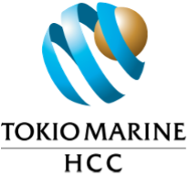

Smoke Test
Branding Pipeline Test
Validating logo, fonts, palette, legend, landscape matrix and PDF export.
Wordings reviewed
- TMHCC — master wording
- Tysers (Zurich)
- Yutree (AXA)
- Liberty
- Allianz

Indicative wording comparison — broking reference only.
Subject to TMHCC legal/underwriting sign-off.

1 Coverage comparison at a glance
✓ Covered ◐ Partial / conditional / sub-limit ✗ Not covered / not identified ? Unclear – requires review
Section of cover | TMHCC | Tysers  (Zurich) | Yutree  (AXA) | Liberty | Allianz | Wording E  (pending) | Comment
Section 12 · Media Liability / PI | ✓ | ✓ | ✓ | ✗ | ✗ | … | TMHCC, Tysers (S8 PI/E&O) and Yutree (PI-Media) all offer media/PI; Liberty and Allianz do not.
Section 15 · Cyber Liability | ✓ | ✗ | ◐ | ✗ | ✗ | … | Only TMHCC offers standalone cyber (CyberGuard). Yutree has computer-breakdown only.

Reviewer note: This is a pipeline smoke test only.

