**Group Project - Proposal**

Wil, Baker W0441287

Josh, Skeete W0430825

Hanpyeong, Jang W0293200

Abdulrahman, Al-Kasem W0427319

**Project description**

The aim of this project is to develop a Windows Presentation Foundation (WPF) application that uses Entity Framework to display data from the provided IMDB_Project SQL Server database.

The application will showcase proper use of main WPF course concepts, including databinding, XAML UI practices, LINQ, and other related features. Additionally, the application will allow for filtering of data through the implementation of LINQ searches.

The WPF application will consist of at least three pages, not counting the home page, that will enable users to view and interact with the data in different ways. These pages will include functionalities such as Director search, show search, Movie search, and Genre search, displaying the corresponding data in an organized and user-friendly manner.

The home page will provide users with an overview of the application's features and options, including navigation to other pages. The other pages will include a range of functionalities, such as displaying information about movies, actors, directors, and other related data.

The application will have a user-friendly interface that allows users to interact with the data easily. Additionally, the application will provide an efficient search and filtering mechanism to help users find the desired data quickly.

Overall, the project aims to provide a fully functional WPF application that demonstrates a wide range of core WPF concepts and features, allowing users to explore and interact with the data in an intuitive and efficient manner.

**Wireframe of application**

<https://www.figma.com/file/ahMgnNCkZgxwvBHQsn4C3o/Untitled?node-id=0%3A1&t=oQXfxPAwwCzniPS3-1>

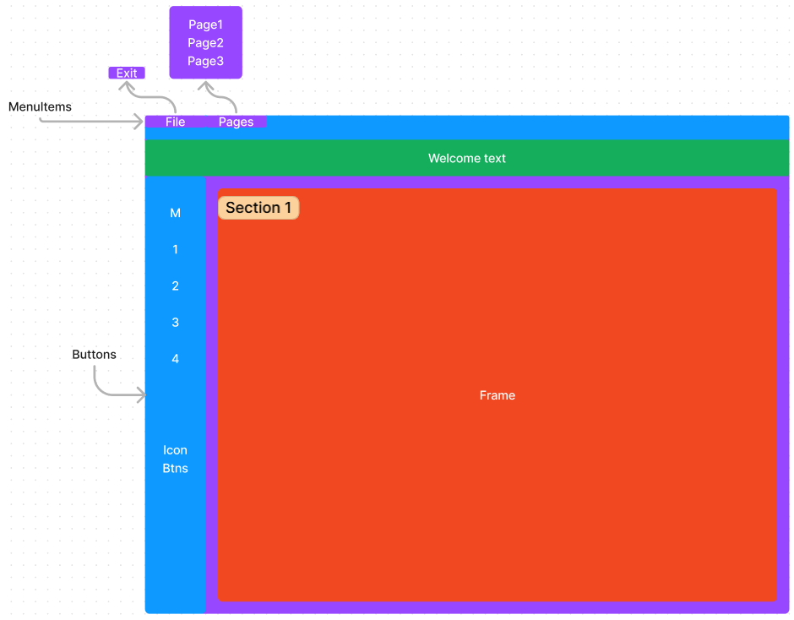

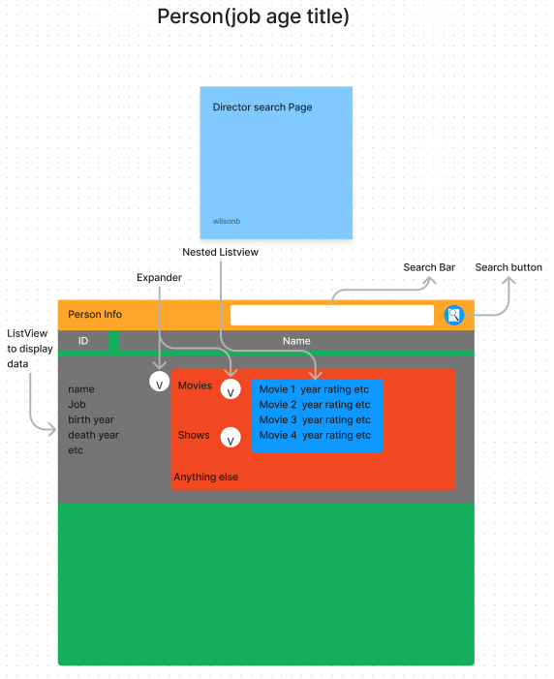

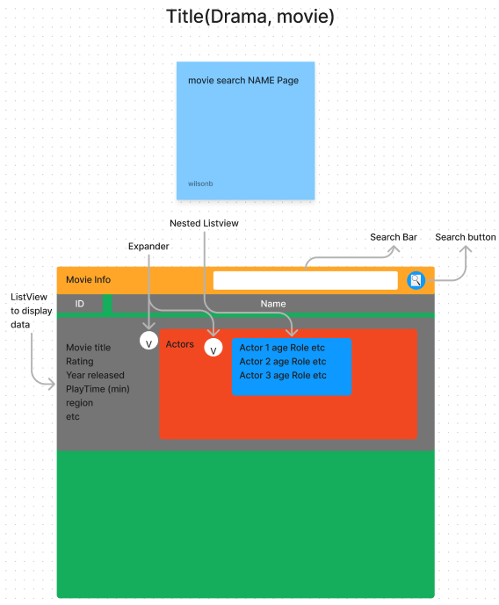

**Workplan, including timeline and member task assignments.**



Work Plan PROG-2500

Project: develop a WPF application using entity framework to display data from the provided IMDB database.

Tasks:

* Define the scope the WPF requirements.
* Design the layout of the WPF application using wire framing tools.
* Develop front end code and styles based off wire frame.
* Develop back-end logic.
* Test WPF application for any errors in logic.

Team Member Assignment

* Project Manager: Wilson baker
* Front End Design: Hanpyeong Jang, Wilson baker
* Back-End development: Joshua Skeete, Abdulrahman
* Testing: Joshua Skeete, Wilson Baker

Timeline:

* Wire framing design planning (1 Day)
* Front end development (4 days)
* Back-end logic (4 days)
* Testing and error handling (2 days)

Monitoring progress

* To keep progress in order we will meet weekly to discuss our progress with the project

The project will start on April 6th and will be completed by April 17th.

Project submission deadline is April 18th at 2:30pm.