**10920 CS 512200 VLSI Design for Manufacturability**

**Final Project**

Deadline: June 23, 2021

1. **Problem Description**

The hybrid lithography decomposition problem with triple patterning and E-beam shots for a standard cell-based layout is defined as follows:

1. Input:
2. A polygon-based layout (.out).
3. A coloring distance.
4. Objective:

Give each polygon a mask color (A, B, C) or specify it as E-beam polygon (E). Any polygon selected as E will not conflict with any other mask polygon. Any two mask polygons of the same color (A/B/C) will have a violation if the shortest distance between each other is less than the user-defined coloring distance. Your output must ensure that there is no conflict and minimize the number of E-beam shots. Note that coloring conflict will only occur between polygons belonging to the same row. For simplicity, we assume that each E-beam polygon requires one E-beam shot.

1. **Testcases(.out)**

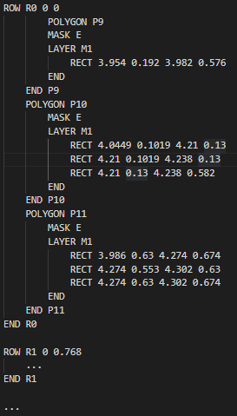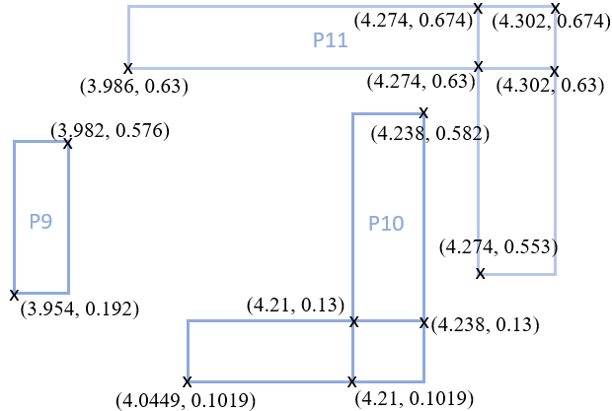The testcases define all rows and the polygons on them. Each row entry starts with the keyword "ROW", its name (RX) and the lower left coordinates of the row. (In the example below, the lower left coordinates of R0 are (0, 0).) Then, a list of polygon entries associated with the row will be listed. Finally, a row entry ends with the keyword "END RX". Each polygon entry starts with the keyword "POLYGON" and its name (PX) and ends with the keyword "END PX". The mask color of each polygon is defined after the keyword "MASK" and is preset to E-beam type "E". The shape of each polygon is specified by a series of rectangles, each rectangle begins with the keyword "RECT" followed by four floating-point numbers x1 y1 x2 y2 where (x1, y1) is the lower left coordinate of this rectangle and (x2, y2) is the upper right coordinates.

1. **Output Format**

The format of the output file is the same as that of the input testcase, except for the change of the letters after the keyword "MASK", the rest of the content must be exactly the same as the input file.

1. **Verify**

The executable file "Verify" will check whether your program output satisfies the following requirement and report the number of E-beam shots when there is no violation.

(1) All polygon shapes remain unchanged.

(2) The mask type of each polygon is one of A, B, C and E.

(3) No coloring conflicts.

Execution:

./Verify [ Coloring distance ] [ Original testcase file path ] [ Your output file path ]

Example:

./Verify 0.064 ./M0.out ./my_M0.out

Because it is an executable file, please change the execution authority yourself.

1. **Language/Platform**

Language: C/C++

Platform: Linux

1. **Required Items**

Please compress Project/ (using tar) into one with the name Project_{StudentID}.tar.gz before uploading to eLearn

* Ex: Project_109******.tar.gz

1. src/ contains all your source codes, your Makefile and README

* README must describe how to compile and execute your program

1. output/ contains all your output files of all testcases
2. testcase/ contains all testcases
3. bin/ contains your compiled executable file

The compiled executable file needs to be able to input three parameters in order.

(i) User defined coloring distance (floating point number)

(ii) Input file path

(iii) Output file path (the output file can be named arbitrarily)

Example:

./Hybrid_Lithography 0.064 ../testcase/M0.out ../output/My_M0.out

1. Project_{StudentID}_report.pdf which is your report, your report should contain the following content:
   1. A cover page containing the title, your name and student ID
   2. How to compile and execute your program.
   3. Your algorithm flow and explanation.
2. **Grading**

* 90%: The solution quality.
* 10%: The completeness of your report
* No scores for testcases executed for more than 5 minutes.