COMPANY PROFILE

OF

POMILLY EAST AFRICAN LIMITED

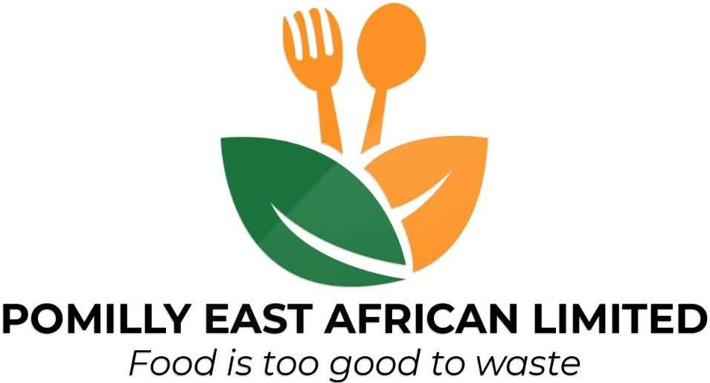

P.O BOX 5338-00100, Capital Center, Nairobi, Kenya.

+254 751 877 377 | +254 745 462 781

info@pomilly.com

.

- Pomilly East African Limited is an environmental sustainability and acoustic services company that aims at improving basic environmental standards through biotechnology and recycling food wastes.

- Business, Administrative & Contact Information

Company name: Pomilly East African Limited

Founded On: 3rd March 2018

CEO & Founder: Pondi Collins

Deputy CEO and Co-Founder: Milkah Mwai

Managing Director: Jane Nderi

Email: info@pomilly.com

Tel: +254751877377 | +254745462781

- Introduction

Company History

Pomilly East African Limited was set up by Milkah Mwai and Pondi Collins, a pair of friends running a food distribution business, After observing the food industry for more than a decade, they realized the need for a food bank in Kenya.

Founded in March 2018 The PEAL (Pomilly East African Limited) visited more than 30 charity organisations and homes to gain better insight into the situation on the ground. We also took the time to understand the operating models of each organisation that provides free meals and dry rations to the needy and less fortunate families and individuals.
We were given charity status in August 2019 and IPC status in May 2020.
We are registered in The Global Foodbanking Network
.

What we do

1. We help in Environment conservation and protection through Agricultural/food wastes recycling. (Waste management)
2. We enhance food security through sustainable farming and consulting.
3. Advocacy for free hunger world,Zero foodwastes,and free food for all
4. Selling Recycling machines and Sustainable farming simulators.
5. Education on community engagement on foodwastes recycling, food security and importance of food banking.
6. Research on, climate, Environment and Agricultural analyses

- Strategy

  - Vision statement

Pomilly East African Limited aims at elimination of landfills by reducing food waste through individual and corporate responsibility, and utilizing food waste as a resource because food is too good to waste.

  - Mission statement

Pomilly East African Limited promotes sustainable environmentally sound and cost effective practices in managing food waste as a resource through waste reduction, recycling, innovative technology, customer services consultancy, and education.

  - Values

Pomilly East African Limited promotes sustainable Environmentally sound and cost-effective practices in managing food waste as a resource through waste reduction, recycling science, innovative technology, customer services consultancy, education and sustainable Food banking technology. Our core values are fundamental in driving our organisational culture. They are;

- Integrity: We live our commitments and hold ourselves to the highest level of ethical uprightness and honesty.

- Transparent: We are efficient, accountable and responsibly apply resources entrusted to us for optimal benefit to our communities

- Innovative: We pilot innovative solutions to the environmental challenges and support scale up for community level impact.

- Quality: We put on our personal and professional best to deliver to the satisfaction of all. We maintain the Gold Standard.

  - Company goals

Pomilly East African Limited is a biotech company that recycles (Agricultural wastes) foodwastes into; clothes and medicine, we are to protect the environment, climate and food security, food wastes and sustainable farming is our future food system as we try to eliminate landfills and pollutions. Through this we improve food security globally and conserving the environment by managing food waste and enhancing sustainability.

  - Company Motto

Food is too good to waste

- Company concept

  - Services

- Sustainable Agricultural Consultancy

- Food Waste Recycling Industry

- Food Banking Food Security

- Environmental, Occupational Safety & Public Health Consultancy

- Attachments and supporting Documentation (available on request)

  - Copy of detailed curriculum vitae or resume of partners, owners & management.

  - Copy of identity documents of directors and shareholders.

  - Company/CC documents

  - Tax clearance certificate

  - Maps showing location.

  - Any other relevant substantiating documentation.

Thank you for taking the time to go through this Company profile.
If there are any questions or comments, please feel free to contact us.

